To Slow Climate Change, Curb Methane First

It can trap 80 times as much heat as CO2 in the first 20 years after being emitted.

By
Fred Krupp
Nov. 16, 2023 at 6:56 pm ET
704

Gift unlocked article

Listen
(3 min)
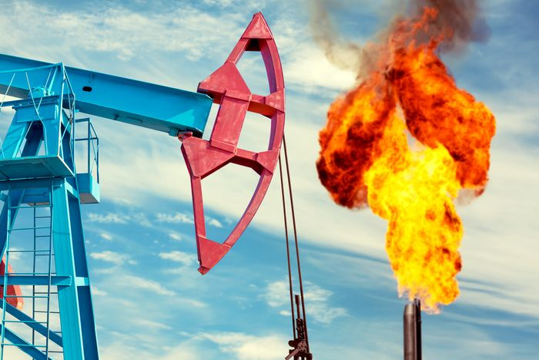An oil pump at work. PHOTO: GETTY IMAGES/ISTOCKPHOTO
Many environmentalists are understandably skeptical about a climate gathering that will be led by the chief executive of the United Arab Emirates’ national oil company. But the meeting, which begins Nov. 30 in Dubai, could have a positive outcome if the oil and gas industry makes a verifiable commitment to cut methane pollution.
Reducing methane pollution is the most effective way to slow the rate of global warming in the short term, according to the United Nations Environment Program. Cutting carbon-dioxide emissions is important for long-term climate health, but reducing methane pollution now will result in lower global temperatures than we’d otherwise see in the next decade.
Methane can trap 80 times as much heat as carbon dioxide in the first 20 years after its release into the atmosphere, before it is chemically broken down. The methane released this year will cause as much warming over the next decade as all the CO2 emissions from all fossil fuels burned this year, according to estimates based on peer-reviewed studies.
These climate talks are the industry’s chance to show it is ready to be part of the climate solution. Recent actions are worrisome:
Exxon
and
Chevron
are spending billions to buy other oil and gas companies,
BP
and
Shell
have weakened their commitments to reduce climate pollution, and a new report predicts an increase in fossil-fuel production through 2030.
The industry must shift its course and commit to serious methane reductions. Investor-owned and national oil companies should pledge to keep methane emissions below 0.2% of natural-gas production, an ambitious target but one that some operations have already achieved. For some companies, that would mean cutting methane pollution by 80%. Because global temperatures are rising and cuts to methane pollution could help counteract that, the fossil-fuel industry should meet these targets by 2030, not 2050.
Accountability should back up the industry’s commitments. Companies should sign up for the U.N. Environment Program’s Oil and Gas Methane Partnership, which requires participants to submit their emissions data for independent verification. Also, my organization—and others with similar programs—will soon launch satellites into orbit to monitor methane pollution around the world. Much of the emissions data collected will be open-source and available to all, including scientists and activists. If companies fail to meet their commitments, we will know it.
Cutting methane isn’t the only action the industry needs to take. It must embrace the goals of the Paris climate agreement, ramp up investment in renewable energy, and support electrification of vehicles and buildings wherever possible. It should also accelerate the development and deployment of the low- and zero-carbon fuels and feedstocks needed to help ships, planes and heavy industry become less dependent on fossil fuels.
The result of these climate talks must be more than words on paper. Diplomatic agreements are important, but we also need significant short-term action. An industry agreement to cut methane pollution would be a huge and verifiable accomplishment.
Mr. Krupp is president of the Environmental Defense Fund.

