
Mere House
Day Nursery
Tel : 01942717694
Email : merehousedaynursery@gmail.com

“Because every child deserves a home away from home

Mission statement
We strive to support all childrens’ innate love of learning with highly qualified staff, equipment and stimulating environments. We believe it is highly important to incorporate health, fitness and maintaining and recycling the environment into every day use to allow a balanced and insightful upbringing.

✓✓ Thank you for taking the time to read through our nursery prospectus. Our nursery is part of a group of three nurseries who all share the same vision, educational ethos and approach to working with children and families.
We are located on the grounds of Nicol Mere Primary School, allowing us to be the prime feeder into the school. We place a large emphasis on discovering the world around us and believe our welcoming and unique environment plays a key role in supporting and extending childrens’ development and learning. Our superb outside area includes a variety of opportunities for children to explore and actively learn.
Children enjoy planning and nurturing a variety of organic vegetables and ﬂowers, which also encourages continuous investigation into creepy crawlies (aided by our bugs corner).
We now have our own forest area within our grounds that our children have access to. This provision has been specifically created for Preschool age children with the aim to: nurture their love of nature and foster a healthy relationship with the outdoors from an early age.
✓✓ Children learn to co-operate with each other throughout every part of their day in our nursery, whilst gaining conﬁdence and independence through active play.
✓✓ Activities are planned to promote emotional, social, moral, spiritual and social development. Children are encouraged to be active and interactive, they feel valued as individuals, which gives them the conﬁdence to explore, learn and develop into strong and caring individuals.

Learning through play

Meet our management team

Proprietors
Mere House Day Nursery Limited is owned by Carla Lee and Harriet Wilson. Carla Lee has an NVQ level 4 and 13 years experience as an owner and manager of 2 Children’s Day Nurseries. Harriet has Qualified Teacher Status (QTS), a Post Graduate Certficate in Education and a degree in Sports and Nutrition. Harriet also has 6 years experience as an Owner and Manager of a large Childrens Nursery.
Management
The manager at Mere House Day Nursery is Julie Hodgkinson & the deputy manager is Lauren Donaghy. Julie is Level 3 qualified & has 12 years experience in early years. Lauren is Level 3 qualified & has 9 years experience in early years.

The rest of our team
Each of our rooms is supported by a Nursery Room Supervisor who is qualified to N.V.Q Level 3 or above. We also employ N.V.Q Level 2 and 3 staff who are deployed throughout the building. All staff hold an up to date, enhanced DBS Check. It is a requirement that anyone working in our Nursery receives training and approved certificates on Child Protection, Food Hygiene and First Aid. Staff are encouraged to expand their knowledge in areas of child care which is of interest to them and regularly attend courses run by our Local Early Years Department. In addition, we provide in house training to support our staff’s development .

Our special places

 0-3 room
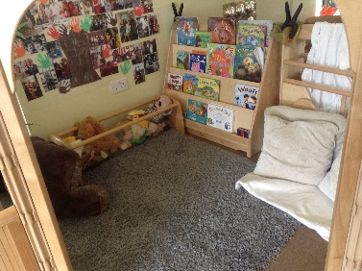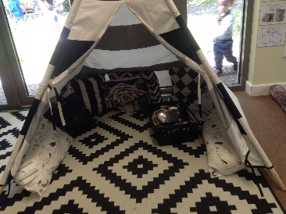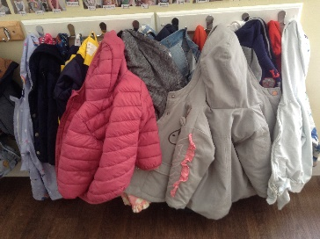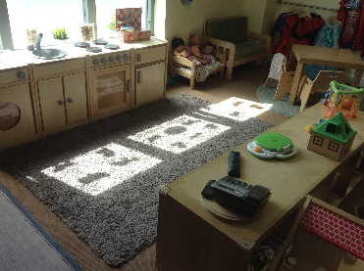
From birth to 3 years.

We don’t like to age restrict our rooms but believe children will feel happiest and most confident in this room until they are roughly 3 years of age and then it is time to progress. We provide stimulating environments and activities in here to start a child’s journey for learning and communication. A variety of experiences are available for the children in this room including treasure baskets, cosy corners, sensory areas, home corner, messy play area.
Children in this room will start to explore their skills, environments and independence. We have direct access to our outdoor play area and a large range of choices inside including book and cosy corner, home corner, construction and small world play, outdoor sports lessons, dance and baby sign.

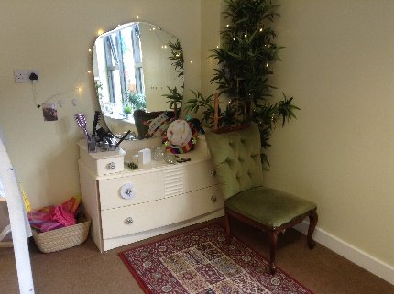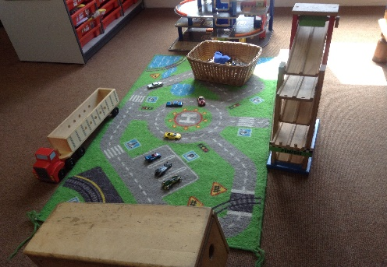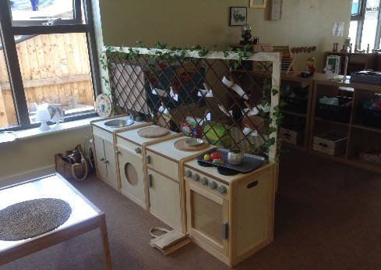

 Pre school room
As children’s confidence grows and they start to demonstrate skills in building relationships they are becoming ready for school and we will help this transition in our pre school. We work with the local primary schools to ensure the child’s transition is as smooth as possible.
Through play children improve their knowledge and understanding of the world. We have the opportunity to offer interactive ICT equipment for the children, maths, literacy, dance sessions, sports lessons, forest school sessions and sign language.
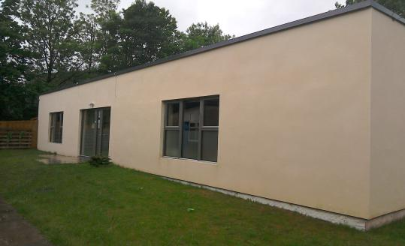
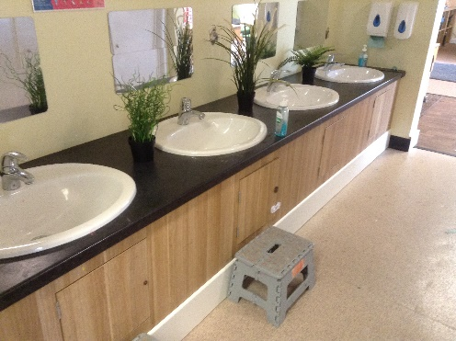

Parents as partners

 Parents/main carers are children’s first and most enduring educators. When parents and practitioners work together in a nursery the results have a positive impact on a child’s development and learning. We therefore seek to develop an effective partnership with all parents. Each child is assigned a Key Person. Their role is to help your child become familiar with our nursery and to feel safe and confident within it, and also to develop their learning and understanding of the world. They also talk to parents to make sure that the needs of your child are being met appropriately.
Careful records of your child’s development and progress are created and shared with parents regularly.

 Open Door Policy:
Please feel free to visit the nursery with or without an appointment. We want parents to feel free to come into the Nursery and join in with activities, to have an informal chat about their child or to help with an activity that they may have a certain skill or knowledge about. Appointments can be made with a member of staff if a parent/carer wants to talk about their child, in confidence for a longer period.

 We want all parents to understand our curriculum (EYFS) and we share our observations with parents on a monthly basis. Parents can also send achievements/interests into nursery using the same format . We hold a termly Parents evening.

The Early Years Foundation Stage (EYFS)

 The Early Years Foundation Stage is implemented throughout the nursery. This is a very important stage as it helps your child get ready for school as well as preparing them for their future learning and successes. From when your child is born up until the age of 5, their early years experience should be happy, active, exciting, fun and secure; and support their development, care and learning needs.

 In 2017 the framework was revised to make it clearer and easier to use, with more focus on the things that matter most. This new framework also has a greater emphasis on your role in helping your child develop. It has seven learning areas, these are divided between prime and specific areas of learning and development.

 We ensure parents have the opportunity to review their child’s progress with the nursery on a regular basis. For children we produce daily records containing information about your child’s day, meals eaten, nappy changing and toileting, sleeping and rest times and a general picture of their wellbeing throughout their time at nursery. Daily handover of children both morning and evening is also used as an opportunity to share information. We also inform parents of our topics and planned activities through a regular newsletter. For more information please the visit website: www.ofsted.gov.uk.

Fees

 Full time (weekly) £199.40(Over 2), £208.70(under 2)

 Daily rate £43.60 (over 2), £45.40 (under 2)

 Half - day rate £24.90(over 2), £25.70 ( under 2)

 All children have free ‘settling in’ sessions prior to taking up a place at the nursery.

 Help with the cost of child care is available in a number of ways. Please contact us for further details.

 Free nursery education place: 15 or 11 hours/30 or 22 hours nursery education funding for all 3 - 5 year olds. 15 or 11 hours free childcare is also available to some 2 year olds.

 Working families tax credit: This helps working parents with the cost of childcare. Call the helpline on - 0845 300 3900

 Child tax credit: 9 out of 10 families are entitled to child tax credit whether they work or not.

 We accept childcare vouchers from employers to help with nursery fees.

