The photos with highlighted areas have they key components to answer almost any question, it would simply be a matter of displaying data with the reference to emphasize the issue. That data is contained in my research library already among the various GSA, Eisenhower, Reagan, Bush, Carter, Congressional or court actions and are on one of my websites…
https://countystrong.org
If Senator Finchem would like a presentation to include the short audio clip of the Chief Forester stating in SMR 2 that they own nothing in AZ, they just manage it, I would be happy to put together a PowerPoint presentation that would take about 40 minutes to go through.

Organic Act and Weeks Forestry Act - States retain jurisdiction...
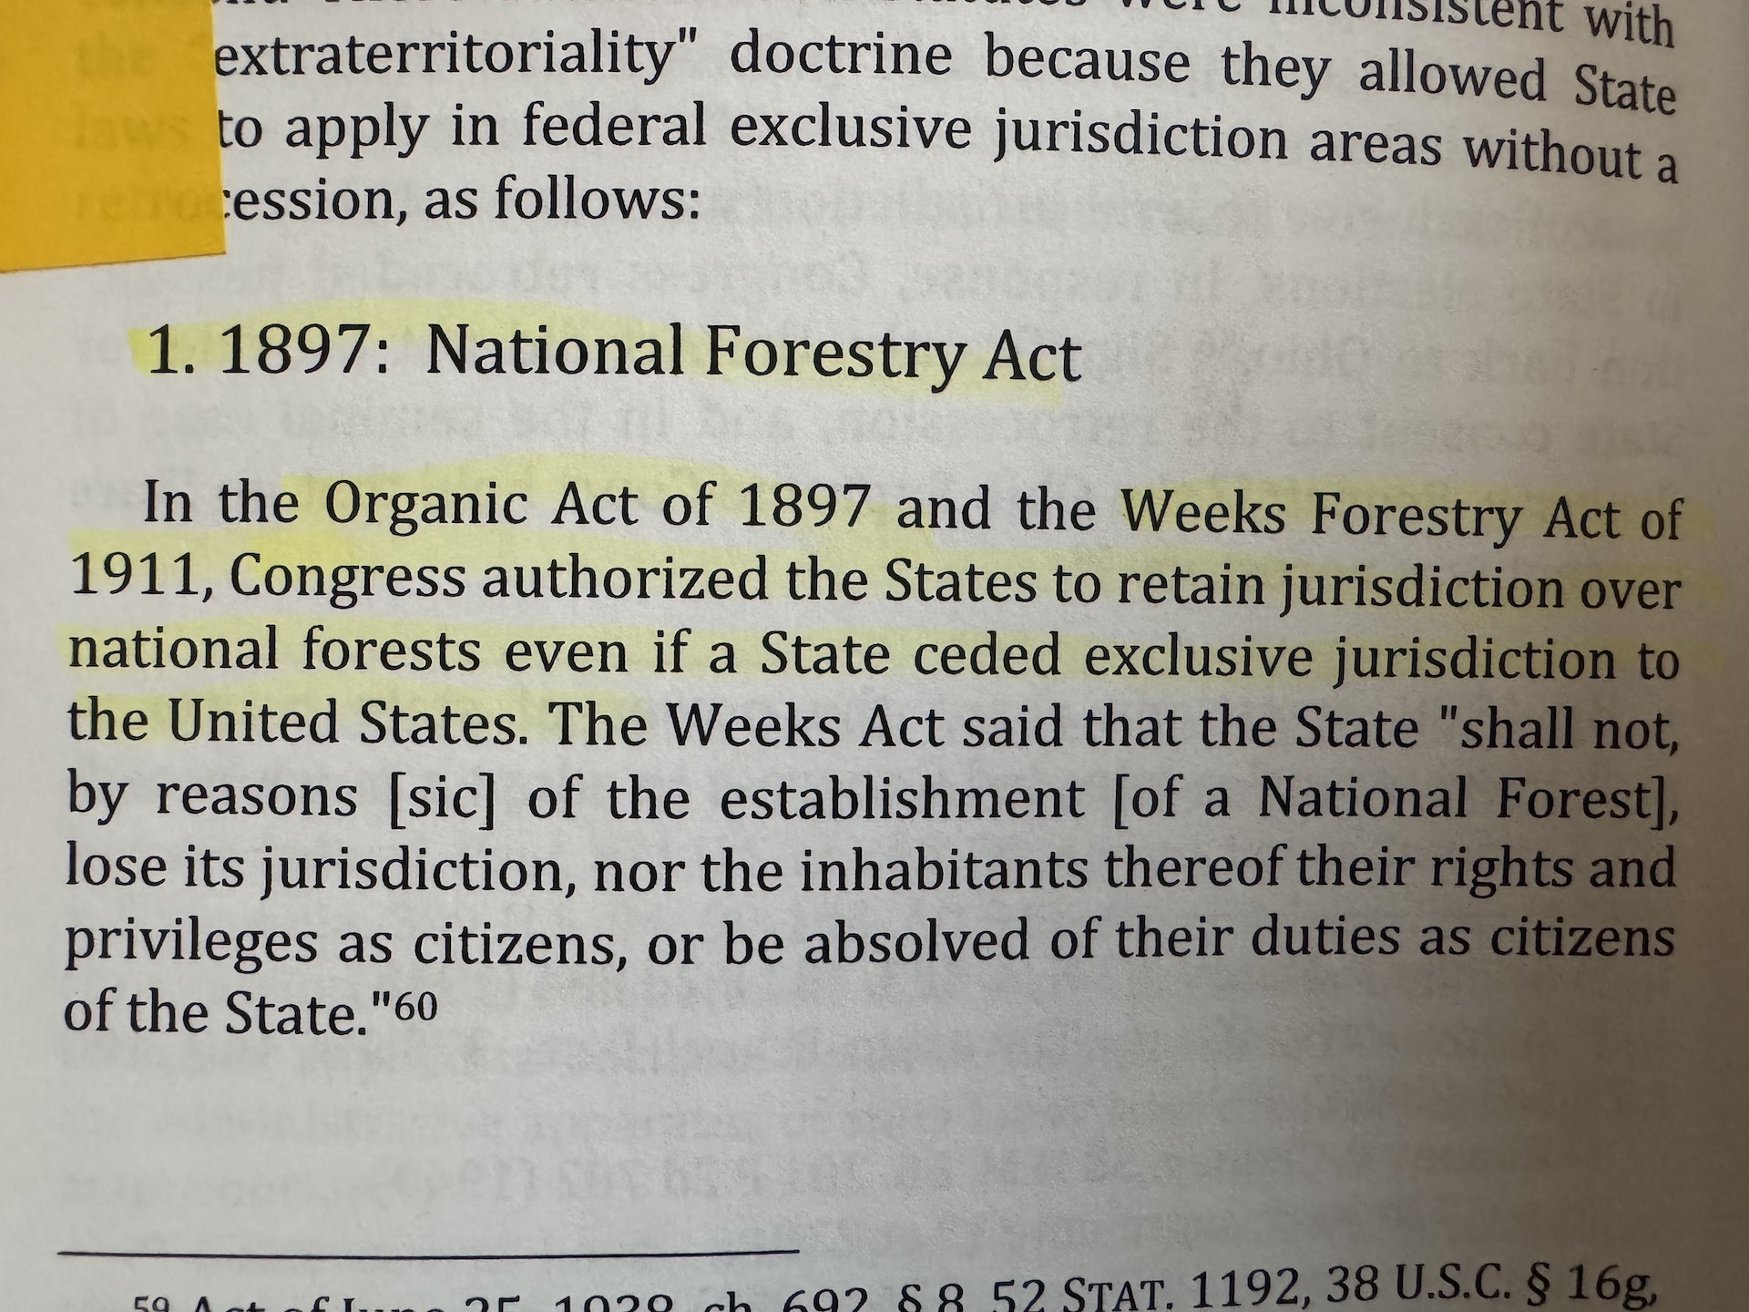

For decades various agencies used the Enclave Clause to claim everything they grabbed fell under that “Needful Buildings Clause”. However through multiple cases the courts ruled that forests and grasslands were NOT included…
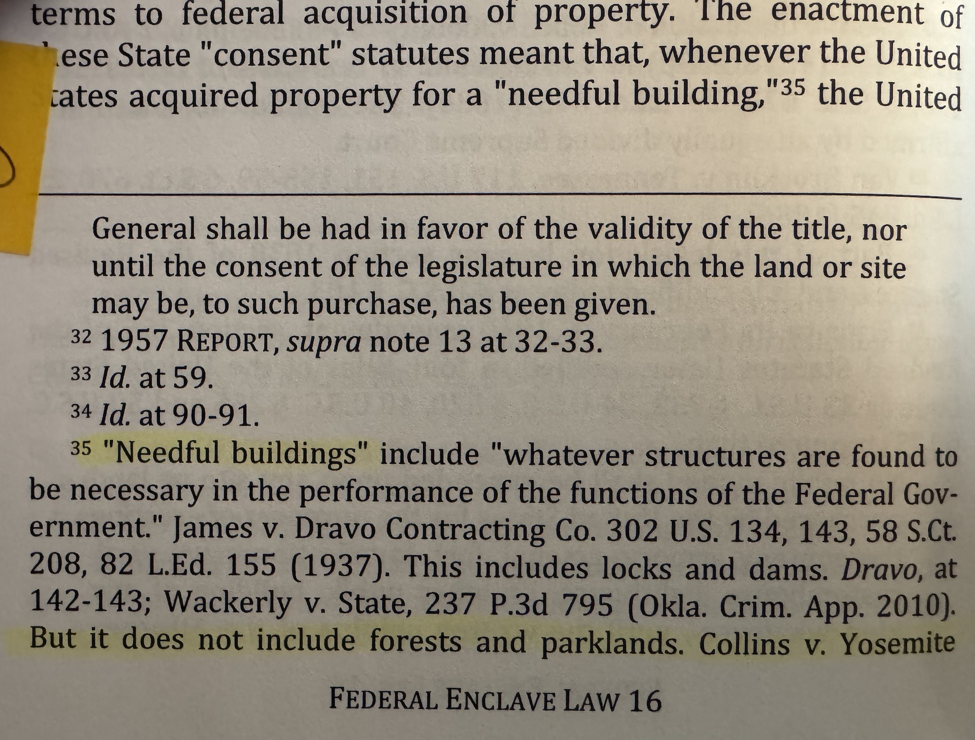

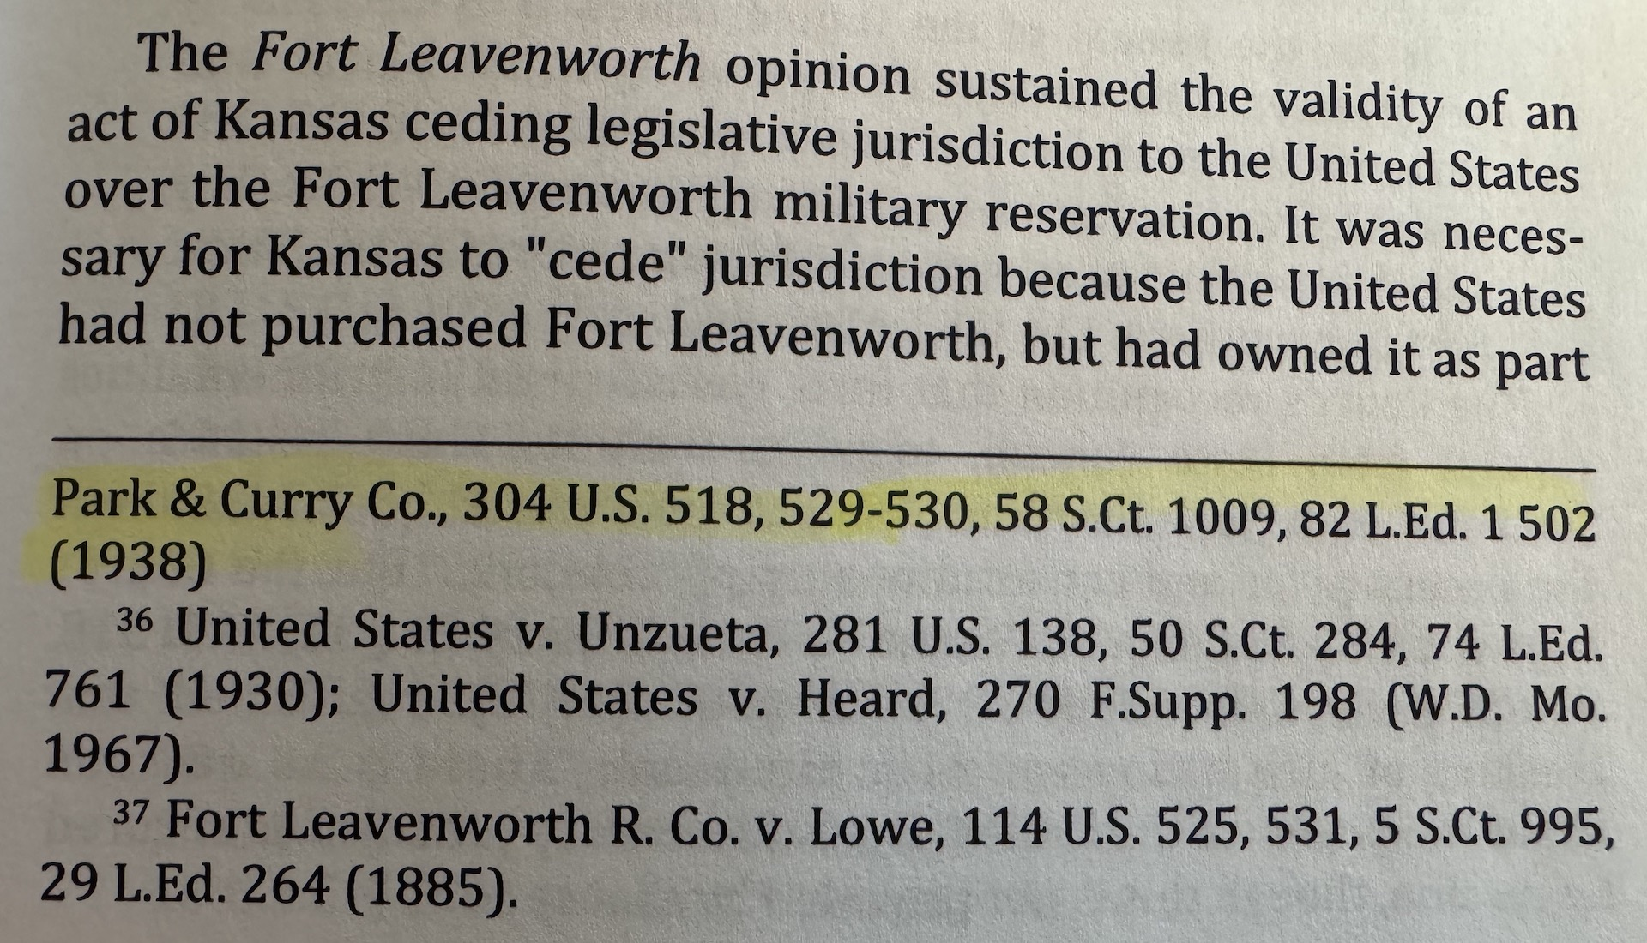

Proprietorial Interest Only (Category 4) is the jurisdictional category approximately 97%+ of our federally managed lands in are held under. For instance, in Arizona the federal government manages 32,538,189 acres, Proprietorial Interest Only (Category 4) is 31,803,194 acres.
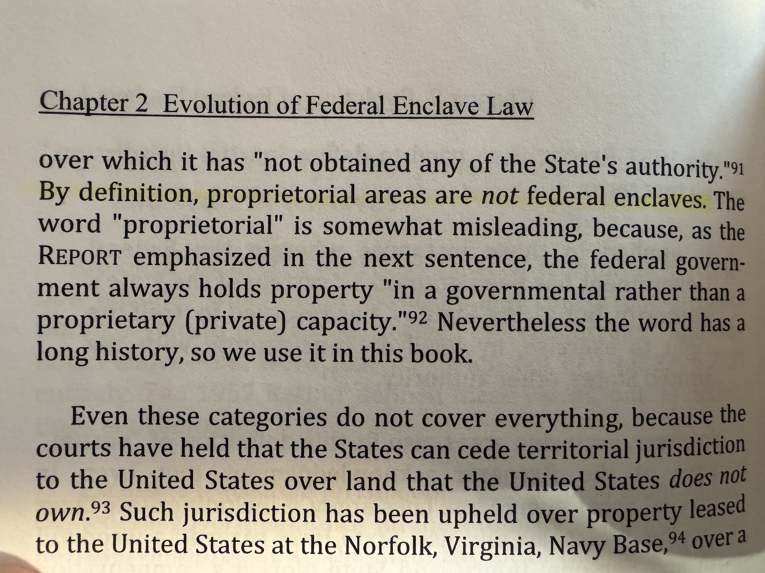

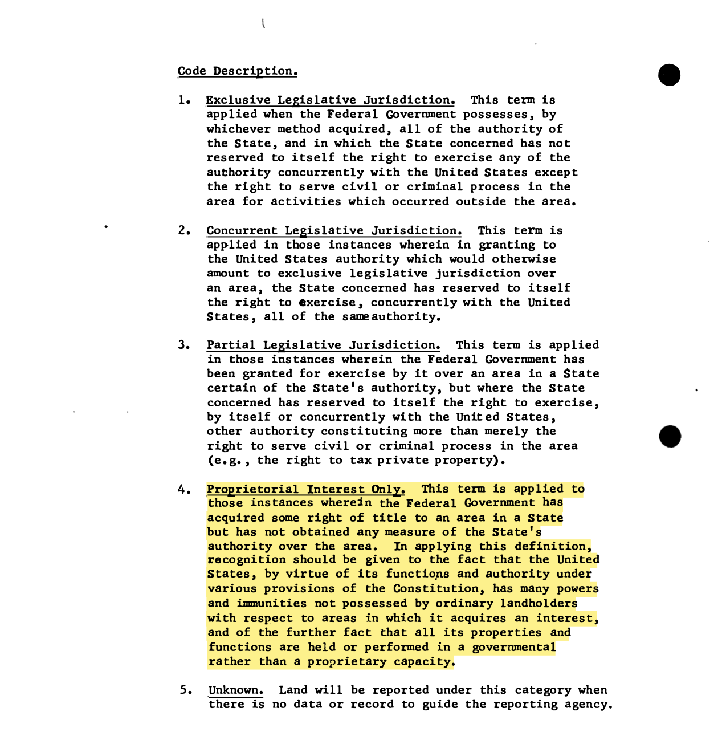

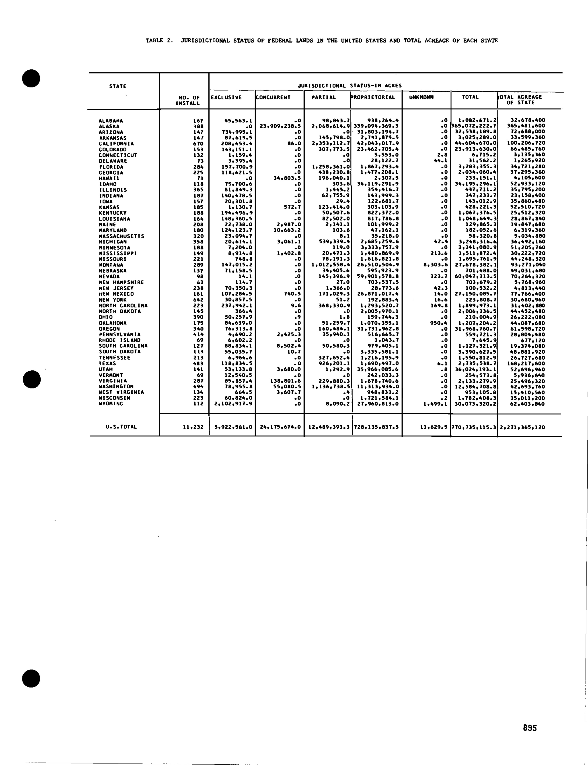

When looking at the border issue in a broader sense (safety of food imports, manufacturing, trafficking, illegal aliens, etc.) we have a solution to enforce strict requirements and laws…

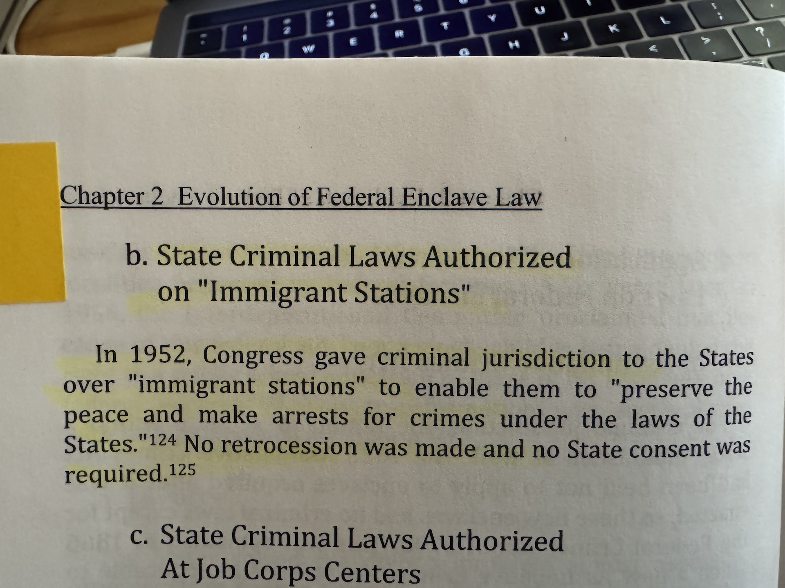

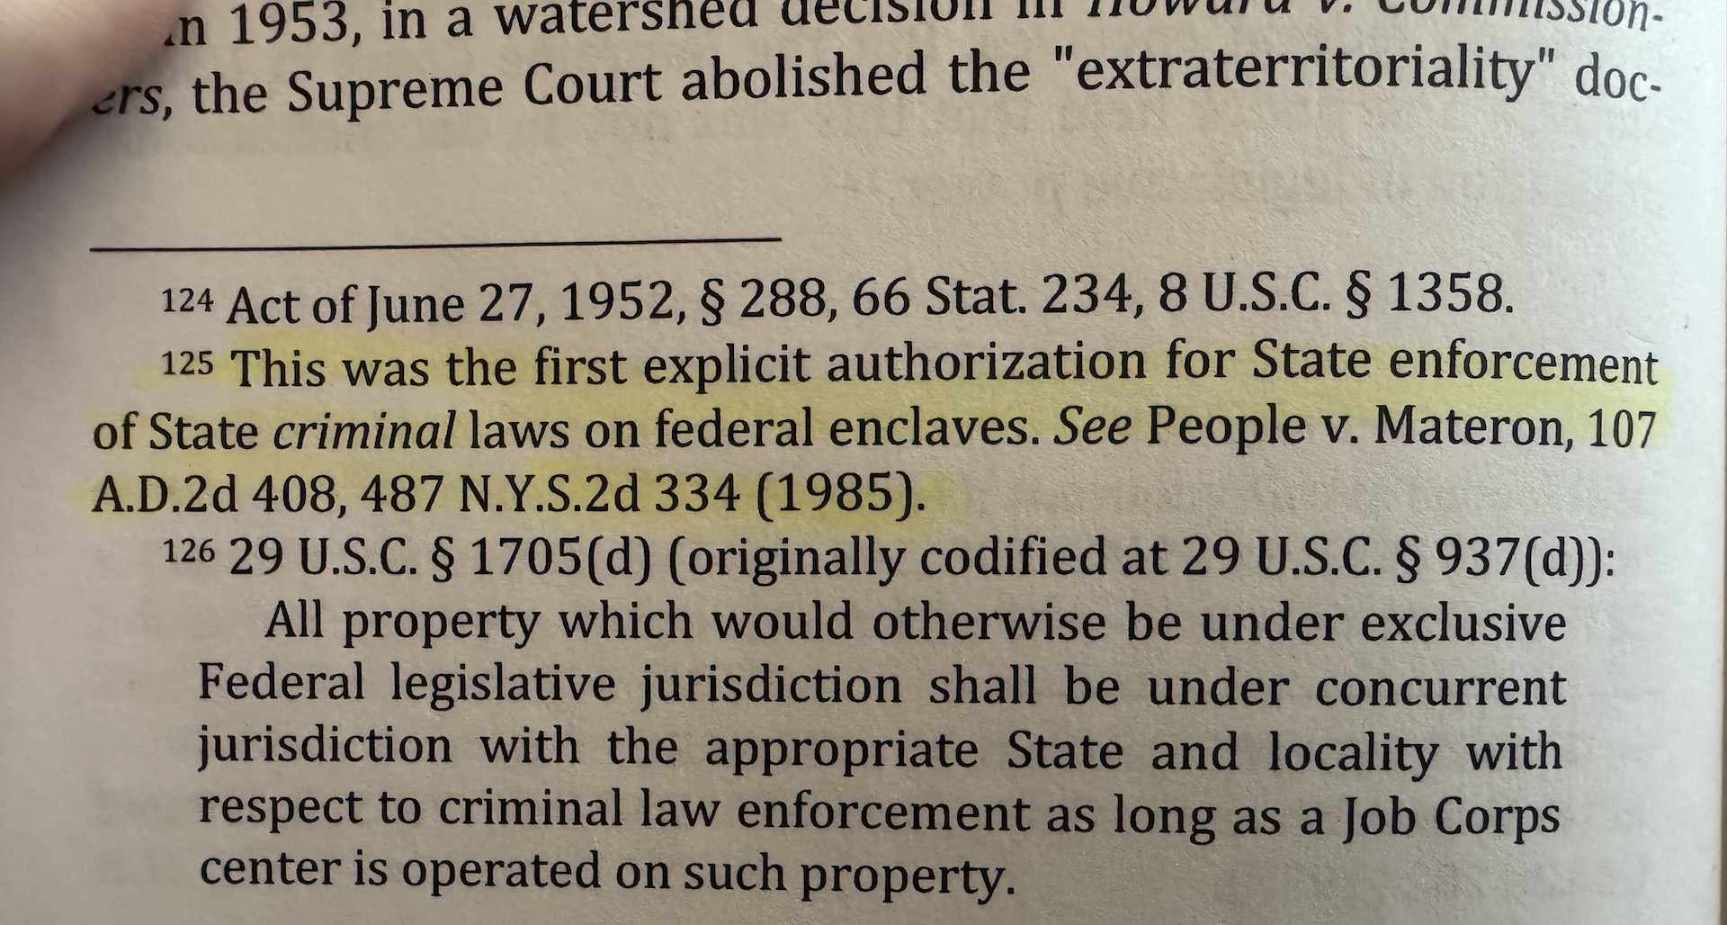

Retrocession was authorized by Congress and given to various Secretarial level positions, for instance the Secretary of the Veterans Administration, the Secretary of Interior, and Secretary of Agriculture…

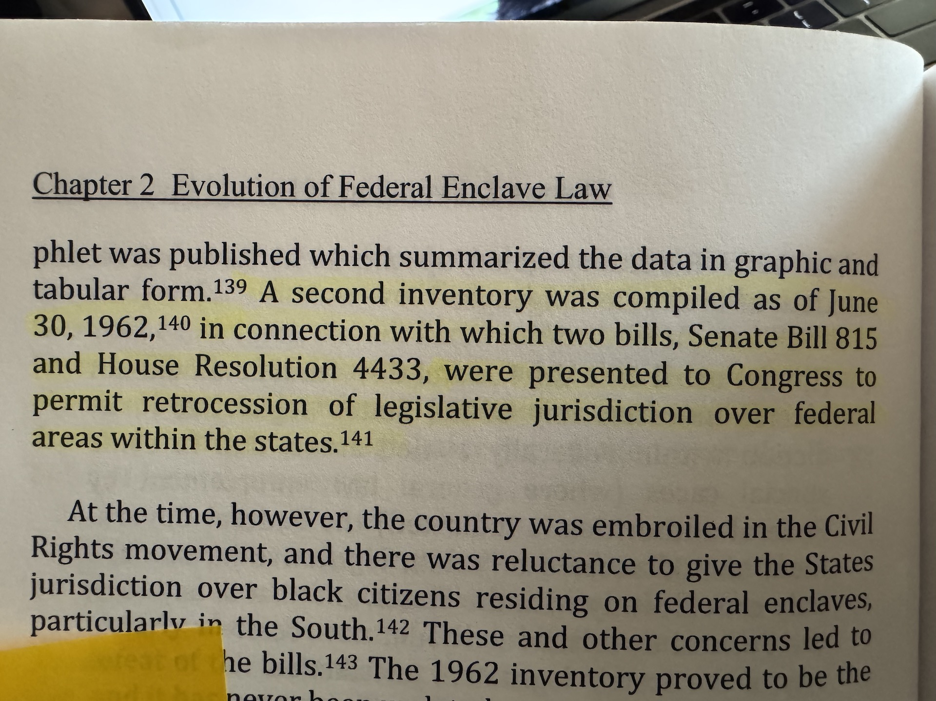

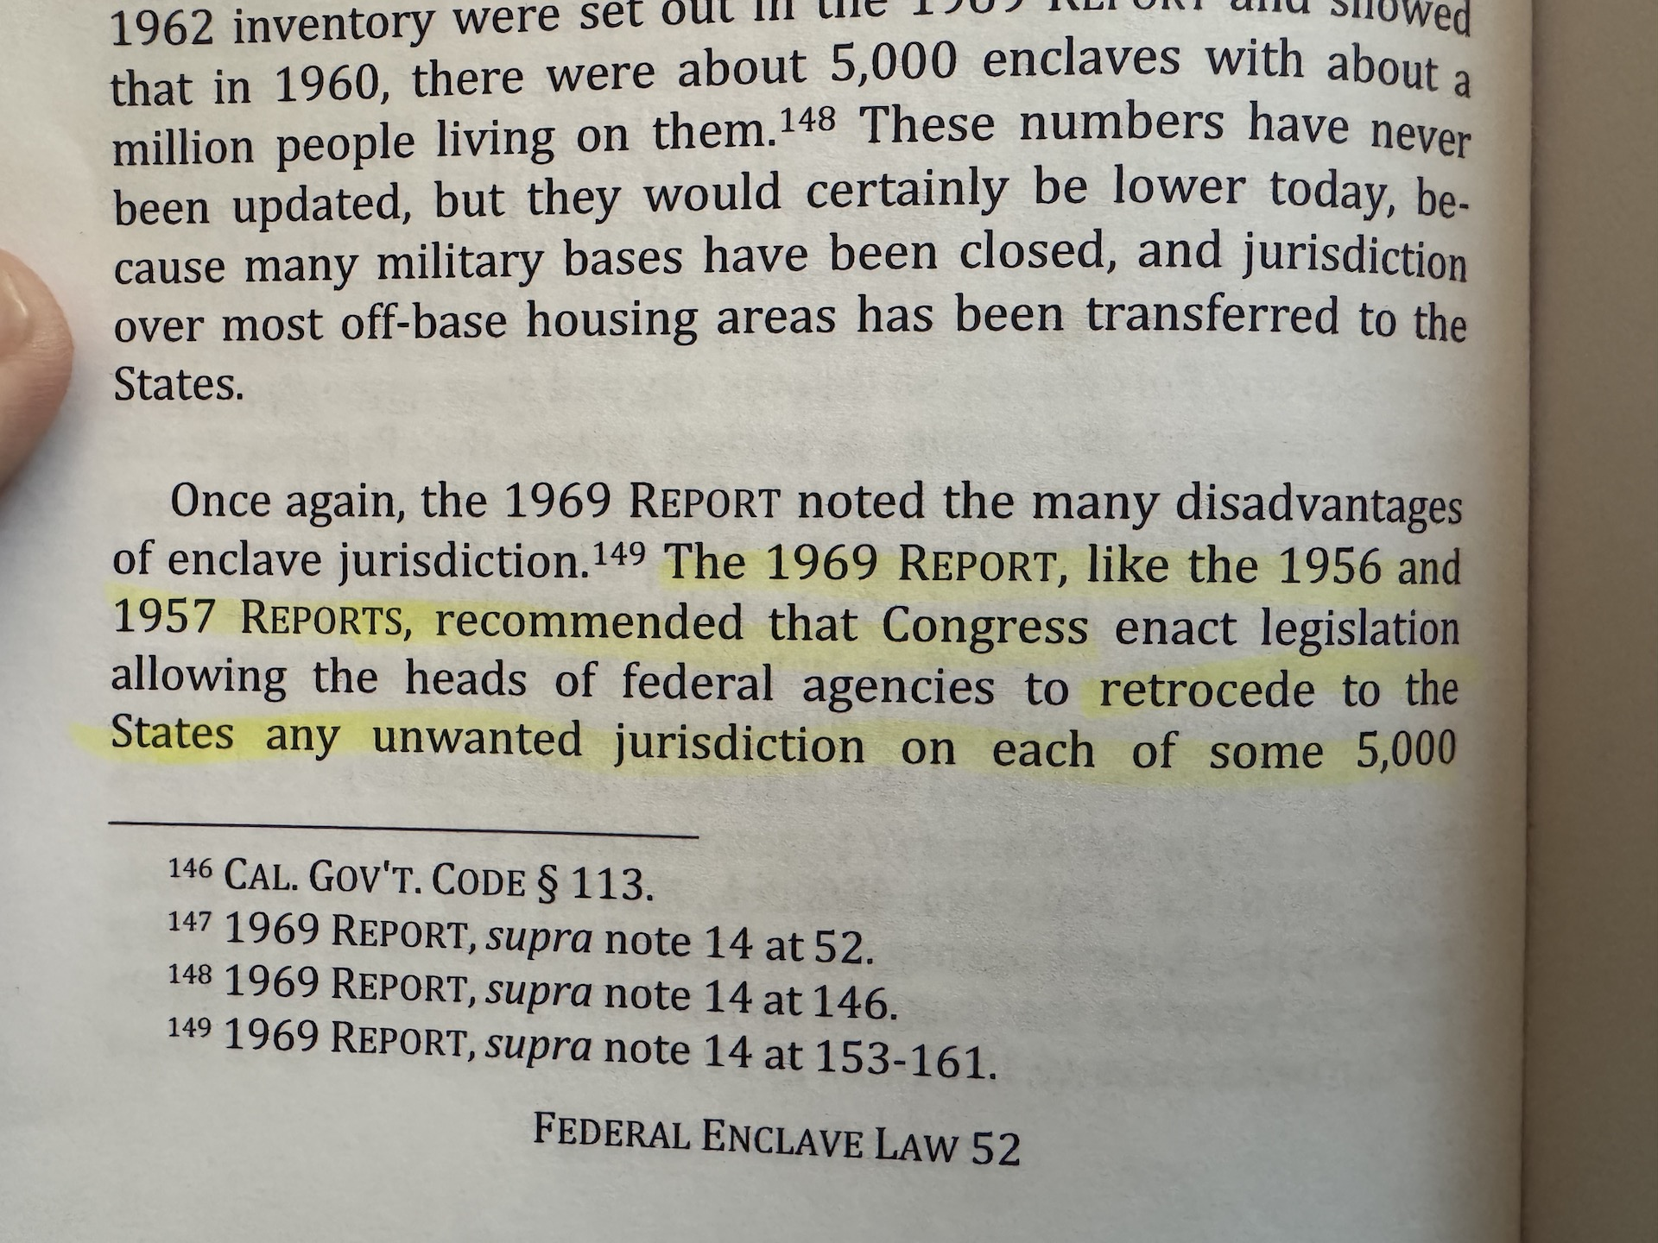

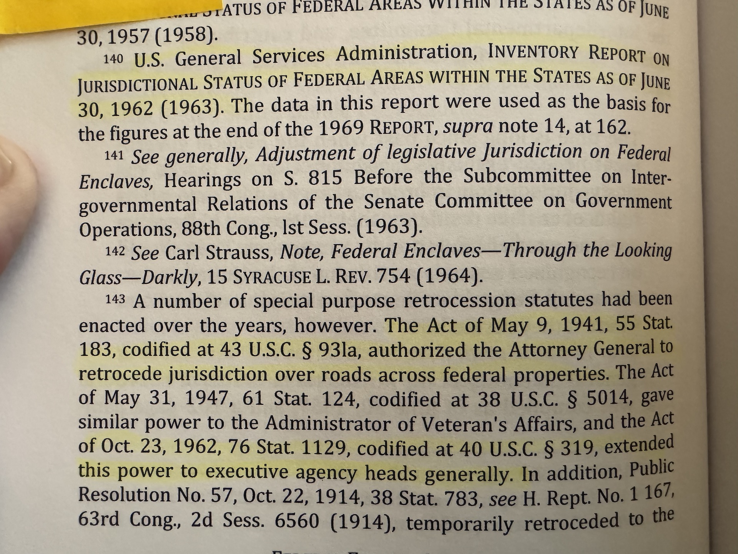

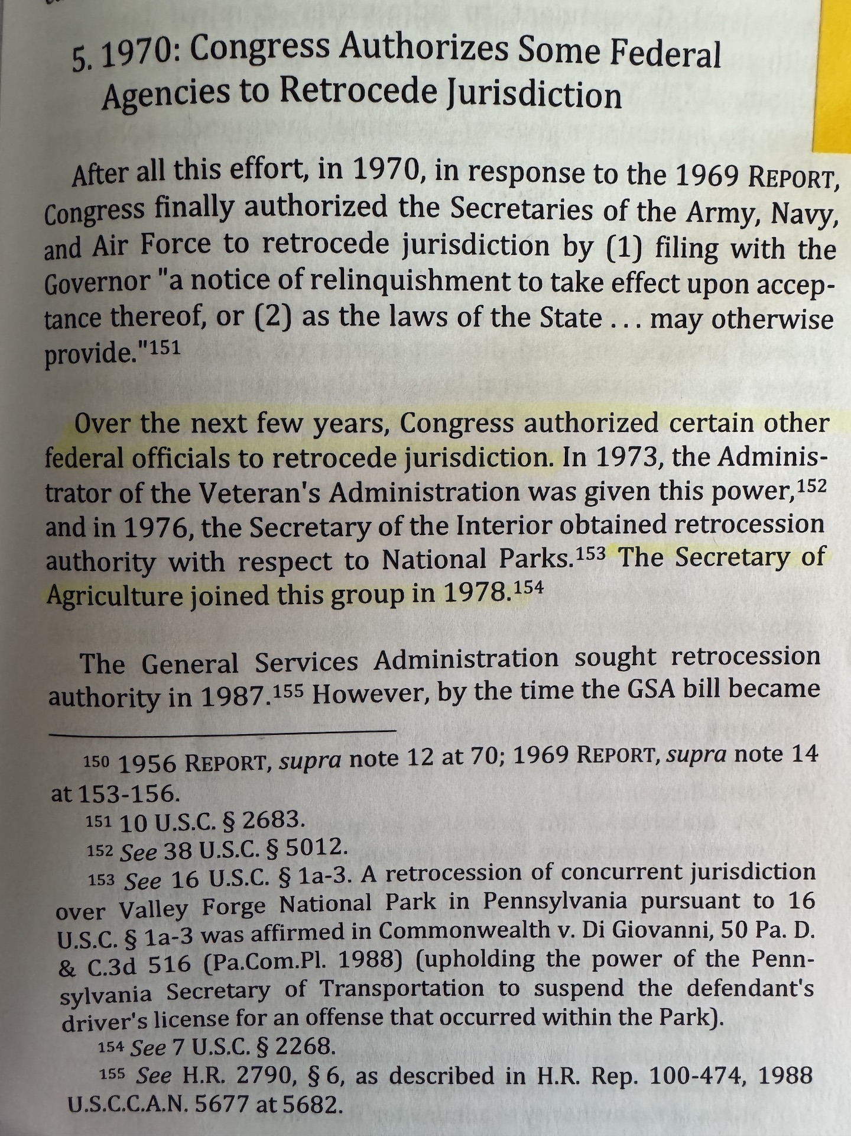

States also possess the right to enforce state environmental laws on federally managed lands. So, the State Lands Department, DFFM, etc. should be forced to present to the legislature the species and areas to be made safe from fires and insect infestation (creating 10,000’s of AZ Jobs). For instance, they should be informing the AZ Legislature that in mixed conifer stands (Like us up here) we want the scientifically proven 25-40 trees per acre, not the 400+ trees per acre in it’s current condition…

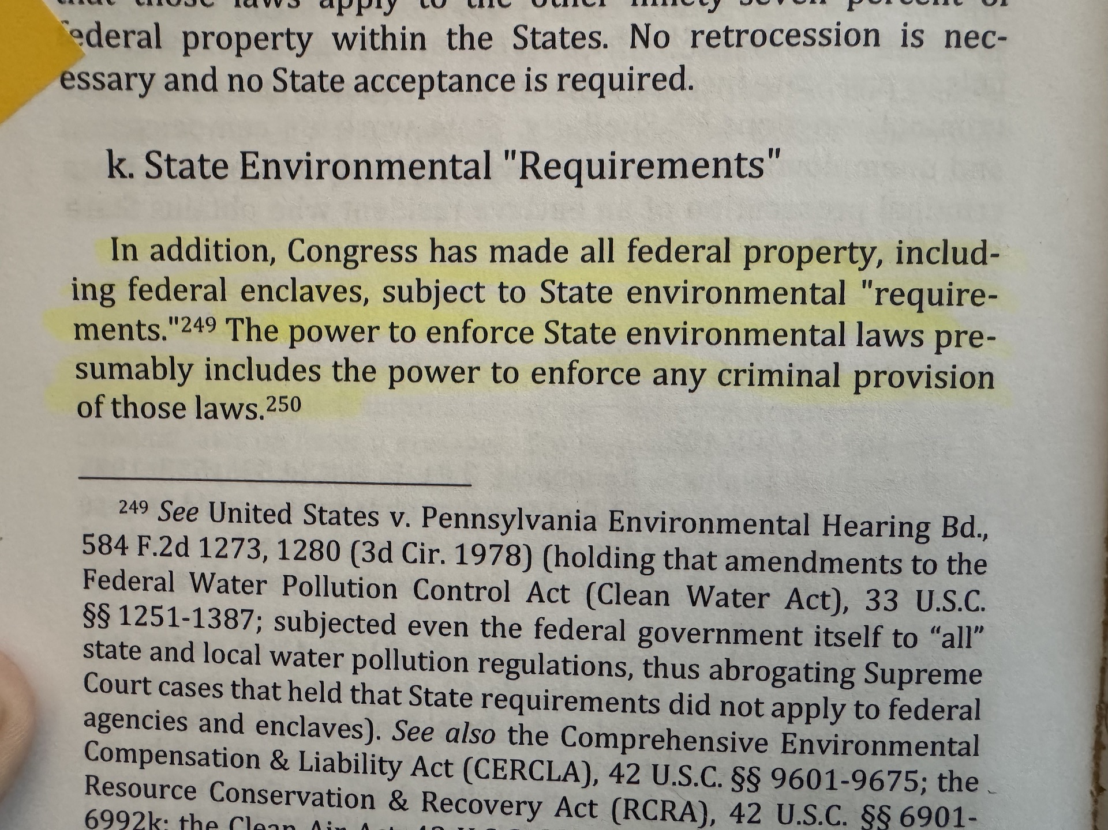

All over the state, “federal officers” will follow residents off of federally managed lands and try to enforce various “laws” illegally, or consistently try to enforce AZ State Civil/Traffic laws on residents. Besides that being illegal on 98% of federally managed lands in AZ, we have the following…

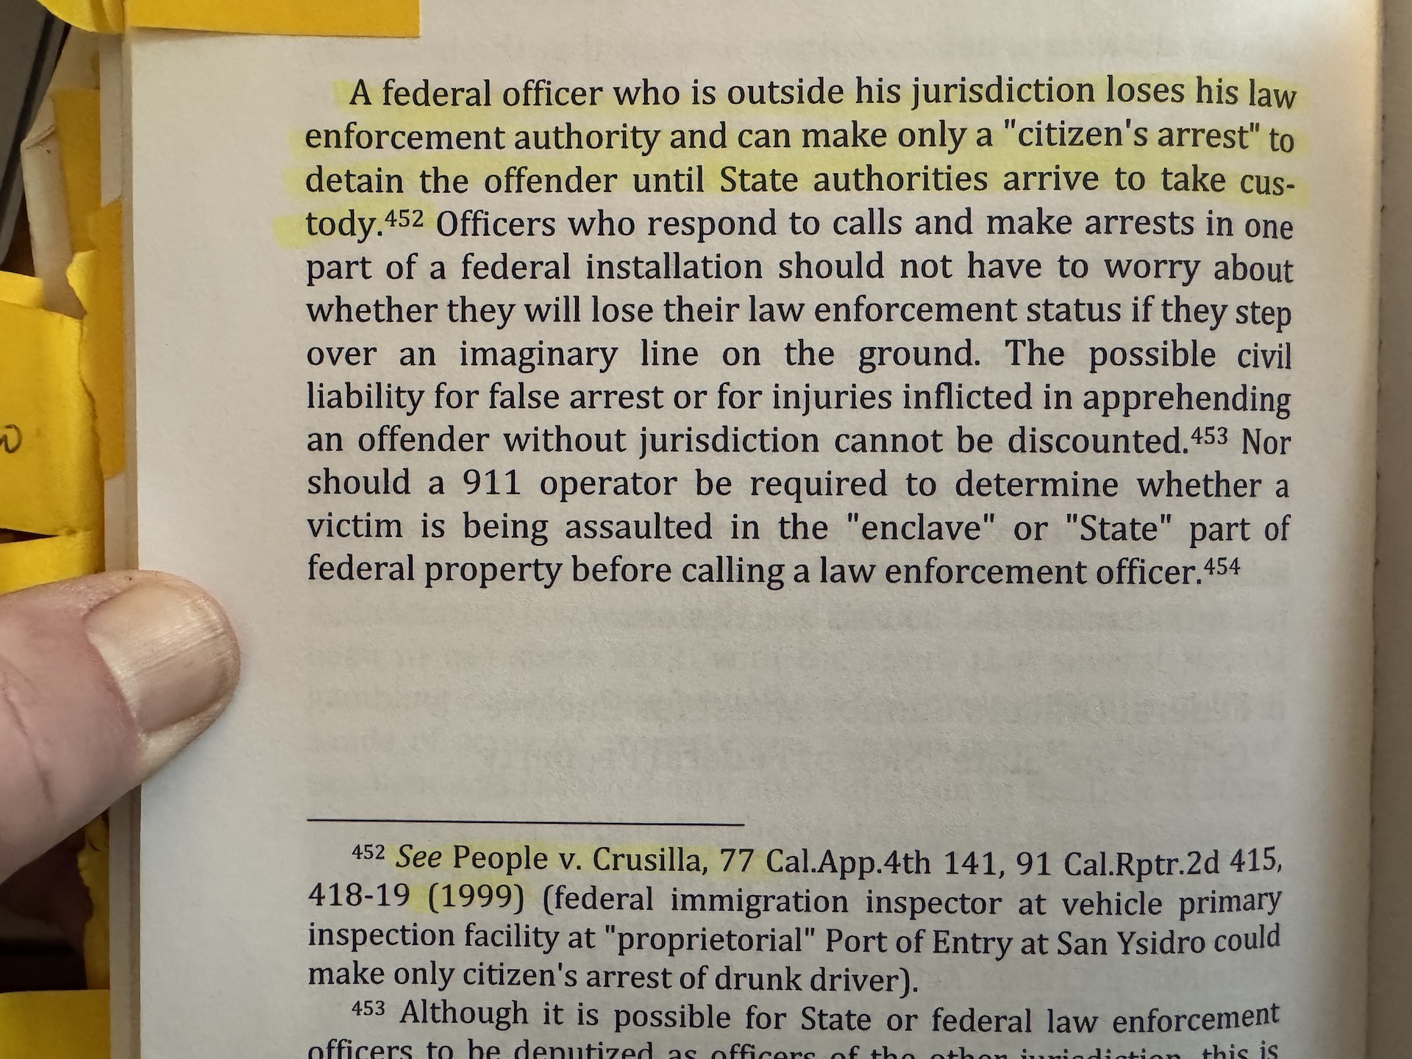

Now in Federal Statutes and CFR’s, as in 665, the DOJ from D.C. down issues a warning to all federal employees (DOJ, AG, FBI, etc.) that they must prove jurisdiction and the defendant doesn’t even have to bring up the question in court, it’s an automatic defense. Now taking into consideration that the DOJ, etc. are all told to go to the GSA for jurisdictional status of lands, and all those GSA reports are cited above or on the website cited above, we quickly see that those federal officers can only act on approximately 2% of land in the state of Arizona…
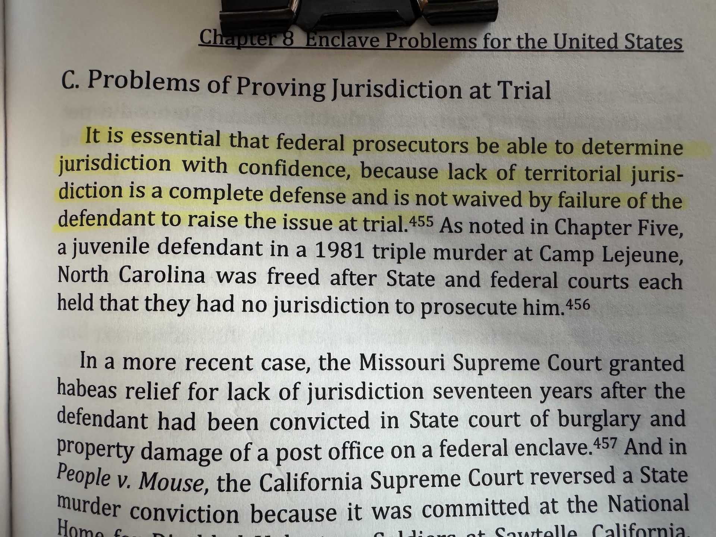

Respectfully submitted,
Doyel Shamley

