August 5 ‘21
Hello! Here's what's happening at Studio Pintura-
We have a new sculpture workshop, a figure study sculpture club, great artworks in the gallery, and we are looking for a couple of new studio members for our spaces.
Also, we are also hosting a weekly Flamenco Guitar class taught by maestro Michael Hauser!
Please take a look, and don't hesitate to get in touch if you want to know more!
Lois and Armando

SCULPTURE OFFERINGS
A New Workshop:
Understanding the ‘Complete Portrait’ with Gabrielle Trom
For Experienced and Beginning Sculptors, and Portrait Painters
who wish to have an in-depth understanding of the facial features, the forms and relationships in the anatomy of the head, while learning to sculpt in Earth Clay.

Gabrielle Trom is a graduate and instructor at the Barcelona Academy of Art, and a current artist-member at Studio Pintura.

Goals:
Understanding the Features of the Face
A look At Anatomy
Building the Profile
Sculpting in an Additive Method
Introduction to Design and Texture in Sculpture
The art of observation

Saturday and Sunday mornings for 4 weekends, 10:00 – 1:00
Aug 28 - 29, Sep 11 - 12, Sep 18 - 19, Sep 25 – 26

Find out more, enroll: https://studiopintura.com/portrait-sculpture-trom
Images by Gabrielle Trom
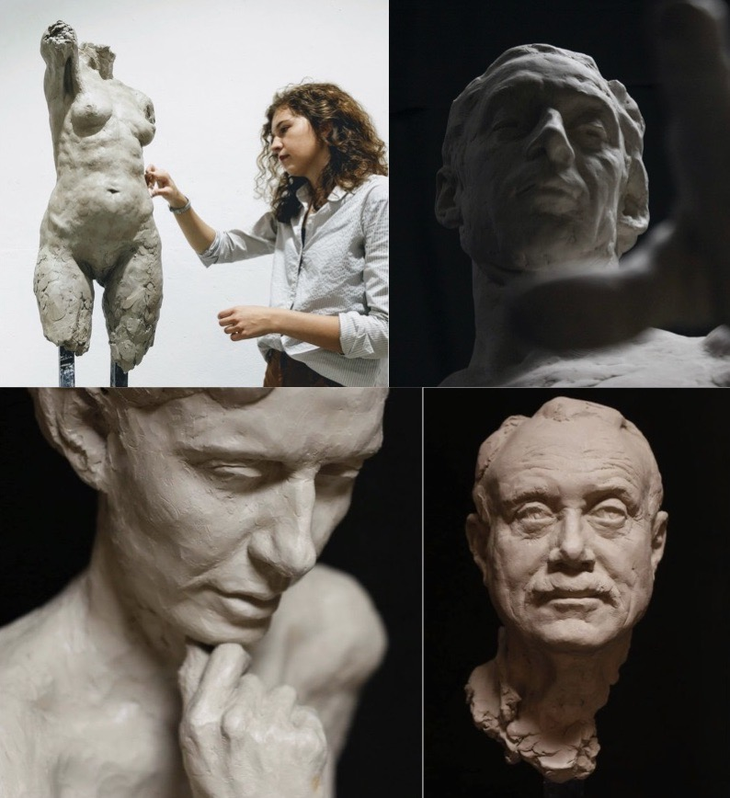

Tuesday Night Sculpture Club (Ongoing):
This ongoing group meets on Tuesday nights to do figurative sculpture study working with a model. Cost is $80 for four weeks, or $160 for 8 weeks.
This is a group with no instructor, but a helpful atmosphere. Beginners are welcome!

NEXT SESSSION STARTS AUGUST 10, 7:00pm - 10:00pm.
Please get in touch if you want to find out more, or if you want to sign up!
Lois (612) 801-1053 or Armando (651) 270-8983

We will be working with this pose, as an unclothed figure study:

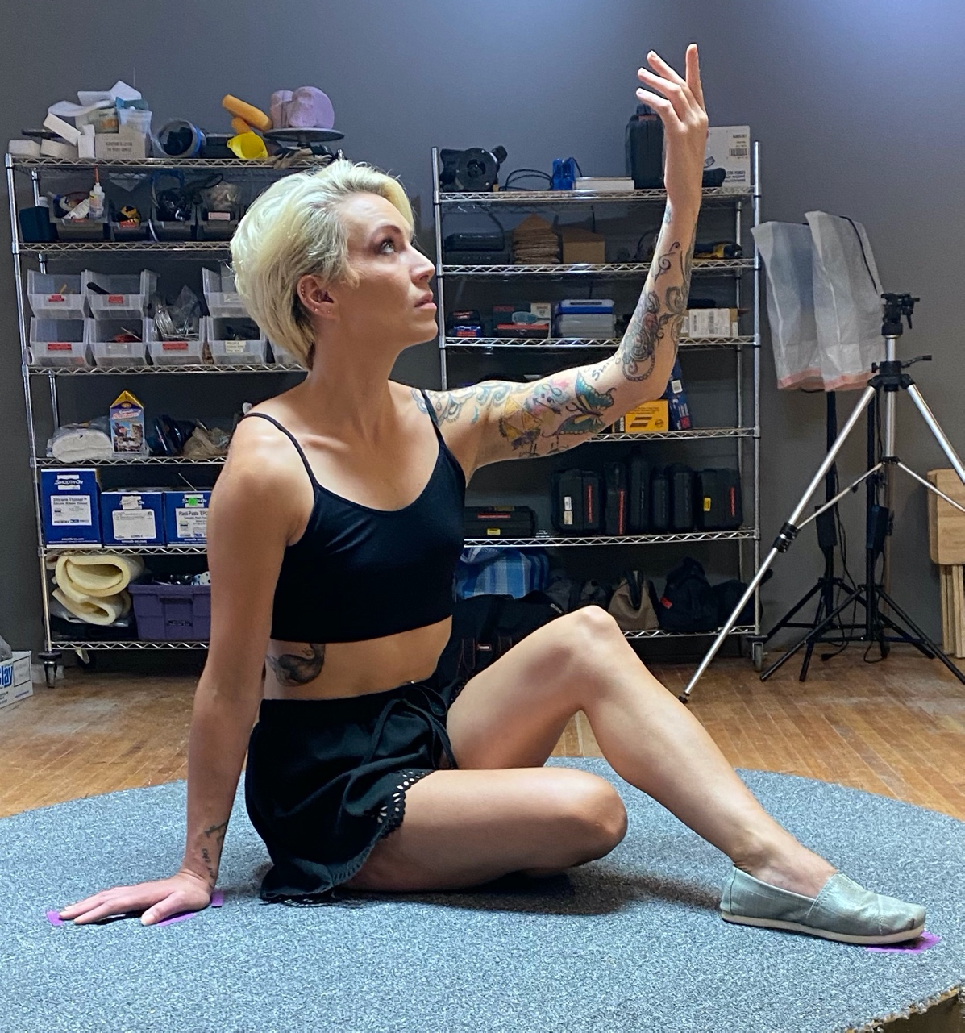

BECOME AN ARTIST-MEMBER OF STUDIO PINTURA:
TWO SHARED WORK/DISPLAY SPACE OPPORTUNITIES
Studio 350 - North Light Studio
Studio Pintura is looking for a motivated, emerging painter to become a member of our studio. Includes ample painting space in the beautiful North Light Studio, 15' of display space, and access to the wood and framing shop. We are open for all open studio events at NKB including Art-a-Whirl®, Art Attack!, Open Saturdays, and various Northrup King Building events throughout the year. $350/month

Studio 295 - Sculpture and Ceramics Studio
We are looking for one or two sculptors and/or ceramicists to share the work space, a wood shop, and a kiln. Monthly fee depends on space requirements.

IN THE GALLERY NOW: Studio Pintura Fine Art Gallery, showing works by:

Mark E. Marcuson Charles Kapsner
Sophea Woolner Loren Chantland
Jon Burns Steven J. Levin
Linda Marsh Gabrielle Trom
Faisal Alahmad Armando Gutiérrez G
Lois Rhomberg James Shoop

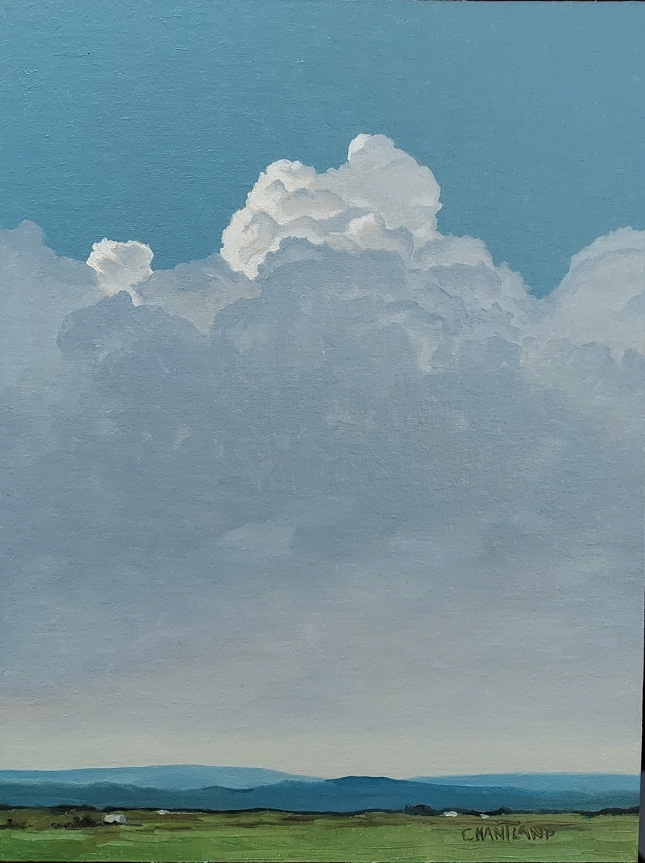 Loren Chantland – Iowa Sky

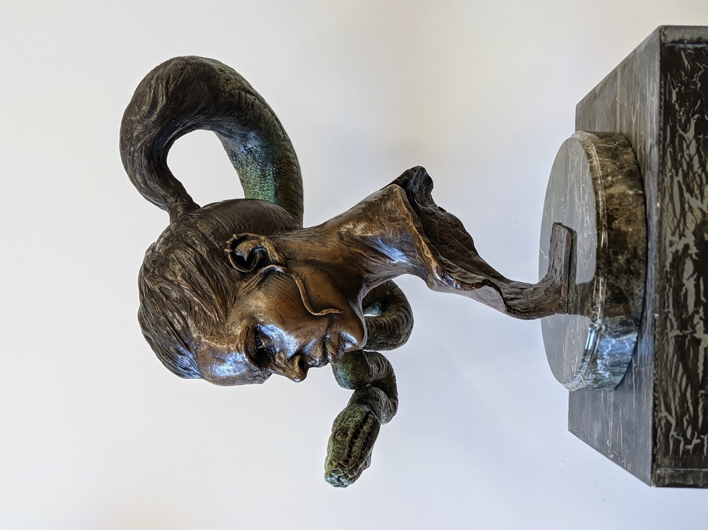 Faisal Alahmad – Medusa’s Complex
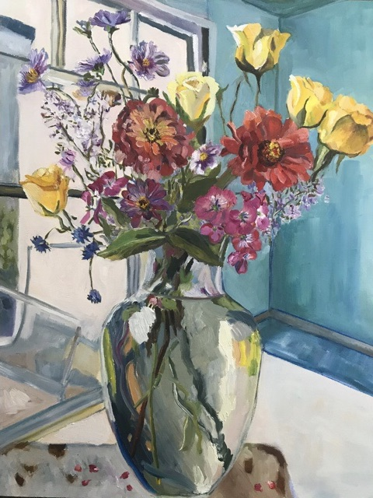 Sophea Woolner – Medusa’s Complex
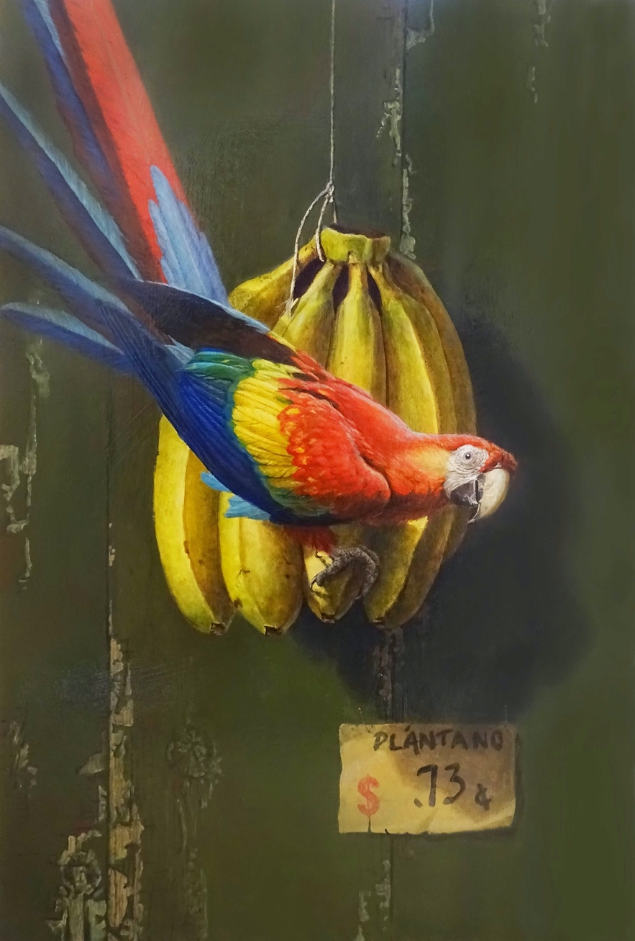 Mark E. Marcuson – Unexpected Guest

