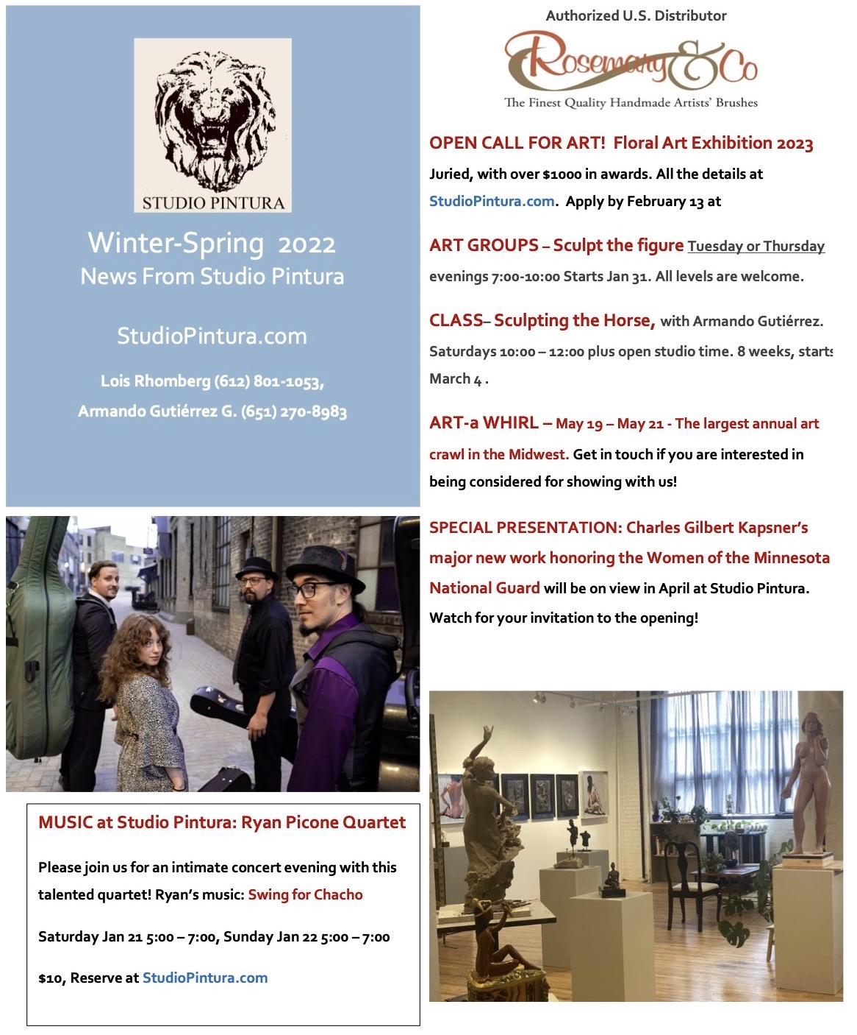

Studio Pintura 6th Annual Juried Floral Art Exhibition

Apply by Monday February 13, at StudioPintura.com, Floral 2023.

How to Apply – Read the guidelines at StudioPintura.com, Floral 2023 page.

We suggest Jpegs with 300 DPI, titled as follows:
LastName-Title-Size-Medium-Price.
For example, “Adams-Spring Pinks-10”x12”-oil on panel-$650”

Thanks so much, and we are looking forward to another great exhibit!
Lois and Armando

Your Information:
- NAME, as you would like it to appear
- EMAIL ADDRESS (even if we have it)
- Preferred PHONE NUMBER
- A one-paragraph artist’s statement

Information about each of your entries:
TITLE, SIZE, MEDIUM,
PRICE, including a 40% gallery commission
If necessary, include a note about which image goes with each title.
Please be complete!

Agreements: Please agree to the following:
“I agree that my name with images of my artworks can be used to promote/market my work, or the exhibition as a whole” in a press release, and online.
“I have read the guidelines”.

Awards:
First Prize $500, Second prize $350, Third Prize $200, Honorable mentions $50.
Juried by Studio Pintura

Entry Fee and Gallery Commission:
$35 for 3 entries, $5 each additional entry, up to 6 pieces.
40% Gallery commission on sales

SCULPTURE STUDY at Studio Pintura

“Sculpture Club” Tuesday Evenings New pose starts Jan 31 (10 weeks)
Sign up at StudioPintura.com –
Jan 31, Feb 7, 14, 21, 28, March 7, 14, 21, (skip the 28th), April 4, 11

Meet for 10 Tuesdays with other artists to sculpt from a model. Portrait or figure.
No instructor, but guidance is available from fellow sculptors if requested.
New to figurative sculpture? Let us know and we can help you get ready to start!

Total fee $200 for 10 nights, including model fee.

“Sculpture Club” Thursday Evenings New pose starts March 9 (8 weeks)
Sign up at StudioPintura.com - Feb 9, 16, 23, March 9, 16, 23, April 13, 20

Meet for 8 Tuesdays with other artists to sculpt from a model. Portrait or figure.
No instructor, but guidance is available from fellow sculptors if requested.
New to figurative sculpture? Let us know and we can help you get ready to start!

Total fee $160 for 8 nights, including model fee.

CLASS - The Art of Sculpting a Horse - Starts March 4 - With Armando Gutiérrez
8 Saturday classes, 10:30 – 1:00, plus open studio time

Sign up at Studio Pintura.com –
March 4,11,18, 25, April 8, 15, 22, 29

Designed for horse lovers! The goal is to create a 1/6 scale horse sculpture in plasticene clay, suitable for molding and casting.

To achieve a good equine sculpture, it’s important to understand anatomy, the characteristics of the breed, and also to use practical knowledge of the horse’s behavior and personality.
We will study equine anatomy using a variety of study aids including 3-D models, hand-outs and books. Additional resources from participants are welcome.
Armature design and sculpting methods will also be covered.
Each student chooses a pose for their sculpture, whether standing, in motion, or an out-of-the-box expressive design.

All experience levels welcome. Limited to 10 Students.
Tuition $280, materials are separate. List will be provided.

