**Beaworthy Parish Council**

MIN0062020

**DRAFT Minutes of the Beaworthy Parish Council Meeting**

A Virtual Meeting held on Thursday **30 July 2020** at 7.30pm via Zoom.

1. **Apologies** – Cllr Balsdon – unable to connect
2. **Present -** Cllr Coleman, Cllr Johnstone, Cllr Wonnacott, Cllr Sanders, A Braidwood (Clerk).
3. Councillors present voted on a Chair for the meeting. It was unanimously agreed Cllr Coleman would Chair the meeting.
4. **Chairman’s welcome.**
5. **Public Forum** - two members of the public were present including Cllr Southcott (WDBC)
6. **Declarations** of interest in items on the agenda. Cllr Sanders – member of PCC.
7. **Minutes of the previous meeting** held on **4th June 2020** were approved as a true record and signed by the chair.
8. **Planning –**
   1. **1948/20/FUL** – It was **RESOLVED** by 3 votes to support and one abstention for this application but with the following comments. The Council retains some reservations about the visual impact. Although it goes someway to improving on the initial design the council feel it does not go towards enhancing the housing stock of the parish.
   2. **2000/20/FUL** – It was unanimously **RESOLVED** to support this application with the following comments: A good location and plot, with access to the Pegasus Way.
9. **BT Phone Box** – It was unanimously **RESOLVED** to object to the removal of the Public Call Box (PCB) with the following comments: The statistics used to base the removal of the PCB are inaccurate as the phone has been faulty for several weeks, therefore it has not been usable.  This fault was reported on 3 July with a request for it to be fixed.  There was also a request submitted for operating instructions as people may have tried to use it and struggled.  This PCB is located in a rural community with no proximity to an alternative.  The area has an older population with lower income and the possibility of no access to mobile and/or fixed telephones.  
   The mobile signal can be limited therefore it is more likely that the PCB would also be used for emergency calls.  The church is opposite the PCB and they have always relied on it as an option in an emergency.

Page 1 of 2

1. **Defibrillator** – This was discussed but unanimously agreed to postpone any decision until the Parish Hall was completed and to be included on a future agenda for consideration.
2. **Training**- It was proposed by Cllr Sanders and seconded by Cllr Coleman and unanimously **RESOLVED** to contribute 40% towards the cost of ILCA course for the clerk at a cost of £47.52 plus VAT.
3. **SLCC Membership** – It was proposed by Cllr Colemans and seconded by Cllr Sanders and unanimously **RESOLVED** to contribute 40% towards the clerk’s annual membership of SLCC at a cost of £46.80.
4. **Clerks report.** Noted and attached **Annex A**
5. **FINANCES**

14.1 **Finance Report and bank reconciliation -** Noted and attached **Annex B**

14.2 **Accounts for payment** – It was **RESOLVED** to approve the following payments:

* Clerk Salary July 2020 **156.35**
* Clerk Expenses **16.68**

1. **West Devon borough Councillors report/update** - noted and attached **Annex C**. Additionally, Cllr Southcott advised the JLP supplement has now been ratified by West Devon and South Hams.
2. **Part 2 –** Enforcement list noted.Clerk to obtain an update from case officer.
3. **Items for the agenda for next meeting –** Madworthy ditch
4. **Date of next meeting –** 20 Aug 2020
5. **Meeting closed** at 2040 hours**.**

Page 2 of 2

**Annex A**

**Clerk Update Report 30 July 2020**

**Audit**:

All completed, published and on noticeboard with public rights. Receipt acknowledged from PKF Littlejohn.

**Finance**

Bank have confirmed I have information access to discuss any matters but for internal control I am not a signatory and have no authority to make any changes on the account. I have a banking mandate that requires a signature to remove Brian Hill as a standing order request will require all signatories to sign.

**Financial Services Compensation Scheme** - I noticed on the bank statement that the PC account is not eligible for FSCS Protection. 23 Jul 20 - I have spoken to the FSCS to confirm we are actually eligible. Then spoke to Nat West and raised a complaint as we do not come under the exclusions and believe it is an administrative error and have asked how they have categorised the account. I am expecting a response within 5 working days.

**Communication**

I received a copy of a letter from a resident regarding planning app 3598/19/FUL which he has sent to WDBC. This planning application has been withdrawn but I will retain the letter in case the planning application is resubmitted.

I have spoken to the PCC regarding the BT Phone box and the PCC meet on 29th July. I will speak to her on Thursday 30th for an update.

**Planning**

The TPO planning application for St Albans church was approved in a Decision Notice (email forwarded to councillors on 14th July) – I have received an apology from the case officer saying he forgot to check that we had an extension request.

**Annex B**

**Finance Report 30 July 2020**

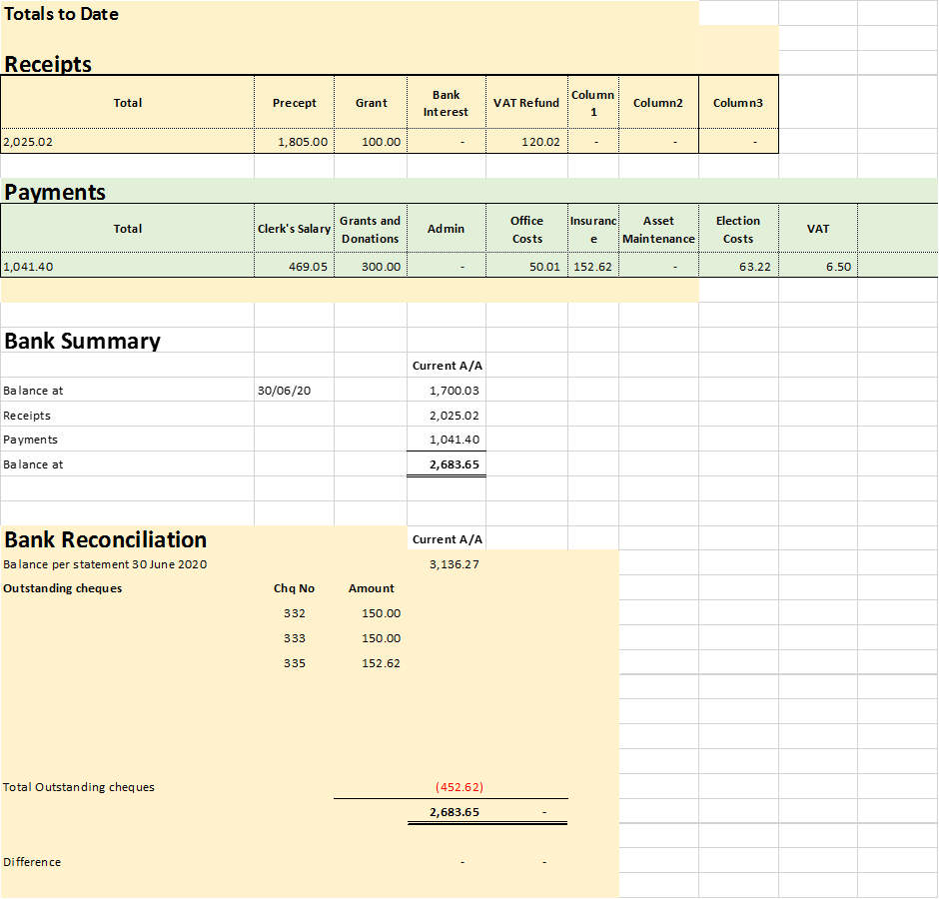

**Annex C**

**WDBC Parish Update – July 2020**

The finance team are looking at the recent central government report detailing support for the various council tiers and how they have been effected by covid-19 and the impact on budgets.

Members have started a series of workshops which will review the corporate strategy and the recovery of the council post covid-19. This will include the possible increased use of virtual meetings, future service provision and greater community involvement and engagement.

Parish clerks were sent a copy of Devon’s’ covid-19 Economy and Business recovery plan for comment.

Eligible families may be able to qualify for free food and vitamin vouchers from DCC’s Healthy Start programme. Details attached.

The Heart of the SW LEP (Local Enterprise Partnership) is launching a free business supportprogramme. To gauge need businesses are required to fill in a short survey:

https://www.surveymonkey.co.uk/r/btbhosw