Restaurants with Vegan Options:  Nationwide Twin Cities (* denotes all-vegan menu)  Burger King Carl's Jr. Cheesecake Factory Chipotle Dairy Queen Noodles and Co. P.F. Chang's Red Robin Sarpino’s Taco Bell TGI Friday's Toppers wahlburgers White Castle Yardhouse Agra Culture The Buzz Coffee & Cafe Crave Everest on Grand Francis Burger Joint * Glam Doll Donuts Gorkha Palace Hamburguesas El Gordo Herbivorous Butcher * the hardtimes cafe The Howe J. Selby's * Midori's Floating World Modern Times Namaste Cafe Parkway Pizza Peoples Organic Pizza Luce Reverie * Soul Bowl Spitz Stray Dog Tilted Tiki Tongue in Cheek Trio * Vegan East * World Street Kitchen  100 % Vegan Brands Beyond Meat daiya earth balance Field Roast Follow Your Heart Gardein The Herbivorous Butcher Impossible Foods Miyoko's So Delicious Strong Roots Tofurky Upton's Naturals Violife Brands With Vegan Options Amy's Annie's Boca Go Veggie Just, Inc. Lightlife Morning Star Farms Primal Kitchen Sweet Earth Tattooed Chef Yves Veggie Cuisine  Visit us: LivingThePlantLife.com  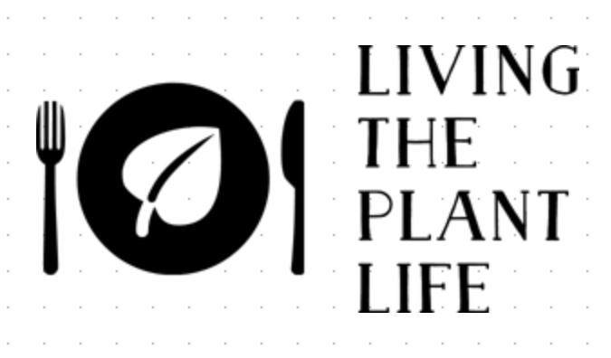  Restaurants with Vegan Options:  Nationwide Twin Cities (* denotes all-vegan menu)  Burger King Carl's Jr. Cheesecake Factory Chipotle Dairy Queen Noodles and Co. P.F. Chang's Red Robin Taco Bell TGI Friday's Toppers wahlburgers White Castle Yardhouse The Buzz Coffee & Cafe Coconut Whisk Cafe * Crave Crepe and Spoon * Francis Burger Joint * Glam Doll Donuts Hamburguesas El Gordo Hark! Café * Herbie Butcher’s Fried Chicken * Herbivorous Butcher * the hardtimes cafe (veg and vegan) The Howe Infused Life * Insane Vegan * J. Selby's * Midori's Floating World Cafe Modern Times Parkway Pizza Pizza Luce Reverie * Seed Cafe * Stalk and Spade * Tilted Tiki Trio * Vegan East *  100 % Vegan Brands Beyond Meat daiya earth balance Field Roast Follow Your Heart Gardein The Herbivorous Butcher Impossible Foods Miyoko's So Delicious Tofurky Upton's Naturals Violife Brands With Vegan Options Amy's Annie's Boca Go Veggie Just, Inc. Lightlife Morning Star Farms Sweet Earth Tattooed Chef Yves Veggie Cuisine  Visit us: LivingThePlantLife.com |  |  | The Beginner’s Guide to Plant-Based Shopping  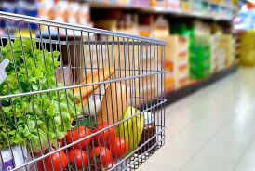  This guide is to help you as you begin your journey into plant-based eating.

Whether you are choosing to go vegan for the animals or a plant-based diet for your health or the environment, getting started can be confusing.  This guide is to help you discover a whole new world of food and flavors that won’t disappoint. Ok….some may….but don’t let that stop you. There will be plenty more that will ROCK! This guide is not intended to include EVERY vegan food option that is available; we just want to get you started with the basics. Be ready to take some time to explore the grocery stores to find all of the amazing plant-based choices.  Many things that you already eat may be plant-based. Other things that you wouldn’t imagine have animal products in it, do. Bread, for example, often has milk in it. The most important thing to do is to read ingredients on everything. When a label says “this may contain” or “made in a facility that uses”, it is not made with that ingredient; it is an allergen disclaimer.  Throughout the brochure, the brands will be listed with the following code for stores in which they can be found.  T=Target WF=Whole Foods C=Cub CO=Co-Ops W= Walmart FT=Fresh Thyme TJ=Trader Joe’s H=HyVee A=All Grocery Stores  Ingredients to Avoid  - Beeswax  - Casein or Caseinate is a dairy product  - Confectioner’s Glaze on candy. Also listed as Resinous Glaze, Shellac, Natural Glaze, or Pure Food Glaze. This is made from bug secretions.  - Gelatin  - Honey  - L. Cysteine (often found in bread products)  - Whey (often found in bread and sweets) |  |  | Accidentally Vegan:  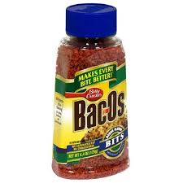 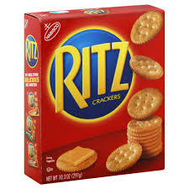 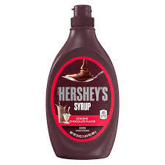 - Bac O’s and McCormick’s Bac’n Pieces - Bisquick - Campbell’s Mushroom Gravy - Doritos Spicy Sweet Chili–Flavored Tortilla Chips - Frito’s - Girl Scout Cookies (6 types) - Hershey’s Chocolate Syrup - Jello Pudding (in the box) - Oreos - Pop Tarts without frosting - Pringles original - Potato chips (without cheese or sour cream flavoring) - Ritz Crackers - Twizzlers  Pet Food and Treats  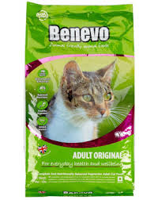 Ami Cat and Dog Foods Benevo Cat and Dog Foods Buddy Biscuits Peanut Butter Treats Halo Wet and Dry Dog Foods Natural Balance Vegan Formula Wet and Dry Food: Pet Supplies Plus, Petco V-Dog Wet and Dry Food and Treats
 |  |  | 9

Ice Cream  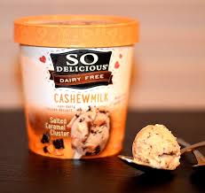 Ben and Jerry’s Dairy Free: T, CO, WF Halo Top Vegan: W, T, WF, C, CO Oatly: T, WF, H, CO Rice Dream: WF, T, CO So Delicious: WF, T, CO,  Random Food Items:  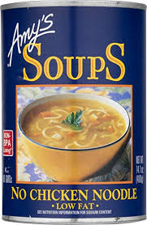 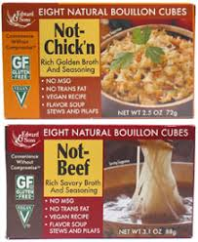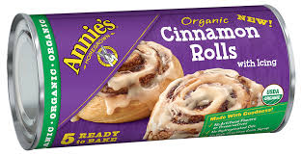 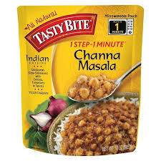 Amy’s Canned Chili and Vegan Soups (No-Chicken Noodle, Vegetable, etc.). A Pacific Wild Mushroom Gravy: WF, CO Tofurky Holiday Gravy: WF, CO, FT Imagine No-Chicken Broth: WF, CO Edward & Son’s Not Beef and Not Chik’n Bouillon: WF, C Upton’s Naturals Pad Thai and Thai Spaghetti: WF, CO Vegenaise Tartar Sauce: WF Annie’s Organic Cinnamon Rolls (refrigerated): A Worcestershire Sauce (most brands contain anchovies): Annie’s Naturals, Essential Everyday (Super Valu Brand) Tasty Bite Indian Meal Pouches: A | : |  | Meat Replacements  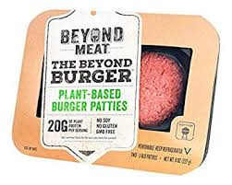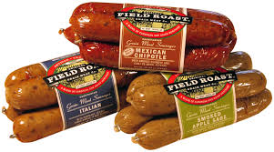 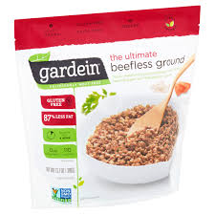 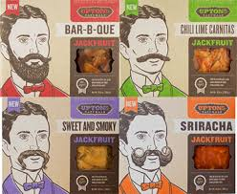 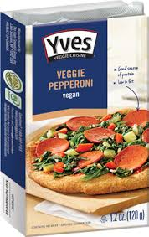 Impossible Meat: burgers, sausage, brats, chicken, and more!: T, WF, W, CO Beyond Meat: crumbles, chicken strips, burgers, brats, breakfast sausages and more! T, WF, CO Boca Vegan Meats: W, T, WF, CO Field Roast: hot dogs, chorizo, hamburgers, sausage, etc. T, WF, CO, W, FT, Gardein: fish fillets, meatloaf, chicken strips, chicken fingers, hamburger crumbles, turkey cutlets, chicken sliders, pork bites, etc. They are in the frozen food section: A Herbivorous Butcher: steaks, bacon, hot dogs, sausage, everything you would find at a traditional butcher shop can be found at their NE Mpls store or online. LightLife: ground sausage, hot dogs, etc. T, WF, CO, C, FT, TJ, H Morningstar Farms Vegan: W,T, WF, CO, C Sweet Earth: T, CO, Tofurky: deli meat, pizza, roasts, sausages, hot dogs, etc. FT, WF, T, CO, TJ, H Upton’s Naturals has BACON! And many other meat alternative options. T, WF, CO. FT Yves Veggie Cuisine: salami, etc. W, CO
8 |  |  | 1

Butter Alternatives  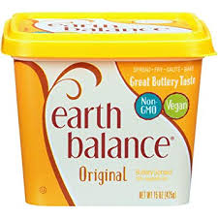 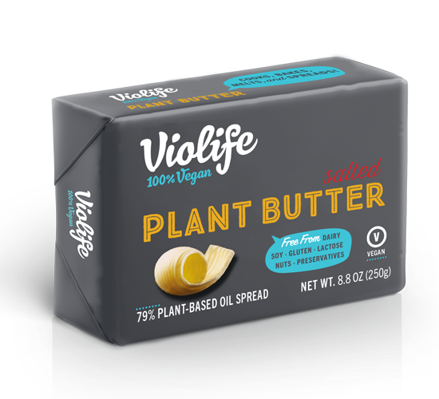 Earth Balance: A Violife Plant Butter: WF, CO, FT I Can’t Believe It’s Not Butter Vegan: A Blue Bonnet Light: A Country Crock Plant Butter: A  Milk and Creamers  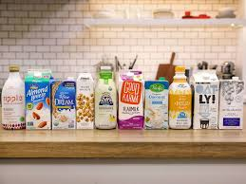 There are a gajillion options…soy, almond, cashew, flax, rice, oat, pea protein, hemp, etc. All grocery stores have many from which to choose.  Yogurt  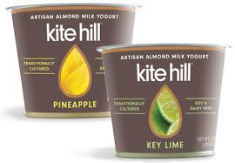 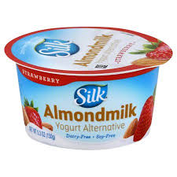 Kite Hill: WF, CO, H Daiya: WF, T, W, CO Silk: T, W, WF, CO So Delicious: W, WF, T, CO Oui (dairy-free): E |  |  | Frozen Snacks  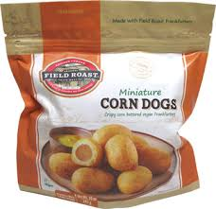 Field Roast Corn Dogs: WF, W Amy’s Vegan Margherita Swirls and Pizza Rolls: CO Wholly Veggie! Mozzarella Sticks: E Sweet Earth Vegan Snacks: T  Frozen Meals  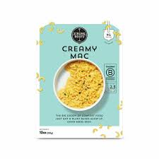 Gardein Ultimate Bowls: T, W, WF Amy’s Dairy-Free Meals: T, WF, CO Sweet Earth Vegan Meals: T Strong Roots: H, WF, FT  Frozen Pizza  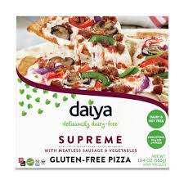 Daiya: FT, WF, C, CO Amy’s Vegan Pizzas: FT, WF Tattooed Chef: T, WF
2 |  |  | 7

Snacks  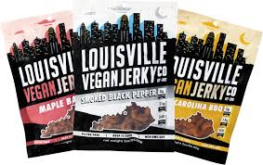 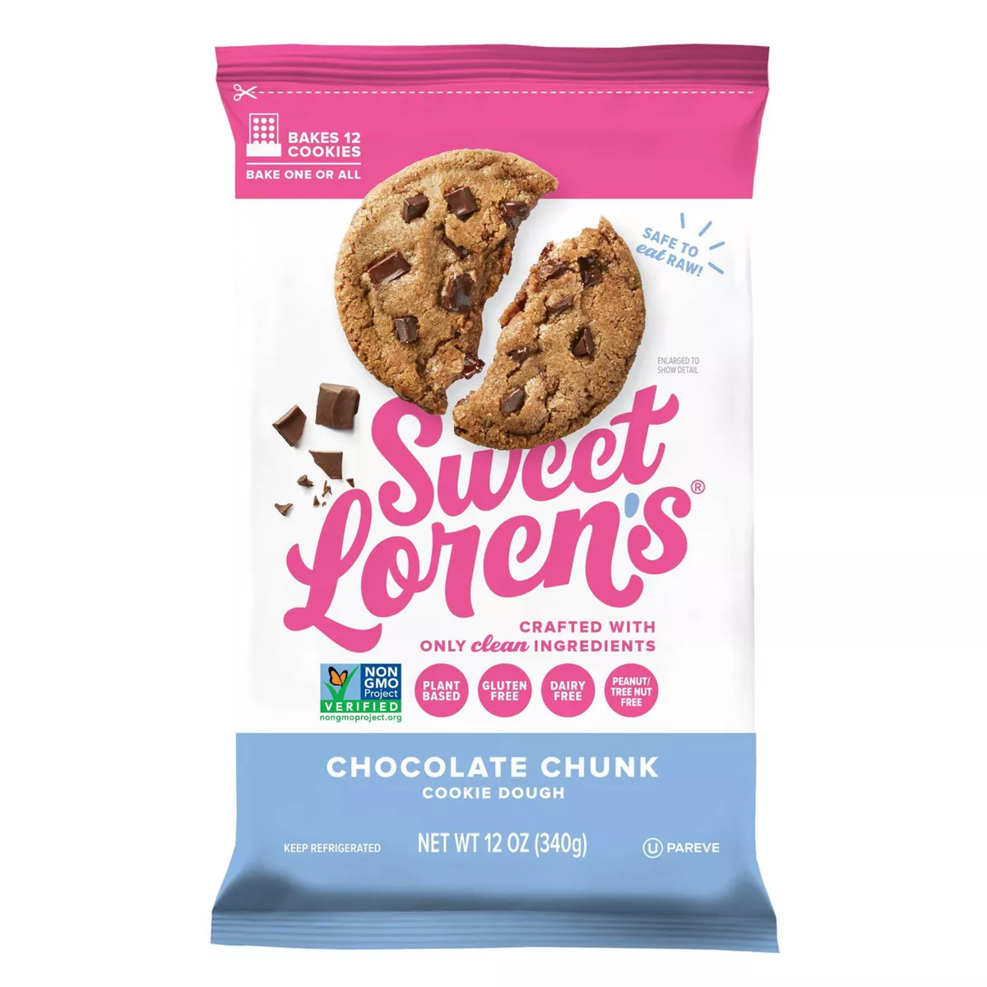 Sweet Loren’s Cookie Dough: E Earth Balance Cheddar Crackers: WF, FT Earth Balance White Cheddar Popcorn: WF, FT Hippeas: T, WF, CO, FT, H Louisville Vegan Jerky: FT Trader Joe's Vegan Banana Bread: TJ  Chocolate and Candies  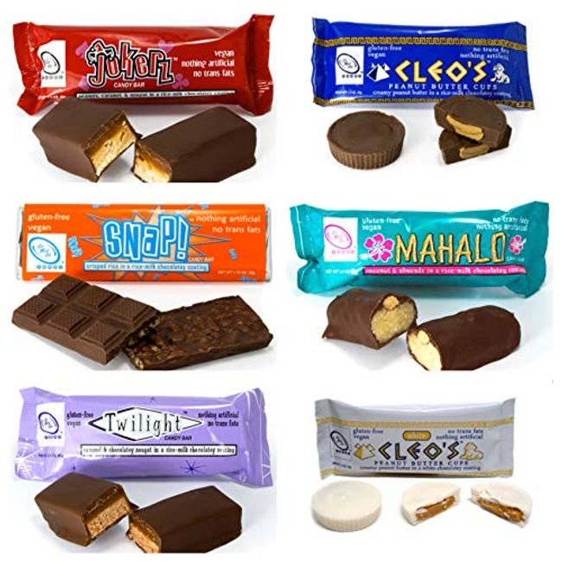 Go Max Go (all the childhood classics!): online Justin’s Dark Chocolate Peanut Butter Cups: A Enjoy Life Chocolate Chips (for baking): A Unreal Vegan Chocolates: WF Cocomels Caramels: WF  Mac and Cheese  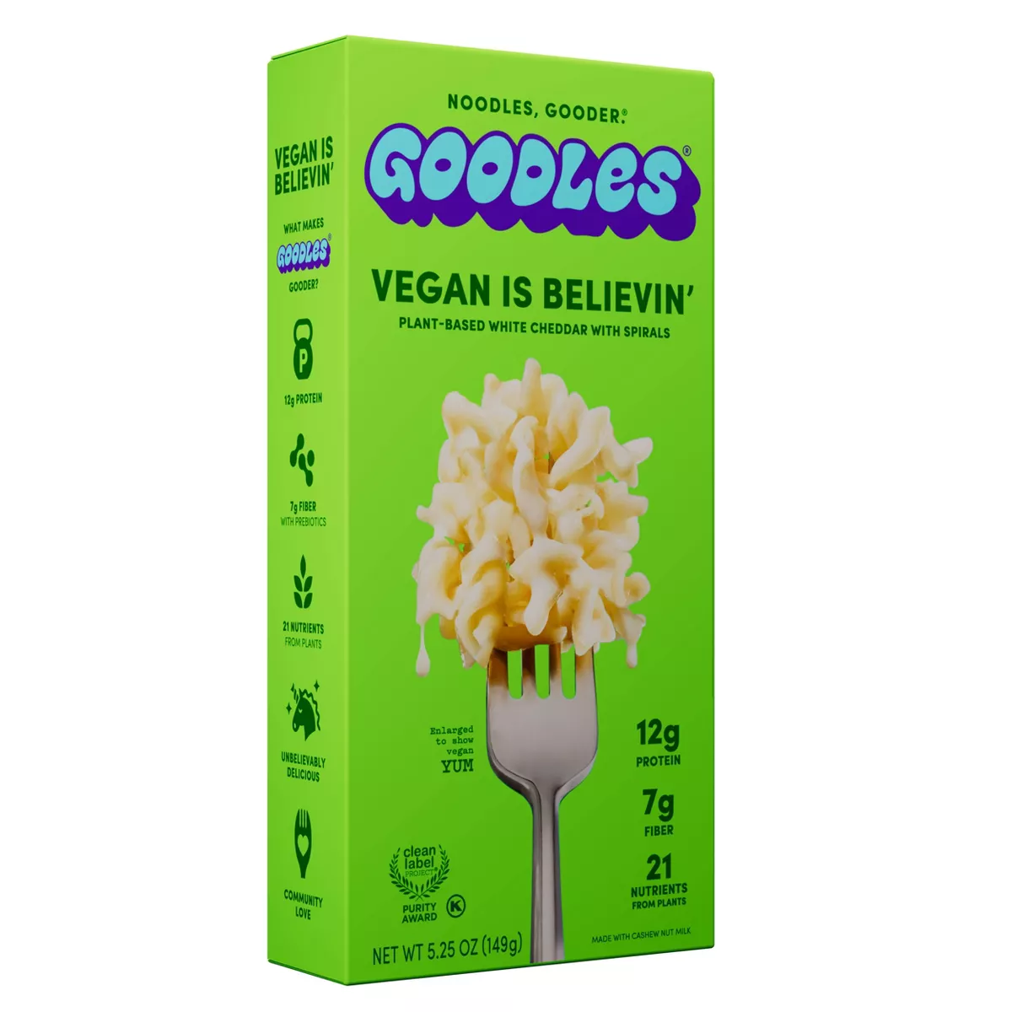 Goodles Vegan Is Believin’: E Upton’s Naturals: WF, CO Annie’s Vegan Mac: WF, CO Strong Roots: H, WF, FT |  |  | Cheese Slices  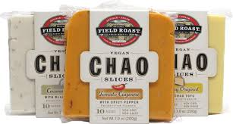 Field Roast Chao Cheese: WF, CO, W Follow Your Heart: WF, FT, CO, T, W Miyoko’s: WF, CO Violife: E  Cheese Shreds  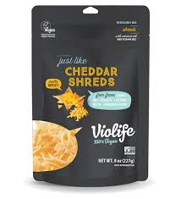 Violife: WF, CO So Delicious: WF, FT, CO, H Daiya: T, WF, FT, CO, W, H Follow Your Heart: WF, CO, H Trader Joe’s: TJ  Cheese Spreads or Dips  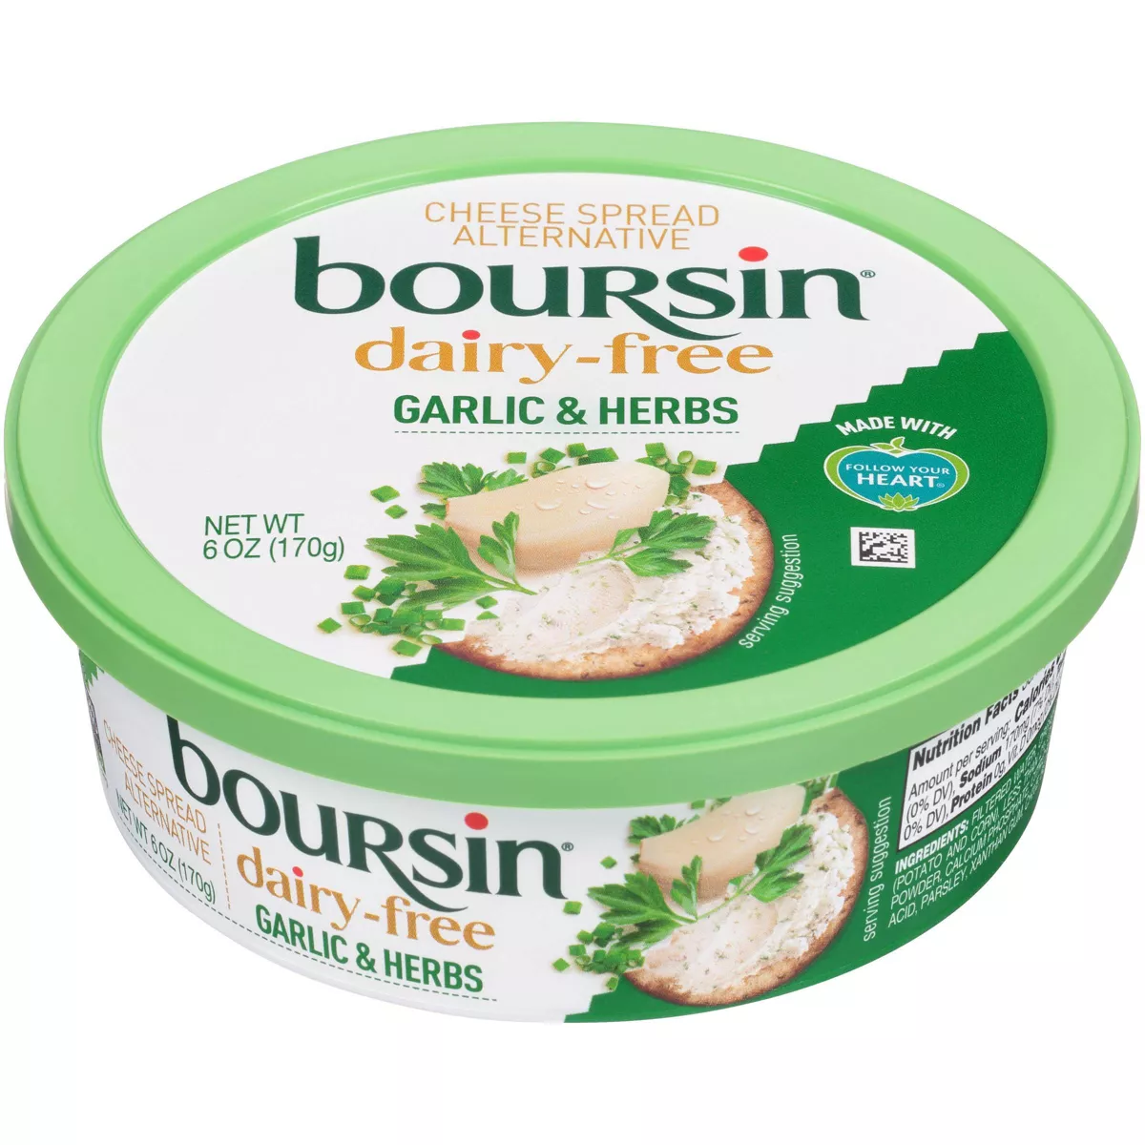 Boursin Dairy-Free Garlic and Herbs: E Kite Hill Dips: FT Babybel Plant-Based: E Miyoko’s Kitchen: Miyoko’s website or WF Herbivorous Butcher: online or Mpls store  Ricotta Cheese  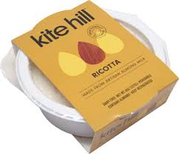 Kite Hill: WF, CO
6 |  |  | 3
Parmesan Cheese  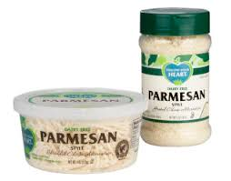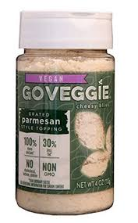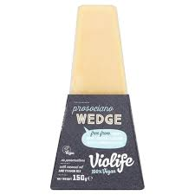 Follow Your Heart: WF, CO, H, FT Go Veggie Vegan: FT, WF Violife: WF  Cream Cheese  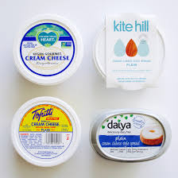 Kite Hill (regular, chive and jalapeno): WF, CO, H Tofutti: WF, CO, C, H Miyoko’s (plain, scallion and unlox): TJ Daiya: WF, CO, H Follow Your Heart: WF, CO  Sour Cream  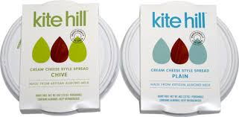  Kite Hill Sour Cream: T, WF, CO Kite Hill Cream Cheese can also be used as an amazing sour cream replacement! The chive cream cheese is just like Top the Tater! C, WF, CO, H Tofutti: C, CO, WF, H Follow Your Heart: WF, CO, H |  |  | Egg Replacements  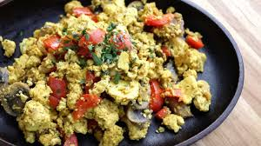 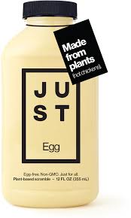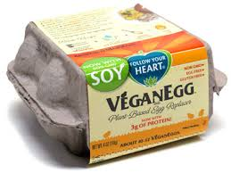 Just Egg (for scrambles & French toast): FT VeganEgg (for scrambles and baking) : WF, CO The Neat Egg: T Ener G Egg Replacer: WF Tofu: Can be used as a scrambled egg replacement and is found in all grocery stores. Other alternatives can be found here: http://www.peta.org/living/food/egg-replacements/  Mayonnaise Alternatives  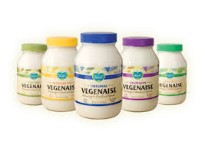 Follow Your Heart Vegenaise: WF, CO, C, H Just Mayo: WF, CO Hellman’s Vegan Mayo: T, C Sir Kensingtons Classic Fabanaise Vegan Mayo: WF, CO  Dressings  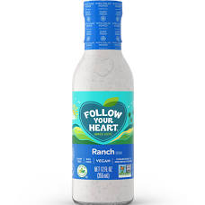 Daiya: WF, CO Follow Your Heart: WF, FT, H
4 |  |  | 5

