  The Beginner’s Guide to Plant-Based Shopping
  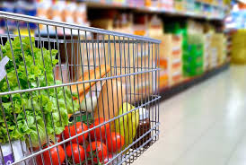
  This guide is to help you as you begin your journey into plant-based eating.
  Restaurants with Vegan Options:
  Nationwide | Twin Cities (* denotes all-vegan menu)
  Burger King  Carl's Jr.  Cheesecake Factory  Chipotle  Dairy Queen  Noodles and Co.  P.F. Chang's  Red Robin  Taco Bell  TGI Friday's  Toppers  wahlburgers  White Castle  Yardhouse | Agra Culture  The Buzz Coffee & Cafe  Crave  Everest on Grand  Francis Burger Joint *  Glam Doll Donuts  Gorkha Palace  Hamburguesas El Gordo  Hark! Café *  Herbivorous Butcher *  the hardtimes cafe  The Howe  J. Selby's *  Midori's Floating World |  | Modern Times  Namaste Cafe  Parkway Pizza  People's Organic  Pizza Luce  Reverie *  Soul Bowl  Spitz  Stray Dog  Tilted Tiki  Tongue in Cheek  Trio *  Vegan East *  World Street Kitchen
  100% Vegan Brands  Beyond Meat  daiya  earth balance  Field Roast  Follow Your Heart  Gardein  The Herbivorous Butcher  Impossible Foods  Miyoko's  So Delicious  Strong Roots  Tofurky  Upton's Naturals  Violife |  | Brands With Vegan Options  Amy's  Annie's  Boca  Go Veggie  Just, Inc.  Lightlife  Morning Star Farms  Primal Kitchen  Sweet Earth  Tattooed Chef  Yves Veggie Cuisine
  Visit us: LivingThePlantLife.com
  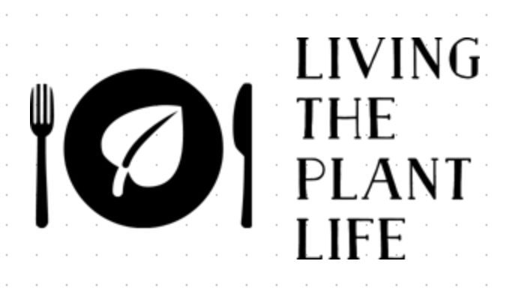

Whether you are choosing to go vegan for the animals or a plant-based diet for your health or the environment, getting started can be confusing.  This guide is to help you discover a whole new world of food and flavors that won’t disappoint. Ok….some may….but don’t let that stop you. There will be plenty more that will ROCK! This guide is not intended to include EVERY vegan food option that is available; we just want to get you started with the basics. Be ready to take some time to explore the grocery stores to find all of the amazing plant-based choices.  Many things that you already eat may be plant-based. Other things that you wouldn’t imagine have animal products in it, do. Bread, for example, often has milk in it. The most important thing to do is to read ingredients on everything. When a label says “this may contain” or “made in a facility that uses”, it is not made with that ingredient; it is an allergen disclaimer.  Throughout the brochure, the brands will be listed with the following code for stores in which they can be found.  T=Target WF=Whole Foods C=Cub CO=Co-Ops W= Walmart FT=Fresh Thyme TJ=Trader Joe’s H=HyVee A=All Grocery Stores  Ingredients to Avoid  - Honey  - Beeswax  - Casein or Caseinate is a dairy product  - Confectioner’s Glaze on candy. Also listed as Resinous Glaze, Shellac, Natural Glaze, or Pure Food Glaze. This is made from bug secretions.  - Whey (often found in bread and sweets)  - L. Cysteine (often found in bread products)  - Gelatin
  Meat Replacements
  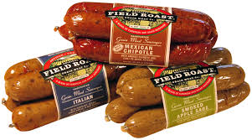  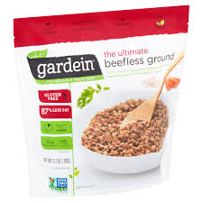  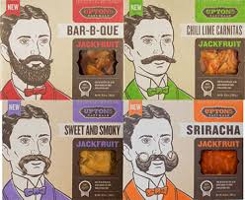  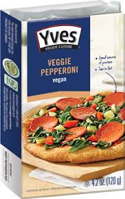 | Impossible Foods: burgers, sausage, brats, chicken and more!. A  Beyond Meat: crumbles, chicken strips, burgers, brats, breakfast sausages and more! A  Boca Vegan Meats: W, T, WF, CO  Field Roast: hot dogs, chorizo, hamburgers, sausage, etc. T, WF, CO, W, FT,  Gardein: fish fillets, meatloaf, chicken strips, chicken fingers, hamburger crumbles, turkey cutlets, chicken sliders, pork bites, etc. They are in the frozen food section: A  Herbivorous Butcher: steaks, bacon, hot dogs, sausage, everything you would find at a traditional butcher shop can be found at their NE Mpls store or online.  Lightlife: ground sausage, hot dogs, etc. T, WF, CO, C, FT, TJ, H  Morning Star Farms Vegan: W,T, WF, CO, C  Sweet Earth: T, CO  Tofurky: deli meat, pizza, roasts, sausages, hot dogs, etc. FT, WF, T, CO, TJ, H  Upton's Naturals has BACON! And many other meat alternative options. T, WF, CO. FT  Yves Veggie Cuisine: Salami, etc. W, CO
    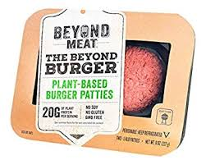
 |  |  | 1

 | : |  | Cheese Slices  Cheese Shreds  Cheese Spreads or Dips  Ricotta Cheese
  Butter Alternatives
   | Earth Balance: A  Violife Plant Butter: WF, CO, FT  I Can't Believe It's Not Butter Vegan: A  Blue Bonnet Light: A  Country Crock Plant Butter: A
    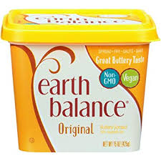
    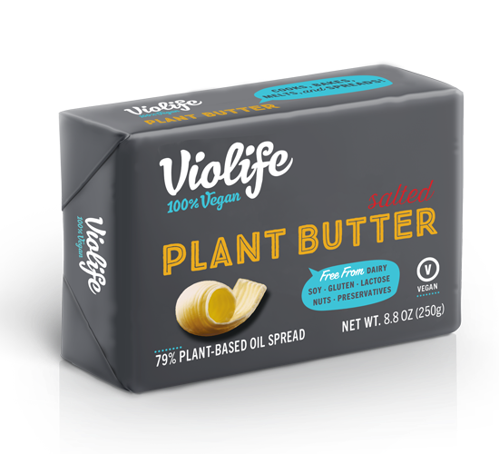
  Milk and Creamers
   | There are a gajillion options…soy, almond, cashew, flax, rice, oat, pea protein, hemp, etc. All grocery stores have many from which to choose.
    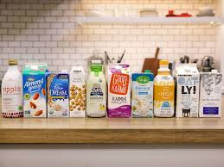
  Yogurt
   | Kite Hill: WF, CO, H  daiya: WF, T, W, CO  Silk: T, W, WF, CO  So Delicious: W, WF, T, CO  Oui (dairy-free): E
    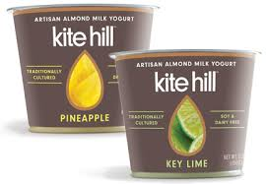
    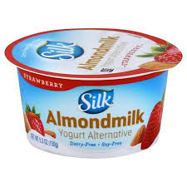
   | Field Roast Chao Cheese: WF, CO, W, T  Follow Your Heart Cheese: WF, FT, CO, H  Violife: WF, FT
    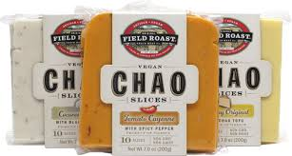
   | Violife: E  So Delicious: WF, FT, CO, H  daiya: T, WF, FT, CO, W, H  Follow Your Heart Cheese: WF, CO, H  Trader Joe's: TJ
    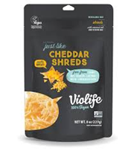
   | boursin Dairy-Free Garlic and Herbs: E  Kite Hill Dips: WF, FT, CO  Babybel Plant-Based: E  Miyoko's: Miyoko’s website, T, CO, WF  The Herbivorous Butcher: online or Mpls stroe
    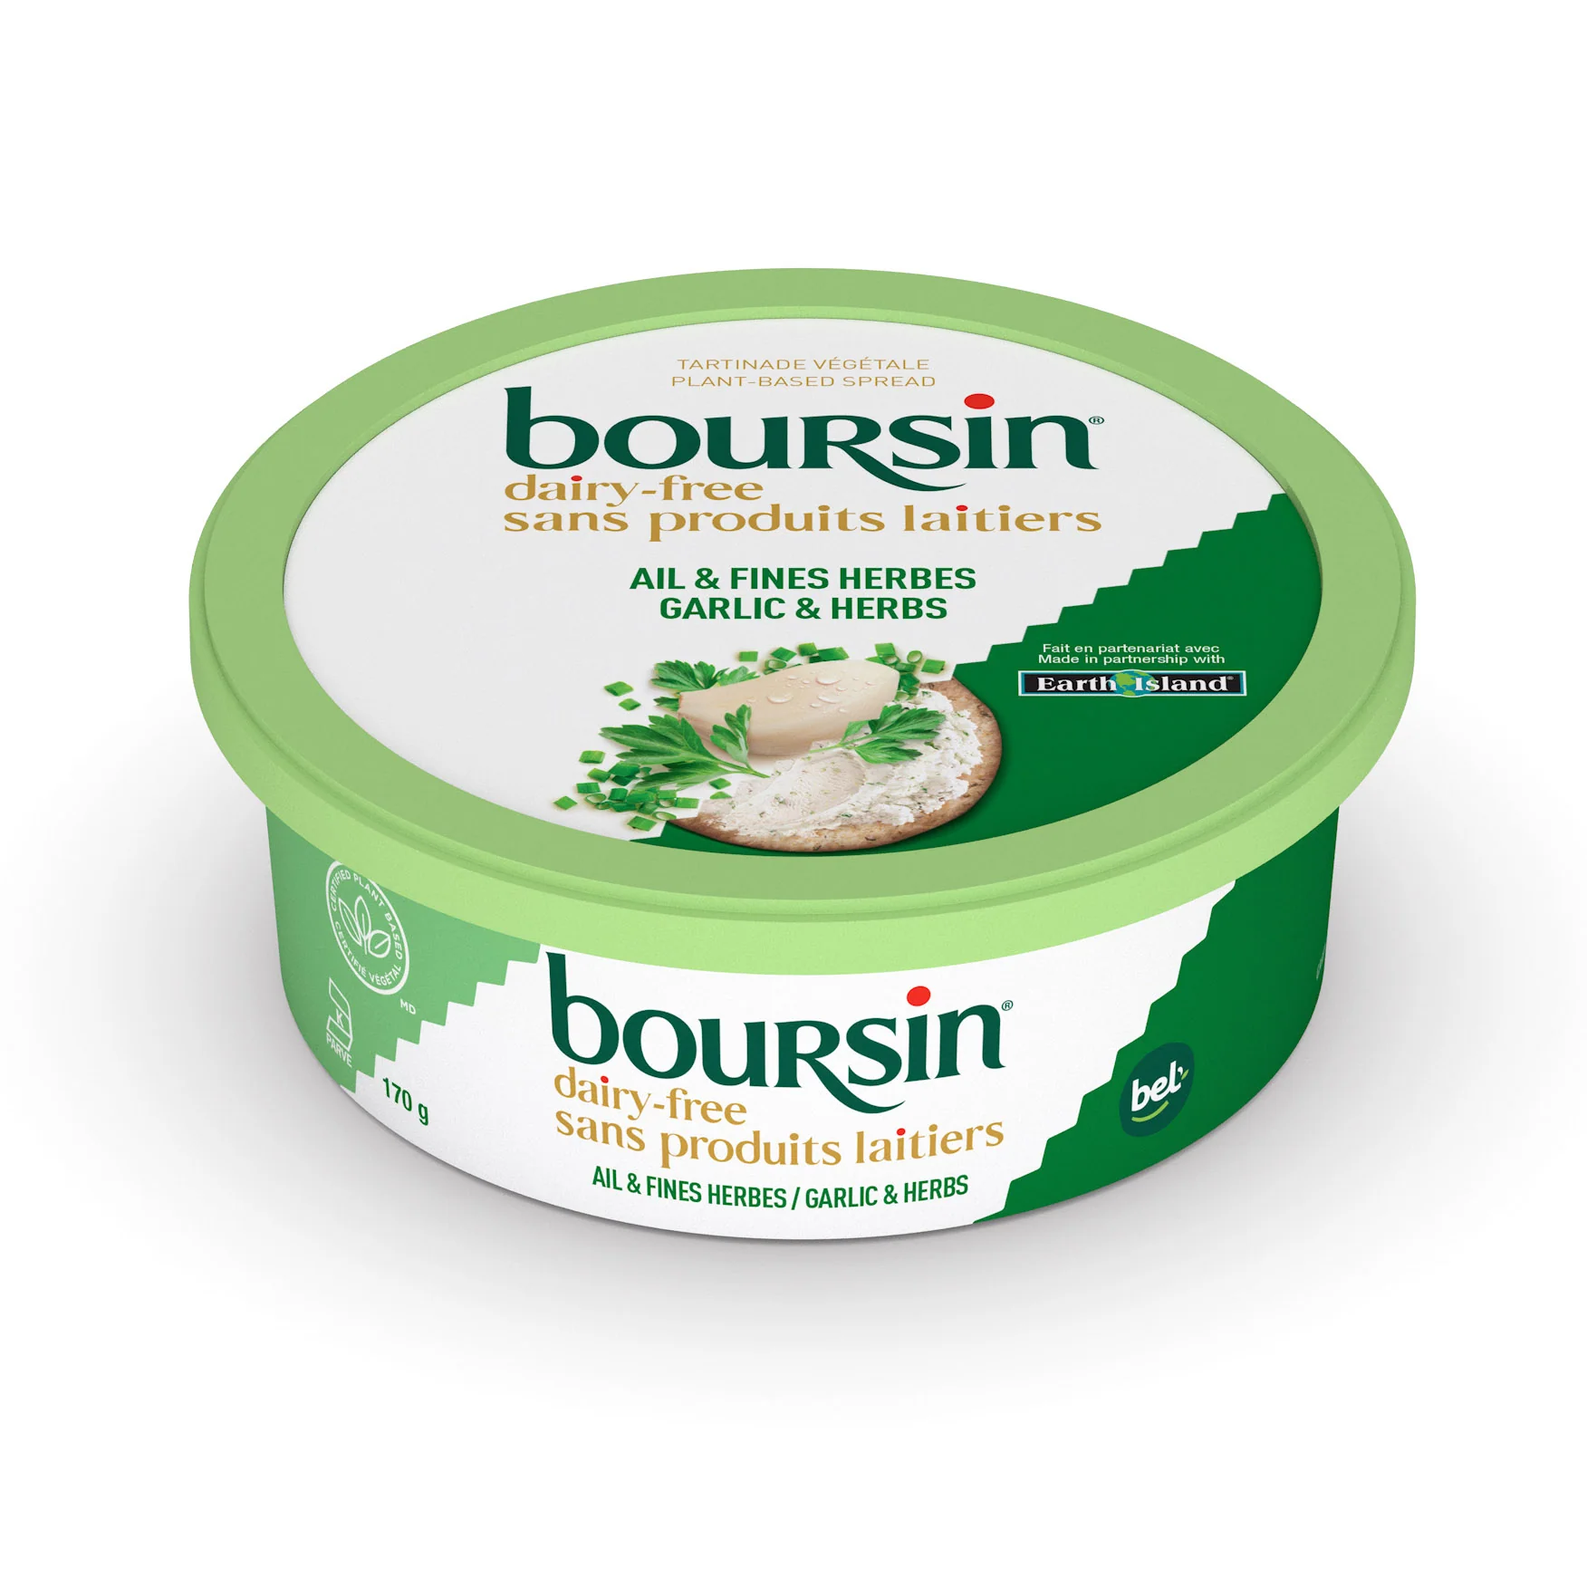
   | Kite Hill: WF, CO
    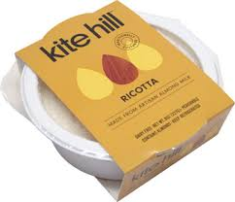
2 |  |  | 3 | 1

Parmesan Cheese  Cream Cheese  Sour Cream |  | : |  |  |  | Egg Replacements  Mayonnaise  Dressings
   | Follow Your Heart Cheese: WF, CO, H  Go Veggie Vegan Cheese: FT, WF  Violife: WF
    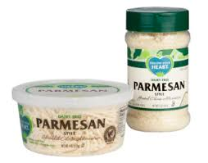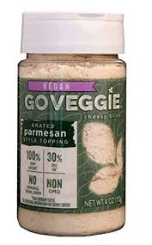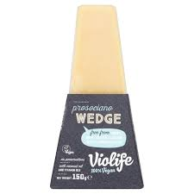
   | Kite Hill (regular, chive and jalapeno): WF, CO, H  Tofutti: WF, CO, C, H  Miyoko's (plain, scallion and unlox): TJ  daiya: WF, CO, H  Follow Your Heart Cheese: WF, CO
    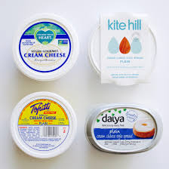
   | Kite Hill: T, WF, CO  Kite Hill Cream Cheese can be used as an amazing sour cream replacement! The chive cream cheese is just like Top the Tater! C, WF, CO, H  Tofutti: C, CO, WF, H  Follow Your Heart: WF, CO, H
    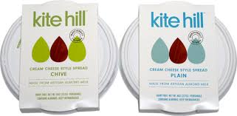
    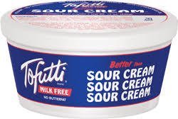
  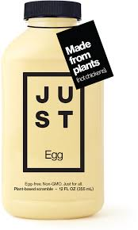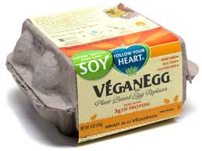 | Just Egg: (for scrambles & French toast): FT  VeganEgg (for scrambles and baking) : WF, CO  The neat egg: T  Ener-G Egg Replacer: WF  Tofu: Can be used as a scrambled egg replacement and is found in all grocery stores.  Other alternatives can be found here: http://www.peta.org/living/food/egg-replacements/
    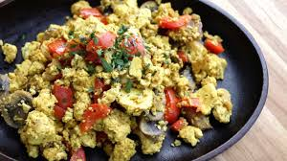
   | Follow Your Heart Vegenaise: WF, CO, C, H  Just Mayo: WF, CO  Hellman's Vegan Mayo: T, C  Sir Kensington's Classic Fabannaise Vegan Mayo: WF, CO
    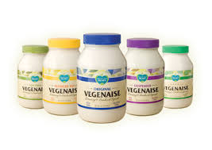
   | daiya Dressings: WF, CO  Follow Your Heart Dressings-WF, FT, H  : WF, CO
    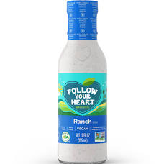
4 |  |  |  |  |  | 5
Snacks  Chocolate and Candies  Mac and Cheese | :
   | Sweet Loren's Cookie Dough: E  Earth Balance Cheddar Crackers: WF, FT  Earth Balance White Cheddar Popcorn: WF, FT  Hippeas: T, WF, CO, FT, H  Louisville Vegan Jerky: FT  Trader Joe's Vegan Banana Bread: TJ
    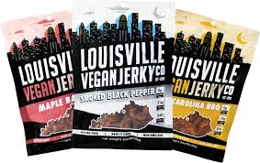
    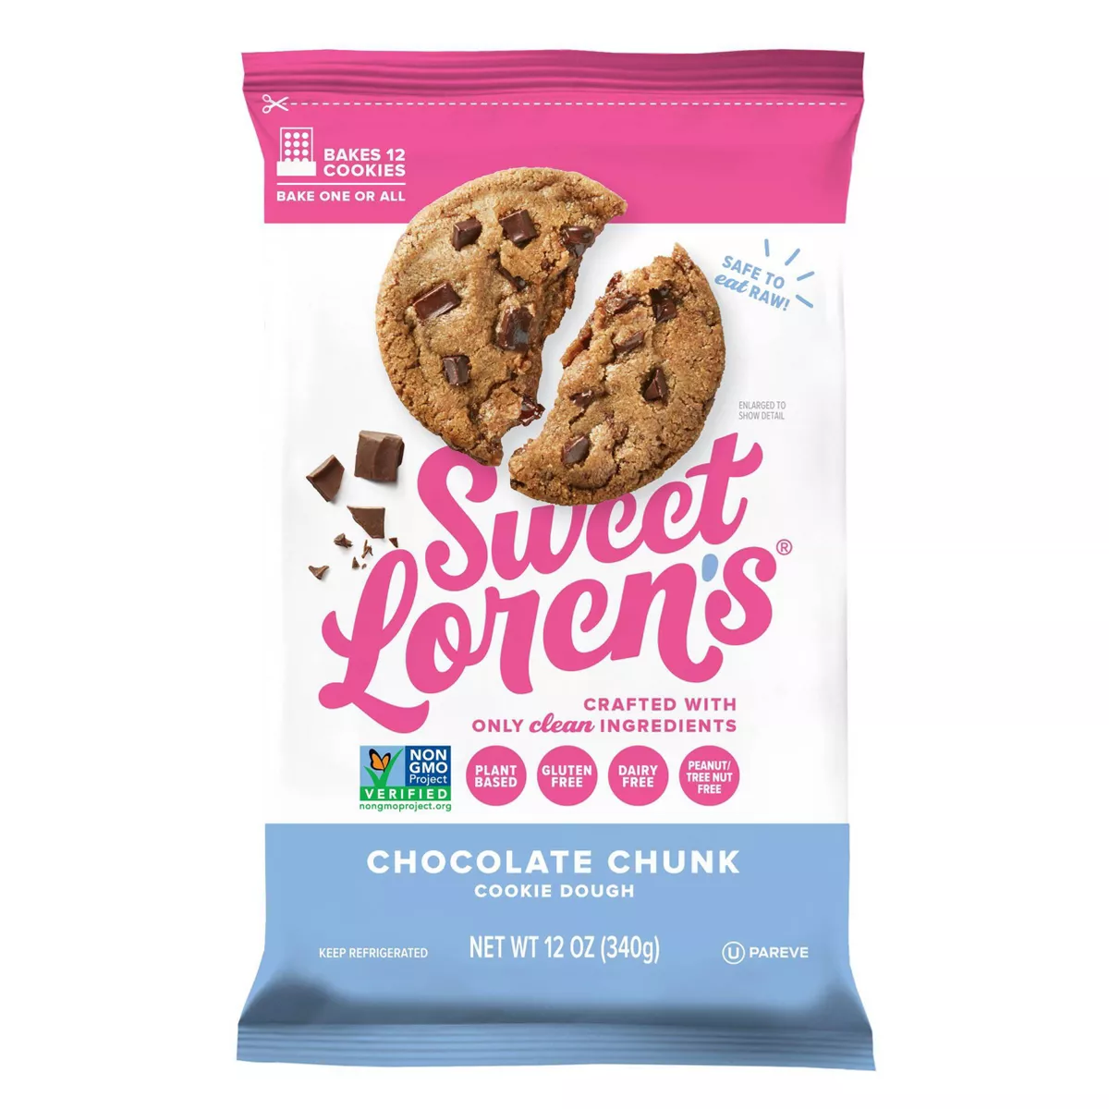
   | Go Max Go (all the childhood classics!): online  Justin's Dark Chocolate Peanut Butter Cups: A  Enjoy Life Chocolate Chips (for baking): A  Unreal Vegan Chocolates: WF  Cocomels Caramels: WF
    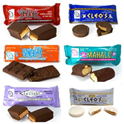
   | Goodles Vegan is Believin': E  Strong Roots: H, WF, FT  Upton's Naturals Ch'eesy Mac: WF, CO  Annie's Vegan Mac: WF, CO
    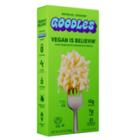
  Frozen Snacks
   | Field Roast Miniature Corn Dogs: WF, W  Wholly Veggie! Mozzarella Sticks: E  Amy's Vegan Snacks: T, WF, CO  Sweet Earth Vegan Snacks: E
    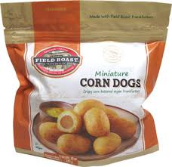
  Frozen Meals
   | Gardein Skillet Meals: T, W, WF  Amy's Vegan Meals: T, WF, CO  Sweet Earth Vegan Meals: T  Strong Roots: H, WF, FT
    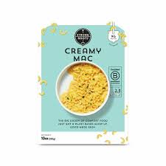
  Frozen Pizza
   | daiya: FT, WF, C, CO  Amy's Vegan Pizzas: FT, WF  Tattooed Chef: T, WF
    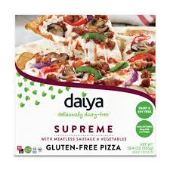
6 |  |  |  |  | 7
Ice Cream  Random Food Items: |  | :
   | Oatly: E  Halo Top Vegan: W, T, WF, C, CO  Rice Dream: WF, T, CO  So Delicious: WF, T, CO,  Ben and Jerry's Non-Dairy: T, CO, WF
    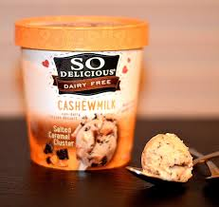
  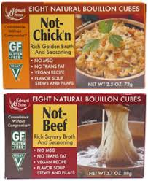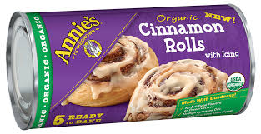  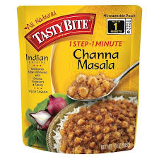 | Amy's Soups and Chili (No-Chicken Noodle, Vegetable, etc.): A  Pacific Wild Mushroom Gravy: WF, CO  Tofurky Savory Gravy: WF, CO, FT  Imagine No-Chicken Broth: WF, CO  Edward & Sons Vegan Bouillon Cubes: WF  Upton's Naturals Pad See Ew, Massaman and Thai Spaghetti: WF, CO  Vegenaise Tartar Sauce: WF  Annie's Organic Cinnamon Rolls (refrigerated): A  Worcestershire Sauce (most brands contain anchovies): Annie's Naturals, Essential Everyday (Super Valu Brand)  Tasty Bite Vegan Meal Pouches: A
    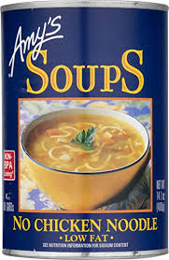
  Accidentally Vegan:
  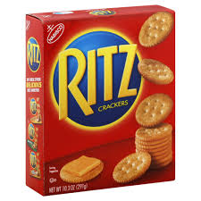  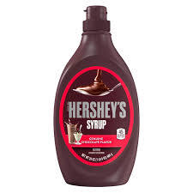 | - Bac O’s and McCormick’s Bac’n Pieces  - Bisquick  - Campbell’s Mushroom Gravy  - Doritos Spicy Sweet Chili–Flavored Tortilla Chips  - Frito’s  - Girl Scout Cookies (6 types)  - Hershey’s Chocolate Syrup  - Jello Pudding (in the box)  - Oreos  - Pop Tarts without frosting  - Pringles original  - Potato chips (without cheese or sour cream flavoring)  - Ritz Crackers  - Twizzlers
    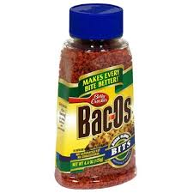
  Pet Food and Treats
   | ami Cat and Dog Foods  Benevo Cat and Dog Foods  Buddy Biscuits Peanut Butter Treats  Natural Balance Vegan Formula Wet and Dry Food: Pet Supplies Plus, Petco  v-dog Dry and Wet food and treats
    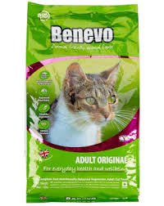
8 |  |  |  |  |  | 9

