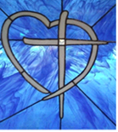
Let your Light shine Matthew 5:16
Freedom Center Ministries Inc.
April – May - June 2021 news

Greetings to our beloved Family and Friends,
What a wonderful season it is! Folks on the move to see what they have missed around the World! They are seeking places to go. Not, to be on the move, but to reconnect with family and friends. Some friends on mission journeys have returned to Kentucky with donation needs for local folks and have shown excitement to serve! The families of 679 folks were served at FC shop. We are blessed to see our God family; since they postponed their journeys last year. The joy to share our stories and fellowship was great. But God’s Agape love is more amazing!
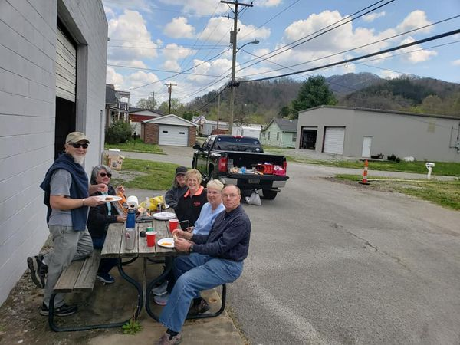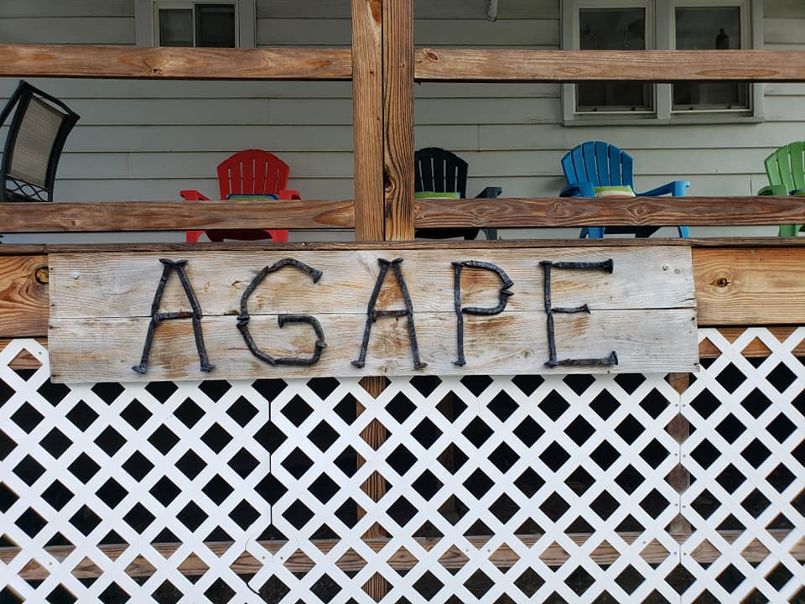
Every moment amazing! Every hour I need Him. Can you feel the Holy Spirit’s presence? Yes, as God’s Children, we raise our HALLELUJAH Banner.
A local friend of FCM raised his banner. But first, thanks to the women that so beautifully crocheted hundreds of prayer pocket crosses. Now, Steve’s story goes like this. On a hospital visit to my wife, a lady was crying in the parking lot. I spoke with her and gave her a pocket cross. She said the timing of this was an encouragement, for my husband just lost his leg to cancer. Steve went into the hospital and gave everyone in his path a pocket cross. They were very thankful! He has more stories.

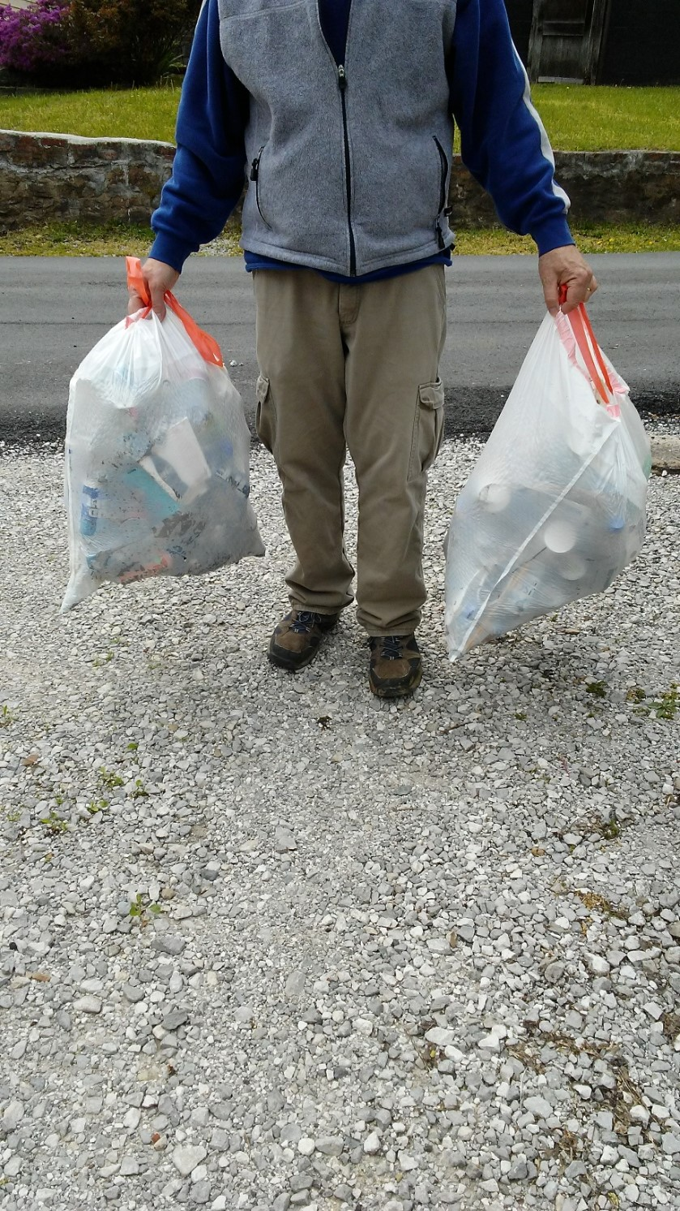 ” Pick of the Litter” Ministry 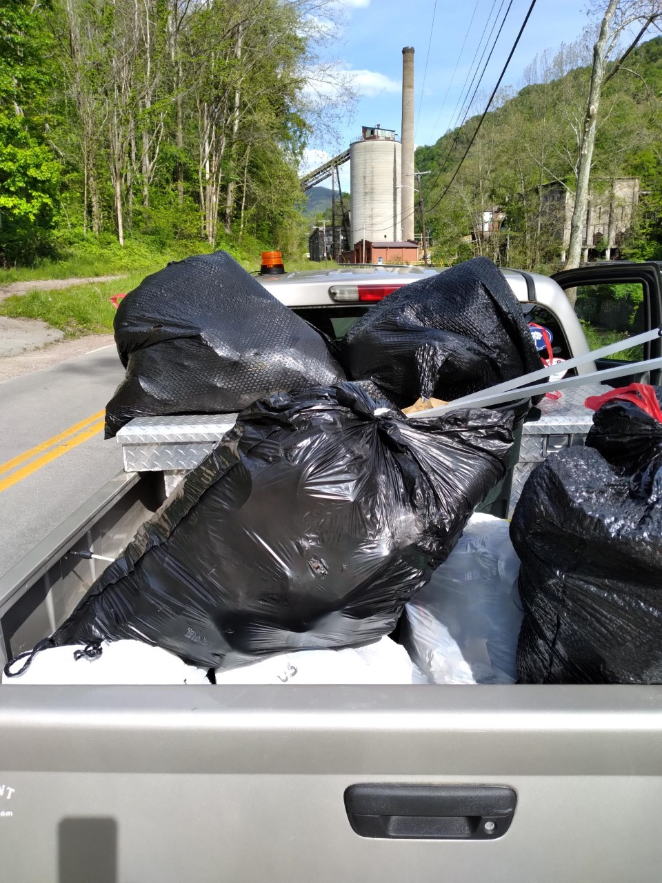
We enjoy and appreciate God’s creation! Because of that, we are on a mission to keep it clean and put trash/garage in the proper place. So, here is a challenge for all of us. The “Pick of the Litter” is a community service that all folks can take part in. For you, your church, your family, your group, your school or others may pick a street, road, or area in your town/community to help keep clean. If we all pitched in and picked up, our towns and mountains would remain beautiful. Thank you for your consideration to keep our community clean and healthy!
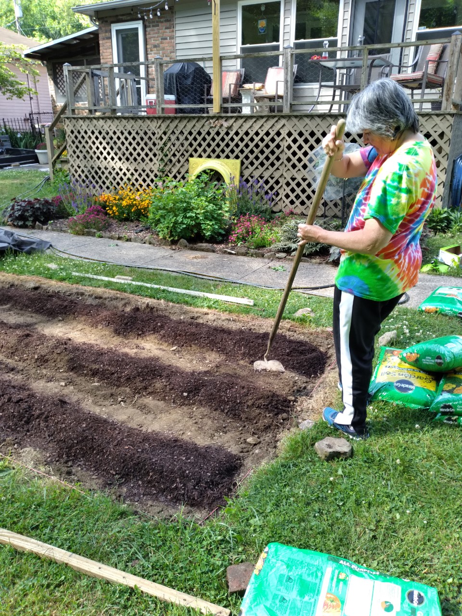 Back yard ministry. Our vegetable and herb garden will help keep us healthy and assist our neighbors with grocery provisions. There is nothing like fresh veggies! God is good.
Missionary Teams on the 2021 Calendar:
April 18th - 24th - Riverland Hills BC, Irmo, SC
April 29th - May 1st - Union BC, Griffin, GA
May 30th - June 5th Harmony Grove BC, Cumming, GA
July 19th - 23rd - Back to School Mission Week: Buck Creek BC, Longs, SC; Wampee BC, Longs, SC; Ben Avon BC, Spartanburg, SC; Memorial BC, Frankfort, KY; Indian Lake BC, Northport, AL
August 1st - 7th Riverland Hills BC, Irmo, SC

September 23rd - 26th Freedom BC, Salisbury, NC
October 10th - 15th Union BC, Griffin, GA
Open Dates are available; as God leads contact FCM. If your church/group is planning to come and serve with Freedom Center Ministries, please contact us. Thank you!
Agape House Lynch, KY is a place where missionaries stay when they GO/come to serve.

PRAISE OUR LORD FOR:
Holy Spirit's faithfulness in every detail of life & ministry
Our health, families, medical personal, public workers
Financial and physical resources that have been donated
679 friends served at FC
Faithful partners in ministry and prayer
The volunteers helping with this ministry giving of their time, talents, and resources to build relationships with our local people.

PRAY TO THE ALL SUFFICIENT ONE FOR:
FCM needs a web master
Mercy and strength for all medical personal
America and leaders
FCM folks on prayer list- salvation, jobs, healing
School children & teachers on summer break
Missionary couple for long term service with FCM
Unbelievers around the World
July - Back to School Mission Week

FCM SHOP NEEDS AT THIS TIME:
T-Shirts for all genders, ages, and sizes
Men belts, blue jeans
Women’s current style blue jeans, bras
All sizes sheet sets (especially queen and king)

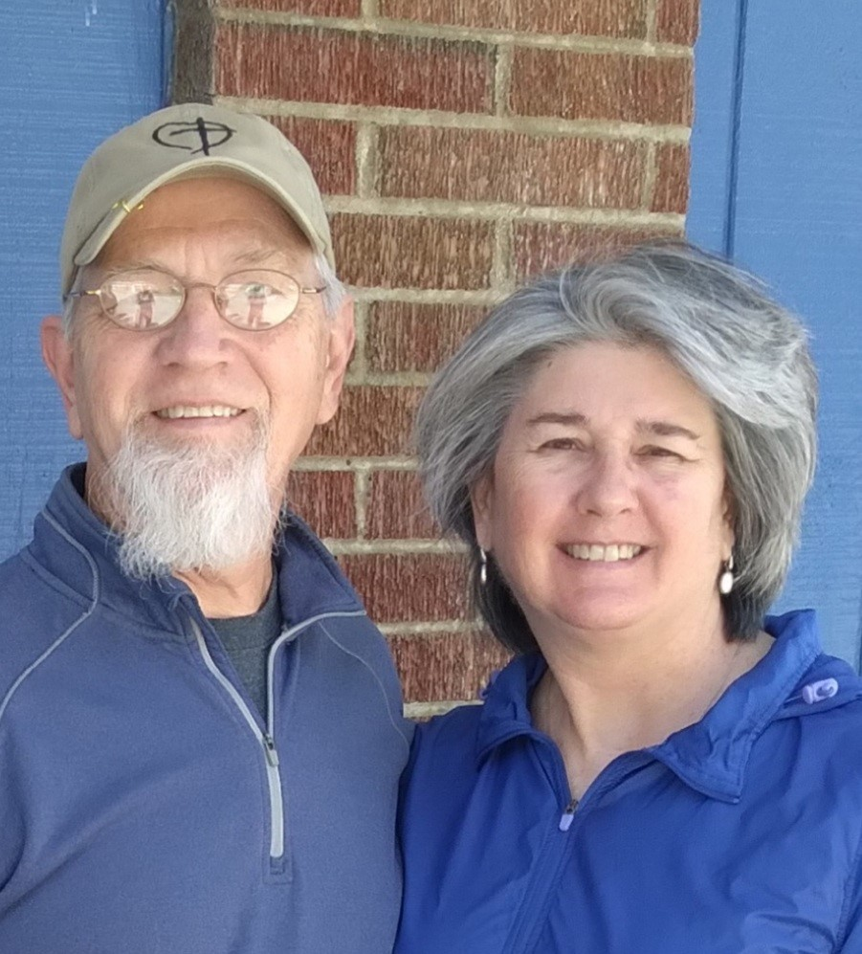
In the Vine, John 15 ... Servants for Jesus Christ!
George and Robin Lewis, Directors
Linda Alford, Co-Director
Freedom Center Ministries, Inc.
P O Box 794
Lynch, KY 40855
606-899-5804
A 501(c) (3) non-profit organization
Email georgelewis52@hotmail.com
www.freedomcenterministries.com


