Jesus is the LIGHT John 8:12

Freedom Center Ministries, Inc.
August 2019 News

Greetings Friends and Family,
Grace and peace to you from God our Father and Lord Jesus Christ. We praise Him for all blessings!
Hope all went well getting your children ready for school. Freedom Center helped prepare several hundred children from three counties. Our Harlan County is in session...now with water issues, they have missed some days of class. Please pray, thank you for your thoughts and prayers!
As Robin and I rise each morning, we ask the Holy Spirit to bring folks to FC that we may share Jesus. There was 497 friends/folk came to shop...some of them came early for Bible study. We also had five teams serve and drop off donations: from Culpepper, VA, Lancaster, KY, Cleveland, TN and two from Salem and Irmo, SC; the SC missionaries helped stock winter clothes and bedsheets. They were a huge help; we are so thankful for our brothers and sisters’ extra hands! Also, thank them for encouragement!
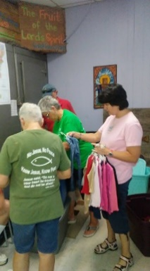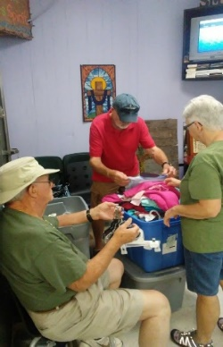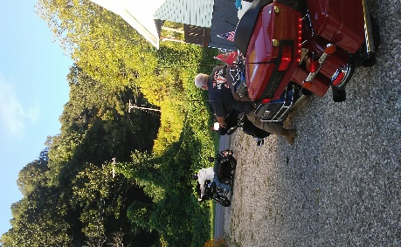
Trinity Riders
Cleveland, TN Faithful servants of God!
Now that the weather is cooler, there is the need to stock more long sleeve clothes each day. So, as God leads, come enjoy the mountains, hang up clothes, and love on the folks. Be sure to call ahead to reserve Agape House for overnight visits.

Missionary Teams on the 2019 Calendar:
October 6th - 11th Union BC, Griffin, GA
October 17th – 20th - Jamestown BC, Conway, SC
Open Dates are available; as God leads contact Freedom Center Ministries, Director
If your church/group is planning to come and serve with Freedom Center Ministries and you are not listed, please contact us. Thank you!
Agape House Lynch, KY is a place where missionaries stay when they GO/come to serve.
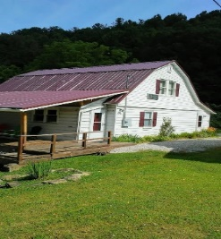

PRAISE OUR LORD FOR:
- Holy Spirit's presence in every detail of our lives and ministry
- Financial and physical needs that have been donated
- 497 friends served at FC...some attended Bible fellowship
- His faithfulness
- All our missionary teams
- Mission outreach
PRAY TO THE ALL SUFFICIENT ONE FOR:
- FCM folk's on prayer list- salvation, jobs, sickness, healing
- Missionary couple to assist with FC ministry year-round
- Ministers and missionary’s physical health
- Laborers
- Mercy on the local nursing home patients
- A changed mindset for folks
- Kentucky & US schoolteachers & children
- America and leaders
- Miner families that lost jobs
FCM SHOP NEEDS:
- Men's blue jeans and tennis shoes
- Men’s belts
- PLEASE NO WOMEN’S WINTER CLOTHES
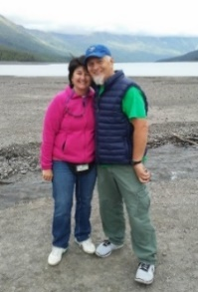
In the Vine, John 15 ... Servants for Christ!
George and Robin Lewis, Directors
Linda Alford, Co-Director
Freedom Center Ministries, Inc.
P O Box 794
Lynch, KY 40855
606-899-5804
A 501(c) (3) non-profit organization
Email georgelewis52@hotmail.com
www.freedomcenterministries.com

