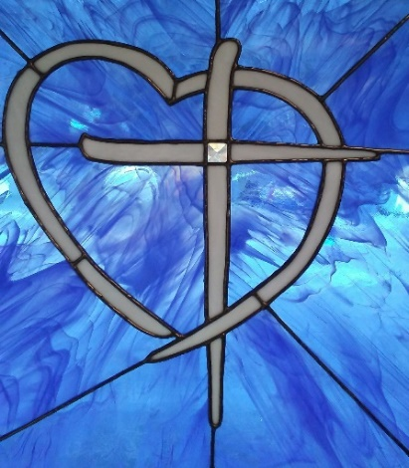

Jesus is the **LIGHT** John 8:12

**Freedom Center Ministries, Inc.**

July 2019 News

Greetings Family and Friends,

Summer is behind us and the school months are before us. Please pray for the children and families! Also, special thoughts and prayers for the coal miners!! Be safe and alert on the streets, your life is important to the Lord...Go share His love and serve Him...what a blessing it is.

Volunteer missionary said: We are ready to join our mission family and see what God has in store!! Praying for traveling mercies on all the mission teams headed out! Prepare our hearts, our minds, and our souls Lord that your will may be done!

These eight church mission teams served the Lord and shared His love with the local folks: Buck Creek BC, Longs, SC, Ben Avon BC, Spartanburg, SC, Wampee BC, Longs, SC, Indian Lake BC, Northport, AL, Longwood BC, Northport, AL, Memorial BC, Frankfort, KY, First Baptist, Russell, KY, Freedom BC, Salemburg, NC.

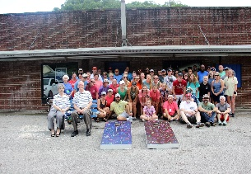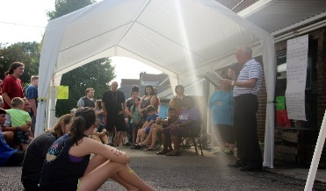

Kentucky Mission 2019 was fantastic... folks received Jesus!

It was a wonderful July Back to School Mission Week! We served 249 children and their parents with prayers, God’s word, free clothes, shoes, socks, underwear, haircuts, face painting, school supply stuff, food, and fun games! One dad sat at the picnic table and re-dedicated his life to God and his wife and son prayed to receive Jesus as Savior. We have 5 new brothers and sisters in Christ...2 children and 3 parents. Thanks to the 80 volunteer missionaries for coming to Eastern Kentucky to love on the folks and serve our Lord. Thanks and praise to the Holy Spirit for His faithfulness.painting, school supply stuff, and food! One dad redicated his life and his wife and son received Jesus. We have 5 new brothers and sisters in Christ...2 children and 3 parents. Thanks to the 80 volunteer missonaries for coming to Eastern Kentucky to serve the folks and our Lord. Thanks and praise to the Holy Spirit.... painting, school supply stuff, and food! One dad redicated his life and his wife and son received Jesus. We have 5 new brothers and sisters in Christ...2 children and 3 parents. Thanks to the 80 volunteer missonaries for coming to Eastern Kentucky to serve the folks and our Lord. Thanks and praise to the Holy Spirit....e painting, school supply stuff, and food! One dad redicated his life and his wife and son received Jesus. We have 5 new brothers and sisters in Christ...2 children and 3 parents. Thanks to the 80 volunteer missonaries for coming to Eastern Kentucky to serve the folks and our Lord. Thanks and praise to the Holy Spirit....

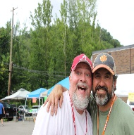 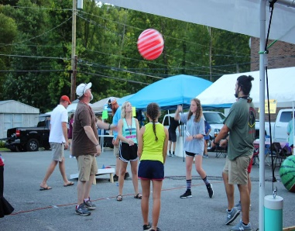 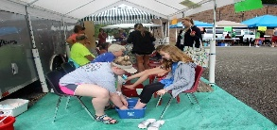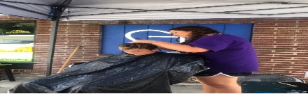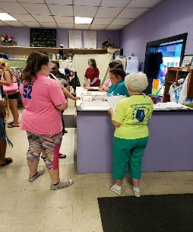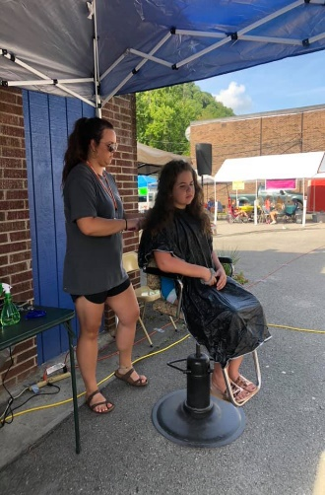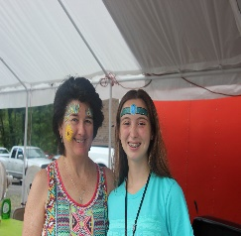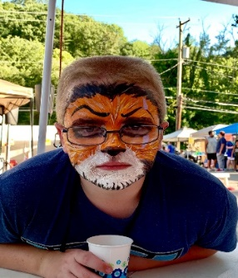 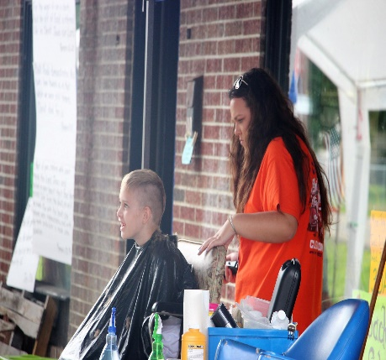

Another volunteer said: What an amazing week it has been. We got to love on so many sweet children and share Jesus with them. This is always my favorite week of the year and I always hate to leave. There are so many sad stories and my heart aches for these people. Please pray for them and that they will realize God is all they need and nothing else will fill the void they have but Him. So many lives were changed this week even the lives of those on the mission team. The Lord truly blessed us this week like He always does, and I am already counting down the days until next year. God is so good!

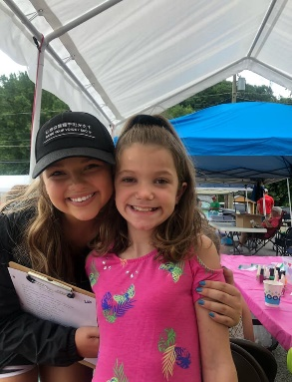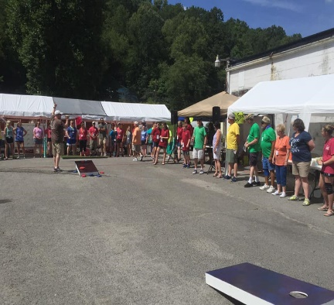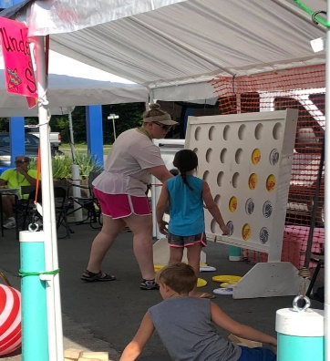

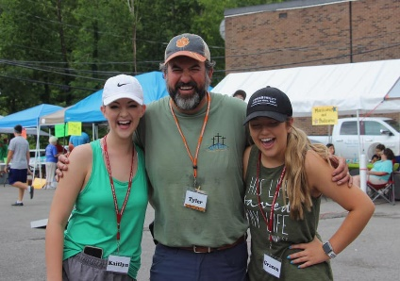 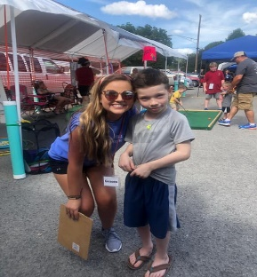 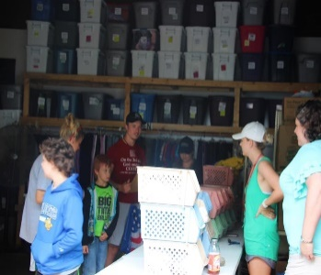 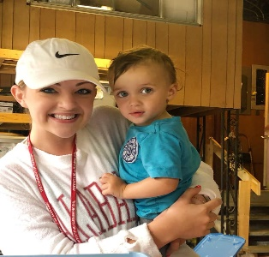 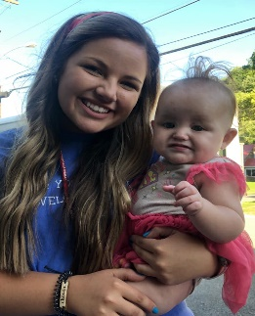 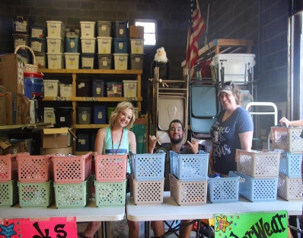 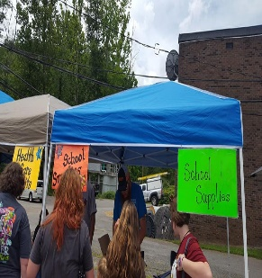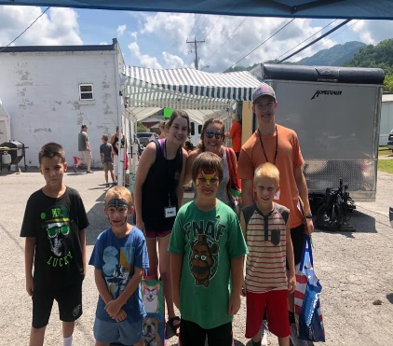 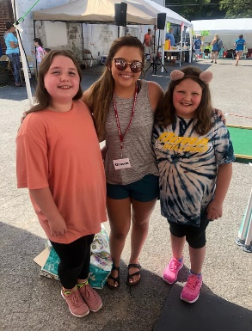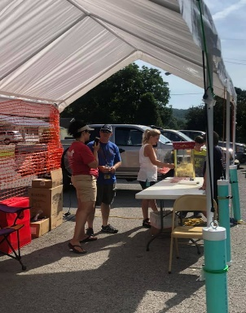 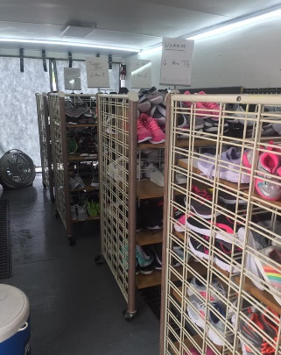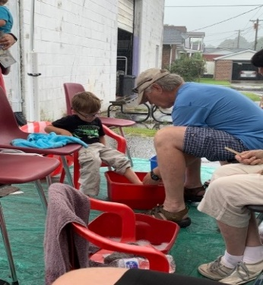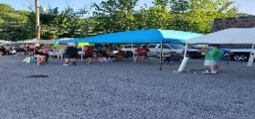

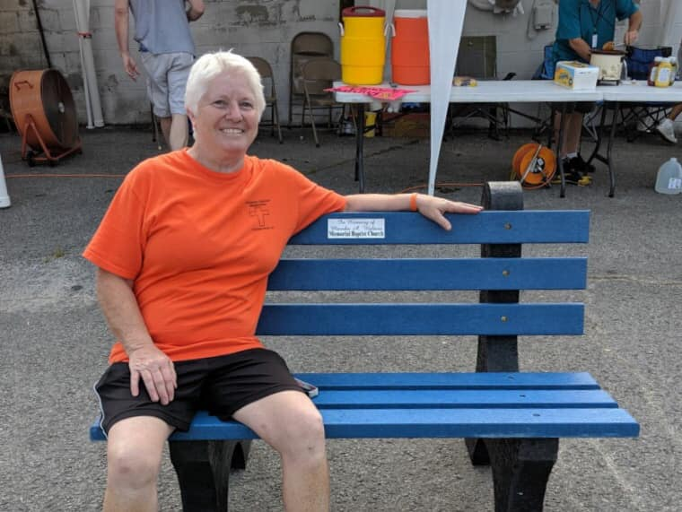

**One morning we were able to dedicate a bench that is in Memory of** [**Marsha Barker Walters**](https://www.facebook.com/marsha.barkerwalters?__tn__=%2CdK-R-R&eid=ARDf4bFKLKFjlXSgfOYv-aGvEYLqrRoIS5E3l0cD1kXq1JyIv6oFjnmHuM9MGCvn-9kOJQI62H5sM9Ux&fref=mentions)**. She always loved going to Lynch on our mission trips. The Freedom Center has her memory as a permanent resting place. I hope a bear stops by to visit her.**

Other volunteers went throughout the community: landscaped yards and picked up litter along the streets. While some volunteers helped a family build part of their house; which they lost by the fire, others served the folks at a nursing home and adult day center. You will never know how the Lord will guide you until you GO. One brother was chosen to give a bride away at a wedding...he was a visitor at the day center. The family member did not show up to do his part. So we must be ready when God’s calls!

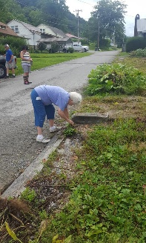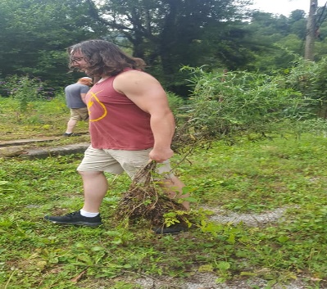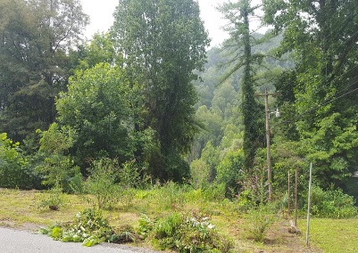 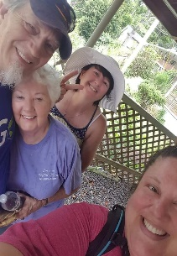

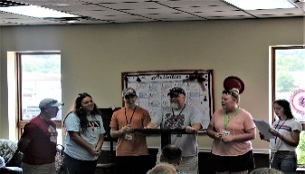 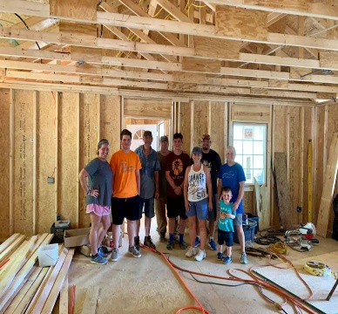 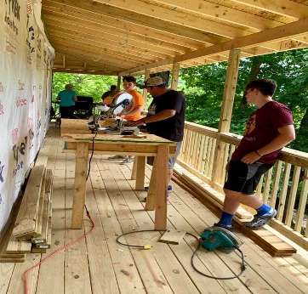The Mission Teams in our community loving on the people of this community... some they knew from previous visits, but in many cases, they loved on people they had never met before! They all drove hundreds of miles from their families, their homes, their jobs... everything familiar, and came here, filled with the Holy Spirit, an overwhelming amount of God’s love, and loaded with everything and anything they thought our community could use! WOW!!! They worked countless hours, in the heat and rain, and all the time... smiling and sharing The Mission Teams in our community loving on the people of this community... some they knew from previous visits, but in many cases, they loved on people they had never met before! They all drove hundreds of miles from their families, their homes, their jobs... everything familiar, and came here, filled with the Holy Spirit, an overwhelming amount of God’s love, and loaded with everything and anything they thought our community could use! WOW!!! They worked countless hours, in the heat and rain, and all the time... smiling and sharing God’s Love!

Later in the week, some of the volunteer missionaries drove to Topmost, Kentucky to share Jesus and give them clothes , shoes, and school love on some sweet precious kids at Beaver Creek Elementary School. This was a first for this mission team and we had so much fun being able to just spend some time and play with these kids. We also got to sightsee on the mountain and it was beautiful! God is so so good!!

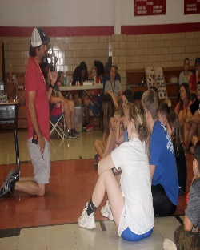

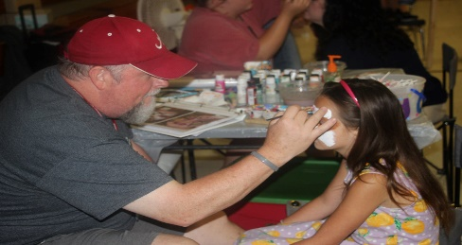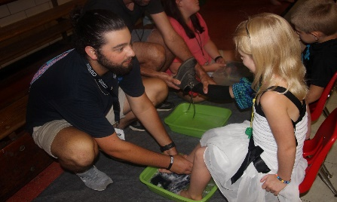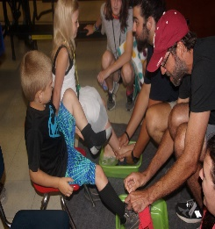

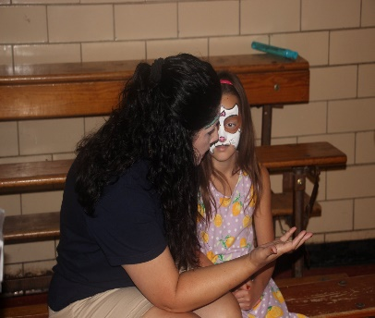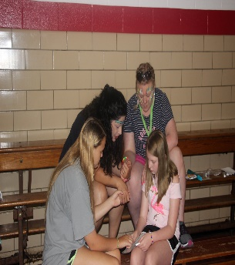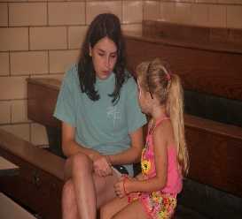

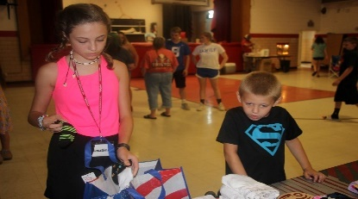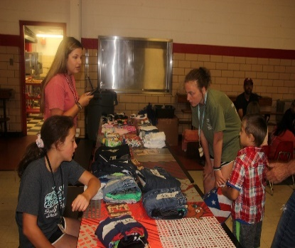

Out of an adjacent KY County, FBC Whitesburg, KY brought some young volunteer missionaries to Freedom Center to serve. After the Back to School mission week, we had a lot of preparation for the next week. These children along with the leaders helped in a huge way to organize several items in the warehouse.

The last week in July the faithful Union BC volunteers from Iva , SC served throughout the community and did some work on the Agape house. They blessed Lynch and Benham: painted park benches, fire station/town hall, some neighbor’s deck. The Agape house received a spigot, electrical outlet, carpentry work inside and out. They even had time to inspect and sort Freedom Center donations.

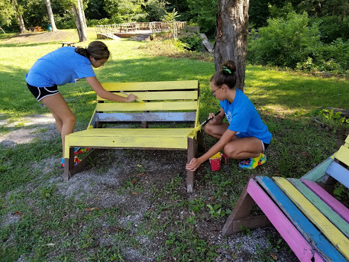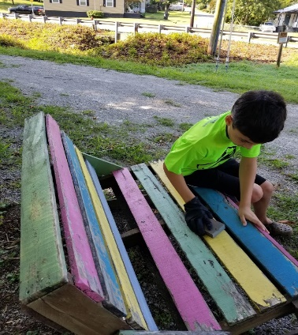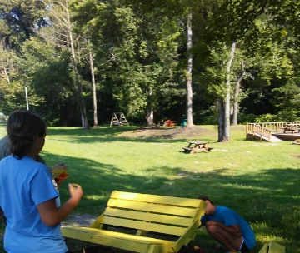

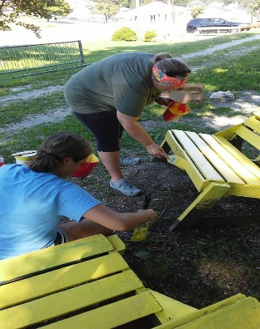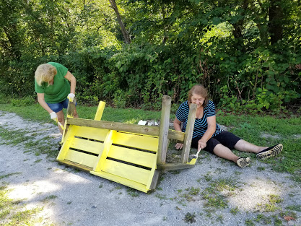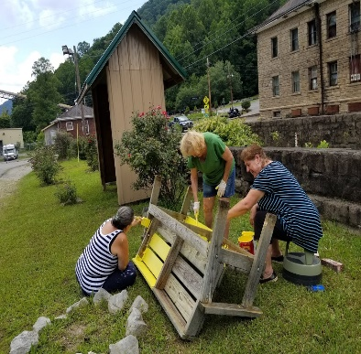

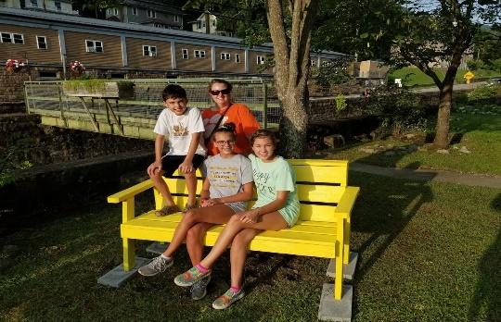

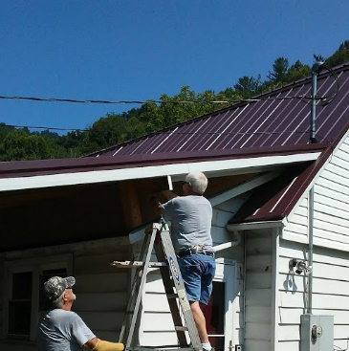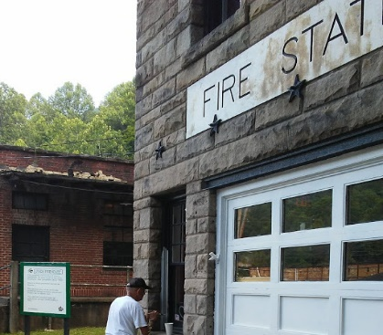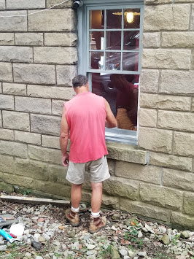The Mission Teams in our community loving on the people of this community... some they knew from previous visits, but in many cases, they loved on people they had never met before! They all drove hundreds of miles from their families, their homes, their jobs... everything familiar, and came here, filled with the Holy Spirit, an overwhelming amount of God’s love, and loaded with everything and anything they thought our community could use! WOW!!! They worked countless hours, in the heat and rain, and all the time... smiling and sharing God’s Love!   
Thank You to all who made that trip, and shared the love of Jesus Christ to our community... in so many ways... spiritually, emotionally, physically, and financially! 💙💙💙💙💙💙💙💙  
Until our paths cross again... God Bless You All !The Mission Teams in our community loving on the people of this community... some they knew from previous visits, but in many cases, they loved on people they had never met before! They all drove hundreds of miles from their families, their homes, their jobs... everything familiar, and came here, filled with the Holy Spirit, an overwhelming amount of God’s love, and loaded with everything and anything they thought our community could use! WOW!!! They worked countless hours, in the heat and rain, and all the time... smiling and sharing God’s Love!   
Thank You to all who made that trip, and shared the love of Jesus Christ to our community... in so many ways... spiritually, emotionally, physically, and financially! 💙💙💙💙💙💙💙💙  
Until our paths cross again... God Bless You All !

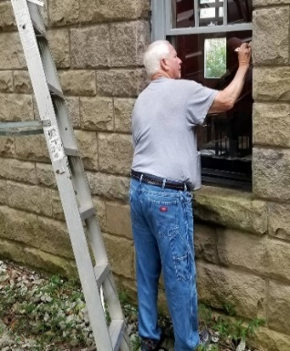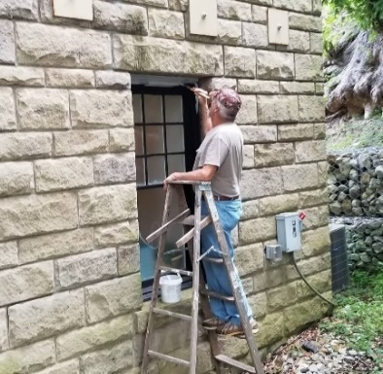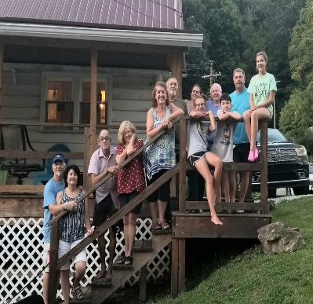

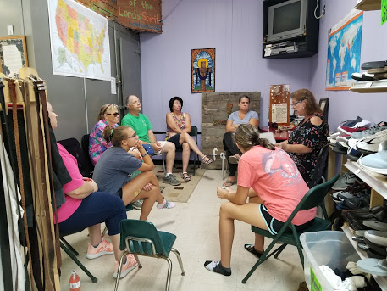 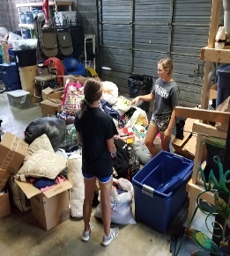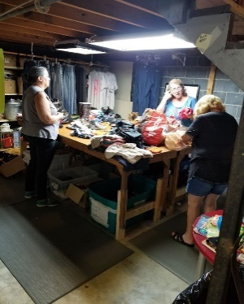 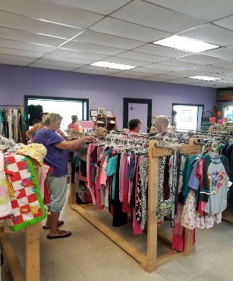

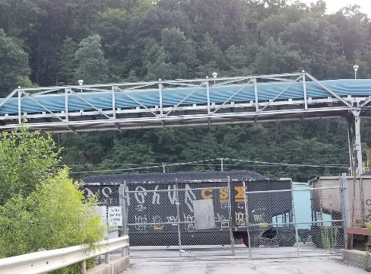

Harlan County coal mine closed the gates, no jobs-no pay. Please continue to pray with the coal miner families.

**Missionary Teams on the 2019 Calendar:**

October 6th - 11th Union BC, Griffin, GA

October 17th – 20th - Jamestown BC, Conway, SC

Open Dates are available; as God leads contact Freedom Center Ministries, Director

If your church/group is planning to come and serve with Freedom Center Ministries and you are not listed, please contact us. Thank you!

Agape House Lynch, KY is a place where missionaries stay when they GO/come to serve.

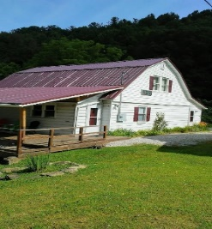

PRAISE OUR LORD FOR:

* Holy Spirit's presence in every detail of our lives and ministry
* Financial and physical needs that have been donated
* 554 friends served at FC...some attended Bible fellowship
* His faithfulness
* All our missionary teams
* Mission outreach in the Leatherwood and Baxter communities

PRAY TO THE ALL SUFFICIENT ONE FOR:

* FCM folk's on prayer list- salvation, jobs, sickness, healing
* Missionary couple to assist with FC ministry year-round
* Henry Hughes physical health
* Laborers
* Mercy on the local nursing home patients
* A changed mindset for folks
* Kentucky & US schoolteachers & children
* America and leaders
* Miner families that lost jobs

FCM SHOP NEEDS:

* Men's blue jeans and tennis shoes
* Summer clothes: baby, toddler, boys, and girls thru high school
* Queen and King size bed sheet sets
* Throw rugs
* Bath towels
* Women underwear size 5-10
* PLEASE NO WOMEN’S WINTER CLOTHES

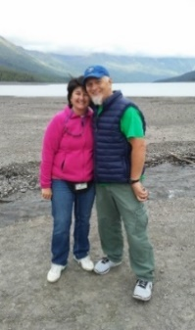

In the Vine, John 15 ... Servants for Christ!

George and Robin Lewis, Directors

Linda Alford, Co-Director   
Freedom Center Ministries, Inc.   
P O Box 794  
Lynch, KY 40855  
606-899-5804

A 501(c) (3) non-profit organization

**Email** [georgelewis52@hotmail.com](mailto:georgelewis52@hotmail.com)

www.freedomcenterministries.com

[](https://www.facebook.com/217088601664223/photos/1169665403073200/)