

Jesus is the **LIGHT** John 8:12

**Freedom Center Ministries, Inc.**

November-December 2019 News

Greetings Missionary Friends and Family,

In 2004, my family asked how long we would be in Kentucky. After mission tours in Africa, they knew I would be obedient and follow the Lord. Now, after 15 years in Kentucky other people have asked the same question. Our answer is still the same “we will stay here till God calls us somewhere else.” He called us here and we know we are in His will.

Henry Blackaby has stated that to experience God, we should find where He is at work and join Him there.

One week, we traveled up the mountain to visit a family where we found many physical needs...some could be met, and others could not be met. As God leads, come and share your skills and story to meet the physical and spiritual needs.

Another time Freedom Center Ministries assisted Connie with firewood and coal to heat her house. Her family has received assistance throughout the years. We have prayed and counseled with them in many life circumstances.

Brenda, a Christian lady came to FCM for family needs. Some items included pots and pans and gas for the car. Through prayer and counsel, we were able to get her and her family a safe location to stay.

Hope for Appalachia of VA, shared their Christmas winter project with students in about 30 schools. They also brought donations to FCM.

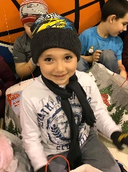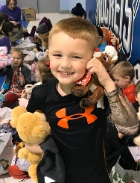

Remember the words of the Lord Jesus, it is more blessed to give than to receive. Acts 20:35

The Elsmere Baptist Church was committed to a mission project for the Appalachian area. They contacted the Freedom Center to inform that they would provide 100 Christmas backpacks to give to students.   
We delivered the backpacks on December 13th to Mountain View Elementary School in Leslie County, Kentucky. We talked with some of the students as they received Christmas and school supplies.  
The school staff was excited and appreciated the effort that was made to assist their students. It is a joy to give a blessing, we are grateful to have so many people come to serve with us and provide for the student and family.  
  
 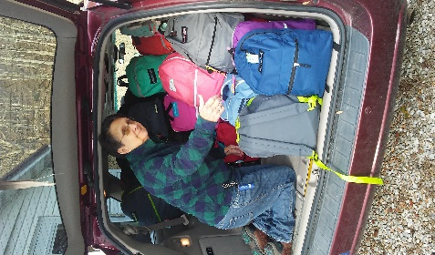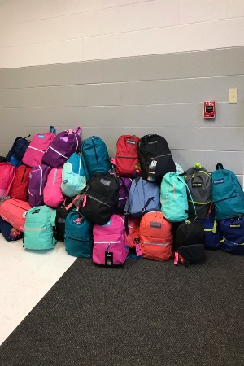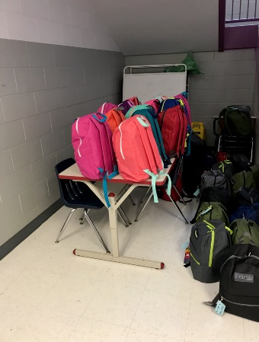

**NEW THIS YEAR 2020**

Below is a list of projects we want to do this year. Pray and match your team’s gifts with a project and call us to set a date.

Springtime (March, April, May)

Free haircuts, tennis camp, cornhole tournament w/food

Summer (June, July, August)

Free haircuts, cornhole tournament w/food, Public housing fun and food, movie night outside at FC

Fall (September, October, November)

Tennis camp, cornhole tournament w/food, winterize homes in the community, outdoor concert at FC

Winter (December)

Help with The Empty Stocking Project in the community

**The folks are not taking many houseware items, so we are only accepting coffee makers, pots, pans, and silverware. Thank you for your donations.**

Missionary Teams on the 2020 Calendar:

March 22nd - 26th FBC Salisbury, NC

May 4th - 8th Kershaw BA, Camden, SC

May 24th - 30th Riverland Hills BC, Irmo, SC

July 18th - 25th “Back to School Mission Week” - Buck Creek BC, Longs, SC

Open Dates are available; as God leads contact Freedom Center Ministries.

If your church/group is planning to come and serve with Freedom Center Ministries and you are not listed, please contact us. Thank you!

Agape House Lynch, KY is a place where missionaries stay when they GO/come to serve.

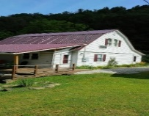

PRAISE OUR LORD FOR:

* Holy Spirit's faithfulness in every detail of ministry
* Financial and physical needs that have been donated
* 538 friends served at FC and Bible fellowship
* Faithful workers
* A new contact in Leslie County School
* Mission outreach in Leatherwood

PRAY TO THE ALL SUFFICIENT ONE FOR:

• FCM folk's on prayer list- salvation, jobs, healing

• Missionary couple for long term service with FC ministry

• Ministers and missionary’s physical health

• Mercy on the local nursing home patients

• A changed mindset for folks

• Kentucky & US schoolteachers & children

FCM SHOP NEEDS AT THIS TIME:

• Men's blue jeans and tennis shoes

* Summer clothes for all ages, all genders
* Reading glasses (strength 2.50-4.00)

• PLEASE NO WOMEN’S WINTER CLOTHES

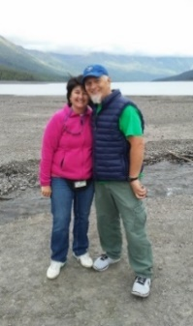

In the Vine, John 15 ... Servants for Christ!

George and Robin Lewis, Directors

Linda Alford, Co-Director   
**Freedom Center Ministries, Inc.**   
P O Box 794  
Lynch, KY 40855  
606-899-5804

A 501(c) (3) non-profit organization

**Email** [georgelewis52@hotmail.com](mailto:georgelewis52@hotmail.com)

www.freedomcenterministries.com

[](https://www.facebook.com/217088601664223/photos/1169665403073200/) 