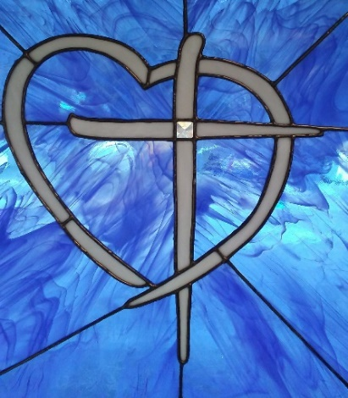

Greetings Family and Missionary Friends,

Thank ya'll for your prayers! It is a joy to share from Eastern Kentucky, where God has adorned the mountains with brilliant colors of red, yellow, and gold. We are blessed to be called to such a wondrous place.

The friends that we serve, say "we are thankful that you are here; I have clothed all my children at FC." One mother came in with four generations of girls, she said, I like FC and glad you all are here. Occasionally words of encouragement are nice to hear.

The folks are in a great need for basic winter supplies. They come in for help with heating oil, electric bills, beds, and other items. FCM can accommodate some, but all needs cannot be met. Through counsel, we have learned that some of the situations are one's choice, but some are not. There are many house fires throughout the year. We were able to assist a family that lost their home and everything by fire last month. Please pray for the Lord's wisdom as we serve His folks.

Our volunteer missionaries from Union BC, Griffin, GA did magnificent work on their first day... a great difference in the warehouse. We got all the summer bins up and the winter bins down off the shelves. The store racks got stocked with winter clothes just in time for cold weather. So thankful for the manpower that God provided through our brothers and sisters. We praise our Father for our Georgia missionary family. The ladies cleaned the entire warehouse and shop. While the men did some maintenance work on the mission house. We got a lot of items organized that God sent to meet physical needs. The Bible was shared in fellowship and needs were requested in prayer.

In preparation for their second October journey, Jamestown BC, Conway SC had a church-wide project to collect coats for the giveaway. They bought winter clothes and men's boots to stock the store. The folks brought the family and neighbors to coat giveaway! We were blessed with many smiles from the parents and grandparents. The children enjoyed picking out gloves and caps. The volunteers were blessed as they helped the families pick out the right coat. The (140) folks received coats, toboggans, and gloves. We all shared the love of Jesus with hugs, prayer, and laughter.

Missionary Teams on the 2019 Calendar:

November 6th - 9th Paducah BC, KY

In next month’s newsletter, we will share some projects for 2020.

Open Dates are available; as God leads contact Freedom Center Ministries, Director

If your church/group is planning to come and serve with Freedom Center Ministries and you are not listed, please contact us. Thank you!

Agape House Lynch, KY is a place where missionaries stay when they GO/come to serve.

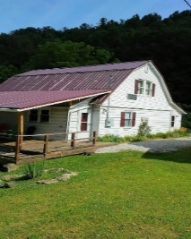

PRAISE OUR LORD FOR:

• Holy Spirit's faithfulness in every detail of ministry

• Financial and physical needs that have been donated

• 475 friends served at FC and Bible fellowship

• All our missionary teams

• Mission outreach

PRAY TO THE ALL SUFFICIENT ONE FOR:

• FCM folk's on prayer list- salvation, jobs, healing

• Missionary couple for long term service with FC ministry

• Ministers and missionary’s physical health

• Mercy on the local nursing home patients

• A changed mindset for folks

• Kentucky & US schoolteachers & children

FCM SHOP NEEDS:

• Men's blue jeans and tennis shoes

* Men's flannel shirts
* Summer clothes for all ages
* Bed blankets (please, no throws)

• Men’s belts

• PLEASE NO WOMEN’S WINTER CLOTHES

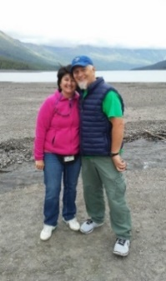

In the Vine, John 15 ... Servants for Christ!

George and Robin Lewis, Directors

Linda Alford, Co-Director   
Freedom Center Ministries, Inc.   
P O Box 794  
Lynch, KY 40855  
606-899-5804

A 501(c) (3) non-profit organization

**Email** [georgelewis52@hotmail.com](mailto:georgelewis52@hotmail.com)

www.freedomcenterministries.com

[](https://www.facebook.com/217088601664223/photos/1169665403073200/)