AI in Your Setting: A Task for Teachers



November 2025

Copyright - Koru Education Ltd.

An AI Workflow for Teachers: From Idea to Classroom
This workflow treats AI not as a replacement, but as a teaching assistant or a "co-pilot." You, the teacher, are always the expert in the room. This process ensures that AI enhances your professional judgment, rather than supplanting it.

The Workflow Diagram
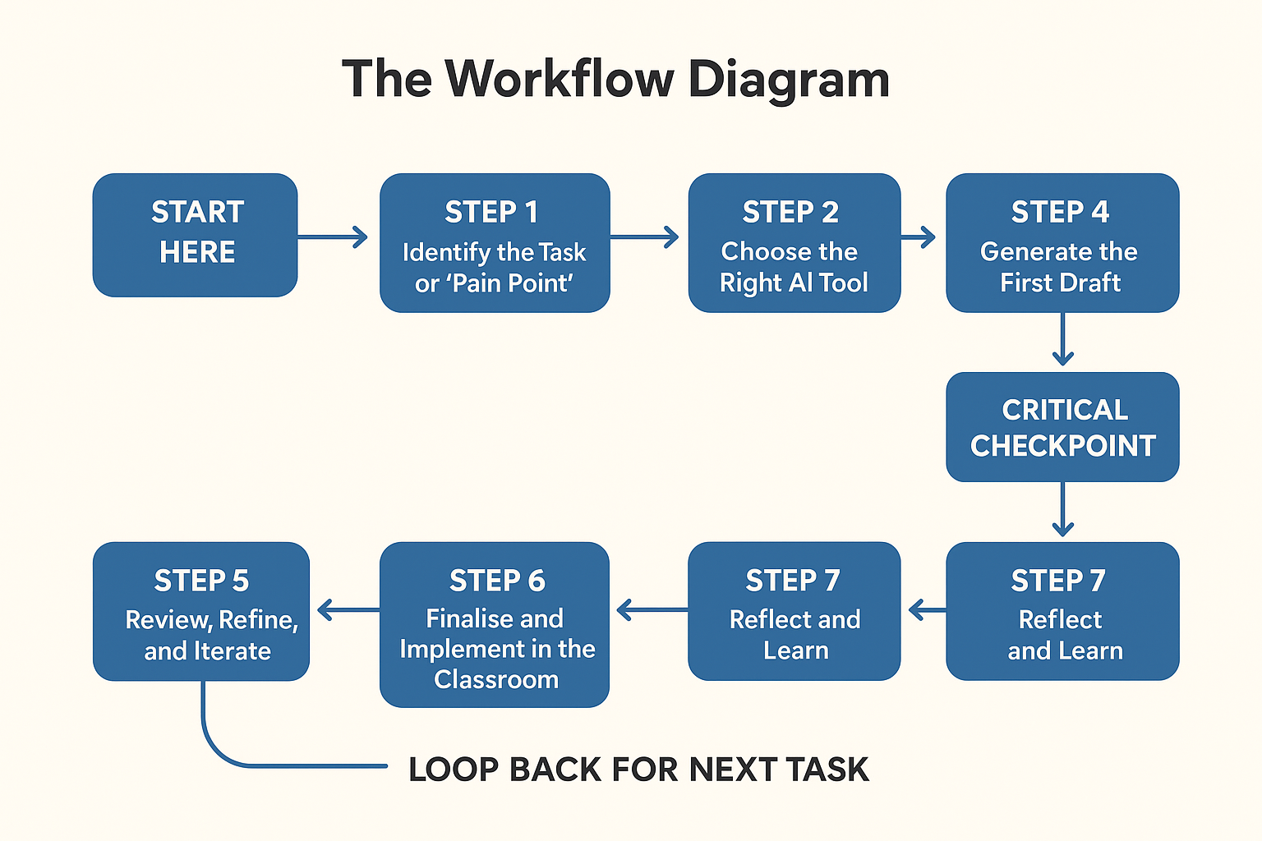

Detailed Breakdown of Each Step
Here is a more detailed explanation of what each step involves, with examples.

STEP 1: Identify the Task or "Pain Point"
- What it is: Before you even open an AI tool, pinpoint a specific, real-world task you need to accomplish. Start small and specific.
- Why it's important: AI works best when given a clear problem to solve. Vague goals lead to vague results.
- Example in action:
  - Instead of thinking: "I need help with my teaching."
  - Think: "I need to create a 10-question multiple-choice quiz on the Tudors for my Year 8 history class."
  - Or: "I have a great article on photosynthesis, but it's too complex for some of my Year 5 students. I need to simplify it."
What is the task or pain point?
Task or Pain Point (Teacher/Student/SLT?) | Comments

STEP 2: Choose the Right AI Tool
- What it is: Select a platform that is well-suited for your specific task. Not all AI tools are the same.
- Why it's important: Using a specialised tool can save you time and give you much better, more relevant results.
- Example in action:
  - For lesson planning & resource generation, a tool like MagicSchool.ai or Eduaide.ai is designed for teachers.
  - For differentiating text, a tool like Diffit is perfect.
  - For general brainstorming, drafting emails, or creating exemplars, a general-purpose tool like Google Gemini or ChatGPT is excellent.
Platform or Solution | Why?

STEP 3: Craft a Clear Prompt
- What it is: This is the instruction you give the AI. The quality of your prompt directly impacts the quality of the output.
- Why it's important: This is how you control the AI. Being specific about role, format, audience, and topic is key.
- Example in action (for creating a quiz):
  - Weak prompt: "Make a quiz on the Tudors."
  - Strong prompt: "Act as a Year 8 history teacher. Create a 10-question multiple-choice quiz about the Tudor monarchs, from Henry VII to Elizabeth I. The questions should test students' knowledge of key dates, events, and individuals. Ensure there are four answer options for each question, with plausible distractors. Provide a separate answer key at the end."
Prompt | Desired outcome

STEP 4: Generate the First Draft
- What it is: Run your prompt and let the AI produce its initial response.
- Why it's important: Think of this as a starting point, not a finished product. It's a lump of clay for you to mould.
- Example in action: The AI generates the 10-question quiz. You might notice one question is too easy, and another's wording is a bit confusing. This is completely normal.
Rate the outcome:
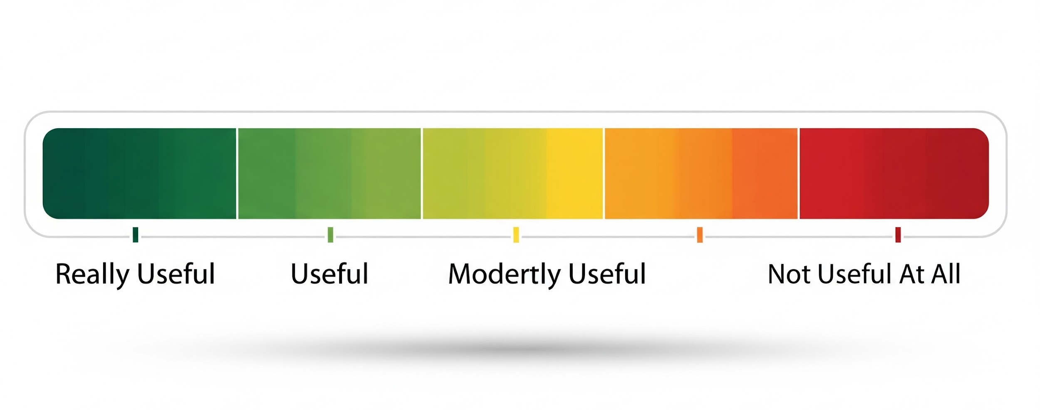

STEP 5: Review, Refine, and Iterate (The "Human-in-the-Loop")
- What it is: This is the most important step. You must now apply your professional expertise. NEVER copy and paste AI content directly into your classroom without review.
- Why it's important: AI can make factual errors ("hallucinate"), exhibit hidden biases, or produce content that isn't pedagogically sound for your specific students. You are the expert who catches these issues.
- Review Checklist - See below.
- Review and update
Review Checklist:
  - Accuracy: Are the facts correct? (e.g., Does the quiz have the right dates?)
  - Relevance: Is this aligned with my curriculum and learning objectives?
  - Appropriateness: Is the tone and complexity right for my students?
  - Bias: Is the content fair, inclusive, and balanced?
Refine and Iterate: Edit the text directly or ask the AI to make changes.
Example prompt for iteration: "That's a good start. For question 5, make the distractors more challenging. For question 8, rephrase it to be clearer for a 12-year-old. Replace question 3 with a new question about the Spanish Armada."
Updated Prompt:

STEP 6: Finalise and Implement in the Classroom
- What it is: Once you have reviewed and edited the AI-generated draft into a high-quality resource, it's ready to be used.
- Why it's important: This is where the AI's efficiency pays off, allowing you to use a polished, well-suited resource with your students.
- Example in action: You print the refined Tudor quiz and use it as a starter activity in your lesson.
Are you happy to use this with:
- Students
- Teachers/Colleagues
- Line Manager
- Parents

If not - why not?

STEP 7: Reflect and Learn
- What it is: After the lesson, briefly reflect on how the resource worked in practice.
- Why it's important: This closes the loop and improves your AI skills for the next time. Reflection is a core part of a teacher's professional practice.
- Reflection Questions:
  - How did the students respond to the resource?
  - Did it help them achieve the learning objective?
  - What worked well about the AI generation process?
  - What would I do differently next time I use AI for a similar task?
- Example in action: You realise the multiple-choice format worked well, but next time you will ask the AI to include two short-answer questions to encourage deeper thinking. This insight informs your next "Task" (Step 1).
What went well? | Even better if..?

What will you do next?

What | When | Why
Create free Napkin AI account | End of November | To improve my graphics

