Halito!

Our names are Wak Ofi and Ofi Tohbi! What is your name?

Write your name here_________________________________

Wak Ofi means Cow Dog in the Choctaw Language. (Wak rhymes with Rock. Say Ofi like this - Oh Fee.)

Ofi Tohbi means White Dog in the Chickasaw Language. (Say Ofi like this - Oh Fee. Say Tohbi like this - Toe be.)

Do you know where the word Oklahoma comes from?
There are two Choctaw words that go together and make the word Oklahoma.

The two words are Okla and Homma.
Okla means people. Homma means red.
Color our pictures. Which one of us do you think has white fur?

*Halito means Hello in the Choctaw language. Say hah-lee-toe
Copyright Dana Mowdy Spencer & Carol Mowdy Bond
Chahta I Tek Tuklo - Two Choctaw Sisters

May be used for personal at-home, family use without permission. Permission must be requested for classroom or other use. www. TwoChoctawSisters.com
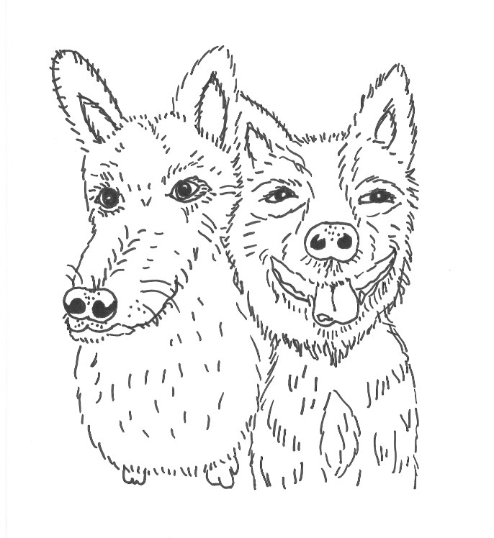
Ofi Tohbi Wak Ofi

