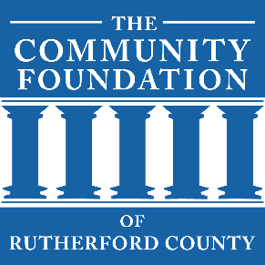
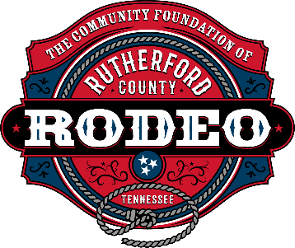

SPONSORSHIP AGREEMENT

4th Annual CFRC Rodeo

March 6 & 7, 2026

The Community Foundation of Rutherford County

I wish to purchase the following Sponsorship valued at: Choose an item.

All sponsorship packages are subject to approval and are available on a first come, first served basis. Every attempt will be made to accommodate or customize your preferred sponsorship.

This document is editable. The cells will expand to fit what you type.

SPONSOR information
Company or Individual: Choose an item. |  | Date: Click or tap to enter a date.
Name: Click or tap here to enter text. |  | Contact (Decision Maker): Click or tap here to enter text.
Address: Click or tap here to enter text. | City/State: Click or tap here to enter text. |  |  | Zip: Click or tap here to enter text.
Business Phone: Click or tap here to enter text. |  | Contact (Mobile Phone): Click or tap here to enter text.
Contact Email Address: Click or tap here to enter text. |  |  | Paying by: ☐ Check ☐ Online (See Below)*
Board Member / Rodeo Representative: Choose an item.

Signature of sponsor
Signature of Sponsor (Type Name): Click or tap here to enter text.
Title: Click or tap here to enter text.
NOTE – Save File and Email completed Sponsorship Agreement to: info@cfrutherford.org
If paying by check, please make check payable to CFRC and mail to:
CFRC
1784 W. Northfield Blvd., #383
Murfreesboro, TN 37129-1702
*If paying online, payment instructions will be emailed to you after the submission of this form.
Please send company logo(s) to info@cfrutherford.org. The following file types are preferred:
Vector (EPS, AI, SVG) files for banners & programs. For other applications, PNG or PDF will suffice.
It is our full intention to comply with your branding standards and guidelines.
Your CFRC Board of Directors Sincerely Appreciates Your Support

