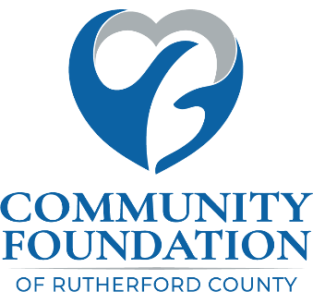
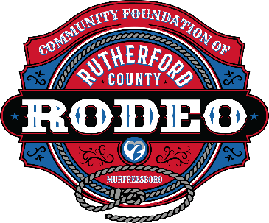

SPONSORSHIP AGREEMENT

4th Annual CFRC Rodeo

March 6 & 7, 2026

I agree to purchase the following Sponsorship: Choose an item.

All sponsorship packages are subject to approval and are available on a first come, first served basis. Every attempt will be made to accommodate or customize your preferred sponsorship.

his document is editable. The cells will expand to fit what you type.

SPONSOR information
Company or Individual: Choose an item. |  | Date: Click or tap to enter a date.
Name: Click or tap here to enter text. |  | Contact (Decision Maker): Click or tap here to enter text.
Address: Click or tap here to enter text. | City/State: Click or tap here to enter text. |  |  | Zip: Click or tap here to enter text.
Business Phone: Click or tap here to enter text. |  | Contact (Mobile Phone): Click or tap here to enter text.
Contact Email Address: Click or tap here to enter text. |  |  | Paying by: ☐ Check ☐ ACH ☐ Online (See Below)*
Board Member / Rodeo Representative: Choose an item.

Signature of sponsor
Signature of Sponsor (Type Name): Click or tap here to enter text.
Title: Click or tap here to enter text.
NOTE – Save File and Email completed Sponsorship Agreement to: info@cfrutherford.org

If paying by check, please make check payable to CFRC and mail to:
CFRC
Attention: KG Rollins
1784 W. Northfield Blvd., #383
Murfreesboro, TN 37129-1702
*To pay by ACH or Credit Card, please visit — https://cfrutherford.org/payment-options

Please send company logo(s) to info@cfrutherford.org. The following file types are preferred:
Vector (.Ai, .eps, .svg, .pdf) files for programs. For other applications, a PNG (300 dpi) will suffice.
It is our full intention to comply with your branding standards and guidelines.

Your CFRC Board of Directors Sincerely Thanks You for Your Support

