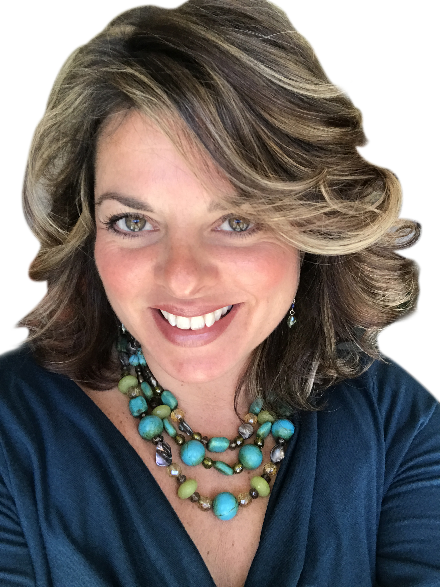
"Annelies brings you back to the human experience.”
~ S. G. Wake County Government
BIO
Annelies Gentile, MA, ACC helps professionals navigate change. As an integrative life and leadership coach, she also acts as consultant, facilitator, speaker, and trusted guide for leaders, entrepreneurs, and executives ranging from Fortune 500 companies to fields of government, healthcare, law, education, non-profits, arts, tech, science and sales. Annelies’ approach is both interesting and inspiring. You won’t often find her in front a powerpoint slide (very much) but you will find her facilitating catalyzing workshops, restful retreats and thought-provoking keynote presentations exploring core essentials that range from resiliency to communication skills to empathy and leadership to mindfulness and creativity. She also coaches individuals, groups, and teams to better nourish their integrity and fuel personal and professional visions.

Although she’s rich in credentials, Annelies’ notes her real secret to success—is compassion. She’s traversed twenty-two countries and forty-nine U.S. states, confirming her philosophy that most people want and need the same three things: to be heard, to feel safe, and to have a sense of belonging. How we all get there is what tears us apart, triggering conflict and additional chaos. Through a presence-based approach, Annelies reminds us of what’s important.
Her education includes a master’s degree in coaching (Maryland University of Integrative Health), and additional graduate studies in creativity, conflict transformation, and peacebuilding (European Graduate School in Switzerland), and transformative leadership (Tai Sophia Institute). She is also professionally accredited with ICF (International Coaching Federation). Annelies is also a published author. Annelies lives in Raleigh with her family and sweetheart Greg Whitt of Drum for Change. Learn more at www.conduitforchange.com

CLIENT LIST INCLUDES...
• Wake Forest Baptist Medical Center, Rex Hospital, UNC-Healthcare
• City of Raleigh Government, Wake County Government, Wake Forest Chamber of Commerce
• North Carolina State University, Wake County Public Schools, Caldwell Fellows
• Legal Aid, United States Center for Refugees and Immigrants
• IBM and Bank of America
EDUCATION
• Master’s degree in coaching (Maryland University of Integrative Health)
• Graduate studies in conflict transformation/peacebuilding (European Graduate School in Switzerland)
• Transformative leadership (Tai Sophia Institute)
• Professionally accredited with ICF (International Coaching Federation)
BOOK
• From Chaos to Calm :: Leading Change From the Inside Out
- http://www.conduitforchange.com/conduitforchange.com/NEW_Book.html

