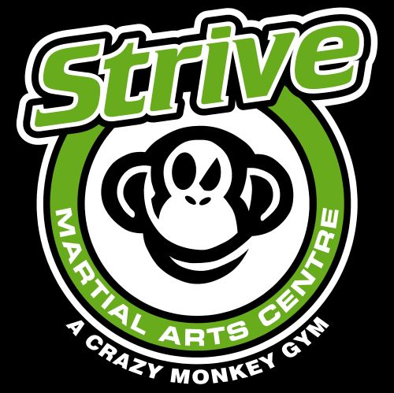 STRIVE JUNIOR WAIVER

I, the Student, and/or, we, the Parent(s)/Guardian(s) of a minor (hereafter, I/We), who is a Student, UNDERSTAND, and AGREE to abide by, all of the following:
- I/We understand that certain dangers exist in the type of training, which is offered by Strive Martial Arts Centre. These dangers extend to all types of PHYSICAL and mental harm or injury. Those among those dangers (but not limited to) are Death, Dismemberment, Paralysis, Loss of Function or Faculty, and Permanent or Temporary injury to various parts of the body.

- I/We understand that participation of any type, by the Student, is voluntary. That participation is not a requirement of either enrollment or continued affiliation with STRIVE MARTIAL ARTS CENTRE. It is also understood that Strive prohibits participation, by any Student, in any activity that is deemed to be unsafe (as determined by either, Student, Parent/Guardian, or Instructor).

- I/We assume and accept sole RESPONSIBILITY for any and all types of physical and mental harm (described as dangers in Paragraph 1 above) that may happen to me (the Student), or that I (the Student) may inflict upon some other person. I/We also assume and accept sole responsibility for any or all loss/damage to any property, which occurs as a result of my (the Student) actions.

- I/We agree to release from all liability (including negligence) and to waive all rights to civil litigation or suit against, any, and/or, all of the following: Strive Martial Arts Centre, its' owners and staff, lessee(s), sub-lessee(s), their businesses and owners/staff, and/or the owner(s) of any property, place, or location which is used in whole, or in part, as a place of business by the Strive Martial Arts Centre.

- I/We agree that any video/photographs, or the like can be used for advertising, promotion and/or any other reason without the permission of those in the graphic and the use of such material doesn’t entitle anyone to compensation for its’ use.

- I/We agree for my child to take part in sparring.
PARENT/GUARDIAN NAME: ________________________________
SIGNATURE: ____________________________
DATE: ____________

- I/We also agree to the following:
I have received and read a copy of Strive Martial Arts Centre’s sparring information
INITIAL: _______________
I will not use the martial arts techniques that I learn, to injure another person, except in self - defense, or to prevent grievous injury to another.
INITIAL: ________________

I/We, by Signature(s) below, attest that I/We have read and fully understand this WAIVER of Liability, and I/We sign freely, without coercion, and I/We agree to abide by all that it states.
PARENT/GUARDIAN NAME:______________________
SIGNATURE: __________________
DATE: ___________________

