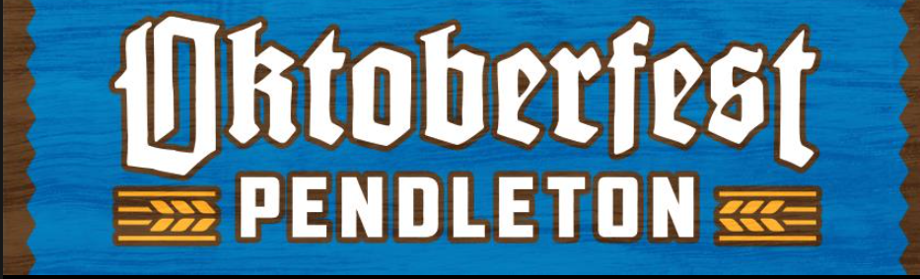

SATURDAY, OCTOBER 11th 2025
2:00-9:00 p.m.

COMMERCIAL EXHIBITOR/VENDOR/FOOD CONCESSION CONTRACT

Concessions Offered: _______ Food Concession _______ Commercial Space

Applicant’s Business Name: _________________________________________________________________
Address: ___________________________________ City: _________________________ State: __________
Cellphone: ______________________________________________________________________________
Email: ___________________________________________________________________________________
Name of person authorized to sign contract: ____________________________________________________

Size of Tent/Trailer: __________________
Volts: _____________________ Amps: ____________________ Water: __________
Products: ________________________________________________________________________________

Vendor fee (DUE August 15): $150 or $100 non-profit. Fees are due before setup is allowed.

This contract is accepted upon conditions that the business as stated above is to be conducted in accordance with the Oktoberfest Pendleton Rules and Information. It is agreed that the purchaser/vendor will hold Oktoberfest Pendleton harmless by reason of any claims given rise to anyone patronizing the Concession’s business, and the Concession does hereby release, relieve and discharge Oktoberfest Pendleton from any claims. Oktoberfest Pendleton assumes no responsibility for damaged, missing, stolen or weather-related events.
I (please print) ________________________________, as Agent for the Concession, accept this contract and agree to lease the assigned space at Oktoberfest Pendleton for the above stated date and agree to the conditions set by this contract.

Signed: _______________________________________, Date: _____________________________________
Please Complete and return lease along with fee by August 15th to:
Oktoberfest Pendleton, PO Box 1624, Pendleton Oregon 97801.

