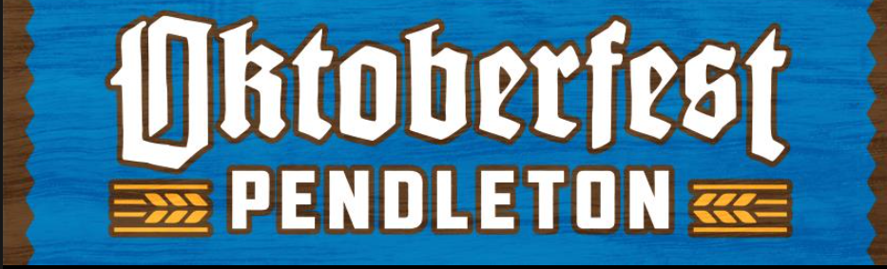

SATURDAY, OCTOBER 11th 2025, 2-9 p.m.

COMMERCIAL EXHIBITOR/VENDOR/FOOD CONCESSION APPLICATION
This application is NOT an offer of space. Please do not send money at this time! Your application must first be approved by our Oktoberfest Pendleton Vendor and Concessions Committee. Upon approval, you will be notified and a contract offer will be extended to you. Once you receive written notification of approval and your contract, please complete it and mail it back with your payment. Applications are due by July 31st.

Type of Space Applying for: _______ Food Concession _______ Commercial Space

Applicant’s Business Name: _________________________________________________________________
Address: ___________________________________ City: _________________________ State: __________
Cellphone: ______________________________________________________________________________
Email: ___________________________________________________________________________________
Name of person authorized to sign contract: ____________________________________________________

If you will not be in charge of your booth, please indicate name, address and telephone number of the person will be operating your booth: ___________________________________________________________________________________________________________

___________________________________________________________________________________________________________

If you are a non-profit and have a 501c(3) please include that number: _______________________________

____________ Food Concessions, non-profit $100
____________ Food Concessions, profit $150
____________ Commercial Vendor, profit $75

Tent: ________ Tent Dimensions: ____________ Trailer Size of unit (incl. tongue and hitch): _____________

Electrical Needs (Please check all that is needed – you must supply your own extension cords)
_______ 110-volt _______ 220-volt

Do you need access to a water faucet? ________

If you are applying for a Commercial Space, list all products you want to display or sell during Oktoberfest Pendleton. Include photographs or brochures of products.
__________________________________________________________________________________________________________________________________________________________________________________

If you are a new applicant, please send photographs of your booth set-up/food unit and Plug-in needed. Photographs will not be returned – those can be mailed or emailed to Oktoberfestpendleton@gmail.com. Please note, this event is sponsored by Hill Meat Company, therefore we are requesting you use their pork products whenever applicable.

Oktoberfest Pendleton reserves the right to withhold approval on the basis that the proposed activity would not be in harmony with, or in the best interest of promoting and representing Oktoberfest Pendleton. By signing below, you are also swearing that all information provided in this application is correct and that you have read the enclosed Commercial Vendor/Concession Rules, and in consideration of being allowed to participate in Oktoberfest Pendleton, agree to abide by all such rules.

Signature _____________________________________________ Date: __________________

Please return this application to:
Oktoberfest Pendleton, PO Box 1624, Pendleton, OR 97801
Or Email Oktoberfestpendleton@gmail.com

