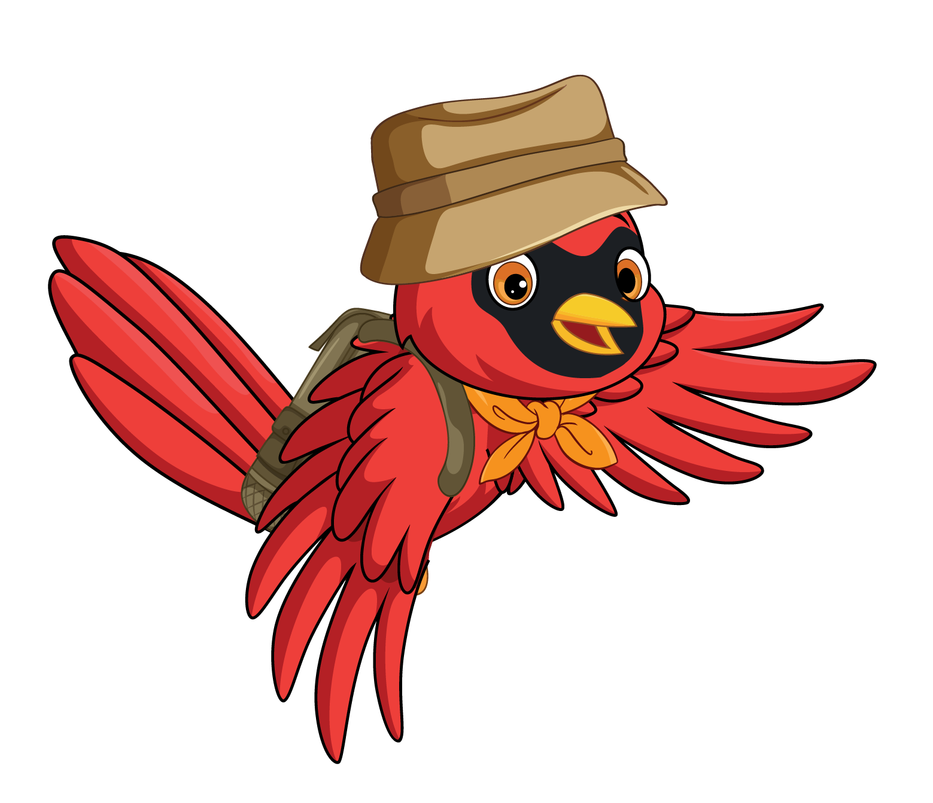

| M | A | R | S | H | M | A | L | L | O | W | D | O | S | F |
| --- | --- | --- | --- | --- | --- | --- | --- | --- | --- | --- | --- | --- | --- | --- |
| A | C | K | C | N | Q | R | Q | M | E | A | B | A | L | D |
| P | L | C | K | S | P | I | D | E | R | R | U | K | X | K |
| L | X | C | P | M | Z | B | H | Y | L | B | D | T | P | L |
| E | G | A | C | O | V | H | I | J | E | L | M | W | I | J |
| W | J | M | G | R | T | A | K | A | R | E | U | B | N | M |
| K | W | P | H | E | B | I | E | P | F | R | I | V | E | R |
| P | Z | F | K | S | B | P | A | I | Q | W | D | L | A | H |
| M | G | I | U | H | O | F | F | E | V | O | A | E | F | C |
| J | T | R | A | I | L | R | N | T | N | O | T | U | I | A |
| S | E | E | V | I | O | N | C | R | Y | D | E | M | R | N |
| T | S | D | T | O | R | C | H | E | X | S | I | N | E | O |
| A | Z | T | E | N | T | J | R | E | G | Z | T | V | F | E |
| R | O | I | Y | D | S | H | Y | Q | O | F | O | S | L | X |
| S | L | E | E | P | I | N | G | B | A | G | M | W | Y | G |

MARSHMALLOW WARBLER WOODS HIKE

CAMPFIRE TRAIL FIREFLY

SLEEPING BAG RIVER TENT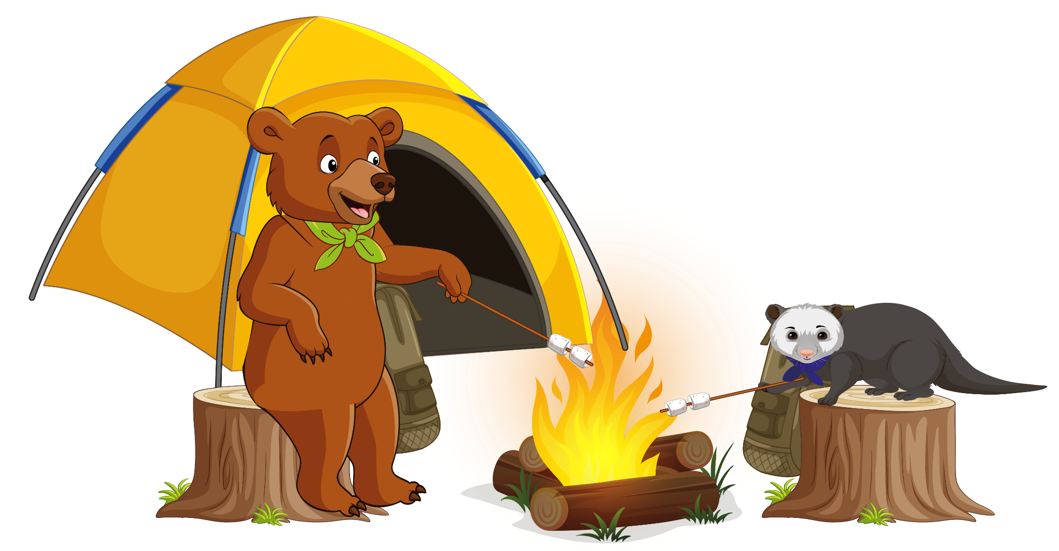

SMORES TREE PINE

MAPLE ELM OAK

STARS SPIDER CANOE