The 32nd Annual Lexington Sister Cities Young Artists Showcase
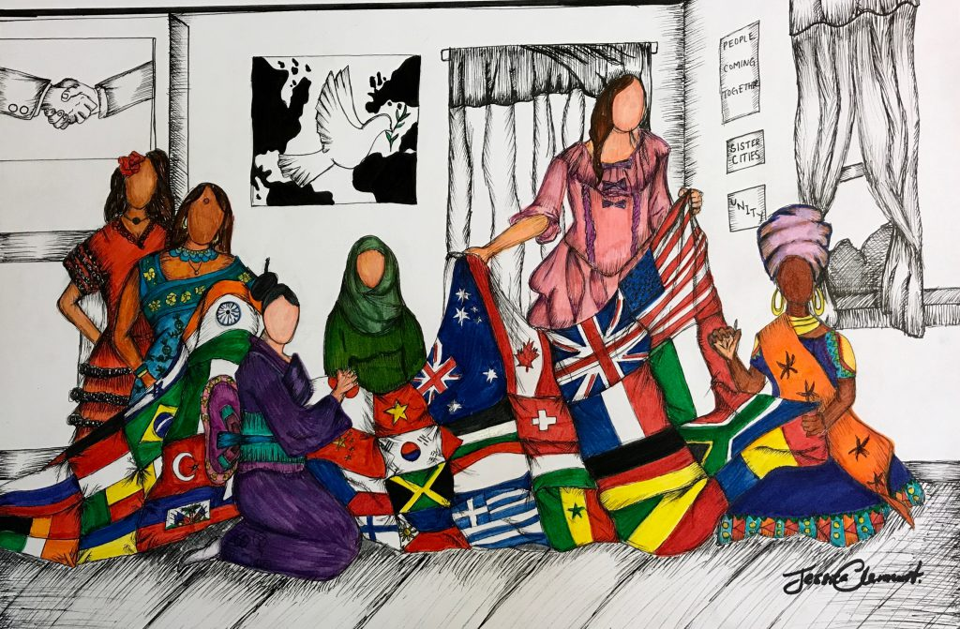
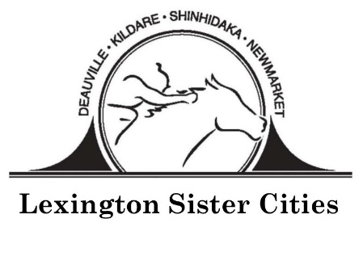
2020 Theme: “One World: Out of Many, We are One”

www.lexingtonsistercities.org
Facebook: www.facebook.com/lexingtonsistercities
Instagram: @lexingtonsistercities
The 32nd Annual Young Artists Showcase
“One World: Out of Many, We are One”

Submission Guidelines
DEADLINE: March 12th, 2020

Theme:
Sister Cities programs throughout the world each maintain the goal to promote peace through mutual respect, understanding, and cooperation – one individual, one community at a time.

This year’s theme asks students to explore these questions by highlighting citizen diplomacy and the creative ways that we create peace though people-to-people interaction.
- How can internationally engaged future leaders help communities address global challenges of – social unity and peace – in the 21st century?
- How does international experience affect an individual or community’s ability to adapt?
- What are some examples/illustrations of coming together and celebrating our humanity?

Students are encouraged to draw inspiration from their experiences with Sister Cities, travel, exchange, international friendships, and the many ways that people cultivate relationships across cultures.

Medium & Specifications:
- Only two dimensional (2D), unframed artwork.
- All media, except photography, accepted. (See information on Annual Photography Challenge on the Lexington Sister Cities website.)
- Dimensions of the art and matting must not exceed 24 in. x 36 in or 61 cm. x 91.5 cm.
- Use of copyrighted or trademarked images is prohibited.
- Entries must not be plagiarized, stolen, or copied from any other source. Entries must not defame or invade the rights of any person, living or dead.
- All entries must be supported by matting if applicable.

Entries:
Each participating student artist must be between 13 and 18 years of age by April 1st, 2020. All entries must be the original design and artwork of the entrant. Only new pieces inspired by the theme should be submitted. Art work will be on exhibit at the Central Bank Gallery from March 20th – May 1st, 2020.

Students must submit their artworks to their art teachers by Thursday, March 5th or to Lauren Michul at Central Bank by Thursday, March 12th. Address: 300 W. Vine Street, Lexington, KY 40507.

Judging:
A panel will judge entries on the basis of originality, composition, and theme interpretation. Artist’s name, title, description of work and name of school are kept confidential until judging has been completed. The judges’ decision will be final.

Awards:
Local Competition: First, second, and third places will be chosen and cash prizes will be awarded by Central Bank to the students. 1st place will receive $250, 2nd place - $150, and third place - $100.
International Competition: The winning student’s artwork will be submitted to the worldwide Sister Cities International competition. From the ten finalist entries (5 from the U.S. and 5 international) one U.S. artist and one artist from abroad will be selected as overall winners. The two overall winners will each receive $1000.

Young Artists Showcase Entry Form
Deadline: March 12th, 2020

Please print clearly and enclose this form with the artwork
“Global Citizens: Resilient Communities.”
Name: ____________________________________________________________________________________
Birth Date: __________________________ Phone: ________________________________________________
Home Address: _____________________________________________________________________________
City: ____________________________________ State: ______________________ Zip: _________________
Email: ____________________________________________________________________________________
School: ___________________________________________________________________________________
Parent Names: _____________________________________ Parent Email: ____________________________
Art Teacher: _______________________________________________________________________________
Describe Entry (size, medium, etc.): ____________________________________________________________
__________________________________________________________________________________________
Title of Work: _____________________________________________________________________________
What inspired you to create this work? __________________________________________________________________________________________
________________________________________________________________________________________________________________________________________________________________________________________________________________________________________________________________________________________________________________________________________________________________________

All showcase entries become the artistic property of Lexington Sister Cities and Sister Cities International. Although the artist retains his/her copyright for other uses, Lexington Sister Cities and Sister Cities International will retain perpetual, non-exclusive rights to use submitted artwork in any future publication, promotional material and/or online service with no compensation other than credit with the artist’s name and community. Lexington Sister Cities and Sister Cities International reserves the right to free reproduction and exhibition of all submissions. Lexington Sister Cities and Sister Cities International take no responsibility and will not compensate for any lost or damaged artwork. All fees associated with the showcase become the property of Lexington Sister Cities and Sister Cites International and will not be returned.

By submitting the entry, we agree to give Lexington Sister Cities and Sister Cities International, its members and affiliates, permission to publish and display the submitted entry at public exhibits, online, in publications and/or promotional materials, at the discretion of Lexington Sister Cities and Sister Cities International. We agree to abide by all the rules and terms of the showcase and agree to waive all claims of any kind against the showcase organizers.

Artist Signature _______________________________________________________ DATE _____________

Parent/Guardian Signature ___________________________________________ DATE _____________

For more information, contact Lexington Sister Cities:
Taylor Gilkison, Assistant Director
(859) 258 – 3137
tgilkison@lexingtonky.gov

