The 2nd Annual Lexington Sister Cities
Young Musicians Showcase

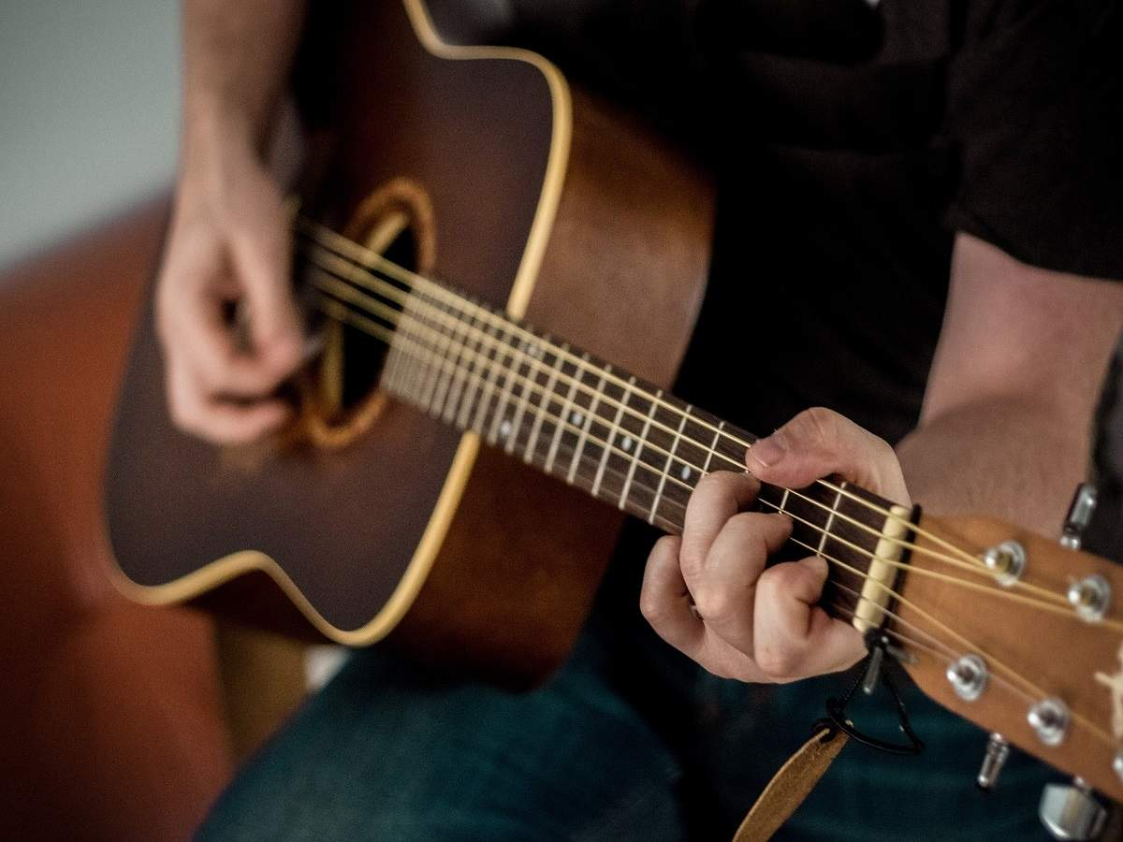

2022 Theme:
“Generation Rescue: Sustainable Water for All.”
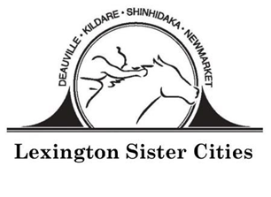
www.lexingtonsistercities.org
Facebook: www.facebook.com/lexingtonsistercities

The 2nd Annual Young Musicians Showcase
“Generation Rescue: Sustainable Water for All”

Submission Guidelines
DEADLINE: February 25, 2022

Theme: “Generation Rescue: Sustainable Water for All”
Students should explore the following questions:
- What does water sustainability mean to you?
- Has your community been affected by climate change and water disruption?
- How can you, as a future leader, contribute to the solution?

Specifications:
- Students may select one (1) piece of music to submit for this showcase.
- Only audio submissions will be accepted; no videos.
- Submissions cannot exceed 4 minutes.
- The piece must be original.

Entries:
Each participating student musician must be between 13 and 18 years of age by April 1, 2022. All entries must be the work of the entrant. Only pieces inspired by the theme should be submitted.

Music must be submitted to Lexington Sister Cities by February 25, 2022
Students should submit their music pieces in MP3 format. It will probably be necessary to use file sharing software such as Google Drive to send large files.
Email: lexingtonsistercities@gmail.com

Judging:
Judges will evaluate submissions based on theme interpretation, and creativity. The judges’ decision will be final. The top five selected will be sent to Sister Cities International for the international competition.

International Competition: First, Second and Third place winners will be selected in the Sister Cities International competition. The Grand Prize Winner (first place) will receive $1,000, 2nd Place will receive $250, and 3rd Place will receive $100. The winners will be published on the Sister Cities International website.

Young Musicians Showcase Entry Form
Deadline: February 25, 2022

Please print clearly or type and enclose this form with entry

Name: ____________________________________________________________________________________
Birth Date: __________________________ Phone: ________________________________________________
Home Address: _____________________________________________________________________________
City: ____________________________________ State: ______________________ Zip: _________________
Email: ____________________________________________________________________________________
School: ___________________________________________________________________________________
Parent Names: _____________________________________ Parent Email: ____________________________
Music/Band/Choir Teacher: __________________________________________________________________
Title of Work: _____________________________________________________________________________
What inspired you to create this work? __________________________________________________________________________________________
____________________________________________________________________________________________________________________________________________________________________________________

All showcase entries become the artistic property of Lexington Sister Cities and Sister Cities International. Although the musician retains his/her copyright for other uses, Lexington Sister Cities and Sister Cities International will retain perpetual, non-exclusive rights to use submitted piece in any future publication, promotional material and/or online service with no compensation other than credit with the musician’s name and community. Lexington Sister Cities and Sister Cities International reserves the right to free reproduction and exhibition of all submissions. Lexington Sister Cities and Sister Cities International take no responsibility and will not compensate for any lost or damaged pieces.

By submitting the entry, we agree to give Lexington Sister Cities and Sister Cities International, its members and affiliates, permission to publish and display the submitted entry at public exhibits, online, in publications and/or promotional materials, at the discretion of Lexington Sister Cities and Sister Cities International. We agree to abide by all the rules and terms of the showcase and agree to waive all claims of any kind against the showcase organizers.

Artist Signature _______________________________________________________ DATE _____________

Parent/Guardian Signature ___________________________________________ DATE _____________

