The 35th Annual Sister Cities
Young Artists Competition: Classic Medium Showcase Application
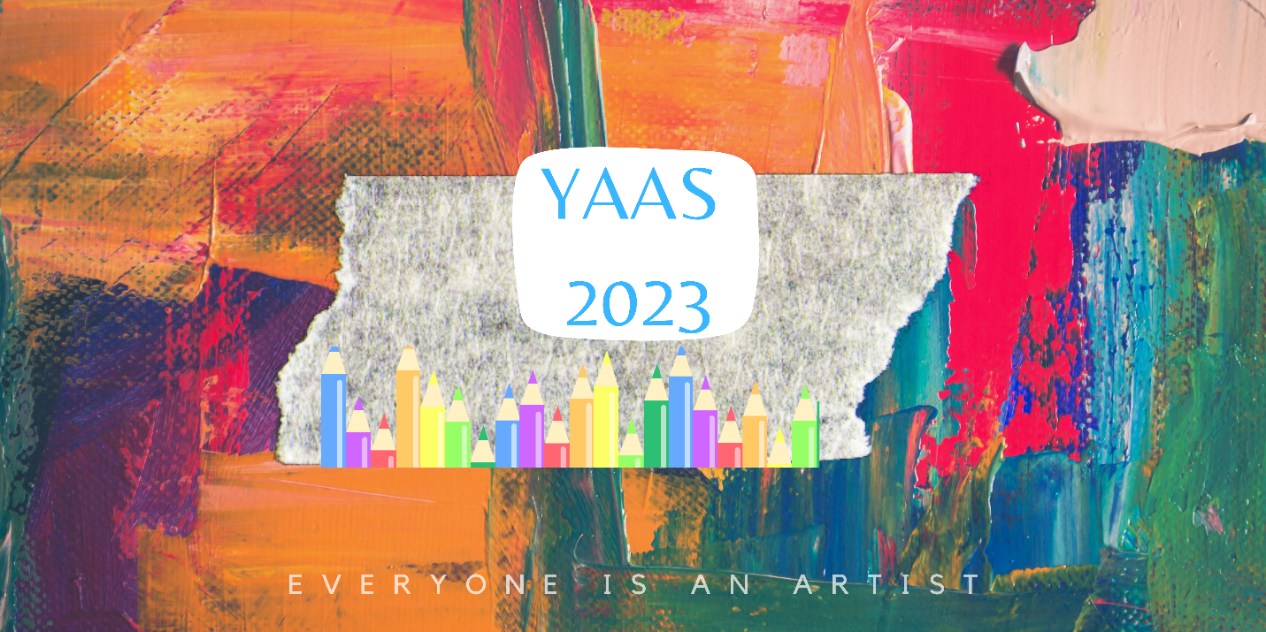

2023 Theme:
“Peace by Piece: Food Security in my Community”

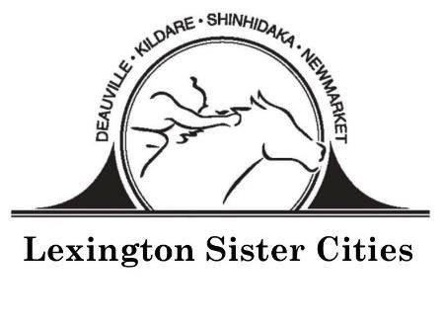
www.lexingtonsistercities.org
Facebook: www.facebook.com/lexingtonsistercities

Submission Guidelines
DEADLINE: February 24, 2023

Theme: “Peace by Piece: Food Security in my Community”
Students should explore the following questions:
- What food resources does your community have to help low income food needs?
- How does your local agricultural base play a role in your community food system?
- How can you, as a future leader, contribute to the solution?

Medium & Specifications:
- Media accepted in this category include oil, acrylic, watercolor, charcoal, colored pencil, crayon, ink, marker, etching, collage, etc. For digital medium artwork, see separate application.
- Only two dimensional (2D), unframed artwork will be accepted.
- Dimensions of the art and matting must not exceed 24 in. x 36 in or 61 cm. x 91.5 cm.
- Use of copyrighted or trademarked images is prohibited.
- Entries must not be plagiarized, stolen, or copied from any other source. Entries must not defame or invade the rights of any person, living or dead.
- All entries must be supported by matting if applicable.

Entries:
- Each participating student artist must be between 13 and 18 years of age by April 1, 2023. All entries must be the original design and artwork of the entrant. Only new pieces inspired by the theme should be submitted. When describing their artwork in the application form, students are encouraged to discuss how their local communities and/or international cities are approaching this year’s theme. Students can talk about collaborative efforts between communities, give project examples, or explore areas of potential cooperation within the Agricultural field.
- Students must submit their artwork to their art teacher by Friday, February 24, 2023 or to the Lexington Sister Cities Office, 208 E. Main St., Lexington, KY 40507.

Awards:
Local Competition: First, second, and third places will be chosen and cash prizes will be awarded by Central Bank to the students. 1st place will receive $250, 2nd place - $150; and third place - $100. The winning student’s teacher will receive $250 from Lexington Sister Cities for art supplies.
International Competition: First, Second, and Third place winners will be selected in the international competition in Washington D.C. The Grand Prize Winner (1st place) will receive $1,000; 2nd place will receive $250; and 3rd place will receive $100. The winning art pieces will be published on the Sister Cities International website.

Young Artists Competition Entry Form
DEADLINE: February 24, 2023

Please print clearly or type and enclose this form with the artwork
“Peace by Piece: Food Security in my Community”

Name: ________________________________________________________________________
Birth Date: __________________________ Phone: ____________________________________
Home Address: _________________________________________________________________
City: __________________________ State: _________________Postcode: ________________
Email: ________________________________________________________________________
School: _______________________________________________________________________
Parent Names: ________________________________Parent Email: ______________________
Art Teacher: ___________________________________________________________________
Describe Entry (size, medium, etc.): ________________________________________________
______________________________________________________________________________
Title of Work: _________________________________________________________________
What inspired you to create this work? ____________________________________________________________________________________________________________________________________________________________
______________________________________________________________________________
All competition entries become the artistic property of Lexington Sister Cities and Sister Cities International. Although the artist retains his/her copyright for other uses, Lexington Sister Cities and Sister Cities International will retain perpetual, non-exclusive rights to use submitted artwork in any future publication, promotional material and/or online service with no compensation other than credit with the artist’s name and community. Lexington Sister Cities and Sister Cities International reserves the right to free reproduction and exhibition of all submissions. Lexington Sister Cities and Sister Cities International take no responsibility and will not compensate for any lost or damaged artwork.
By submitting the entry, we agree to give Lexington Sister Cities and Sister Cities International, its members and affiliates, permission to publish and display the submitted entry at public exhibits, online, in publications and/or promotional materials, at the discretion of Lexington Sister Cities and Sister Cities International. We agree to abide by all the rules and terms of the showcase and agree to waive all claims of any kind against the showcase organizers.

Artist Signature _______________________________________DATE ___________________

Parent/Guardian Signature ___________________________ DATE ______________________

