The 35th Annual Sister Cities
Young Artists Showcase (Photography)

2023 Theme:
“Peace by Piece: Food Security in my Community”

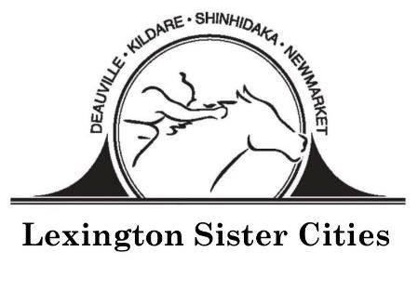
www.lexingtonsistercities.org
Facebook: www.facebook.com/lexingtonsistercities

The 35th Annual Young Artists Competition
“Peace by Piece: Food Security in my Community”

Submission Guidelines
DEADLINE: February 24, 2023

Theme: “Peace by Piece: Food Security in my Community”
Students should explore the following questions:
- What food resources does your community have to help low income food needs?
- How does your local agricultural base play a role in your community food system?
- How can you, as a future leader, contribute to the solution?

Specifications:
- Students may only submit one (1) photograph
- File uploaded must be in either a .jpeg or .png format.
- To ensure the judges have the best quality of your work, please confirm that photographs are no less than 180 dpi
- Judges will evaluate submissions based on theme interpretation and creativity.
- All work must be original, free from watermarks.
- Photo editing is allowed.

PHOTOS MUST BE SUBMITTED TO LEXINGTON SISTER CITIES VIA EMAIL
lexingtonsistercities@gmail.com

Entries:
- Each participating student artist must be between 13 and 18 years of age by April 1, 2023. All entries must be the original design and artwork of the entrant. Only new pieces inspired by the theme should be submitted. When describing their artwork in the application form, students are encouraged to discuss how their local communities and/or international cities are approaching this year’s theme. Students can talk about collaborative efforts between communities, give project examples, or explore areas of potential cooperation within the Agricultural field.

Judging:
- A panel will judge entries based on originality, composition, and theme interpretation. Photographer’s name and name of school are kept confidential until judging has been completed. The judges’ decision will be final. The top five photographs selected will be sent to Sister Cities International in DC for the international competition.

International Competition:
- The Grand prize winner will receive $1,000; second place will receive $250; and third place will receive $100. The photograph will be published on the Sister Cities International website.

Young Artists Competition Entry Form (Photography)
DEADLINE: February 24, 2023

Please print clearly or type and enclose this form with the artwork

Name: ____________________________________________________________________________________
Birth Date: __________________________ Phone: ________________________________________________
Home Address: _____________________________________________________________________________
City: ______________________________ Country: ______________________ Postcode: ________________
Email: ____________________________________________________________________________________
School: ___________________________________________________________________________________
Parent Names: _____________________________________ Parent Email: ____________________________
Art Teacher: _______________________________________________________________________________
Describe Entry (size, medium, etc.): ____________________________________________________________
__________________________________________________________________________________________
Title of Work: ______________________________________________________________________________
What inspired you to create this work? ____________________________________________________________________________________________
_________________________________________________________________________________________________________________________________________________________________________________________
All competition entries become the artistic property of Lexington Sister Cities and Sister Cities International. Although the artist retains his/her copyright for other uses, Lexington Sister Cities and Sister Cities International will retain perpetual, non-exclusive rights to use submitted artwork in any future publication, promotional material and/or online service with no compensation other than credit with the artist’s name and community. Lexington Sister Cities and Sister Cities International reserves the right to free reproduction and exhibition of all submissions. Lexington Sister Cities and Sister Cities International take no responsibility and will not compensate for any lost or damaged artwork. All fees associated with the showcase become the property of Lexington Sister Cities and Sister Cites International and will not be returned.

By submitting the entry, we agree to give Lexington Sister Cities and Sister Cities International, its members and affiliates, permission to publish and display the submitted entry at public exhibits, online, in publications and/or promotional materials, at the discretion of Lexington Sister Cities and Sister Cities International. We agree to abide by all the rules and terms of the showcase and agree to waive all claims of any kind against the showcase organizers.

Artist Signature _______________________________________________________ DATE _____________

Parent/Guardian Signature ___________________________________________ DATE _____________

