The 15th Annual Lexington Sister Cities
Young Authors Showcase (Poetry)
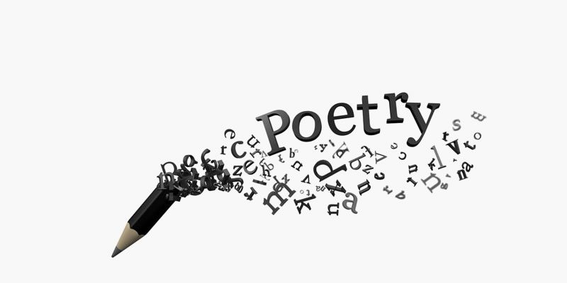

2023 Theme:
“Peace by Piece: Food Security in my Community”

www.lexingtonsistercities.org
Facebook: www.facebook.com/lexingtonsistercities

The 15th Annual Young Authors Showcase (Poetry)
“Peace by Piece: Food Security in my Community”

Submission Guidelines

DEADLINE: February 24, 2023

Theme:
Students should explore the following questions:
- What food resources does your community have to help low income food needs?
- How does your local agricultural base play a role in your community food system?
- How can you, as a future leader, contribute to the solution?

Specifications:
- Students may only enter one (1) poem each into the showcase.
- Poetry submissions are not to exceed 200 words.
- Submissions must be written in English.
- All works must be original.

Entries:
Each participating student poet must be between 13 and 18 years of age by April 1, 2023. All entries must be the original work of the entrant. Only new pieces inspired by the theme should be submitted.

Poems must be submitted to Lexington Sister Cities (via email)
by February 24, 2023.

Email: lexingtonsistercities@gmail.com

Judging:
A panel will judge entries on the basis of originality, composition, grammar, and theme interpretation. Poet’s name and name of school are kept confidential until judging has been completed. The judges’ decision will be final. The top five poems selected will be sent to Sister Cities International for the international competition.

International Competition: First, Second and Third place winners will be selected in the international competition. The Grand Prize Winner (first place) will receive $1,000, 2nd Place will receive $250, and 3rd Place will receive $100. The poems will be published on the Sister Cities International website.

Young Authors Showcase Entry Form (Poetry)
DEADLINE: February 24, 2023

Please print clearly or type and attach this form with the poem

Name: ____________________________________________________________________________________
Birth Date: __________________________ Phone: ________________________________________________
Home Address: _____________________________________________________________________________
City: ____________________________________ State: ______________________ Zip: _________________
Email: ____________________________________________________________________________________
School: ___________________________________________________________________________________
Parent Names: _____________________________________ Parent Email: ____________________________
English/Writing/Language Arts Teacher: ________________________________________________________
Title of Work: _____________________________________________________________________________
What inspired you to create this work? __________________________________________________________________________________________
________________________________________________________________________________________________________________________________________________________________________________________________________________________________________________________________________________________________________________________________________________________________________

All showcase entries become the artistic property of Lexington Sister Cities and Sister Cities International. Although the poet retains his/her copyright for other uses, Lexington Sister Cities and Sister Cities International will retain perpetual, non-exclusive rights to use submitted work in any future publication, promotional material and/or online service with no compensation other than credit with the poet’s name and community. Lexington Sister Cities and Sister Cities International reserves the right to free reproduction and exhibition of all submissions. Lexington Sister Cities and Sister Cities International take no responsibility and will not compensate for any lost or damaged works.

By submitting the entry, we agree to give Lexington Sister Cities and Sister Cities International, its members and affiliates, permission to publish and display the submitted entry at public exhibits, online, in publications and/or promotional materials, at the discretion of Lexington Sister Cities and Sister Cities International. We agree to abide by all the rules and terms of the showcase and agree to waive all claims of any kind against the showcase organizers.

Artist Signature _______________________________________________________ DATE _____________

Parent/Guardian Signature ___________________________________________ DATE _____________

