2019 Lexington Sister Cities Young Artist Competition Winners Announced

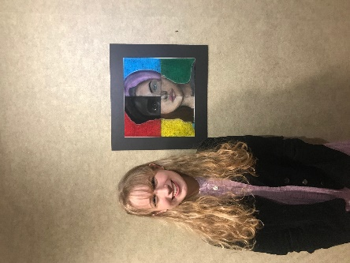

Lexington, KY – Chloe Ertel, a students at Frederick Douglass High School, was selected as the 2019 winner of the 31st Annual Lexington Sister Cities Young Artist Competition.

The Sister Cities Young Artist Competition is sponsored by Central Bank and the John G. Irvin Galleries, as well as the Lexington Sister Cities Commission. The contest was open to all Lexington students aged 13-18.

The theme of the competition was “Global Citizens: Resilient Communities”. Chloe’s piece, “People of the World”, was done on velour paper with pastels. Of her inspiration for the piece, Chloe says, “I was inspired by the prompt, and how people need to put their differences aside and come together in peace.” The writing in the background of Chloe’s artwork is the prompt for the contest written in four different languages.

Second place was awarded to Chase Faulkner of Paul Laurence Dunbar High School for his piece “Resilient Spirit”. Third place went to Maryam Al Azzawi of Paul Laurence Dunbar High School for her work titled “Together”. Gwen Ganadillo from Frederick Douglass High School received honorable mention for her piece “World Peace”. Chloe won $250, Chase received $150, and Maryam won $100 from Central Bank. Additionally, honorable mention Gwen Ganadillo was awarded $50 from Lexington Sister Cities. Mayor Linda Gorton, Luther Deaton of Central Bank, and Councilmember and Sister Cities Chairman Bill Farmer awarded prizes to the winning students.

The winning art teacher, Rebecca Banks of Frederick Douglass, received a $250 prize from Lexington Sister Cities to use for classroom supplies.

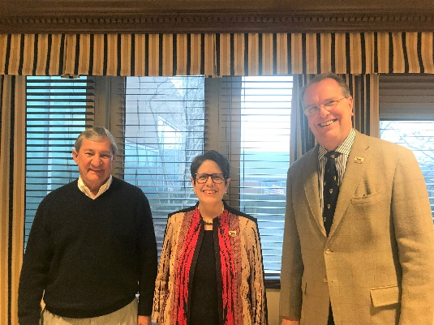
Luther Deaton, Mayor Gorton, and Councilmember Farmer.
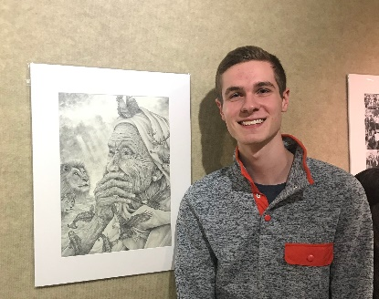
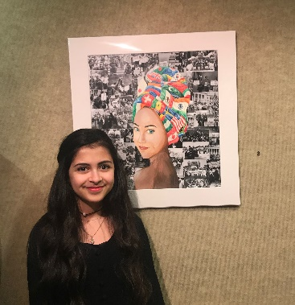
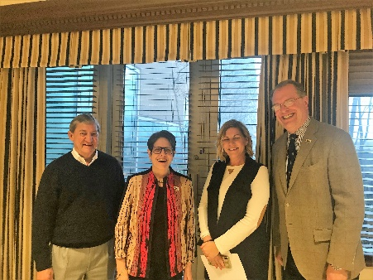
Luther Deaton, Mayor Linda Gorton, Bill Famer, and winning teacher Rachel Banks.
Maryam Al Azzawi, 3rd place winner.
Chase Faulker, 2nd place winner.

All entries will be on exhibit at the Central Bank Gallery through April 26, 2019.

The 1st place piece will be submitted to the worldwide Sister Cities International Competition at the annual conference in Huston, TX from July 17-19, 2019.

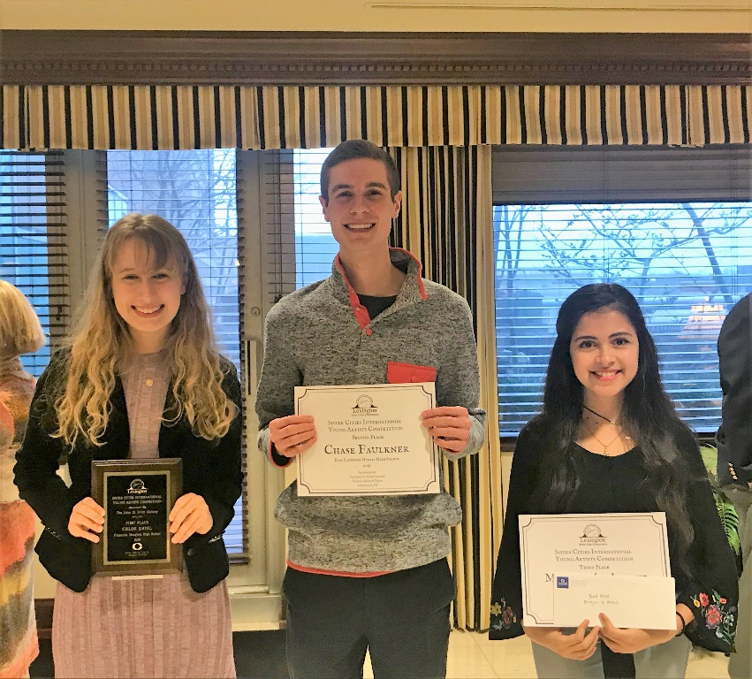

www.lexingtonsistercities.org
Facebook: Lexington Sister Cities
Instagram: @lexingtonsistercities
Blog: lexingtonsistercities.blogspot.com

