***New Holland Arts & Crafts Festival***

**June 28, 2025 9AM-2PM**

New Holland Community Memorial Park, 401 E Jackson Street

Sponsored by the ***New Holland Summer Arts Association***

**ELIGIBILITY**: Open to all artists and crafters either professional or hobbyist. Commercial mass-produced items are not acceptable. No yard sale items - We reserve the right to remove unacceptable items from the show.

**RESPONSIBILITY**: Each vendor is responsible for his/her own work. The sponsors are not responsible for any loss or damage. Each artist or crafter must provide his/her own set up equipment. Set-up time is 6:00 – 8:30AM. Vendors are required to maintain displays until 2:00PM.

**SALES**: There will be no commission charged. Children may exhibit art or craft items if supervised by an adult. Please note in the space provided if you are interested in donating an item to the Chinese Auction.

**DEMONSTRATIONS**: Artists and crafters are encouraged to demonstrate their work. This will help make the festival interesting!

**ENTRY FEE: $30.00 per 10’x10’ space. This fee is non-refundable**. A confirmation email will be sent upon receipt of your registration fee. All spaces are outdoors in the park.

**RAIN OR SHINE:­** The event will be held rain or shine. There will be no registration refunds. Your registration fee supports the NH Park and NH Summer Arts concert programs.

**DEADLINE**: June 21, 2025. Spaces fill up fast so don’t wait too long

______________________________________________________________________________________

There is convenient parking and restrooms. Food Trucks will be on site. When your check and registration form are received, you will automatically be registered for the show. Please come to the registration table on the morning of the show for your space assignment. QUESTIONS?? Website: newhollandsummerarts.com

Please email us at [newhollandsummerartsassoc@gmail.com](mailto:newhollandsummerartsassoc@gmail.com) or contact Sue at 717-355-9795

*__________________________________Detach and mail with payment________________________________*

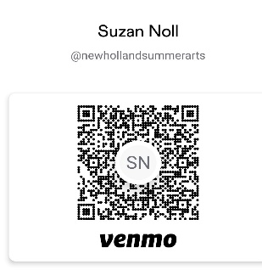

**REGISTRATION FORM**

**Registration deadline: June 21, 2025 Mail to: NH Summer Arts Association**

$30.00 per 10’x10’ space PO Box 532

Make checks payable to: **NHSAA** New Holland PA 17557

Or Venmo: @newhollandsummerarts (notate: Craft show)

NAME:_______________________________________________________________

ADDRESS: ______________________________________CITY/ST/ZIP_____________________

PHONE:_______________________________EMAIL:___________________________________________

Number of spaces desired: **________** same space/s as last year? **___** yes **___** no (not guaranteed)

Describe the artwork or crafts you will be offering for sale: ___________________________________________

I plan to donate an item for the Chinese Raffle: (please, describe): _____________________________________

Questions or comments may be placed on the reverse side of this sheet.

***Thank you for your participation in our show!***