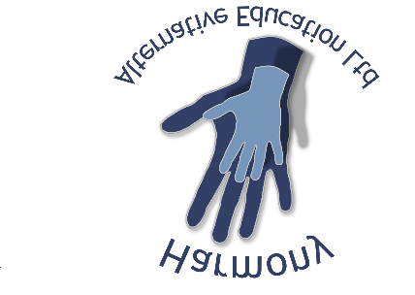
Initial Referral and information Form
Date referral completed: Completed by:
Part 1 - Information about the Young Person
First name(s): |  |  | Surname(s):
DOB:  Age:  NC Year group:  UPN: |  |  | Gender:  School/Pre-school:  GP Practice:
Ethnicity: |  |  | Home language:
Name of parent / carer: |  |  | Home address:
Email of parent / carer: |  |  | Main contact number of parent / carers:
Family living at home with young person: |  |  | Family living elsewhere from home (if relevant):
 | Details of Referrers:
Name of referrer:  Job title:  Agency: |  |  | Address:
Email for referrer:  Email for invoice:  Email for attendance: |  |  | Main contact number:
Other agencies to whom young person is known:
Name: |  | Agency: |  | Last contact date:
Name: |  | Agency: |  | Last contact date:
Name: |  | Agency: |  | Last contact date:
Does young person have a CIN or CP plan? Y/N  Please attach information  Date of last meeting: |  |  | Does the young person have an EHCP? Y/N  Please attach reports and plan  Date of last Annual Review:

PART 2: RISK ASSESSMENT- BASED ON PRESENTATION AT CURRENT/MOST RECENT PLACEMENT

Student name: | Key Stage: | Setting name: | Date of birth:

BEHAVIOUR  Type of behaviour | FREQUENCY  H – Hourly  D – Daily  W – Weekly  O – Occasionally  R – Rarely  N - Never | HAZARD  (Potential for harm)  0 = Never  1 = Minimal  2 = Moderate  3 = Significant  4 = Extreme (all the time) | PROBABILITY  (Likelihood of harm)  0 = Never  1 = Improbable  2 = Possible  3 = Probable  4 = Likely | LEVEL OF RISK  (Hazard x Probability = Level of risk)  0 = Never  1 = Low  6 = Medium  16 = High | OPINION OR KNOWLEDGE?  K = knowledge  O = Opinion
 |  |  |  |  | MITIGATION
Self Harm

Bullying

Abusive or violent language

Sexually abusing/inappropriate behaviour

Violent/Aggressive/Intimidating behaviour

Impulsive dangerous behaviour

Substance/Alcohol misuse

Offensive on a basis of
Gender/Race/Religion/Disability or Sexuality
(please highlight as appropriate)
Absconding/Absence

Damage to property

Offending behaviour
(eg theft)

Carrying/Use of weapons

Vulnerable to bullying

Mental health difficulties

Additional information/comments:

Young person plan for success:
Identified learning differences- state if formal diagnosis (dx+date and details) | Interests (state if special interest or other context)
What would we see should the young person become dysregulated?

Strategies and learning techniques that have worked for the young person in the past:

Strategies and teaching techniques that have NOT WORKED for the young person in the past and any particular triggers:

