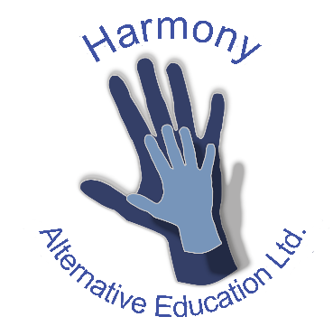

Online Home Learning Responsible User Agreement
To ensure my safety in online learning:
• I will only use technology for school purposes as directed by my teacher.
• I will only use technology for online learning when there is an adult in the room.
• I will not reveal my passwords to anyone.
• I will be responsible for my behaviour and actions when using technology, this includes the resources I access and the language I use
• I will make sure that all my communication with other pupils, teachers and others using technology is responsible and sensible.
• I will not deliberately browse, download, upload or forward material that could be considered offensive or illegal. If I accidentally come across any such material, I will report it immediately to my teacher or my parent.
• I will not record or take photos of my classmates or teachers during face to face sessions.
•I understand that when using TEAMS and other applications provided by the school that my use can be monitored and logged and can be made available to my teachers.
I understand that these rules are designed to help keep me safe and that if they are not followed, my parents may be contacted.
Guidelines for pupils using Microsoft Teams
• Use Teams from a communal room that is free from distraction such as a living room, home office or kitchen.
• Be on time for your Teams session
• Be dressed appropriately for learning
• Interact patiently and respectfully with your teachers and peers
• Provide feedback to teachers about your experiences and any relevant suggestions
• You MUST NOT record each other’s online interactions
• Make sure you end the session as soon as the teacher indicates to do so.

