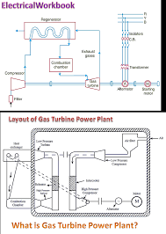

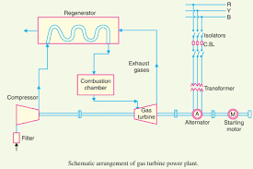

How gas turbines produce electricity

In order to generate electricity, the gas turbine heats a mixture of air and fuel at very high temperatures, causing the turbine blades to spin. The spinning turbine drives a [generator](https://www.ge.com/gas-power/resources/education/how-a-gas-generator-works) that converts the energy into electricity.

The gas turbine can be used in combination with a [steam turbine](https://www.ge.com/gas-power/resources/education/how-steam-turbines-work)—in a combined-cycle power plant—to create power extremely efficiently.

**1. Air-fuel mixture ignites:**

The gas turbine compresses air and mixes it with fuel that is then [burned at extremely high temperatures](https://www.ge.com/gas-power/resources/education/how-turbine-combustion-works), creating a hot gas.

**2. Hot gas spins turbine blades:**

The hot air-and-fuel mixture moves through blades in the turbine, causing them to spin quickly.

**3. Spinning blades turn the drive shaft:**

The fast-spinning turbine blades rotate the turbine drive shaft.

**4. Turbine rotation powers the generator:**

The spinning turbine is connected to the rod in a generator that turns a large magnet surrounded by coils of copper wire.

**5. Generator magnet causes electrons to move and creates electricity:**

The fast-revolving generator magnet creates a powerful magnetic field that lines up the electrons around the copper coils and causes them to move.

The movement of these electrons through a wire is electricity.

Gas Turbine Power Plant – Parts, Working, Advantages and Disadvantages

A power generating plant which has gas turbine as the prime mover for the generation of electrical energy, is called the gas turbine power plant. The block diagram of a typical gas turbine power station is shown in the figure.

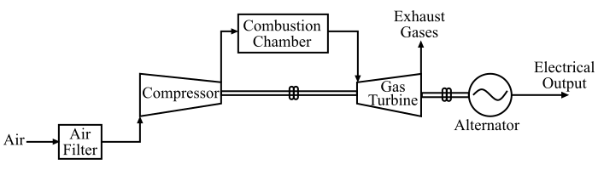

In a gas turbine power plant, natural air is used as the working agent. The air is compressed with the help of a compressor and fed to a combustion chamber where heat is added to this compressed air, which increases the temperature of the air. The heat to the compressed air is added either by burning fuel in the combustion chamber or by the use of air heaters.

Then, the hot and compressed air from the combustion chamber is passed through the gas turbine where it expands and does the mechanical work, i.e. the heat energy of the compressed air is converted into mechanical energy. The gas turbine drives the alternator which converts the mechanical energy of the turbine into electrical energy.

Also, it is important to note that the compressor, gas turbine and the alternator are mounted on the same shaft so that the mechanical power of the turbine can be utilised for the operation of the compressor.

The gas turbine power stations are primarily used as the standby power plants for hydroelectric power plants for driving auxiliaries in the power plants at starting.

Advantages of Gas Turbine Power Plant

A gas turbine power plant has following chief advantages −

* The design and layout of a gas turbine power plant is quite simple than a thermal power plant since no boilers and their auxiliaries are needed.
* As a gas turbine power station does not require boilers, feed water arrangement, etc. For this reason, it is much smaller in size than a thermal power plant of the same generating capacity.
* A gas turbine power plant requires less water as compared to a thermal power plant since no condenser is used.
* The capital and running costs are much lower than that of a thermal power plant of the same generating capacity.
* The maintenance cost is also quite small.
* The construction and operation of a gas turbine are much simpler than that of a steam turbine.
* In a gas turbine power plant, there are no standby losses.
* A gas turbine power plant can be put into operation quickly from the cold conditions.

Disadvantages of Gas Turbine Power Plant

The disadvantages of a gas turbine power plant are given as follows −

* The overall efficiency of a gas turbine power plant is very low, about 20%, because the exhaust gases from the turbine contain sufficient heat.
* The temperature of the combustion chamber is very high (about 1700 °C). Hence, its life is comparatively reduced.
* There is a problem in starting the gas turbine power plant since before starting the gas turbine, the compressor has to be operated for which power is needed from some external source. Although, once the plant is started, the external power is not required because the turbine itself supplies the necessary power to the compressor.
* For a gas turbine power plant, the net output of the plant is very low. It is because a greater part of the power developed by the turbine is used in driving the compressor.