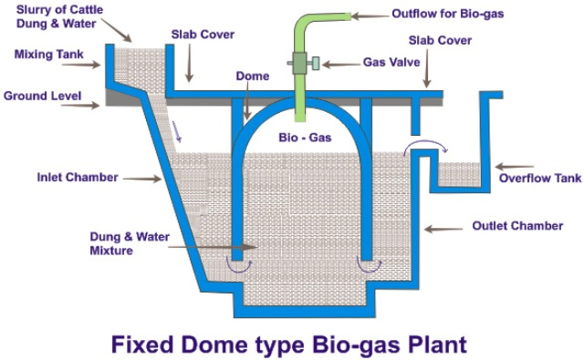

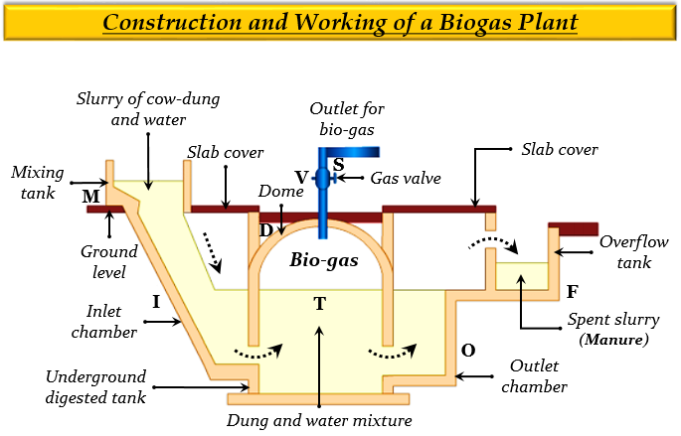

**Construction &working of biogas plant**

**Biogas** is a clean and efficient fuel. It is a mixture of methane (CH4), carbon dioxide (CO2), hydrogen (H2) and hydrogen sulphide (H2S). The chief constituent of biogas is methane (65%).

**Principle** :Biogas is produced as a result of anaerobic fermentation of biomass in the presence of water.

**Construction**:The biogas plant is a brick and cement structure having the following five sections:

1. Mixing tank present above the ground level.
2. Inlet chamber: The mixing tank opens underground into a sloping inlet chamber.
3. Digester: The inlet chamber opens from below into the digester which is a huge tank with a dome like ceiling.The ceiling of the digester has an outlet with a valve for the supply of biogas.
4. Outlet chamber: The digester opens from below into an outlet chamber.
5. Overflow tank: The outlet chamber opens from the top into a small over flow tank.

**Working** :

1. The various forms of biomass are mixed with an equal quantity of water in the mixing tank.
2. This forms the slurry. The slurry is fed into the digester through the inlet chamber.
3. When the digester is partially filled with the slurry, the introduction of slurry is stopped and the plant is left unused for about two months.
4. During these two months, anaerobic bacteria present in the slurry decomposes or ferments the biomass in the presence of water.
5. As a result of anaerobic fermentation, biogas is formed, which starts collecting in the dome of the digester.
6. As more and more biogas starts collecting, the pressure exerted by the biogas forces the spent slurry into the outlet chamber.
7. From the outlet chamber, the spent slurry overflows into the overflow tank.
8. The spent slurry is manually removed from the overflow tank and used as manure for plants.
9. The gas valve connected to a system of pipelines is opened when a supply of biogas is required.
10. To obtain a continuous supply of biogas, a functioning plant can be fed continuously with the prepared slurry.