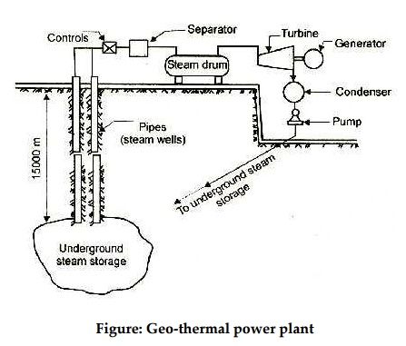

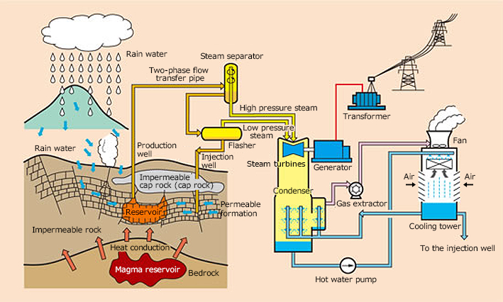

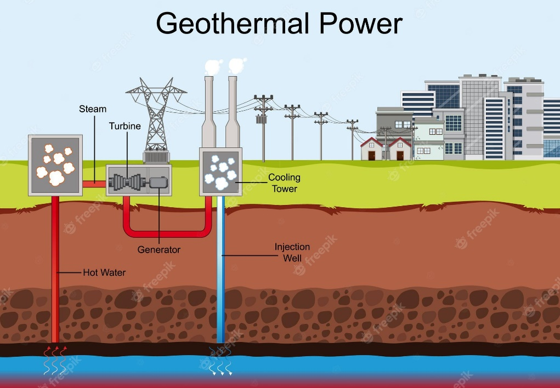

In geothermal power generation, groundwater is heated by a magma reservoir to high-temperature, high-pressure steam that is used to power a turbine to generate electricity. Since delivering Japan's first practical thermal power plant in 1960, Fuji Electric has delivered about 60 geothermal turbines both in Japan and abroad, including the world's largest 140 MW plant. In addition to manufacturing the individual parts of equipment used in power plants, we are also engaged in the overall plant design, manufacture and construction.