**load curve**

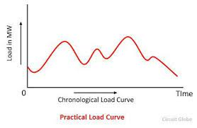

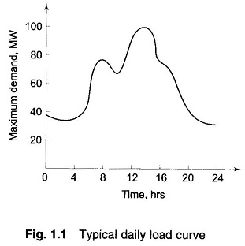

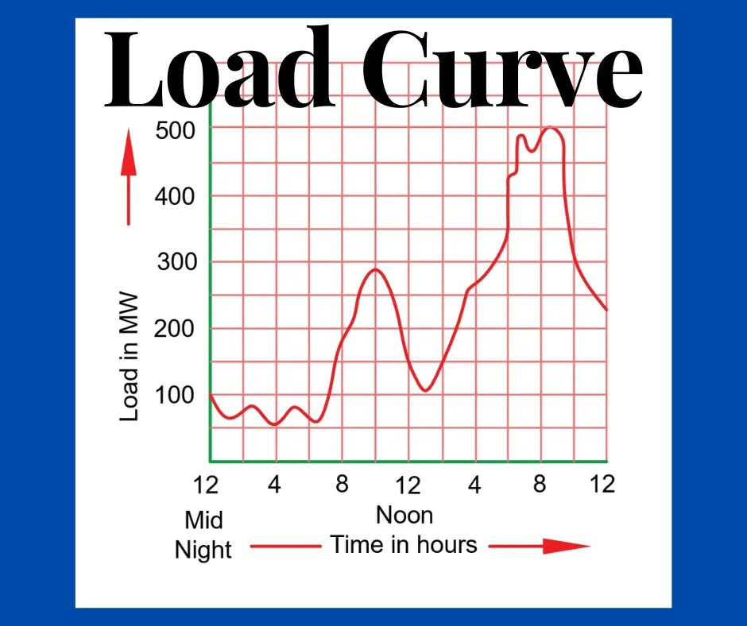

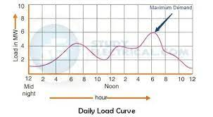

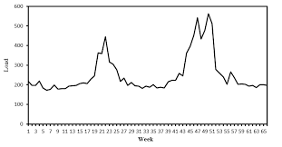

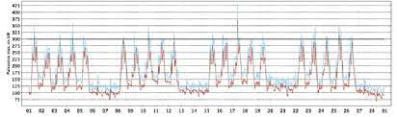

* A load curve, also known as a demand curve or a load profile, is a graphical representation that shows the variation of electrical power consumption or demand over a specific period, typically a day, week, month, or year.
* It is a fundamental tool used in the energy industry to analyze and understand the electricity consumption patterns of consumers.
* The load curve typically plots the power demand on the y-axis (vertical axis) and the time of the day on the x-axis (horizontal axis).
* The load curve can be classified into different types based on the time period they cover, such as:

1. **Daily Load Curve**: Shows the variation of power demand over a 24-hour period, typically in one-day increments.
2. **Weekly Load Curve**: Represents the power demand pattern over a week, covering all seven days.
3. **Monthly Load Curve**: Displays the variation of power demand over a month, with each point representing one day's average demand for that particular month.
4. **Annual Load Curve**: Shows the power demand pattern over an entire year, usually in one-hour or 15-minute increments.

Load curves are essential for power system operators, utility companies, and energy planners to ensure the reliable supply of electricity to consumers. By analyzing load curves, they can anticipate peak demand periods, optimize power generation, and plan for capacity expansions to meet the future energy requirements efficiently.

Load curves can be influenced by various factors, such as weather conditions, economic activities, industrial processes, and residential behaviors. For example, during hot summer days, the demand for air conditioning increases, leading to higher peaks in the load curve. Similarly, during weekends, the demand may be lower due to reduced industrial and commercial activities.

Overall, load curves are valuable tools in understanding and managing electricity demand, which helps ensure a stable and sustainable power supply to consumers.

**Daily Load Curve**

A daily load curve, also known as a daily demand curve or diurnal load curve, is a graphical representation that shows the variation of electricity demand over a 24-hour period. It provides valuable insights into the consumption patterns of electricity users throughout the day, helping utility companies and grid operators to manage the power generation and distribution more efficiently.

The daily load curve typically consists of the following key features:

1. **Base Load**: The base load represents the minimum level of electricity demand that occurs consistently throughout the day. It is usually associated with essential services and continuous processes that require a stable power supply, such as lighting, refrigeration, and basic electronic devices.
2. **Morning Peak**: The morning peak is the sharp increase in electricity demand that occurs in the early hours of the day, typically between 6 AM and 9 AM. This peak is often driven by residential activities like preparing breakfast, getting ready for work or school, and increased commercial and industrial activity as businesses start operations.
3. **Midday Dip**: Following the morning peak, there is usually a dip in electricity demand during the late morning and early afternoon, as commercial and industrial activities stabilize, and residential consumption decreases.
4. **Afternoon Peak**: The afternoon peak occurs in the late afternoon or early evening, typically between 4 PM and 8 PM. This is one of the highest points of electricity demand during the day, primarily driven by residential activities, such as cooking dinner, using electronic devices, and cooling homes.
5. **Evening Dip**: After the afternoon peak, there is a slight dip in electricity demand during the late evening, as some activities wind down, and people start preparing for bedtime.
6. **Nighttime Load**: The nighttime load represents the lower level of electricity demand during the late-night and early morning hours, typically between 10 PM and 6 AM. During this period, demand decreases significantly as many businesses and non-essential services are closed, and residential consumption reduces.

The shape and magnitude of the daily load curve can vary based on factors such as climate, culture, and industrial activity in a particular region. For example, in hot climates, there may be more pronounced peaks during the summer months due to increased air conditioning use.

Understanding the daily load curve is crucial for utilities to optimize power generation and distribution. By anticipating peak demand periods, they can ensure sufficient capacity is available to meet electricity needs during high-demand hours and avoid overloading the grid. Additionally, the daily load curve is essential for demand forecasting, energy pricing, and implementing demand response programs to manage peak demand more effectively.

**Weekly Load Curve**

A weekly load curve, also known as a weekly demand curve or weekly load profile, is a graphical representation that shows the variation of electricity demand over a span of one week. It provides a broader perspective of electricity consumption patterns compared to the daily load curve and helps utility companies and grid operators plan and manage resources more efficiently.

The weekly load curve typically exhibits the following characteristics:

1. **Weekday Load Pattern**: The weekly load curve on weekdays usually follows a similar pattern each day. It includes morning and afternoon peaks, as described in the daily load curve section, which are influenced by residential, commercial, and industrial activities during typical working hours.
2. **Weekend Load Pattern**: On weekends, the load curve often displays different patterns compared to weekdays. The morning peak might be less pronounced, and the afternoon peak could occur at a later time due to different consumer behavior, fewer industrial operations, and reduced commercial activities.
3. **Base Load**: Similar to the daily load curve, the weekly load curve includes a base load, which represents the minimum level of electricity demand that occurs consistently throughout the entire week. It is typically associated with essential services and continuous processes that require a stable power supply.
4. **Seasonal Variations**: The weekly load curve might also exhibit seasonal variations, especially in regions with distinct seasonal changes. For example, during the summer, the load curve may show higher and more prolonged afternoon peaks due to increased air conditioning usage.
5. **Holidays and Special Events**: Load curves on holidays and during special events might differ significantly from typical weekly patterns. On holidays, overall electricity demand may decrease as businesses and industries close, and people engage in leisure activities.

Understanding the weekly load curve is essential for utility companies to develop effective load forecasting models, plan maintenance schedules, and optimize power generation and distribution. It helps them identify peak demand periods and plan for capacity requirements during the week, considering both regular and irregular patterns that can occur due to holidays and special events.

By analyzing the weekly load curve, utilities can make informed decisions regarding energy pricing, demand response strategies, and energy storage utilization. Additionally, it assists in resource planning and encourages the development of time-of-use tariffs, which incentivize consumers to shift their energy consumption to off-peak hours, contributing to more efficient grid operation and reduced strain during peak demand periods.

**Monthly Load Curve**

A monthly load curve, also known as a monthly demand curve or monthly load profile, is a graphical representation that shows the variation of electricity demand over a one-month period. It provides a broader perspective on electricity consumption patterns compared to the daily and weekly load curves, allowing utility companies and grid operators to analyze consumption trends over a longer time frame.

The monthly load curve typically exhibits the following characteristics:

1. **Seasonal Variations**: One of the most prominent features of the monthly load curve is the seasonal variation in electricity demand. Different seasons, such as summer, winter, spring, and autumn, can significantly influence energy consumption due to varying weather conditions and corresponding changes in heating, cooling, and lighting needs.
2. **Peak Months**: The months with extreme weather conditions often experience higher electricity demand. For example, during hot summer months, the use of air conditioning increases, leading to higher demand peaks. Similarly, cold winter months may see increased heating demands.
3. **Base Load Stability**: The base load remains relatively stable throughout the year, representing the minimum level of electricity demand required to meet essential services and constant processes.
4. **Holiday and Vacation Periods**: The monthly load curve might exhibit variations during holiday seasons and vacation periods. Some industries may reduce operations during holidays, leading to altered load patterns.
5. **Economic and Industrial Activities**: Economic activities, industrial operations, and production cycles can also impact the monthly load curve. Industries may adjust their energy consumption based on their production schedules, leading to load variations.
6. **Energy Efficiency Measures**: Implementation of energy-efficient practices and technologies can influence the overall electricity demand and shape the monthly load curve.

Understanding the monthly load curve is essential for long-term energy planning and resource management. Grid operators and utility companies use this information to ensure sufficient power generation capacity is available to meet the varying demand throughout the year. It also helps in demand forecasting and optimizing energy procurement and distribution strategies.

By analyzing the monthly load curve, utilities can identify seasonal peaks and troughs, allocate resources efficiently, and make informed decisions regarding the deployment of renewable energy sources and storage solutions. Additionally, it enables utilities to design appropriate demand response programs and time-of-use tariffs that align with the specific demand patterns observed during different months.

Overall, the monthly load curve is a valuable tool for grid management and energy policymakers to ensure a stable and sustainable electricity supply while taking into account the complexities of seasonal variations and changing consumer behaviors.

**Annual Load Curve**

An annual load curve, also known as an annual demand curve or annual load profile, is a graphical representation that shows the variation of electricity demand over the course of a full year. It provides a comprehensive and long-term view of electricity consumption patterns, allowing utility companies and energy planners to analyze the energy needs of consumers throughout different seasons and adapt their strategies accordingly.

The annual load curve typically exhibits the following characteristics:

1. **Seasonal Variations**: Similar to the monthly load curve, the annual load curve shows prominent seasonal variations. Different seasons, such as summer, winter, spring, and autumn, lead to varying electricity demands due to changes in heating, cooling, lighting, and other energy-intensive activities.
2. **Peak Seasons**: The annual load curve identifies peak seasons when electricity demand is at its highest. For example, in many regions, summer and winter tend to be peak seasons due to increased use of air conditioning in summer and heating systems in winter.
3. **Base Load Stability**: The base load remains relatively stable throughout the year, representing the minimum level of electricity demand required to meet essential services and constant processes that are necessary regardless of seasonal changes.
4. **Holidays and Special Events**: The annual load curve may show variations during holidays and special events, with reduced demand during certain periods.
5. **Economic and Industrial Activities**: The load curve can be influenced by economic factors and industrial activities. Economic growth, production cycles, and industrial operations may lead to fluctuations in electricity consumption.
6. **Energy Efficiency Measures**: The impact of energy-efficient practices and technologies on the overall electricity demand can be observed in the annual load curve.
7. **Renewable Energy Integration**: The annual load curve may show the influence of renewable energy sources like solar and wind, which can vary based on weather conditions and availability.

Analyzing the annual load curve is crucial for long-term energy planning, capacity expansion, and infrastructure development. It helps utility companies and grid operators determine the required capacity to meet peak demands during different seasons and avoid power shortages.

By studying the annual load curve, utilities can identify opportunities for load balancing, energy storage utilization, and better integration of renewable energy sources. It also aids in developing pricing strategies and implementing demand response programs to incentivize consumers to shift their energy consumption during peak periods.

Furthermore, energy policymakers and regulators use the insights from the annual load curve to design and implement energy policies that encourage sustainable energy use and grid stability throughout the year.

Overall, the annual load curve provides valuable information for energy planners to ensure a reliable and efficient electricity supply, considering the complexities of seasonal variations and long-term changes in consumer behavior and economic activities.

**Factors Influencing Load Curves**

Load curves in the energy sector are influenced by various factors that can cause fluctuations in electricity demand throughout the day, week, month, or year. Understanding these factors is crucial for effective load forecasting, energy planning, and ensuring a stable power supply. Here are some key factors that influence load curves:

1. **Time of Day**: The most apparent influence on load curves is the time of day. Demand for electricity typically follows a predictable pattern with daily peaks during certain hours when consumption is higher, such as mornings and evenings, and troughs during late-night and early morning hours when consumption is lower.
2. **Weather Conditions**: Weather plays a significant role in shaping load curves. Extreme temperatures, hot or cold, lead to increased electricity demand due to heating, cooling, and ventilation needs. For example, during hot summers, air conditioning usage spikes, leading to higher peak demand.
3. **Seasonality**: Load curves exhibit seasonality, with variations in demand patterns throughout the year. Winter and summer months typically have different load profiles due to the varying energy requirements for heating and cooling.
4. **Economic Activities**: Industrial and commercial activities significantly influence load curves. During business hours, energy demand tends to be higher as companies use electricity for operations and manufacturing processes.
5. **Residential Consumption**: Residential load is influenced by factors such as the number of households, family size, appliance usage, and lifestyle habits. Weekends and holidays might show different load patterns compared to weekdays due to changes in daily routines.
6. **Day of the Week**: Load curves often differ on weekdays and weekends due to variations in industrial, commercial, and residential activities.
7. **Public Holidays and Special Events**: Load curves can be affected by public holidays and special events. On holidays, when businesses are closed or operating at reduced capacity, the overall demand may be lower.
8. **Demographic Factors**: Population density, urbanization, and the size of the consumer base in a region can impact load curves.
9. **Energy Efficiency Measures**: The implementation of energy efficiency initiatives, such as smart appliances, LED lighting, and energy-saving practices, can influence overall electricity consumption and load patterns.
10. **Time-of-Use Tariffs**: Utility companies often implement time-of-use tariffs to encourage consumers to shift their energy consumption to off-peak hours. This can influence load curves by modifying consumer behavior.
11. **Renewable Energy Integration**: The growing integration of renewable energy sources, like solar and wind, can impact load curves due to their intermittent nature. Peak solar generation during the day, for example, might reduce electricity demand from other sources.
12. **Electric Vehicles**: The adoption of electric vehicles can have a significant impact on load curves, especially during charging periods, and may necessitate smart charging strategies to manage demand.
13. **Technological Advancements**: Technological advancements in various sectors can affect electricity consumption patterns. For instance, the widespread adoption of electric heating or cooling systems could lead to changes in load curves.
14. **Energy Policies and Regulations**: Government policies, incentives, and regulations related to energy consumption can influence load curves. For instance, demand response programs may alter peak demand periods.

Understanding and analyzing these factors are essential for load curve management, demand forecasting, and the efficient utilization of energy resources in the power system.

**Significance of load curve**

The load curve holds significant importance in the energy sector and plays a crucial role in various aspects of energy planning, management, and operations. Here are some key significances of the load curve:

1. **Demand Forecasting:** Load curves provide historical data on electricity consumption patterns, allowing energy planners and utility companies to forecast future electricity demand accurately. This forecasting is essential for ensuring sufficient power generation capacity, optimizing resource allocation, and avoiding potential power shortages or overcapacity.
2. **Load Balancing and Grid Stability:** Load curves help grid operators to balance electricity supply and demand in real-time. By understanding the daily, weekly, and seasonal variations in load, grid operators can adjust power generation and distribution to maintain grid stability and avoid blackouts or brownouts during peak demand periods.
3. **Energy Resource Planning:** Load curves aid in determining the appropriate mix of energy resources required to meet electricity demand. This includes planning for the integration of renewable energy sources, such as solar and wind, and optimizing the use of conventional power plants to align with peak demand periods.
4. **Capacity Planning:** Load curves assist in capacity planning for power generation and transmission infrastructure. Utility companies can identify the need for capacity expansions or upgrades based on expected increases in electricity demand.
5. **Optimizing Energy Storage:** Load curves help identify periods of high and low electricity demand, which is critical for optimizing energy storage systems. Energy storage can be used to store excess energy during off-peak periods and release it during peak demand, reducing the need for expensive peaking power plants.
6. **Demand Response Programs:** Load curves inform the implementation of demand response programs, which encourage consumers to shift their energy usage to off-peak hours. These programs help reduce peak demand, alleviate stress on the grid, and promote energy efficiency.
7. **Time-of-Use Pricing:** Load curves are instrumental in designing time-of-use pricing plans. By charging different electricity rates based on peak and off-peak hours, consumers are incentivized to adjust their energy consumption behavior, helping to flatten load curves and avoid demand spikes.
8. **Energy Efficiency Initiatives:** Load curves provide insights into areas of high electricity consumption, enabling targeted energy efficiency initiatives. These initiatives can lead to reduced energy consumption and lower greenhouse gas emissions.
9. **Economic and Policy Decisions:** Policymakers and regulators use load curves to make informed decisions regarding energy policies, incentives, and regulations. The data helps shape policies that promote sustainable energy practices and support grid stability.
10. **Integration of Electric Vehicles:** With the increasing adoption of electric vehicles, load curves become critical for managing the charging demand. Understanding peak charging periods allows utilities to plan for adequate charging infrastructure and avoid stress on the grid during high-demand periods.

In summary, load curves serve as a fundamental tool for energy planning, grid management, and policymaking. By analyzing electricity consumption patterns over time, stakeholders in the energy sector can make data-driven decisions that promote efficient and reliable energy supply while fostering sustainability and environmental responsibility.

**Load Curve Management Strategies**

Load curve management strategies are techniques and initiatives used by utility companies, grid operators, and energy planners to optimize electricity consumption, reduce peak demand, and ensure a stable and efficient power supply. These strategies aim to balance electricity generation and consumption while maximizing the utilization of resources. Here are some common load curve management strategies:

1. **Demand Response Programs:** Demand response programs encourage consumers to adjust their electricity usage during peak demand periods. By offering financial incentives or time-of-use pricing, consumers can shift their energy-intensive activities to off-peak hours, reducing strain on the grid during peak times.
2. **Time-of-Use (TOU) Tariffs:** TOU tariffs charge different electricity rates based on the time of day. Higher rates are applied during peak hours to encourage consumers to reduce energy usage during these periods and shift their consumption to off-peak times when electricity is cheaper.
3. **Energy Storage Solutions:** Energy storage technologies, such as batteries, pumped hydro storage, and flywheels, can store excess energy during periods of low demand and release it during peak demand times. Energy storage helps to balance load curves and ensures a stable power supply during fluctuations.
4. **Load Shifting Techniques:** Load shifting involves moving energy-intensive activities to times when demand and electricity prices are lower. This could include running industrial processes at night or using smart home systems to control the timing of appliances.
5. **Efficiency and Conservation Measures:** Promoting energy-efficient practices and technologies can help reduce overall electricity demand and flatten load curves. Energy-efficient appliances, LED lighting, and building insulation are examples of measures that can contribute to load curve management.
6. **Renewable Energy Integration:** Integrating renewable energy sources, such as solar and wind, into the grid can help diversify the energy mix and reduce reliance on fossil fuel-based power during peak demand periods. The variable nature of renewables may require careful management and coordination.
7. **Microgrids and Distributed Generation:** Implementing microgrids and distributed generation systems allows communities or specific areas to generate and consume their electricity locally. These systems can help manage localized demand and reduce strain on the main grid.
8. **Load Aggregation and Curtailment:** Load aggregation involves aggregating multiple smaller loads and managing them collectively to optimize energy usage. Load curtailment involves reducing non-critical loads during peak periods to avoid high demand charges.
9. **Electric Vehicle (EV) Charging Management:** As the adoption of electric vehicles grows, utilities can implement smart charging solutions to manage the charging of EVs during off-peak hours, preventing excessive demand spikes.
10. **Advanced Grid Management Technologies:** Utilizing advanced grid management technologies, such as smart meters, real-time data analytics, and predictive modeling, enables more accurate load forecasting and better load curve management.
11. **Weather Forecasting and Load Prediction:** Incorporating weather forecasting into load prediction models helps anticipate electricity demand variations based on temperature and other weather-related factors.

By implementing these load curve management strategies, energy stakeholders can reduce the overall electricity demand, lower operational costs, enhance grid stability, and promote energy efficiency while ensuring a reliable and sustainable power supply to consumers.

**Data sources used for load curve analysis**

Various data sources are used to gather information and generate load curves for electricity consumption analysis. These data sources provide valuable insights into the patterns and trends of electricity demand over specific time periods. Some common data sources used for load curve analysis include:

1. **Utility Meter Data:** Utility companies collect electricity consumption data from smart meters or traditional meters installed at consumer premises. Smart meters provide real-time data, enabling more accurate load curve generation.
2. **Historical Load Data:** Historical load data from utility records and databases are crucial for developing load curves over past periods, such as months or years.
3. **AMI (Advanced Metering Infrastructure) Data:** Advanced metering infrastructure systems capture granular electricity usage data at regular intervals, often at 15-minute or hourly intervals. This data helps in creating detailed load curves with higher resolution.
4. **Weather Data:** Weather data, such as temperature, humidity, and solar radiation, is used to correlate weather conditions with electricity demand variations, especially for load curve analysis that includes seasonal effects.
5. **Time-of-Use (TOU) Pricing Data:** TOU pricing data provides information on the electricity rates charged during different time periods, which can be used to understand consumer behavior and load shifting patterns.
6. **Electric Vehicle Charging Data:** With the increasing adoption of electric vehicles, data on electric vehicle charging patterns is becoming important for load curve analysis and management.
7. **Commercial and Industrial Data:** Industrial and commercial consumers often provide electricity consumption data to utility companies for billing purposes. This data is crucial for understanding the demand patterns of different sectors.
8. **Census and Demographic Data:** Demographic data, such as population density, household size, and socioeconomic factors, can be used to analyze load curve variations based on different consumer profiles.
9. **Public Holidays and Events Calendars:** Data on public holidays, special events, and known changes in consumer behavior can be incorporated into load curve analysis to observe variations during these periods.
10. **Energy Management Systems (EMS) Data:** Energy management systems used by industrial and commercial consumers often capture real-time electricity usage data, providing insights into load patterns.
11. **Wholesale Electricity Market Data:** For grid operators and energy planners, wholesale electricity market data is essential to understand demand and supply dynamics and the effects on load curves.
12. **Renewable Energy Generation Data:** Data on renewable energy generation, such as solar irradiance and wind speed, helps in understanding the contribution of renewable sources to the load curve.
13. **Internet of Things (IoT) Sensors:** In some cases, IoT sensors installed in buildings or industrial processes provide electricity consumption data for load curve analysis.

Combining data from these sources and using advanced analytics techniques, such as data mining, machine learning, and statistical methods, load curves can be generated and analyzed to optimize electricity generation and distribution, plan for future demand, and implement effective load management strategies.

**Load curve analysis techniques**

Load curve analysis involves various techniques to understand and interpret the patterns and trends in electricity consumption. These techniques help utility companies, grid operators, and energy planners optimize resource allocation and ensure a stable power supply. Here are some common load curve analysis techniques:

1. **Visual Inspection:** The simplest technique involves visually inspecting the load curve graph to identify patterns, peaks, troughs, and variations. This provides an initial understanding of the load profile.
2. **Smoothing Techniques:** Smoothing techniques, such as moving averages or exponential smoothing, are used to remove noise or irregularities from the load curve data, making it easier to identify underlying trends.
3. **Time Series Analysis:** Time series analysis involves statistical methods to analyze data points collected over time. Techniques like seasonal decomposition, autocorrelation, and forecasting models are employed to understand the cyclic patterns and predict future trends.
4. **Demand Forecasting:** Load curve data is often used for demand forecasting, which includes short-term, medium-term, and long-term predictions of electricity consumption. Forecasting models like ARIMA (AutoRegressive Integrated Moving Average), SARIMA (Seasonal ARIMA), and machine learning algorithms are used for accurate predictions.
5. **Load Duration Curve (LDC):** The Load Duration Curve is a graphical representation that ranks the electricity load from highest to lowest. It helps in understanding the cumulative contribution of different load levels to total energy consumption.
6. **Load Factor Analysis:** Load factor is the ratio of average demand to the peak demand. Load factor analysis helps identify how efficiently energy resources are being utilized, and it assists in capacity planning and cost optimization.
7. **Cluster Analysis:** Cluster analysis is used to group similar load profiles together based on patterns and similarities, helping in identifying different consumer segments with distinct load characteristics.
8. **Demand Response Analysis:** Load curve data is analyzed to design effective demand response programs that incentivize consumers to shift their energy usage during peak demand periods.
9. **Renewable Energy Integration:** Load curve analysis helps in understanding the impact of renewable energy sources on the grid and managing their variable generation to match demand.
10. **Energy Storage Optimization:** Load curve data is used to optimize the operation of energy storage systems, ensuring charging during off-peak periods and discharging during peak demand.
11. **Peak Demand Management:** Load curve analysis helps in managing peak demand through strategies like load shedding, load shifting, and demand-side management.
12. **Load Aggregation:** Load aggregation techniques are employed to combine multiple smaller loads into a single larger load, facilitating efficient resource allocation and demand management.

Load curve analysis techniques are often complemented by advanced data analytics, machine learning, and optimization algorithms to extract meaningful insights from the data and make informed decisions to enhance the reliability and efficiency of the power system.

I. Introduction

A. Background information on load curves and their significance in the energy industry.

B. Overview of the research objectives and scope.

C. Explanation of the importance of load curve analysis for energy planning and management.

II. Literature Review

A. Review of existing literature on load curves, demand forecasting, and load profiling.

B. Examination of previous studies on load curve analysis techniques and methodologies.

C. Identification of gaps and limitations in current load curve research.

III. Methodology

A. Description of the data sources and datasets used for load curve analysis.

B. Explanation of the load curve data collection process and data preprocessing techniques.

C. Presentation of the load curve analysis methods, such as statistical methods, machine learning, or other relevant techniques.

IV. Load Curve Characteristics and Patterns

A. Analysis of daily load curves to identify peak demand periods and variations.

B. Examination of weekly load curves to understand the influence of weekends and holidays on demand.

C. Evaluation of monthly and seasonal load curves to observe trends and patterns over the year.

V. Factors Influencing Load Curves

A. Study of weather-related effects on load curves (e.g., temperature, humidity, seasonality).

B. Analysis of the impact of economic activities and industrial processes on load curves.

C. Assessment of load curve variations due to changes in consumer behavior and technological advancements.

VI. Load Curve Forecasting

A. Overview of load forecasting techniques used in the energy industry.

B. Comparison of short-term, medium-term, and long-term load forecasting methods.

C. Evaluation of the accuracy and effectiveness of different load forecasting models.

VII. Load Curve Management Strategies

A. Exploration of demand response programs and their role in load curve management.

B. Analysis of load shifting and peak shaving techniques to optimize energy consumption.

C. Discussion of load balancing and energy storage solutions for load curve stabilization.

VIII. Case Studies and Real-World Applications

A. Presentation of case studies illustrating load curve analysis in specific regions or industries.

B. Examination of successful load curve management implementations by utility companies.

C. Highlighting the practical implications and lessons learned from real-world load curve applications.

IX. Future Trends and Challenges

A. Discussion of emerging technologies and their potential impact on load curve analysis.

B. Identification of challenges and obstacles in load curve management and forecasting.

C. Proposals for future research directions in load curve analysis.

X. Conclusion

A. Summary of key findings from the load curve research.

B. Discussion of the implications and significance of load curve analysis for the energy sector.

C. Final remarks and suggestions for further advancements in load curve research.