Sl. No. | Nakshatra | Position | Plant name | Botanical name | Family | Click for Details
1. | Ashwini  (Beta Arietis) | 0-13° 20´ | Kajra  (Poison nut) | Strychnos nux-vomica | Loganiaceae | 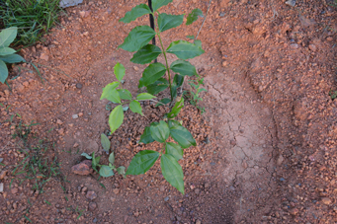
2. | Bharani  (41 Arietus) | 13° 20´-26° 40´ | Amla  (Indian gooseberry) | Embilica officinalis | Euphorbiaceae | 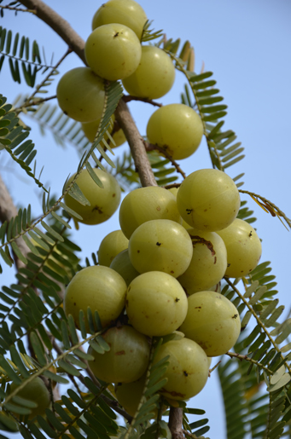
3. | Kritika  (Etatauri Alcyone-2) | 26° 40´-40° 00´ | Umbar  (Cluster fig) | Ficus racemosa | Moraceae | 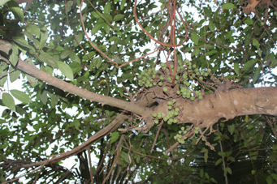
4. | Rohini  (Aldebaran) | 40° 00´-53° 20´ | Jamun  (Java plum) | Syzigium cumini | Myrtaceae | 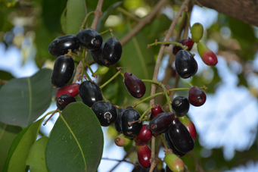
5. | Mrigashirsha (Lambda orionis) | 53° 20´-66° 40´ | Khair  (Cutch tree) | Acacia catechu | Leguminoseae | 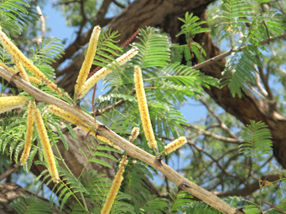
6. | Ardra (Gamma) | 66° 40´-80° 00´ | Sissam  (Indian rosewood) | Dalbergia sissoo | Fabaceae | 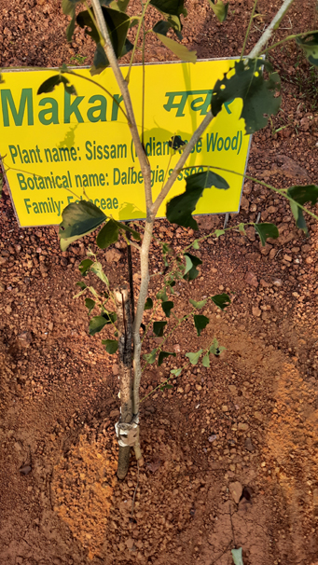
 |  |  | Agar wood  (Krishna guru ) | Aquilaria agallocha | Thymelaeaceae
 |  |  | Krishna kamal  (Passion fruit) | Passiflora edulis | Passifloraceae
 |  |  | Thippali  (Long pepper) | Piper longum | Piperaceae
7. | Punarvasu  (Beta Geminorium pollux) | 80° 00´-93° 20´ | Bamboo | Dendrocalamus strictus | Poaceae | 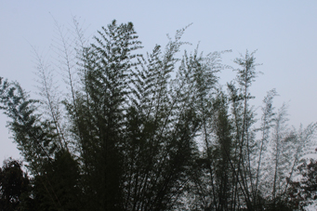
 |  |  | Bamboo | Bambusa arundinaceae | Poaceae
 |  |  | Babul  (Gum arabic tree) | Vachellia nilotica | Fabaceae
8. | Pushya  (Delta Cancri) | 93° 20´-106° 40´ | Peepal  (Sacred fig) | Ficus religiosa | Moraceae | 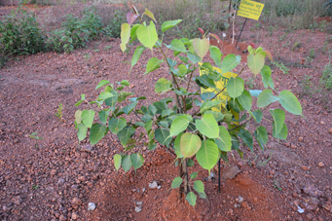
9. | Ashlesha  (Zeta Hydare) | 106° 40´-120° 00´ | Nagkesar  (Indian rose chestnut) | Messua ferrea | Calophyllaceae | 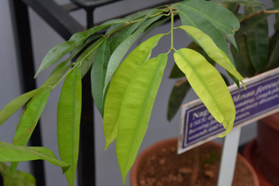
10. | Magha  (Regulus/ Roleonis) | 120° 00´-133° 20´ | Vata vruksh  (Banyan tree) | Ficus bengalensis | Moraceae | 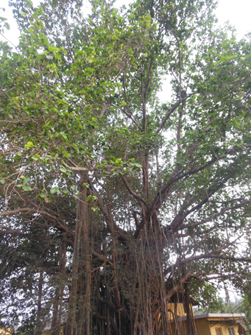
11. | Purva phalguni (Delta Leonis) | 133°20´-146°40´ | Palash  (Flame of forest) | Butea monospema | Fabaceae | 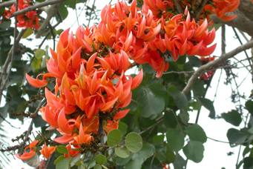
 |  |  | Sita Ashok  (Ashoka tree) | Saraca asoka | Caesalpinaceae
12. | Uttara phalguni (Denebala) | 146° 40´-160° 00´ | Payar Peepal  (Golden rumph’s fig) | Ficus rumphii | Moraceae | 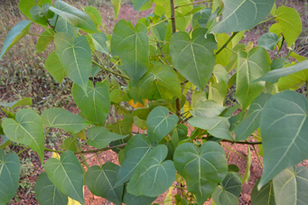
 |  |  | Paras Peepal  (Portia tree) | Thespesia populnea | Malvaceae
 |  |  | Pakur  (White fig) | Ficus infectoria | Moraceae
 |  |  | Shami  (Spunge tree) | Prosopis cineraria | Leguminosae
13. | Hasta  (Delta Corvi) | 160° 00´-173° 20´ | Chameli  (Jasmine) | Jasminum grandiflorum | Oleaceae | 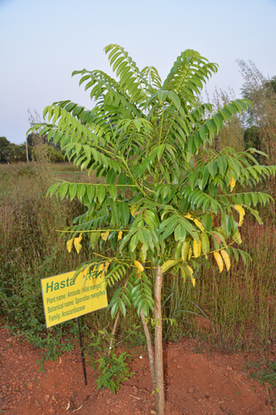
 |  |  | Ambada  (Wild mango) | Spondia magifera | Anacardiaceae
14. | Chitra  (Virginis spica) | 173° 20´-186° 40´ | Bael  (Stone apple tree) | Aegle marmelos | Rutaceae | 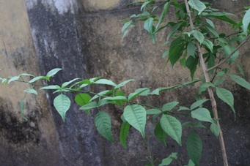
15. | Swathi  (Alpha Bootis/ Arcturus) | 186° 40´-200° 00´ | Arjun  (Arjun tree) | Terminalia arjuna | Combretaceae | 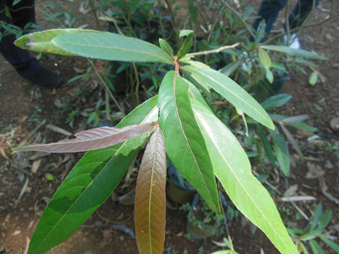
16. | Vishakha  (Alpha Librae) | 200° 00´-213° 00´ | Viklo  (Red spike thorn) | Mytenus emarginata | Celastraceae | 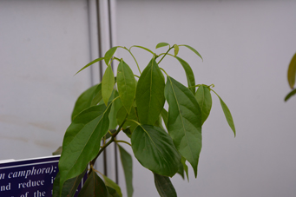
 |  |  | Parijat  (Night Jasmine) | Nyctanthes arbour-tristis | Salicaceae
 |  |  | Nagkesar  (Indian Rose Chestnut) | Messua ferrea | Calophyllaceae
 |  |  | Champhar  (Governor’s plum) | Flacourtia montana | Oleaceae
 |  |  | Dadhiphal  (Elephant apple ) | Limonium acidissimum | Rutaceae
17. | Anuradha  (Delta Scorpii) | 213° 00´-226° 40´ | Bakul  (Bullet wood) | Mimusops elenjii | Sapotaceae | 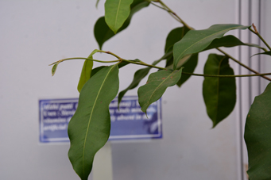
 |  |  | Nagkesar  (Indian rose Chestnut) | Messua ferrea | Calophyllaceae
18. | Jeshta (Antares) | 226° 40´-240° 00´ | Shimalo  (Red silk cotton tree) | Bombax malabaricum | Bombacaceae | 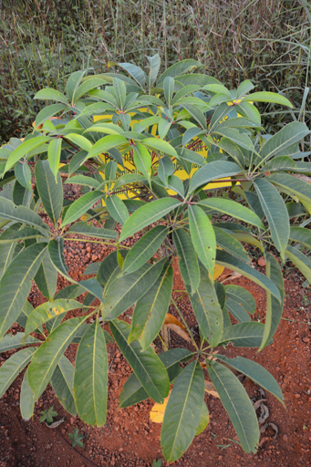
 |  |  | Kate savar  (Red cotton tree) | Bombax ceiba | Bombacaceae
 |  |  | Neem  (Margosa tree) | Azadirachta indica | Meliaceae
19. | Moola  (Lambada Scorpi) | 240° 00´-253° 20´ | Garmalo  (Indian laburnum tree) | Cassia fistula | Leguminacae | 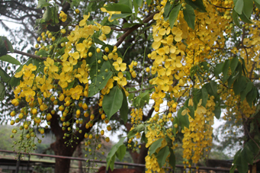
 |  |  | Raal  (White damar) | Vateria indica | Dipterocarpaceae
 |  |  | Bael  (Stone apple tree) | Aegle marmelos | Rutaceae
20. | Purva ashata  (Delta sagittarii) | 253° 20´-266° 40´ | Vet  (Rattan cane) | Calamus rotang | Arecaceae | 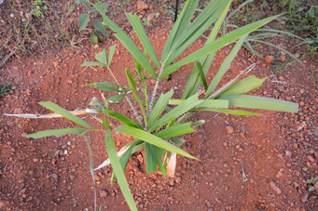
 |  |  | Sita ashok  (Ashoka tree) | Saraca indica | Caesalpinaceae
21. | Uttara ashata (Sigma sagittavivi) | 266° 40´-280° 00´ | Panas  (Jack fruit tree) | Artocarpus heterophyllus | Moraceae | 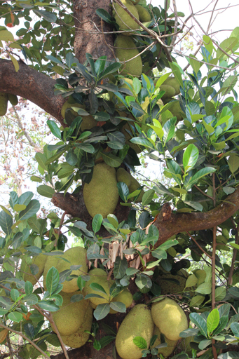
22. | Shravan  (Alpho Aquila/ Altair) | 280° 00´-293° 20´ | Rui  (Milk weed) | Calotropis procera/ gigantia | Asclepiadaceae | 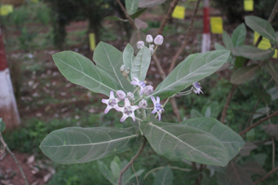
 |  |  | Nariyal  (Coconut tree) | Cocos nucifera | Arecaceae
 |  |  | Sita ashok  (Ashoka tree) | Saraca ashoka | Caesalpinaceae
23. | Dhanishtha  (Beta Dalphini) | 293° 20´-306° 40´ | Shami  (Spunge tree) | Prosopis cineraria | Mimosaceae | 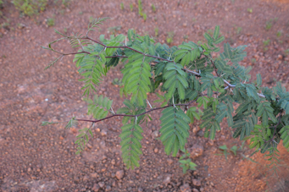
 |  |  | Nariyal  (Coconut tree) | Cocos nucifera | Arecaceae
24. | Shatataaraka (Lambda Aquarii) | 306° 40´-320° 00´ | Kadamb  (Burflower tree) | Mitragyana parvifolia  (Anthocephalus kadamba) | Rubiaceae | 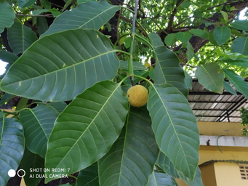
25. | Purva Bhadrapada (Beta pegasi/ Markab) | 320° 00´-333° 20´ | Aam  (Mango tree) | Mangifera indica | Anacardiacea | 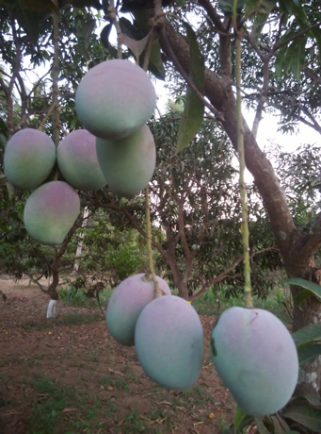
 |  |  | Neem  (Margosa tree) | Azadirachta indica | Meliaceae
26. | Uttara Bhadrapada (Gamma Pegasi/ Algenib) | 333° 20´-346° 40´ | Aam  (Mango tree) | Mangifera indica | Anacardiacea | 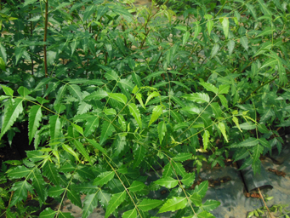
 |  |  | Neem  (Margosa tree) | Azadirachta indica | Meliaceae
27. | Revati  (Zeta piscium) | 346° 40´-360° 00´ | Mahua  (Indian butter tree) | Madhuca indica | Sapotaceae | 