1. Split phase induction motor.
2. [Capacitor](https://www.electrical4u.com/what-is-capacitor/)-start [inductor](https://www.electrical4u.com/what-is-inductor-and-inductance-theory-of-inductor/) motor.
3. Capacitor-start capacitor-run [induction motor](https://www.electrical4u.com/induction-motor-types-of-induction-motor/) (two-value capacitor method. Used to both start and run the motor).
4. Permanent split capacitor (PSC) motor.
5. Shaded pole induction motor.

**Split Phase Induction Motor**

In addition to the main winding or running winding, a single-phase induction motor’s stator carries another winding called auxiliary winding or starting winding. A centrifugal switch is connected in series with auxiliary winding.

This switch aims to disconnect the auxiliary winding from the main circuit when the motor attains a speed up to 75 to 80% of the synchronous speed.

We know that the running winding is inductive in nature. We aim to create the phase difference between the two winding, and this is possible if the starting winding carries high [resistance](https://www.electrical4u.com/electrical-resistance-and-laws-of-resistance/).

In the figure below, the variables represent:

* Irun is the [current](https://www.electrical4u.com/electric-current-and-theory-of-electricity/) flowing through the main or running winding,
* Istart is the current flowing in starting winding,
* VT is the supply voltage.

For a highly resistive winding, the current is almost in phase with the voltage, and for a highly inductive winding, the current lag behind the voltage by a large angle.

The starting winding is highly resistive so, the current flowing in the starting winding lags behind the applied voltage by a very small angle and the running winding is highly inductive in nature so, the current flowing in running winding lags behind applied voltage by a large angle.

The resultant of these two current is IT—the resultant of these two current produce rotating [magnetic field](https://www.electrical4u.com/what-is-magnetic-field/) which rotates in one direction.

In a **split-phase induction motor,** the starting and main current get split from each other by some angle, so this motor got its name as a split-phase induction motor.

**Applications of Split Phase Induction Motor**

Split phase induction motors have low starting current and moderate starting torque.

These motors are used in fans, blowers, centrifugal pumps, washing machines, grinders, lathes, air conditioning fans, etc. These motors are available in size ranging from 1/20 to 1/2 KW.

**Capacitor Start IM and Capacitor Start Capacitor Run IM**

The working principle of capacitor-start inductor motors is almost the same as capacitor-start capacitor-run induction motors.

We already know that a single-phase induction motor is not self-starting because the magnetic field produced is not a rotating type. To produce a rotating magnetic field, there must be some phase difference.

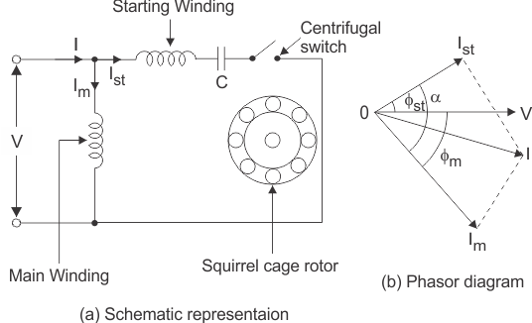

In the case of a split-phase induction motor, we use resistance for creating phase difference, but here we use a capacitor for this purpose. We are familiar with the fact that the [current](https://www.electrical4u.com/electric-current-and-theory-of-electricity/) flowing through the capacitor leads to the voltage.

So, in **capacitor start inductor motor** and **capacitor start capacitor run induction motor,** we are using two winding, the main winding, and the starting winding.

With starting winding, we connect a capacitor, so the current flowing in the capacitor, i.e., Ist leads the applied voltage by some angle, φst.

The running winding is inductive in nature so, the current flowing in running winding lags behind applied voltage by an angle, φm.

Now there occur large phase angle differences between these two currents, which produce a resultant current. This will produce a rotating magnetic field since the torque produced by these motors depends upon the phase angle difference, which is almost 90o.

So, these motors produce very high starting torque. In the case of capacitor start induction motor, the centrifugal switch is provided to disconnect the starting winding when the motor attains a speed up to 75 to 80% of the synchronous speed but in the case of capacitor start capacitors run induction motor.

**There** is no centrifugal switch so, the capacitor remains in the circuit and improves the [power factor](https://www.electrical4u.com/electrical-power-factor/) and the running conditions of the single-phase induction motor.

**Application of Capacitor Start IM and Capacitor Start Capacitor Run IM**

These motors have high starting torque; hence they are used in conveyors, grinders, air conditioners, compressors, etc. They are available up to 6 kW.

**Permanent Split Capacitor (PSC) Motor**

It has a cage rotor and stator. The stator has two windings – main and auxiliary winding. It has only one capacitor in series with starting winding. It has no starting switch.

**Advantages of Permanent Split Capacitor Motor**

No centrifugal switch is needed. It has higher efficiency and pull-out torque.

**Applications of Permanent Split Capacitor Motor**

It finds applications in fans and blowers in heaters and air conditioners. It is also used to drive office machinery.

**Shaded Pole Single Phase Induction Motors**

The stator of the **shaded pole single-phase induction motor** has salient or projected poles. These poles are shaded by a copper band or ring, which is inductive in nature.

The poles are divided into two unequal halves. The smaller portion carries the copper band and is called the shaded portion of the pole.

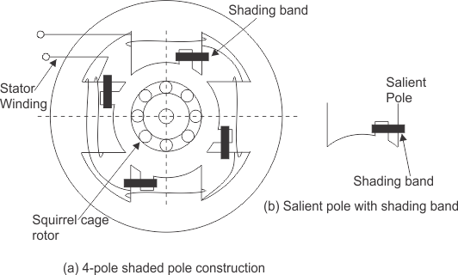

ACTION: When a single-phase supply is given to a shaded pole induction motor’s stator, an alternating flux is produced.

This change of flux induces emf in the shaded coil. Since this shaded portion is short-circuited, the current is produced in it in such a direction to oppose the main [flux](https://www.electrical4u.com/what-is-flux-types-of-flux/).

The flux in the shaded pole lags behind the flux in the unshaded pole. The phase difference between these two fluxes produces resultant rotating flux.

We know that the stator winding current is alternating in nature, and so is the flux produced by the stator current. To clearly understand the working of shaded pole induction motor, consider three regions-

1. When the flux changes its value from zero to nearly maximum positive value.
2. When the flux remains almost constant at its maximum value.
3. When the flux decreases from a maximum positive value to zero.

REGION 1:  
When the flux changes its value from zero to nearly maximum positive value – In this region, the rate of rising flux and current is very high.

According to [Faraday’s law](https://www.electrical4u.com/faraday-law-of-electromagnetic-induction/), whenever there is a change in flux emf gets induced. Since the copper band is a short circuit, the current starts flowing in the copper band due to this induced emf. This current in the copper band produces its own flux.

According to [Lenz’s law](https://www.electrical4u.com/lenz-law-of-electromagnetic-induction/), the direction of this current in the copper band is such that it opposes its own cause, i.e., rise in current.

So the shaded ring flux opposes the main flux, which leads to the crowding of flux in the non-shaded part of the stator, and the flux weakens in the shaded part.

This non-uniform distribution of flux causes the magnetic axis to shift in the middle of the non-shaded part.

REGION 2:  
When the flux remains almost constant at its maximum value- In this region, the rate of rising current and hence flux remains almost constant.

Hence there is very little induced emf in the shaded portion. The flux produced by this induced emf has no effect on the main flux, and hence the distribution of flux remains uniform, and the magnetic axis lies at the center of the pole.

REGION 3:  
When the flux decreases from a maximum positive value to zero – In this region, the rate of decrease in the flux and hence current is very high. According to [Faraday’s law](https://www.electrical4u.com/faraday-law-of-electromagnetic-induction/), whenever there is a change in flux emf gets induced.

Since the copper band is a short circuit, the current starts flowing in the copper band due to this induced emf. This current in the copper band produces its own flux. According to [Lenz’s law](https://www.electrical4u.com/lenz-law-of-electromagnetic-induction/), the direction of the current in the copper band is such that it opposes its own cause, i.e., a decrease in current.

So the shaded ring flux aids the main flux, which leads to the crowding of flux in the shaded part of the stator, and the flux weakens in the non-shaded part. This non-uniform distribution of flux causes the magnetic axis to shift in the middle of the pole’s shaded part.

This shifting of the magnetic axis continues for the negative cycle and leads to the production of a rotating magnetic field. This field’s direction is from the non-shaded part of the pole to the shaded part of the pole.

**Advantages and Disadvantages of Shaded Pole Motor**

The advantages of shaded pole induction motor are

1. Very economical and reliable.
2. Construction is simple and robust because there is no centrifugal switch.

The disadvantages of shaded pole induction motor are

1. Low power factor.
2. The starting torque is very poor.
3. The efficiency is very low as the copper losses are high due to the presence of the copper band.
4. The speed reversal is also difficult and expensive as it requires another set of copper rings.

**Applications of Shaded Pole Motor**

Applications of Shaded pole motors induction motor are-

Due to their low starting torques and reasonable cost, these motors are mostly employed in small instruments, hairdryers, toys, record players, small fans, electric clocks, etc. These motors are usually available in a range of 1/300 to 1/20 KW.

Top of Form

Bottom of Form

Top of Form

Bottom of Form