Marketing Plan Template

How to Use This Template
This template should be used as a starting point for your company’s marketing plan. It includes customizable sections There will be instructions and sample text, as well as prompts in [brackets] for you to complete as guided.

You can add/edit/delete any copy or sections as you see fit. We’ve also included an example of what this template might look like once it’s finished below the template itself.

Keep scrolling to templates
↓↓↓

Your Company Name
Marketing Plan

Our Objective | This statement should reflect your overall strategy outlined in the pages that follow.
Authors of Document | [Name #1]  [Email Address #1]  [Name #2]  [Email Address #2]

Business Summary

Our Company
[Company name] is a company headquartered in [location of HQ] with offices in [satellite office locations]. The company’s mission is to [mission statement].

Our Leaders

[Marketing Leader 1] | [Leader 1] is [company name]’s [job title of Marketing Leader 1]. They will [brief job description of Marketing Leader 1].
[Marketing Leader 2] | [Leader 2] is [company name]’s [job title of Marketing Leader 2]. They will [brief job description of Marketing Leader 2].
[Marketing Leader 3] | [Leader 3] is [company name]’s [job title of Marketing Leader 3]. They will [brief job description of Marketing Leader 3].

Tip: | You might want to call out some of the features that make your leadership team spectacular, such as education, years of experience, and specific areas of expertise. You can also include headshots.

Business Initiatives

[Company name] has the ambitious goal of [overarching company goal]. To help the business do that, our marketing team will pursue the following initiatives in [current year]:

Initiative 1
Description | [Example: Over the next 12 months, we’ll work on building a blog property that becomes a go-to resource for our customers’ burning questions – and our number-one source of leads month over month.]
Goal of initiative | [Example: To increase our website’s rank on Google and create critical top-of-the-funnel marketing content that helps our sales team start more conversations with prospects.]
Metrics to measure success | [Example: 50,000 organic page views per month / 10 content downloads per month]

Initiative 2
Description | [Example: Over the next 12 months, we’ll work on building a blog property that becomes a go-to resource for our customers’ burning questions -- and our number-one source of leads month over month.]
Goal of initiative | [Example: To increase our website’s rank on Google and create critical top-of-the-funnel marketing content that helps our sales team start more conversations with prospects.]
Metrics to measure success | [Example: 50,000 organic page views per month / 10 content downloads per month]

Initiative 3
Description | [Example: Over the next 12 months, we’ll work on building a blog property that becomes a go-to resource for our customers’ burning questions -- and our number-one source of leads month over month.]
Goal of initiative | [Example: To increase our website’s rank on Google and create critical top-of-the-funnel marketing content that helps our sales team start more conversations with prospects.]
Metrics to measure success | [Example: 50,000 organic page views per month / 10 content downloads per month]

Target Market

Industries
In [current year], we’re targeting the following industries where we’ll sell our product and reach out to customers:
Industry 1 | This includes [sub-industries where your business might target more specific segments of your audience]. [Example: Industry 1: Food and Beverage. This includes bar & grills, breweries, steakhouses, etc.]

Industry 2 | This includes [sub-industries where your business might target more specific segments of your audience]. [Example: Industry 1: Food and Beverage. This includes bar & grills, breweries, steakhouses, etc.]

Buyer Personas
Within our target market(s), we’ve identified the following buyer personas to represent our ideal customers:

Buyer Persona 1 | This includes [sub-industries where your business might target more specific segments of your audience]. [Example: Industry 1: Food and Beverage. This includes bar & grills, breweries, steakhouses, etc.]

Buyer Persona 2 | This includes [sub-industries where your business might target more specific segments of your audience]. [Example: Industry 1: Food and Beverage. This includes bar & grills, breweries, steakhouses, etc.]

Competitive Analysis
Within our target market(s), we expect to compete with the following companies:

Company 1
Products we compete with | [This competitor’s product/service, what it does, and what it might do better than yours]
Other ways we compete | [Example: This competitor has a blog that ranks highly on Google for many of the same keywords we would like to write content on]

Company 2
Products we compete with | [This competitor’s product/service, what it does, and what it might do better than yours]
Other ways we compete | [Example: This competitor has a blog that ranks highly on Google for many of the same keywords we would like to write content on]

Company 3
Products we compete with | [This competitor’s product/service, what it does, and what it might do better than yours]
Other ways we compete | [Example: This competitor has a blog that ranks highly on Google for many of the same keywords we would like to write content on]

Tip: | You can use to Spyfu to conduct more thorough research on your competitors online presents. They will not give you everything for free, but they do give you enough to know what your competition is doing.

Market Strategy

Product
[Describe the products with which you will enter the target market described in the section above. How will this product solve the challenges described in your buyer persona description(s)? What makes this product different from (or at least competitive against) your competition?]

Price
[How much are you selling this product for? Is it competitive? Realistic for your customers’ budget? Will you run any seasonal promotions/discounts associated with this product?]

Promotion
[How will you promote this product? Think more deeply than your blog or social media channels. What about this content will drive value into your product?]

People
[Who in the marketing department plays a role in your market strategy? Describe what each of them, or each team, will do to bring your market strategy success.]

Budget
Over the course of [current year], given the cash allotted to the Marketing team, we expect to invest in the following items to ensure we meet the objectives outlined in this marketing plan:
Marketing Expense | Estimated Price
[Expense Name]
[Expense Name]
[Expense Name]
[Expense Name]
[Expense Name]
[To add more rows to this table, right-click a cell, then select Insert > Rows Above / Rows Below]
Total | [Total Marketing Team Expense for Current Year]

Marketing Channels

Over the course of [current year], we will launch/ramp up our use of the following channels for educating our customers, generating leads, and developing brand awareness:

[Website/Publication 1]
Purpose of channel | [Example: Brand Awareness]
Metrics to measure success | [Example: 50,000 unique page views per month]

[Website/Publication 2]
Purpose of channel | [Example: Brand Awareness]
Metrics to measure success | [Example: 50,000 unique page views per month]

[Social Network 1]
Purpose of channel | [Example: Brand Awareness]
Metrics to measure success | [Example: 50,000 unique page views per month]

[Social Network 2]
Purpose of channel | [Example: Brand Awareness]
Metrics to measure success | [Example: 50,000 unique page views per month]

Marketing Technology

We will utilize the following technologies and software to help us achieve our goals and objectives. (based on your business some of this might not be needed.)

Marketing CRM
[Name the CRM you will use and briefly explain how it will be used.]

Email Marketing Strategies
[Name the email marketing strategies you will use and briefly explain how it will be used.]

Marketing Strategies
[Name the marketing strategies you will use and briefly explain how it will be used.]

Advertising Strategies
[Name the advertising you will use and briefly explain how it will be used.]

Social Media Strategies
[Name the social media platforms you will use and briefly explain how it will be used.]

Marketing Plan Example
Need some inspiration? We took the liberty of filling out the template for a mock company. Feel free to take some pointers!

Keep scrolling to the example
↓↓↓

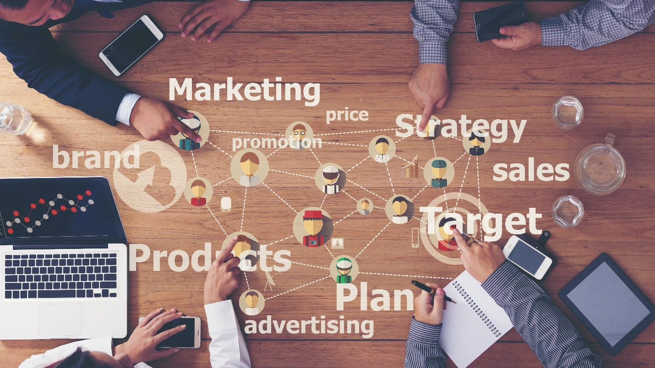

Local Media Solutions

Marketing Plan Example

Our Vision | To continue to contribute to economic growth and education to business owners.
Authors of Document | Christy Tartavoulle  Christy@localmediasolutionsllc.com

Table of Contents | Business Summary  Business Initiatives  Target Market  Market Strategy  Budget  Marketing Channels  Marketing Technology

Business Summary

Local Media Solutions
Local Media Solutions is a Mississippi-based marketing agency. We offer full marketing services and exist to offer unparalleled marketing work to businesses in Mississippi and neighboring areas. Our passion is to develop innovative strategies with our local businesses and in turn achieve economic growth in our community by creating affordable and impactful media solutions. Our marketing agency comes from all facets of the media and digital marketing including media planning, buying, business marketing training, image management, digital analytics, event coordinating as well as areas of talent including musicians, photographers, film producers and web designers.
We guarantee to bring you one step closer to your customer.

Our mission is to empower Mississippi organizations to effectively prepare a marketing plan. To transform people and businesses through remarkable growth is supported by our talented team. At Local Media Solutions, our values aren’t just on the wall for visitors to see, they are evident in every client conversation, every company meeting, every email, and every 1 one 1 conversation.

Our Marketing Leaders
Christy Tartavoulle is the CEO. She started the agency in 2017 bringing twenty-four years of marketing experience including photography
Christy was raised in Jones County, Mississippi. She received her chance in advertising in 1999 from her formal boss Demaris Lee. After seeing the struggles business owners face with no marketing plan, it inspired her to open a business focused on helping local businesses thrive.
Cassey Hust is the Social Media Manager. She has experience in Advertising Sales, digital marketing with specialties in content marketing and graphic design.
Cassey joined the agency in 2022.
Jonathan McGowan is the film producer. Jonathan McGowan with JMAC Productions has over 10 years’ experience in the industry with a proven track record of excellent filming/videography/editing/writing skills and the ability to assist in the development of high quality, creative and compelling concepts for advertising.

Strengths | Weaknesses
- Talent. Local Media solutions includes talent in advertising, marketing, social media, web design, graphic art, photography, videography, jingles, planning, and event coordination.  - Customer base. Our agency serves some of the area’s best business owner and a full reference base. | - Profit margins. Due to a economy crisis and businesses suffering to stay open, we need to keep our prices low.

Opportunities | Threats
- Demand for digital. There is a growing demand for digital marketing services in LMS.  - Growing population. As LMS population grows, so does the number of businesses. | - Competition. There are at least 3 other marketing area agencies, however, we thrive to keep up with the education and new products and software as they surface.  - Slow business growth. Orgs are still struggling to recover from the economic downturn.

Business Initiatives

Local Media Solutions has the ambitious goal of acquiring 10 new customers and retaining 95% of its existing customer base this year. To help the business do that, our marketing team will pursue the following initiatives.

Initiative 1: Invest in Account-Based Marketing
Description | Local Media Solutions has found significant success with digital targeting, but we have yet to dedicate resources to targeted, account-based initiatives. To do this, we will put employees in a full training camp.
Goal of initiative | Appeal to larger, higher-volume clients who want a personalized pitch and approach.
Metrics to measure success | 5 accounts acquired exclusively through account-based marketing campaigns.

Initiative 2: Explode our Online Presence
Description | To build upon our existing online success, we need to invest resources into strategically growing our online presence as well as turning a profit on contacts acquired through these efforts.
Goal of initiative | Through a combination of paid campaigns, new content campaigns, and exploring new online groups, we can tap into new personas and appeal to more potential clients.
Metrics to measure success | Double our organic traffic numbers and paid ad leads.

Initiative 3: Become the Pine Belts Workshop Destination
Description | One area we have yet to pursue is a workshop. We know people are craving online content, community, and education, and LMS is able to provide that to businesses.
Goal of initiative | Produce a minimum of 4 workshops to bring in new leads, engage with existing clients, and provide tactical and topical information to help the Pine Belt businesses thrive.
Metrics to measure success | 200 workshop registrants (25 each session)  10 new clients.

Target Market

Industries
This year, we’re targeting the following industries where we’ll sell our product and reach out to customers:
Medical

Pine Belt Medical continues to grow, and these businesses are pivoting due to a rise in demand for online doctor visits since covid 19. They are on track to use digital more than ever.

Trade Schools

With more trade schools in Mississippi keep growing and with the demand in job opportunities, these educational hubs are an untapped market – particularly private institutes.

Market Strategy

Product
Local Media Solutions is a full marketing agency, offering expert support and services in all the following areas:
- Content Marketing.
- Photography
- Paid Marketing Campaigns.
- Video Production.
- Graphic Design.
- Website Development.
- General Marketing Strategy.
Our services provide a range of options for businesses and organizations of all size and experience. We’re happy to work with for-profit and nonprofit, private, and public, large and small businesses alike.

Price
Our price range varies by business type, size, and need. We craft specific packages based on the impact our work will have on our clients’ bottom lines, the amount of output our team will produce, and the administrative and research billable hours our team will undertake.

Promotion
We promote our services in the following ways:

- Organic channels, such as our website and our blog.
- Paid campaigns on social media and search engines for targeted business owners in San Diego.
- Workshops – our newest investment to speak to prospects, customers, and new contacts alike.

People
Our Marketing Team has 2 employees and 4 subcontractors We have specialists in video graphing, events coordinating, branding, web developers and social eager to help our company reach new heights.

Process
Due to our sprint approach, our process will look different for all customers. Clients will receive all services they are interested in, and we will work with them on a timeline that best suits their needs and budget.

Budget (example and not actuals for LMS)
Over the course of this year, given the cash allotted to the Marketing team, we expect to invest in the following items to ensure we meet the objectives outlined in this marketing plan:
Marketing Expense | Estimated Price
Marketing Software | $10,000
Event Sponsorships | $5,000
Paid Social | $12,000
Paid Search | $30,000
Total | $57,000

Marketing Channels (examples and not actuals of LMS)

Over the course of the year, we will launch (or ramp up) our use of the following channels for educating our customers, generating leads, and developing brand awareness:

Webinars
Purpose of channel | Brand awareness, customer acquisition, and client engagement.
Metrics to measure success | Webinar signups, signup-to-attendance rate, attendee-to-QL rate.

Instagram
Purpose of channel | Employee branding, company brand awareness, visual engagement.
Metrics to measure success | Followers, likes.

