

**Panka Insurance Agency Referral Program**

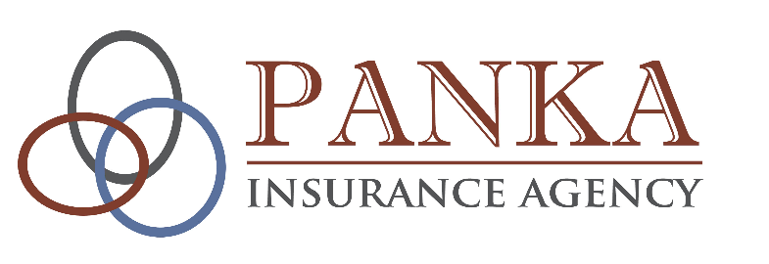

**Ivanhoe Office**

119 W Saxon St | Ivanhoe, MN 56142

(507) 694-1750

**Canby Office**

130 1st St W, Suite 101 | Canby, MN 56220

(507) 223-5527

**Follow us:**

@PankaInsurance Agency

www.pankainsuranceageny.com

**Newsletter | Fourth Quarter 2022**

**Crop Insurance**

Two types of crop insurance are available to farmers in the United States: Crop-Hail and Multiple Peril Crop insurance (MPCI).

**“Crop-Hail”** policies are not part of the Federal Crop Insurance Program and are provided directly to farmers by private insurers. Many farmers purchase Crop-Hail coverage because hail has the unique ability to totally destroy a significant part of a planted field while leaving the rest undamaged. In areas of the country where hail is a frequent event, farmers often purchase a Crop-Hail policy to protect high-yielding crops. Unlike MPCI, a Crop-Hail policy can be purchased at any time during the growing season.

**“Multi-Peril Crop Insurance”** (MPCI) policies must be purchased prior to planting and cover loss of crop yields from all types of natural causes including drought, excessive moisture, freeze and disease. Newer coverage options combine yield protection and price protection to guard farmers against potential loss in revenue, whether due to low yields or changes in market price.

Under the Federal Crop Insurance Program’s unique public-private partnership, there are currently 15 private companies authorized by the United States Department of Agriculture Risk Management Agency (USDA RMA) to write MPCI policies.

The program is overseen and regulated by the Risk Management Agency (RMA). The RMA sets the rates that can be charged and determines which crops can be insured in different parts of the country.

The federal government also subsidizes the farmer-paid premiums to reduce the cost to farmers. In addition, it provides reimbursement to the private insurance companies to offset operating and administrative costs that would otherwise be paid by farmers as part of their premium. Through this federal support, crop insurance remains affordable to a majority of America’s farmers and ranchers.

By combining the regulatory authority and financial support of the federal government with the efficiencies of the private sector, the crop insurance program has succeeded in meeting and even surpassing the goals set forth by Congress for broad participation, diversity and inclusion. By using the private sector, risk is shared among the private companies as well as the government.

*Source: https://cropinsuranceinamerica.org/how-it-works/*

Thank you to everyone who referred a friend or family member to Panka Insurance Agency last year! We love supporting the charitable efforts in our communities so we’ve tied referrals and charitable giving together!

Our referral program rewards you when you refer friends and family to our agency. For every client that receives a proposal from us:

1. We donate $15 to an area non-profit organization,
2. The person that referred someone gets their name entered into a quarterly drawing for a $100 Gift Card.

Both happen regardless of whether the person or business who received the proposal switches to Panka Insurance Agency!

Thank you to all of the people who made those referrals, and congratulations to the 4 winners of the $100 gift cards this year: **Name**, **Name**, **Name**, and **Name**!

Because of those referrals, this year we were able to make a donation of $__ to **Lincoln Elementary Foundation** in Ivanhoe!

Thank you again to everyone for sending friends and family to us, and congratulations to **Lincoln Elementary Foundation**! We are excited to announce that our 2023 non-profit recipient will be **__**!

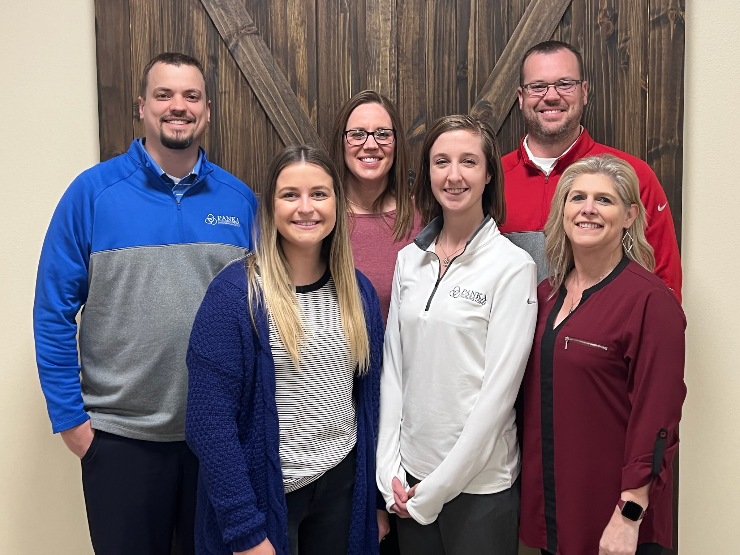

**Wishing you and your family a Happy New Year!**

To learn more about Panka Insurance Agency, check out our new website! **www.pankainsuranceagency.com**

<EMPTY><EMPTY><EMPTY>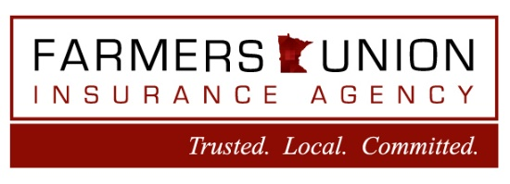<EMPTY><EMPTY><EMPTY><EMPTY><EMPTY><EMPTY>

www.pankainsuranceagency.com

@Panka Insurance Agency

Visit our website or follow us on Facebook to receive updates on our community involvement and for other insurance related updates!

**Lincoln Elementary Foundation**

421 Rebecca St. | Ivanhoe, MN 56142

(507) 694-1540

Your referrals mean the world to us. We work hard to earn each referral with great service and appreciation for your business. We also love supporting the charitable efforts in our communities, so we’ve tied referrals and charitable giving together. *Here’s how it works:*

* A referral is when we get a request for a quote from someone saying you referred them to us, and we complete a proposal.
* For each referral we receive, we will **donate $15** to our charity of choice: **­­­ Lincoln Elementary Foundation (Ivanhoe).**
* We will draw one name from the list of people who referred someone to us each quarter, and the winner will receive a $100 gift card! The person you referred does not need to purchase insurance from us for you to qualify for the gift card!
* **4th Quarter update** – We had # referrals which means we will donate $ to **Lincoln Elementary Foundation!** Congratulations to our 4th quarter winner, **Name**! Enjoy your $100 gift certificate to __ in City! And a huge **THANK YOU** to everyone who gave us a referral! We love referrals, so please keep sending your friends and family to us! referral

Client Spotlight:

**Blue Salon & Spa**

Visit our website to learn more about our services at [**www..com**](http://www.bisbeeph.com).

119 W Saxon St | PO Box 31 | Ivanhoe, MN 56142

130 1st St W, Suite 101 | Canby, MN 56220

www.pankainsuranceagency.com

**Lincoln Elementary Foundation**

421 Rebecca St. | Ivanhoe, MN 56142

(507) 694-1540

**We Reward You When You Refer Your Friends & Family!**

*Our office today in Ivanhoe.*

*Our view during Polish Days!*

*Our office today in Canby.*

*Our office today in Ivanhoe.*

*Our view during Polish Days!*

*Our office today in Canby.*

*Our office today in Ivanhoe.*

*Our view during Polish Days!*

*Our office today in Canby.*