Bath Youth Cheer
Season 5 Competition Cheer
2026/2027 Season Packet
Kindergarten through 8th Grade
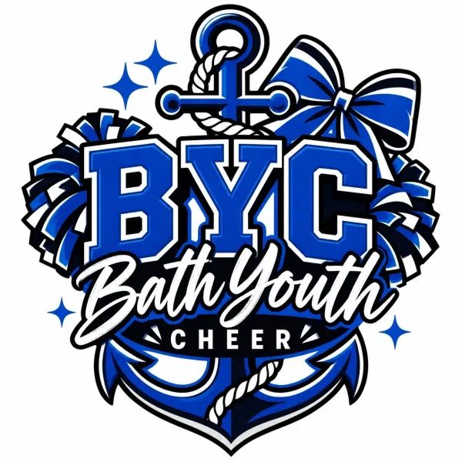
Bath Middle School Cafetria – 6 Old Brunswick Road, Bath, ME

Stay Connected with Bath Youth Cheer!
Make sure you’re following us and staying up to date:
- Website: www.bathyouthcheer.com
- Facebook: www.facebook.com/bathyouthcheer
- Instagram: www.instagram.com/bathyouthcheer
- Fundraising Page: www.facebook.com/share/g/1BVjsLB2QA/
- Email: bathyouthcheer@icloud.com

Table of Contents
Season Schedule & Important Dates – Page 3
- Practice Schedule
- Showcase & Competition – Dates & Location Information
Program Cost & Information – Page 4
- Financial Obligations
- Payment Information
- Payment Methods
General Fundraising Information – Page 5
Practice, Events, & Competition Expectations – Page 6
- Attendance
- Competition Attendance
- Timeliness
- Respect & Behavior Expectations
- Sportsmanship
Uniform Information – Page 7
Competition Cheer Shoes Information – Page 8
Cancellations, Closures & Staying Informed – Page 9
Spectator & Facility Expectations – Page 10
- Commitment Statement

Season Schedule & Important Dates
Competition Practice Schedule: Starting Monday October 26, 2026
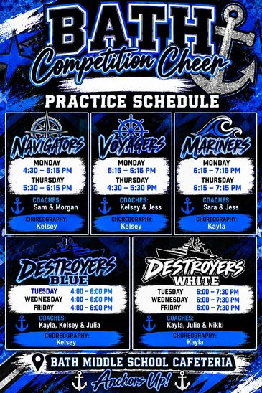
Showcase & Competition Dates & Information:
- Family & Friends Showcase: TBD
- Tentative Competition Schedule: TBD (At least five local competitions)
Program Cost & Information
Competition Financial Obligations:
- Competition Fee: $250.00
- Payment Plan: $50.00 a month October 1, 2026 – February 1, 2027 (5 total invoices)
- Payment Plan with Sibling Discount: $75.00 a month October 1, 2026 – February 1, 2027 (5 total invoices)
- Sibling Discount: A $125.00 sibling discount is available for siblings only who are registered within the same family. The discount does not apply to cousins, friends, or other non-sibling athletes.
- Late Fee: A $25.00 late fee will be applied to any payment that remains unpaid 14 days after the invoice due date. For example, an invoice due on October 1, 2026, will incur a late fee on October 15, 2026.
- Square/Venmo Processing Fee: $3.85
Families are encouraged to participate in fundraising efforts, which help offset program costs and allow Bath Youth Cheer to continue providing an affordable program for our athletes.

Payment Information:
All payments are final. No refunds will be issued for the 2026/2027 competition season.
After your athlete is registered through Jackrabbit, a payment link will be sent to your email on file through Square invoicing.
Families may choose one of the following payment options:
- Pay the full season balance by October 25, 2026.
- Enroll in the monthly payment plan, with the October invoice paid in full by the invoice due date.
The October 25, 2026, deadline allows families participating in the Pie and Cookie Dough Fundraiser time for applicable fundraising credits to be reflected on their invoice.
A $25.00 late fee will be applied to any unpaid balance 14 days after the invoice due date. For payments due October 25, 2026, the late fee will be applied on November 8, 2026.

Payment Methods:
- Square: Payments may be made directly through the Square invoice.
- Venmo: @bathyouthcheerinc
- Cash
Note: When paying through Venmo, please include the applicable processing fee with your payment.

General Fundraising Information
Family participation in fundraising is encouraged and greatly appreciated. Fundraising helps Bath Youth Cheer keep program costs affordable while supporting our athletes and strengthening our presence in the community. Every family’s participation makes a difference and helps support the continued growth and success of our program.
Fundraising is available throughout the competition season to help families offset their athlete’s season balance. Fundraising funds are applied as account credits and have no cash value.
Families who pay their full season balance in advance may not use future fundraising funds for reimbursement. However, fundraising funds may be used toward future BYC invoices, including tumbling classes, stunt clinics, and other eligible program fees offered throughout the season.
For families enrolled in the monthly payment plan:
- Fundraising funds are applied to the newest outstanding invoice.
- Funds cannot be divided between multiple invoices unless the total amount raised is enough to fully cover the newest invoice. Any remaining balance will then be applied to the next invoice.
- Fundraising funds may not be applied toward uniform purchases or uniform replacement costs.
Fundraising funds are valid for 12 months from the date earned. Any unused funds remaining after 12 months will be automatically donated to Bath Youth Cheer.
Families are encouraged to follow the Bath Youth Cheer website under Fundraising Opportunities and our Facebook fundraising page for updates and information on upcoming fundraisers.
Fundraising Opportunities | Bath Youth Cheer
https://bathyouthcheer.com/fundraising-opportunities
www.facebook.com/share/g/1BVjsLB2QA/
Additional fundraising opportunities will be announced throughout the competition season.

Practice, Events, & Competition Expectations
Attendance:
- Cheer is a high-commitment program. Attendance at all practices, competitions, and events is mandatory.
- If an athlete will be late or absent, a parent or guardian must notify BYC as soon as possible by emailing bathyouthcheer@icloud.com.
- Excessive absences or tardiness may affect routine placement and participation.
*Illness and emergencies are understood and handled on a case-by-case basis.

Competition Attendance:
- Competition attendance is mandatory for all athletes. Planned vacations or trips that result in an athlete missing a competition are not permitted.
- If an athlete misses a competition due to a planned vacation or trip, their absence will affect their placement on their competition team.
Timeliness:
- Arrive on time and prepared for all practices, competitions and events.
- Athletes must bring a full water bottle.
- Athletes must wear comfortable athletic practice wear, indoor use only cheer shoes, and ready to begin at the scheduled start time.

Respect & Behavior Expectations:
- Athletes are expected to show respect for themselves, their teammates, coaches, and all program staff at all times.
- Positive attitudes and mutual encouragement help create a strong and supportive team culture.
- Disrespectful language, behavior, or actions toward anyone will not be tolerated.

Sportsmanship:
- Athletes are representatives of Bath Youth Cheer both on and off the mat.
- Good sportsmanship is expected at all practices, competitions, and events.
- This includes cheering for teammates, being kind to other teams, and demonstrating professionalism at all times.
- Negative behavior, unsportsmanlike conduct, or poor representation of the program may lead to consequences, including limited participation.

Uniform Information

Uniform Care:
- Uniforms must be handled with care and kept clean throughout the competition season.
- When not actively competing, athletes must wear a shirt over their uniform at competitions and performances.
- Washing Instructions: Wash uniforms in cold water, inside out, without bleach, and hang to dry. Proper care throughout the season helps keep uniforms looking their best for competitions and performances.
- Uniforms that are lost, damaged, or require replacement due to improper care may result in additional replacement costs for the parent/guardian. No additional discounts or fundraising efforts may be applied toward the replacement purchase of a uniform.

Uniform Purchase:
- Families may purchase their athlete’s uniform for $115.00 to keep after the competition season.
- No additional discounts or fundraising efforts may be applied toward the purchase of a uniform.
- Until purchased, uniforms remain property of Bath Youth Cheer and must be returned in good condition at the end of the season.



Competition Cheer Shoes Information

All athletes are required to wear completely white cheer shoes for competitions. Below are our recommended options that work well for our teams:
- Amazon Option - Amazon.com
  - Amazon.com | chassé Ace II Youth Cheerleading Shoes - White Cheer Shoes for Girls | Cheerleading
  - https://a.co/d/0iEXAwOm
- Chassé Apex Cheer Shoe – Omni Cheer
  - Chasse Apex Shoe - Cheerleading Shoes | Omni Cheer
  - https://www.omnicheer.com/products/chasse-apex-s1702?variant=45869126090925&utm_source=google&utm_medium=cpc&adpos=&scid=scplpS1702-180-4&sc_intid=S1702-180-4&utm_source=google&utm_medium=cpc&adpos=&nbt=nb%3Aadwords%3Ax%3A24134038304%3A%3A&gad_source=1&gad_campaignid=24139033084&gbraid=0AAAAAC0h1e3znzTEp1O3iR5JaQrisyPmQ&gclid=Cj0KCQjw8ofWBhCHARIsANBj4LuqTyxWv_NJ4AVJ2Fs8_HfeFf87kpWRwUAtZyjCC_rGnl_WkXv4ay0aAlPHEALw_wcB
Shoes should provide proper support while allowing the flexibility needed for stunting, tumbling, jumping, and other cheer movements.
When selecting competition shoes, families should look for:
- Completely white shoes, including the sole and details whenever possible.
- A supportive arch and secure fit.
- A flexible design appropriate for cheer and dance.
- Cheer-specific or dance sneakers are recommended.
Completely flat shoes, such as Converse-style sneakers, should not be used as they do not provide the support needed for cheer activities.
Families may purchase cheer sneakers from a variety of retailers and cheer-specific suppliers. There are many styles and price points available, but all competition shoes must be white, supportive, and appropriate for cheerleading.
Recommended Retailer Options:
- Dicks Sporting Goods
- OmniCheer.com
- Amazon

Closures, Cancellations & Staying Informed

Seasonal Breaks & Closures:
Bath Youth Cheer observes scheduled breaks throughout the competition season. Families are encouraged to plan vacations and special events during these periods whenever possible.
- Thanksgiving Week — No scheduled practices or activities.
- December Holiday Break — Optional clinics, camps, or special events may be offered.
- February Spring Break — Optional clinics, camps, or special events may be offered.

Subject to Change. Exact dates and additional details will be communicated to families as they become available.

Communication of Cancellations:
- In the event of inclement weather or unexpected cancellations, Bath Youth Cheer will notify families via email and post updates on Facebook.
- Please make sure your contact information is up to date, so you don’t miss important announcements.

Practice Cancellations & Make-Up Days:
- If school is cancelled, this does not automatically mean practice is cancelled.
- A separate decision will be made by the coaching staff based on weather, travel conditions, and safety.
- If practice is cancelled due to inclement weather, a make-up practice may be scheduled if needed.

Competition Cancellations:
- Competition cancellations are typically determined the night before or the day of the event.
- Families will be notified as soon as information is received from event organizers.

Staying Informed:
- Families are encouraged to stay vigilant and check email and Facebook regularly during inclement weather.
- If you have any questions or concerns, please don’t hesitate to email us directly for clarification.

Spectator & Facility Expectations
Family & Spectator Expectations:
- Families attending practices are asked to help maintain a quiet and respectful environment so athletes and coaches can remain focused on instruction and safety.
- Parents, guardians, siblings, and spectators should avoid disrupting practices through excessive noise, conversations, or distractions.
- Bath Youth Cheer staff may ask individuals to wait in their vehicle if their presence becomes disruptive to practice activities.
- Families are asked to supervise younger children at all times.

Facility & Safety Expectations:
- Doors cannot be propped open unless specifically authorized by facility personnel.
- No pets are permitted inside practice facilities unless required by law as a service animal.
- Food and beverages are not permitted on cheer mats, training surfaces, or equipment. Water is encouraged and should be kept in designated areas.
- All athletes, families, and visitors are expected to treat school property, equipment, and grounds with care and respect.
Bath Youth Cheer is grateful for the use of facilities provided by community partners, including Bath Middle School. Continued access to these facilities depends on our ability to maintain a safe, respectful, and responsible environment for all users.

Commitment Statement
By participating in Bath Youth Cheer, all athletes and families acknowledge that they have read, understand, and agree to follow the Bath Youth Cheer Season 5 Competition Cheer 2026/2027 Season Packet in its entirety.
Participation in the program requires a commitment to follow all policies, expectations, schedules, and financial responsibilities outlined in this packet. Failure to meet these expectations may result in appropriate action, including changes to team participation or removal from the program when necessary.
Questions?
If you have any questions about the competition season, please contact us. bathyouthcheer@icloud,com
Anchors Up!
Bath Youth Cheer Board of Directors
