Hi Family and Friends:

So, it has happened…we finally bought a house! As you might suspect, purchasing a house in Ukraine at this time was quite a process! This process started three years ago when we dared to dream with God about having our own house in which we could grow our family and better serve others.

Finding the right house was a lengthy and detailed process and involved exploring different options - from buying a piece of land and building on it to buying a house that we could move into right away. Unfortunately, we had to deal with dishonesty and misinformation by some of the home builders in Ukraine. People are not always honest about following code and using quality building materials. This house we selected meets our expectations.

The house we purchased is near the city of Ternopil where we currently live. It is a 1,290 square foot house on one floor with 3 bedrooms. The unfinished inside gives us the opportunity to make the inside features to fit our own needs and tastes. We will be hosting speakers and guests from around the world, and our home will be a ministry tool as well as a place to settle.

Some of you may be asking: why buy a house now and in a war-torn country? Our answer is that one must move on in life in confidence and faith in doing God’s work – the ministry we’re called to do - and there *are* great needs here.

We are super excited about this new chapter in our life. God is so good. He has done so many miracles in both our lives. It’s hard to believe that we finally are going to have our own home and will not continue to have to move often. We are so looking forward to filling that house with some joy and laughter and some good times - to see Emma grow there, to be able to host, to share about Jesus with our guests, and to conduct ministry to many people of all ages and background.

We are so grateful for the support you have provided to our ministry over the years. Our need now is to finance finishing the inside of the house; this involves sheet rocking, adding the flooring, plumbing, cabinets, and closets, etc., and purchasing appliances and furniture. We estimate that $75,000 should cover all those expenses. That is a lot of money, and we need a miracle from God. We have explored financing the finishing of the house by taking a loan, but we do not qualify for a loan due to our variable and relatively low income.

We would like to askyou to prayerfully consider making a *special contribution* to us for finishing our house. We need to raise $75,000 to complete the house and move in. **The timing of your response is very critical at this time:** prices here for this kind of construction work are going up every day, as a lot of the men who do construction and remodeling work have been mobilized to the war.

Upon making a special contribution, please write checks to: YWAM Accounting and, on a separate note, please specify that the funds should be designated to: Rosen Klepel. The address for YWAM is: YWAM Accounting/PO Box 3000/Garden Valley, TX 75771. You may also make a donation at: <https://give.ywamtyler.org/s/donation?missionaryId=7015f000001K7in> or our website https://rosenandoksanaklepel.com

Thank you for all that you have done to support our ministry!

In Christ,

Rosen, Oksana and Emma

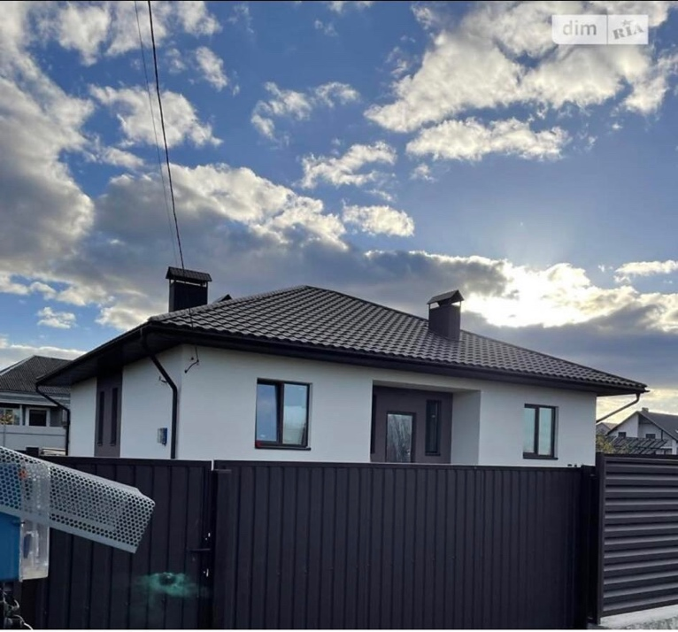 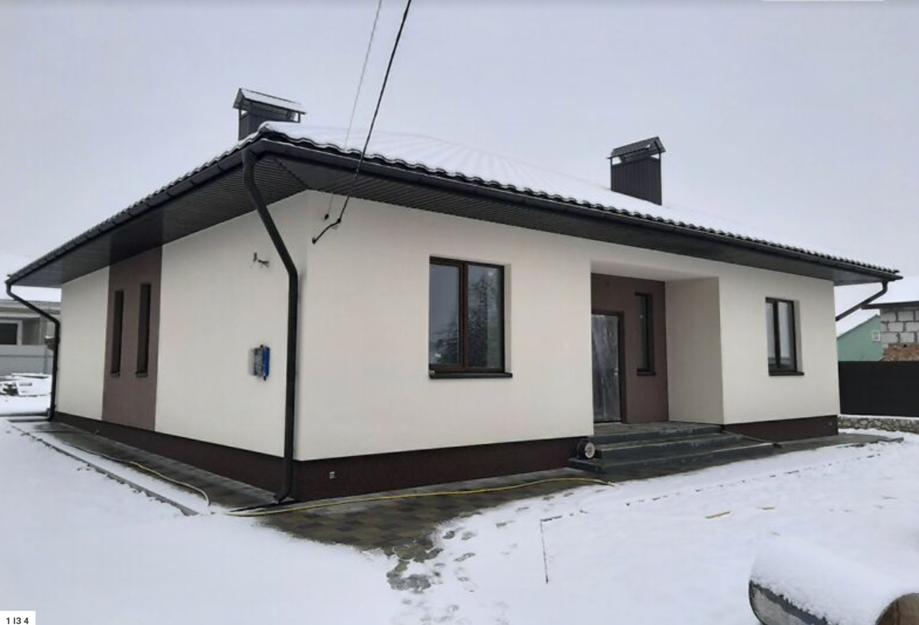 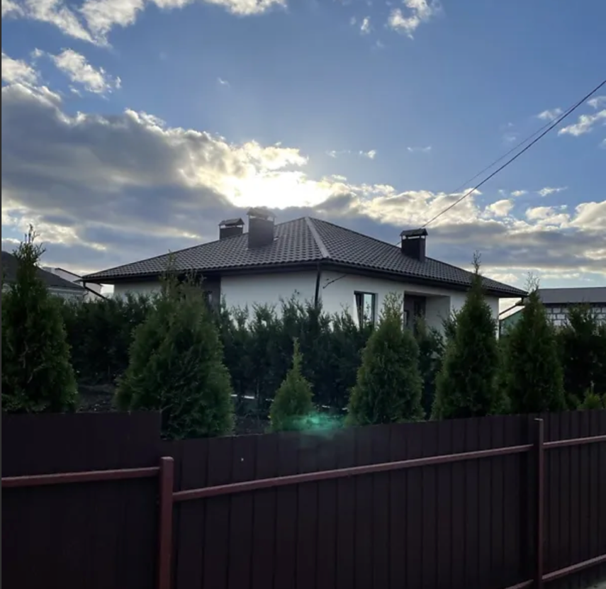

This is the front entrance of the house gate. This is the front of the house and drive way. This is the house from a distance and to the road.

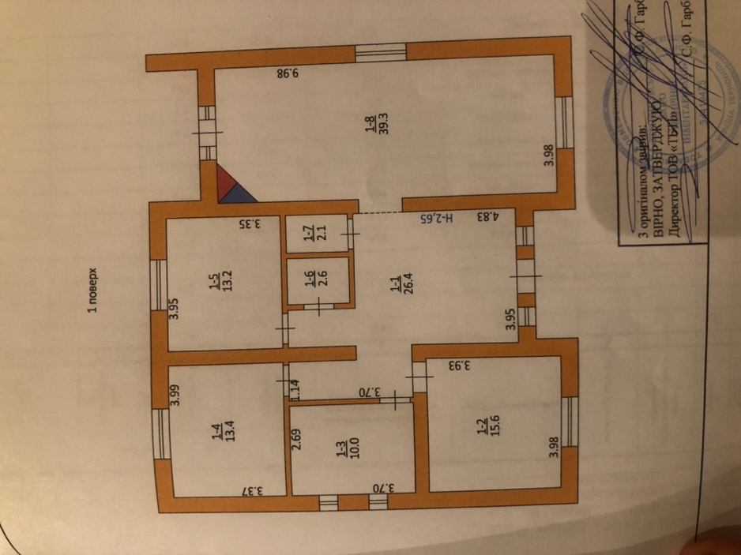 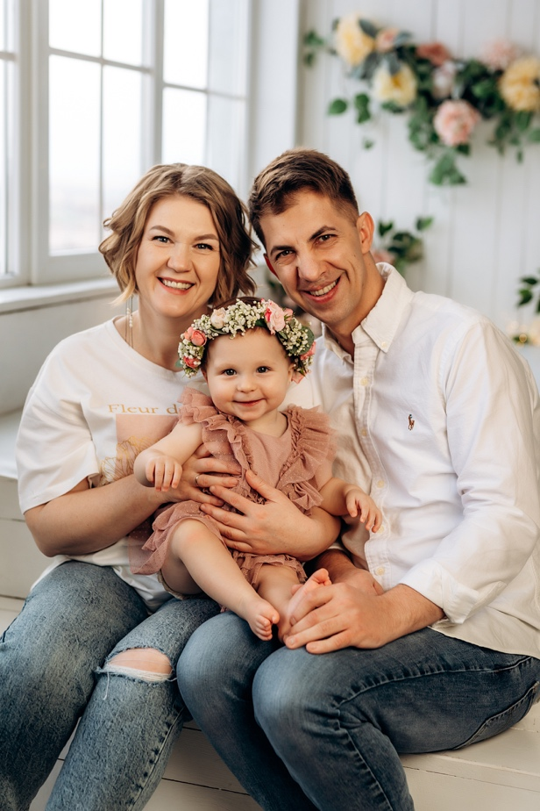

This is the back of the house and back yard. This is the plan of the house. Rosen, Oksana and Emma Klepel