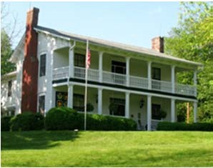

**Process for Becoming a Director on the Shelton House Board**

**A: Candidates who are not currently Directors.**

1. Each candidate completes a “Director Application Form” and forwards this to the Nominating Committee Chair.
2. The Nominating Committee shall interview all candidates, nominate suitable candidates for Board approval, and recruit the approved candidates.

**B: Directors finishing their terms.**

1. A Director finishing a term (whether or not this term was for a full three years) who wishes to serve an additional term must complete a “Director Application Form”, and self‐evaluate their term performance on the “Director Standards &

Expectations” form. Both forms shall be forwarded to the Nominating Committee Chair.

1. The Nominating Committee shall interview all candidates and present all candidates who wish to serve additional terms to the Board for approval. The candidates approved for additional terms shall be presented to the Board for approval at the January Board meeting.

**C: Term Limits.**

There are no limits on how many terms a Director may serve, whether or not those terms were for a full three years. If a Director resigns or chooses not re renew their term as Director, a year must elapse before an application to return to the Board may be considered.

“Director Application Form” and “Director Standards & Expectations” documents are integral parts of this procedure.

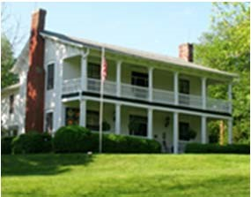

# Director Application Form

|  |  |  |  |  |  |  |
| --- | --- | --- | --- | --- | --- | --- |
| **Personal Information** | | | | | | |
| Last Name | | | First Name | | | MI |
| Street Address | | City | | | State | ZIP |
| Primary Phone Email | | | | Current Employer / Position | | |
| Shelton House Board meetings are on the 3rd Thursday of each month (Jan-Nov) at 6:00 pm. Are you available then? | | | | Best days and times for Committee Meetings | | |
| **Prior Board and Committee Experience (if you have a current résumé, please attach)** | | | | | | |
| Organization | | | Role / Title | | Dates of Service | |
|  | | |  | |  | |
|  | | |  | |  | |
|  | | |  | |  | |
| **Computer Skills** | | | | | | |
| We use MS Word and MS Excel extensively. Are you familiar with both? If so, what versions are you using? | | | | | | |
| **Skills, Experience and Interests that may Contribute Shelton House Board (check all that apply)** | | | | | | |
| ___ Communications  ___ Nominating & Board Development ___ Writing & Grant Writing  ___ Community Involvement ___Operations & Business Processing  ___ Creative Thinking ___ Policies & Procedures  ___ Finance & Accounting ___ Public Relations  ___ Fundraising ___ Social Media  ___ Information Technology ___ Special Events  ___ Leadership ___ Strategic Planning  ___ Marketing | | | | | | |
| Other Skills, Experience and Interests | | | | | | |
| **Terms and Conditions** | | | | | | |
| Directors must comply with Shelton House’s “Director Standards and Expectations” (attached), and all approved policies and procedures. | | | | | | |
| I agree to abide by the above Terms and Conditions. | Signature | | | | Date | |

|  |  |
| --- | --- |
| Send to: | The Shelton House  Nominating Committee  P.O. Box 145  Waynesville, NC 28786 |
| Email to: | info@sheltonhouse.org |

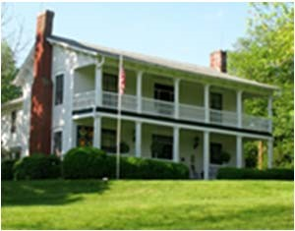

# Director Standards & Expectations

(First time candidates: this is for your information only; you do not need to complete this form.)

|  |  |  |  |  |  |
| --- | --- | --- | --- | --- | --- |
| **Participation** | | | |  | |
| Activity | Expectation | | |  | (Y/N) |
| Meetings | Attend 80% of Board Meetings. Advise of any absences in advance. Excused absenc may be approved by the Chair. | | | es |  |
| Leadership | First term: Actively participate in at least 1 committee or lead a special project. Second term: Chair 1 committee or serve as a Board Officer. | | |  |  |
| **Conduct** | | | |  | |
| Activity | Expectation | | |  | (Y/N) |
| Confidentiality | Keep all meeting discussions private. Observe the Confidentiality Policy at all times. | | |  |  |
| Conduct | Comply with the By-Laws and all Policies and Procedures. Keep conduct among Boar members respectful. Receive no financial gain from serving on the SHELTON HOUSE Board. | | | d |  |
| Public  Relations | Be a knowledgeable public advocate. Maintain a positive public attitude towards all Bo decisions. | | | ard |  |
| Marketing | Recruit new Shelton House subscribers and donors. Bring potential new subscribers t Shelton House events. | | | o |  |
| **Support** | | | |  | |
| Activity | Expectation | | |  | (Y/N) |
| Financial Support | Make a financial contribution to SHELTON HOUSE, or cause others to contribute. | | |  |  |
| Programs & other Events | Be the Shelton House Ambassador by wearing your badge and being available to ans questions at all programs you attend. | | | wer |  |
| Reviews | Provide input to reviews of the By-Laws, all Policies and Procedures, and to the Operations Manager and Curator’s reviews.. | | |  |  |
| Reports | Review monthly minutes of Meetings, Financial, Operations Manager and Curator’s reports, and all Committee reports. | | |  |  |
| Board  Development | Nominate new Directors. Participate in new Director orientation. Provide input to the succession planning process. | | |  |  |
| Planning | Stay informed and provide input for all current issues. Participate in long-range strateg planning. | | | ic |  |
| **Agreement** | | | |  | |
| *I have read and agree to comply with the above* ***Director Standards & Expectations****.* | | Print Name | Signature | Date | |
|  |  |  | |

Director Standards and Expectations Form: Effective Date: July 2017