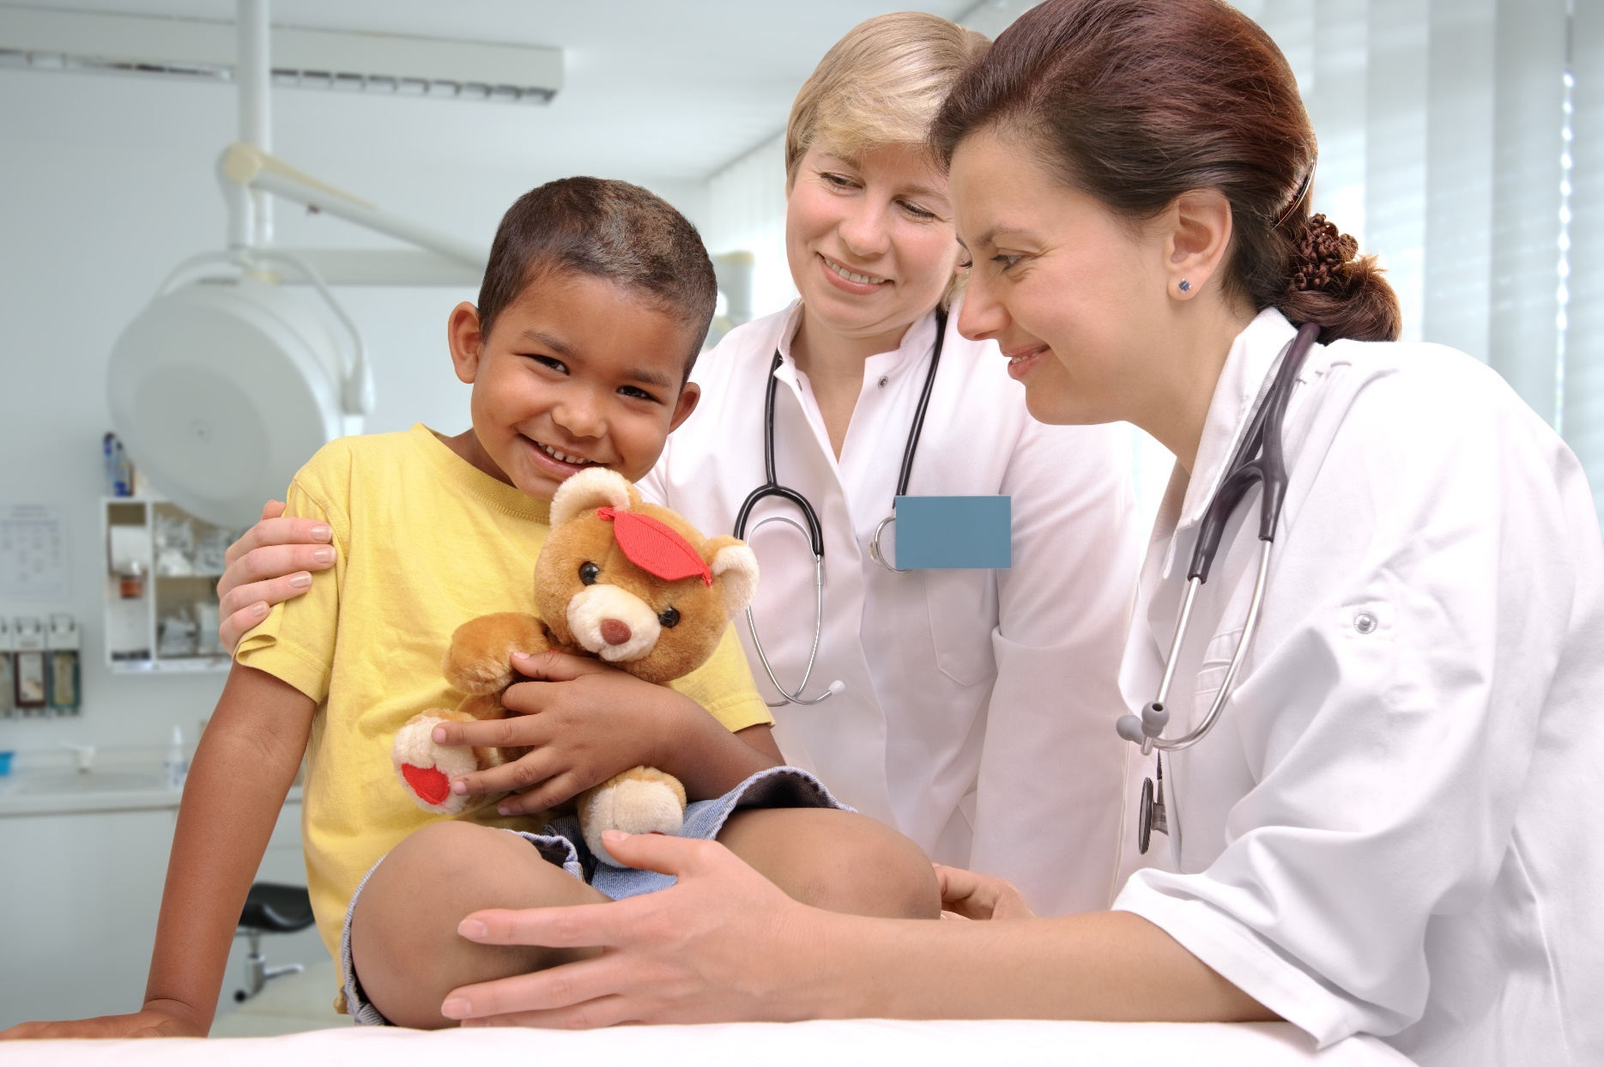

Resources for providers to promote pediatric wellness, preventative care, and immunization

JULY 2020

Table of Contents

The Provider Role 2
Connecting with Families 3
Template Letter to Families 3
Sample Phone Call Scripts 5
Sample Text Messages 6
Other Creative Ways to Reach Patients 7
Connecting on Social Media 8
Back to the Office Social Media Campaign Materials 8
Social Media Messaging 12
Connecting With Traditional Media 14
Template Media Pitch 14
Template Letter to the Editor 18
Additional Resources for Providers 19
Acknowledgements and Contact Information 20

The Provider Role

Dear Pediatric Health Care Provider,

Now more than ever, we share with you a commitment to maintaining the health and safety of Arizona’s children. We also share a commitment to supporting you and your delivery of pediatric care during this unprecedented time.

As a result of the COVID-19 pandemic, we know that your challenges are many, including combatting the virus itself while still addressing ongoing child health-related issues among your patients. All this, while also adjusting your practice and policies to keep your office open in the safest way possible for the infants, children, and adolescents you serve.

The Arizona Chapter of the American Academy of Pediatrics strongly supports you and your continued provision of health care for children, both sick and well, during the COVID-19 pandemic. As you are keenly aware, the recent reductions in well-child visits threaten the well-being and optimal health of Arizona’s youngest population due to delayed vaccination, screening, referrals, and delivery of anticipatory guidance to families.

In an effort to support you and your patients during these challenging times, we have produced the Arizona Pediatric Provider Toolkit, complete with modifiable templates for you to:

- Let your patients know that your practice is open, safe, and still there for them, including:
  - Sample letter to families
  - Sample phone call scripts and text messages
- Ensure your community knows that well-child checks and immunizations remain essential for infants, children, and adolescents, including:
  - Sample social media posts and graphics
  - Template letter to the editor
  - Template media pitch

These templates and tools are for you to customize according to local guidelines, as well as to the
characteristics unique to your patient population. We hope that the easy-to-use resources within the
Arizona Pediatric Practice Toolkit will assist you in your continued efforts to reach out to families,
validate the importance of well-child visits and vaccinations, and emphasize the role you play together
in keeping children healthy now and always.

Sincerely,

Jason Vargas, MD, FAAP
Board President, AzAAP

Anne Stafford, MA
Chief Executive Officer, AzAAP

Connecting with Families

Template Letter to Families

Pediatricians and other pediatric care providers can use the letter below as a customizable template to send to families to encourage them to return to the office for well-child visits and vaccinations.

Hello from [Practice Name]!

We hope that this note finds you and your family safe and healthy! We want to thank you for being flexible and understanding as we adjust office protocols to keep patients and families as safe as possible during this unprecedented pandemic.

As you probably know, Arizona guidelines have transitioned over recent weeks as we’ve seen an increase in infections in our state. Despite this, current guidance still encourages Arizonans’ access to necessary health care visits. These necessary visits include regular checkups (to track healthy growth and development) and routine immunization visits (to protect children and prevent outbreaks of vaccine-preventable disease).

Your family’s health and safety is our primary concern! As such, we want to make you aware of our office’s new protocols and additional safety precautions.

At [practice name], we have made some big changes within our office setting. We have [insert changes made such as separate healthy/sick hours and rooms, triage in parking lot, telehealth, enhanced disinfecting between visits, physical distancing in waiting rooms, screening of staff, etc.].

We’ve also adjusted our protocols for patient visits. For all visits, please call our office at [XXX-XXXXXXX] so that we can find the best way to address your child’s needs. We request that ONE healthy parent or guardian accompany patients to all in-person visits. We ask that you avoid bringing additional children to in-patient appointments at this time. When you visit our office, you’ll notice that we’ve made adjustments to the following: [insert changes such as new no-touch (or physically distanced) check-in procedures, staggered appointment times, universal masking, removal of toys, books, and magazines, enhanced cleaning of all high-touch surfaces, virtual check-out procedures].

- For patients with a “non-contagious” issue, appointments may be offered through telehealth or be scheduled during our in-person well-child visit hours [insert hours here].

- For patients who are sick, appointments will be offered during our in-person sick-patient hours [insert hours if standardized]. We have developed the following protocols for sick visits: [discuss specific procedures for sick patients such as calling at arrival and remaining in vehicle until you have further instructions, payment and forms online, etc.]. If appropriate, appointments may be offered through telehealth.

Connecting with Families

Template Letter to Families Cont.

- For children ages 2 and under, appointments will be offered during our in-person well-child visit hours [insert hours here]. We have developed the following new protocols for well-child visits: [discuss any adjustments here]. We encourage you to maintain your well-child appointment schedule during this important stage of your child’s development. These visits allow for assessment of your child’s growth, tracking of your child’s milestones, and maintenance of immunizations to protect your child from vaccine-preventable disease. If your child is behind on immunizations (or is due for a vaccine in the near future), please call our office to schedule an appointment. If you are unsure if your child is up to date or in need of a vaccine, please call and ask our office staff to check your child’s immunization records.

Please know that these measures are in line with current guidance from Centers for Disease Control and Prevention (CDC), American Academy of Pediatrics (AAP), and the Arizona Department of Health Services (ADHS). Policies will be adjusted as needed to comply with guidance and regulations. We are confident that the policies discussed above will help to maintain the best health environment for your family and all of our patients.

Sincerely
[Insert Practice Name]!

Connecting with Families

Sample Phone Call Scripts

Below are sample scripts you can utilize in phone calls to patients. You may also consider recording a message for your office voicemail or on-hold notification relaying any office protocols and precautions your staff is taking to make in-person appointments safe for families.

WELL VISITS AND ON-TRACK VACCINATIONS

“Hi! This is [name] from [practice name]. I am calling to touch base regarding your child’s wellness visit and vaccinations. [Provider name] thinks it is very important to keep these appointments to assess your child’s growth, track their milestones, and make sure they are up to date with the immunizations necessary to protect them from vaccine-preventable disease. Although the COVID-19 pandemic is ongoing, we are doing everything that we can to ensure the health and safety of our patients. Please give us a call if you have any questions or if there is anything that we can do for you. See you soon!”

NEWBORN APPOINTMENTS

“Hi! This is [name] from [practice name]. I am calling on behalf of everyone at [practice name] to congratulate you on the arrival of your baby. We are so thrilled for you and your family! As you may know, newborn checkups and on-time administration of vaccines are very important to protect the health of your new little one. Although the COVID-19 pandemic is ongoing, [provider name] and all of us here encourage you to keep your scheduled appointments or schedule one if you haven’t already done so. Please let us know if you have any questions or if there is anything that we can do for you. See you soon!”

GENERAL CHECK-IN

“Hi! This is [name] from [practice name]. I hope you and your family are in good health and staying safe. I am calling to let you know that all of us at [practice name] are thinking of you and are here to support you during this unprecedented time. We've modified our practice's policies to minimize our patients’ exposure to others and keep your family safe during appointments; your health is our number one priority. Please let us know if you have questions or if there is anything else that we can do for your family. Although the COVID-19 pandemic is ongoing, we are still seeing patients in the office or by telehealth when appropriate so please contact us if you have any patient care concerns. We hope to see you soon!”

SICK CHILD VISITS

“Hi! This is [name] from [practice name]. I am calling to share some news with you regarding the services that we are offering to our patients. Although the COVID-19 pandemic is ongoing, we are continuing to treat sick patients in a variety of ways. We are offering telehealth visits for concerns that can be treated virtually and office visits to address concerns that are best managed in person. For those children who need an office visit, we have modified our practice policies to minimize office exposure to others. Please don’t put off getting medical attention when your children need it. Give us a call if you have any questions or if there is anything that we can do for you. Take care!”

Connecting with Families

Sample Text Messages

If your practice utilizes text messaging to reach patients, the following messages can be customized and distributed.

SAMPLE 1

Your family's health and safety is our #1 priority! Call our office at XXX-XXX-XXXX to learn about [practice name's] new safety protocols. See you soon!

SAMPLE 2

Visit our website at [practice website] to learn about our new protocols to keep families as safe as possible during this unprecedented pandemic.

SAMPLE 3

Keeping your child vaccinated is key to maintaining their health! To learn about our available vaccination options, contact us at [contact information].

SAMPLE 4

[Practice name] is here for you! Call us today to learn how we're keeping patients safe during office appointments and vaccination visits. XXX-XXX-XXXX

SAMPLE 5

Checkups are important, even during a pandemic! Contact us to schedule your child's well-care appointment today at [contact information].

SAMPLE 6

Don't delay your child's well-care visits! [Practice name] is offering appointments by phone, in person, and through telehealth. Call us today to schedule an appointment. XXX-XXX-XXXX

Connecting with Families

Other Creative Ways to Reach Patients

Create a video showing or explaining to patients what it will look like when they come to your office. Explore video platforms like TikTok, Smilebox or simply use your phone. Here are some examples:

- Lowry Pediatrics video (TikTok)
- Ft. Collins Youth Clinic video
- Pediatric Partners of the Southwest video
- Salud Family Health Centers video
- Children's Clinic STL video
- Sapphire Pediatrics video (Smilebox)
- Western Colorado Pediatric Associates video (TikTok)

- Conduct a Facebook Live to show how your office is keeping patients safe during office visits; here's an example from HealthyChildren.org
- Host a Twitter chat and encourage patients to ask questions about your practice’s response to COVID-19, as well as other general health questions.
- Provide fun, educational activity ideas for kids with your patients' families, like these.
- Implement a pop-up on your website encouraging patients to schedule routine care appointments. Here's an example from Pediatrics 5280.
- Stay connected with your patients via weekly email updates, like this example from Lowry Pediatrics.

National Resources for Families

Click here to be directed to COVID-19 information for families provided by HealthyChildren.org. Information includes:

- Symptoms of COVID-19
- Who is at risk for COVID-19
- How COVID-19 affects children
- How to protect your family from COVID-19
- How to care for someone with COVID-19
- Dealing with school and childcare closings
- How to talk to children about COVID-19
- And much more!

Local Resources for Families

Resources include those provided by the Arizona Department of Health Services and the Arizona Department of Education

- COVID-19 Testing Locations - ADHS
- COVID-19 Data Dashboard - ADHS
- Stop the Spread of Germs - ADHS
- COVID-19: Guidance and Suggestions - ADE
- Special Education Guidance for COVID-19 - ADE

Connecting on Social Media

Back to the Office Social Media Campaign Materials

This social media toolkit builds on the work that has been done thus far and is meant to provide our members with easy to use resources to reach out to families and the community. The images below are sized to integrate with your practice's website, Facebook and Twitter accounts and encourage parents to keep up with their child's health by contacting their pediatrician. We hope you will join us in posting these social messages to get Arizona children and families Back to the Office.

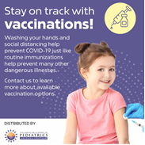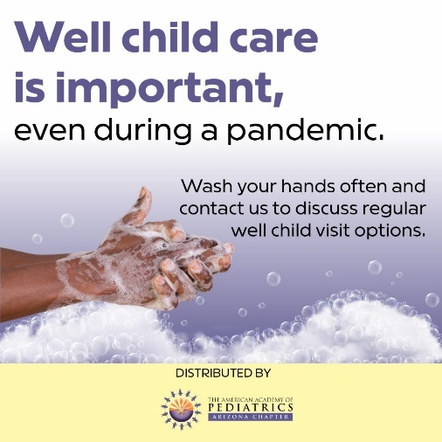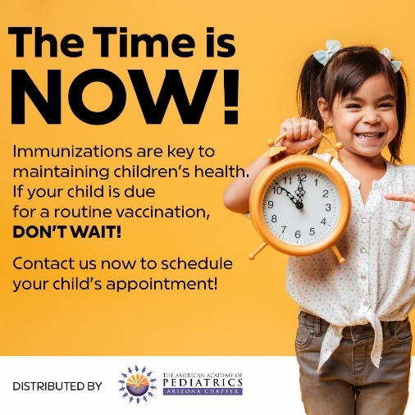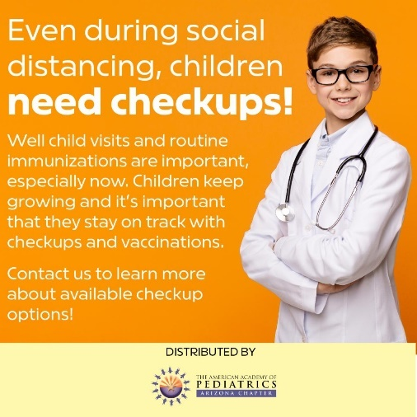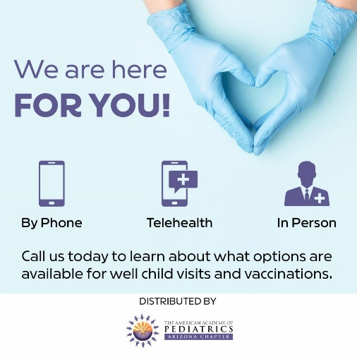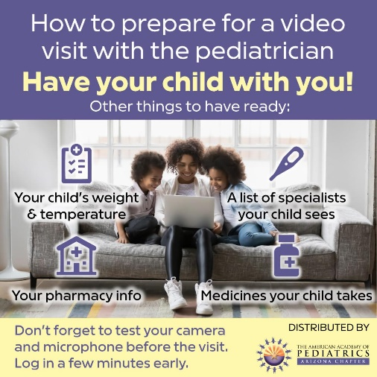

Connecting on Social Media

Back to the Office Social Media Campaign Materials Cont.

The infographic below can be printed and hung in your pediatric office or shared as an inforgraphic on your website or social media channels.

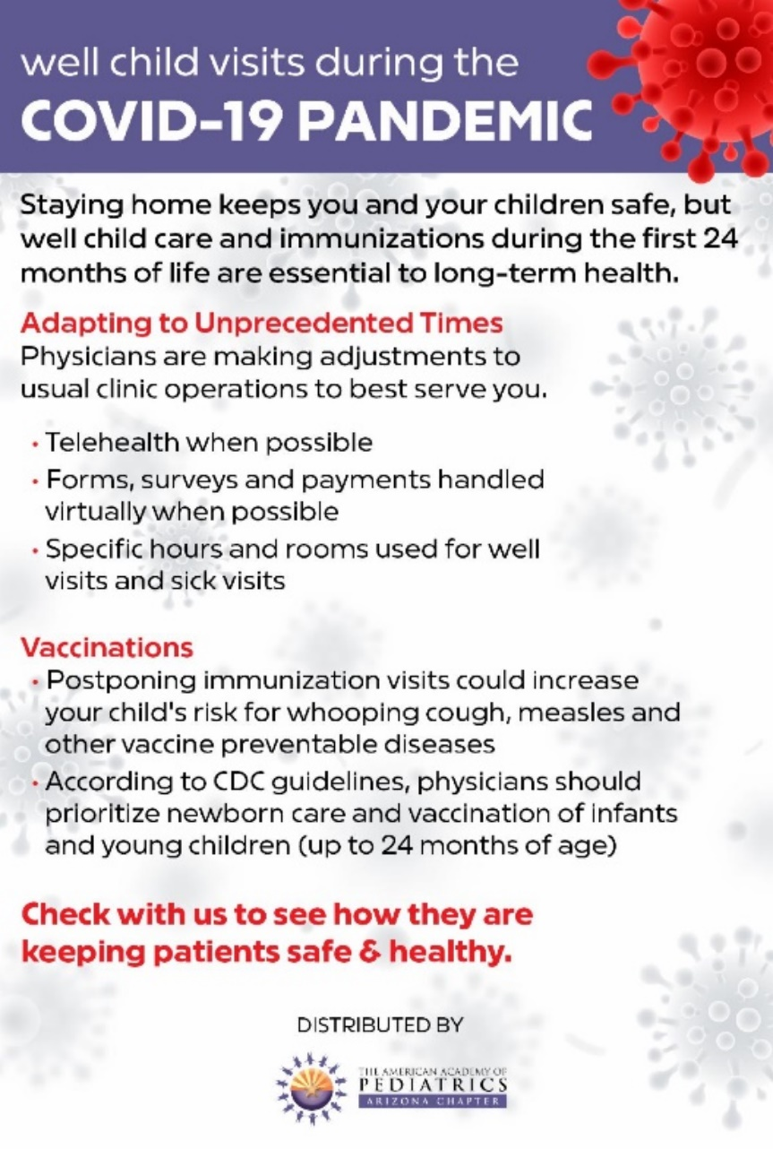

Connecting on Social Media

Back to the Office Social Media Campaign Materials SPANISH

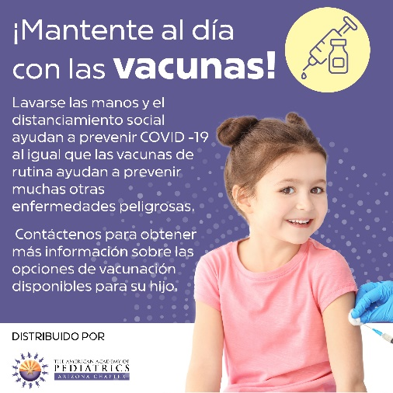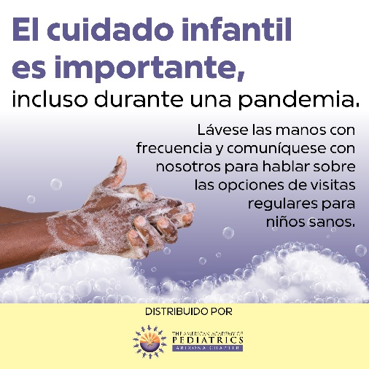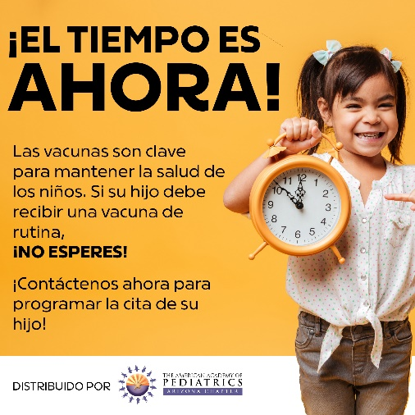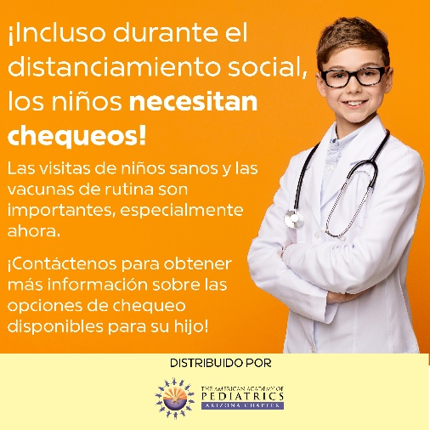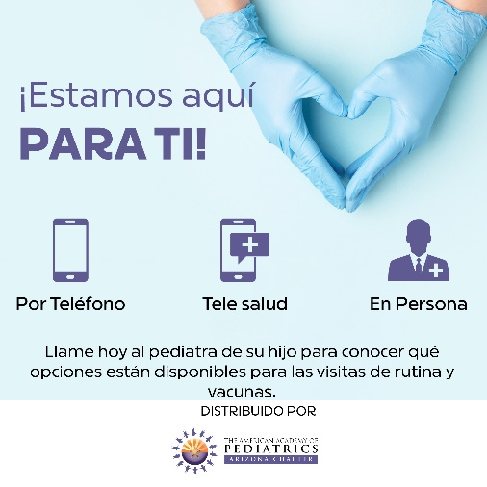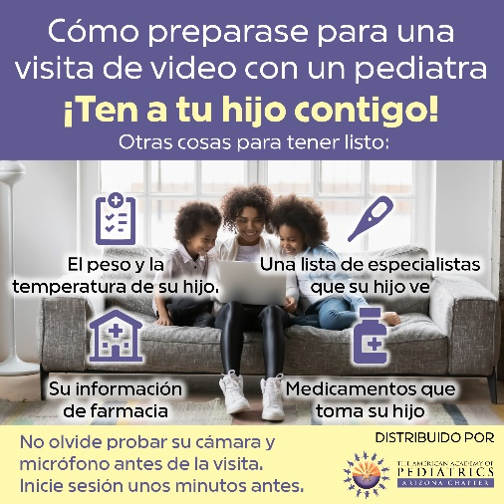

Connecting on Social Media

Back to the Office Social Media Campaign Materials SPANISH Cont.

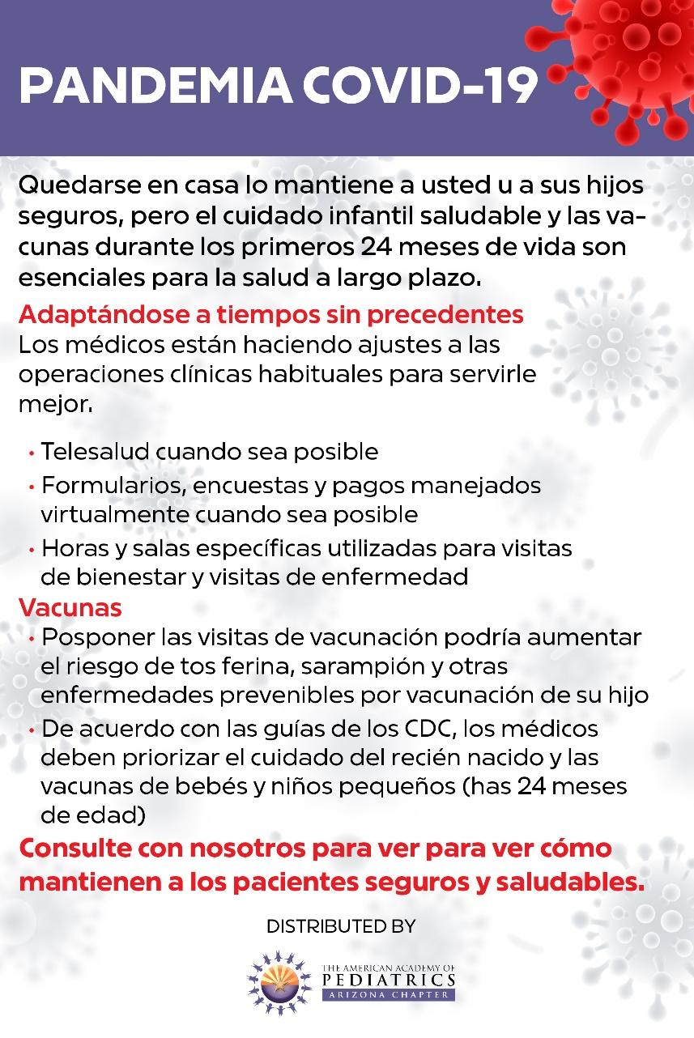

Connecting on Social Media

Social Media Messaging

Use these draft social media messages along with the corresponding graphics to encourage families to contact your office for well-child care, vaccinations, and other important health care issues. These messages can be edited to align with the needs of your specific patient population and your practice’s policies.

DON'T WAIT!

Facebook: Vaccination rates around the country have fallen sharply due to the COVID-19 pandemic, leaving many children unprotected against disease. While there’s not yet a vaccine for coronavirus, there are vaccines to protect your child from 16 infectious diseases! Our office is open and providing well-child care and vaccinations. Don’t delay—contact us today to schedule your child’s appointment! [insert contact method]

Twitter: While there’s not yet a vaccine for coronavirus, there are vaccines to protect your child from 16 infectious diseases! Our office is open and providing well-child care and vaccinations. Don’t delay— contact us today to schedule your child’s appointment! [insert contact method]

Instagram: Did you know? While there isn’t yet a vaccine to protect against coronavirus, there ARE vaccines that protect your child against 16 infectious diseases! Don’t delay vaccination. Our office is open for well child appointments and vaccinations. Contact us today to schedule your child’s appointment! [Link in bio]

KEEP UP WITH VACCINATIONS

Facebook: Vaccines are one of the best ways to keep your child healthy and safe. Keeping up with routine vaccinations helps protect your child against harmful and sometimes deadly diseases. Contact our office to learn about available vaccination options, and how we’re working hard to keep your family safe during office visits! [insert contact method]

Twitter: Vaccines are one of the best ways to keep your child healthy and safe. Keeping up with routine vaccinations helps protect them against harmful and sometimes deadly diseases. Contact us to learn about available vaccination options! [insert contact method]

Instagram: Just like washing your hands and practicing social distancing helps protect against COVID-19, vaccines protect against many other dangerous illnesses! Keep up with routine vaccinations for your child and help keep them safe and healthy. Contact us to learn about available vaccination options! [Link in bio]

Connecting on Social Media

Back to the Office Social Media Campaign Materials Cont.

CHILDREN NEED CHECKUPS

Facebook: Well-child care is important, even during a pandemic! Missing well-child visits could put your child at risk. Our office is open and ready to safely provide well-care, sick-care, mental health screenings, immunizations, physicals, and more. Contact us to schedule your child’s appointment and learn about precautions we’re taking to protect your family during office visits. [insert contact method]

Twitter: Well-child care is important, even during a pandemic! Our office is open and ready to safely provide well-care, sick-care, immunizations, etc. Contact us to schedule your child’s appointment and learn what we’re doing to protect your family during office visits. [insert contact method]

Instagram: Even during a pandemic, it’s important that children receive well-care! Missing well-child visits could put children at risk. Our office is open and ready to safely provide well-care, sick-care, immunizations, etc. Contact us to schedule an appointment and learn about steps we’re taking to protect families during office visits. [Link in bio]

OUR FIRST PRIORITY

Facebook: At [practice name], our first priority is your family’s health—always. We know families might feel nervous about bringing children in for well-care and other important health issues. Contact us to learn about the many precautions our office is taking to keep your family safe during office visits. [insert contact method]

Twitter: At [practice name], our #1 priority is your family’s health—always! We know families might be nervous bringing children in for well-care and other important health issues. Contact us to learn about the precautions our office is taking to keep your family safe during office visits. [insert contact method]

Instagram: At [practice name], our #1 priority is your family’s health—always! We know families might be nervous bringing children in for well-care and other important health issues. Contact us to learn about the many precautions our office is taking to keep your family safe during office visits. [Link in bio]

WE ARE HERE FOR YOU

Facebook: At [practice name], we are here for you! We’re offering pediatric appointments by phone, through telehealth, and in person. It’s important for children to continue receiving well-care and vaccinations. Contact us to schedule your child’s appointment and learn about the precautions we’re taking to keep your family safe during in-person visits! [insert contact method]

Twitter: At [practice name], we are here for you! We’re offering pediatric appointments by phone, through telehealth, and in person. Contact us to schedule your child’s well-care appointment and learn about the precautions we’re taking to keep your family safe during office visits! [insert contact method]

Instagram: [Practice name] is here for you! We’re offering pediatric appointments by phone, through telehealth, and in person. Contact us to schedule your child’s well-care appointment and learn about the precautions we’re taking to keep your family safe during in-person visits! [Link in bio]

Connecting with Traditional Media

Template Media Pitch

It’s important for the public to be informed about the importance of pediatric care during the pandemic, and the media is a great way to reach the public. The below media pitch can be sent to a reporter or producer at your local TV station or to a newspaper via email.

An estimated 70% to 80% of children are NOT seeing their pediatric providers right now.

The problem:

Vaccinations, chronic health problems, everyday illnesses, and regular health checkups have been pushed aside by fears of COVID-19. This is putting children at risk for many other critical—even life-threatening—health issues. [Provider's name] in [city, state] is available for a virtual video or phone interview to address these concerns and what they mean for children in Arizona.

Why is this so concerning?

- The American Academy of Pediatrics is alarmed with the current pediatric visitation rates and is telling parents to reach out to their local pediatric health care provider NOW to determine the safest way for their child to get well-child and sick-child medical care.
- [Provider’s name] is a practicing [pediatrician, physician assistant, etc.] in Arizona. [He/she] wants to reassure parents that pediatric clinics are open and have implemented important policies and protocols to keep children safe during appointments.
- Pediatric health care providers are concerned about mental health problems in children and teens, including increased suicide attempts.
- Doctors are seeing flare-ups of asthma, diabetes, and other conditions as families delay health care visits.
- Pediatric providers are concerned about parents’ delaying or skipping newborn health checkups, including screenings for jaundice and failure to thrive—conditions in which a few days can mean life or death.
- Vaccination rates, including for infectious diseases like measles and pertussis, are dropping. We need to take steps to avoid additional preventable disease outbreaks in communities already threatened by COVID-19.
- Pediatric health care providers are also concerned about delayed diagnoses and treatments for common childhood illnesses, from ear infections to broken bones.

Solutions:

[Provider’s name] can share stories from [his/her] own practice about what [he/she] is seeing in
children, and can walk your viewers through the options, including:

- Which health care concerns might be addressed by your provider via a video or telephone visit.
- If your child needs to be seen in person, how health care providers are making in-person health care visits as safe as possible. This may include separate "sick" and "well" entrances, seeing patients in the parking lot, or seeing vulnerable newborns before the office opens to other patients.
- How to talk with your pediatric health care provider about what visits can safely be delayed, and which are important for your child's current and long-term health.

Connecting with Traditional Media

Media Pitch Cont.

Use the following resources to guide you in an interview:

Suggested questions to send to the reporter after you’ve secured an interview.

Note: You can send this list of suggested questions to the reporter/producer after you have secured an interview. Add the spokesperson’s bio to the top.

- A question many parents have been asking is whether it’s safe to bring their child in to the pediatrician for their scheduled well-child visit, and for immunizations – or if it’s better to wait until after the pandemic. What do you advise?
- From a business perspective, with patient volumes so low, are you worried about the viability of smaller pediatric practices? What sorts of tough decisions have you had to make for your own practice? What does it mean for children’s health care if practices have to close?
- What illnesses or injuries are you worried you are NOT seeing now, with so many fewer patients coming into your office? Are children with serious medical problems just not being diagnosed?
- What should parents do if their child is sick or injured, or is having a hard time emotionally right now?
- What kinds of health care visits can happen by video or telephone, and which ones need to be in person?
- How are pediatricians making in-person visits as safe as possible right now?
- With potential stay-at-home orders, what about children whose homes aren’t safe?
- What advice do you have for parents of teenagers, who are missing out on a lot of the social interactions that are so important to them?

Talking points for spokespersons.
Note: Sharing your personal experiences and what you have seen among your own patients will make your interview more engaging. For example, if you had to plead with a new mom to bring a baby in for a well visit, during which you diagnosed a treatable problem; you were able to effectively counsel a family during a telehealth visit; you met a family in the parking lot to do a throat culture.

Q: A question many parents have been asking is whether it’s safe to bring their child in to the pediatrician for their scheduled well-child visit, and for immunizations – or if it’s better to wait until after the pandemic. What do you advise?

A: It is still important to get scheduled vaccines to protect children and prevent diseases like measles and pertussis, which can be dangerous for children and easily spread in communities. We are worried about what disease outbreaks we could have later this summer/fall, if many children are behind on their vaccines.

Connecting with Traditional Media

Media Pitch Cont.

Q: From a business perspective, with patient volumes so low, are you worried about the viability of smaller pediatric practices? What sorts of tough decisions have you had to make for your own practice?

A: For many practices in Arizona, patient volumes are at 20-30 percent of previous levels. In my own practice, [share examples of impact, such as we have furloughed staff.] I know many pediatricians with small practices are really struggling, and we worry some of them may not still be in business two months from now. That would leave many children without access to health care, or they will have to drive a lot farther for care. I’m really worried this will become a serious challenge for many families, especially in rural areas where there may not be another pediatrician nearby. We have been anxiously awaiting critical financial help that we’ve been assured is coming from the federal government.

Q: What illnesses or injuries are you worried you are NOT seeing now, with so many fewer patients
coming into your office? Are children with serious medical problems just not being diagnosed?

A: Share specific examples from your practice, such as patients delaying care for urgent or chronic health issues. If pediatricians across the country are seeing 30% of patients … that is a lot of vaccines that are delayed, which could have serious repercussions. Many parents are just not calling because they think we are busy – but we are not too busy to take care of children. We are still here to take care of children, and we know we cannot just put children’s health on pause for two months.

Q: What should parents do if their child is sick or injured, or is having a hard time emotionally right now?

A: First thing, call your pediatrician. There are some things we can help with over the phone, or in a video visit. [give examples] Or, if your pediatrician really needs to see you in person, they will tell you how that can happen safely. What we DON’T want, is for parents to feel like they have to handle this alone. They are not alone. We are here to help you make sure your child is as healthy as possible, which is really important right now.

Q: What kinds of health care visits can happen by video or telephone, and which ones need to be in person?

A: Spokesperson to answer

Q: How are pediatricians making in-person visits as safe as possible right now?

A: Spokesperson to answer, using specific examples from their practice or other practices in state

Connecting with Traditional Media

Media Pitch Cont.

Q: With potential stay at home orders, what about children whose homes aren’t safe?

A: This is a real concern. People are under tremendous stress right now, both emotional and financial. And research has shown that when families are stressed, children are at an increased risk of being abused. We want to remind parents and caregivers to be sure to take care of themselves – get enough sleep, eat healthy, get some exercise – and reach out to support networks for help. That can include your pediatrician. With a phone call or video visit, your pediatrician can help you with strategies to manage your children’s behavior, cope with a crying baby, or handle some of the other parenting challenges people are facing right now. As a pediatrician, I want every family in my practice to know I am here to help them through this.

Q. What advice do you have for parents of teenagers, who are missing out on a lot of the social interactions that are so important to them?

A: Social distancing can be especially hard for teens, who may feel cut off from their friends. And some teenagers are facing big letdowns as important milestone events like graduations and proms are being cancelled. I would tell parents to try to create a healthy daily routine, including time of online learning, exercise, sleep, family meals, and downtime. Encourage them to connect with friends online or by phone. If you are sensing your teen is sad or depressed, they may need more support, and I’d recommend reaching out to your pediatrician to see if their emotional health can be screened in an e-visit. This is not something to let go and hope it gets better. Even before the pandemic, we were worried about increased rates of suicide among adolescents, and we know that now teens are facing additional stresses. It's important to know that your teen CAN feel better, and your pediatrician can help.

Connecting with Traditional Media

Template Letter to the Editor

We welcome you to update and personalize the sample letter below, which is based on a recent statement from AAP, for publication as a letter to the editor in your local newspaper. Check your local paper for their letter to the editor guidelines.

On May 8, the U.S. Centers for Disease Control and Prevention published new data that documents what pediatricians around the nation have been reporting for weeks: many, many children have missed receiving important immunizations to protect them against diseases like measles, meningitis, and whooping cough.

As a pediatric health care provider, this is incredibly worrisome. We do not want to return to a time when parents had to worry that their infant could die of meningitis or measles – especially when we have vaccines to prevent these potentially devastating diseases. With no coronavirus vaccine available, the COVID-19 pandemic is giving all of us real-time insight into what this vulnerability feels like. Fortunately, we have vaccines to protect children and teens against 16 different diseases.

Immunizing infants, children, and adolescents is important and should not be delayed. I’m concerned
that children who have missed vaccines have also missed other critical health care that occurs during
pediatric visits, including physical exams, developmental and mental health screenings, and other important care.

I've heard first-hand that parents are worried about bringing their child to get well-care. But I want to reassure families that, as providers of pediatric care, our number one priority is our patients' safety. Nationwide, we've innovated ways to make office visits even safer, including setting different hours or locations for well and sick children, implementing rigorous sanitation and cleaning practices, and conducting portions of visits by telehealth. AAP urges all parents to contact their child's health care provider to schedule a visit to catch up on vaccines or for a well-child checkup to track growth and development. AAP is continuously providing resources and recommendations to guide pediatricians in managing visits safely and effectively.

As social distancing restrictions begin to lift around the country and people begin to circulate, children and teens who are not vaccinated will be at higher risk for contracting a disease that could be prevented by a vaccine. While we wait for scientists and doctors to develop a vaccine for coronavirus,
let’s work together to protect our children in every way that we can, today.

Additional Resources for Providers

Clinical Guidance and Data
- Guidance on Providing Pediatric Well-Care During COVID-19 (AAP)
- FAQs and Guidance Related to Childcare During COVID-19 (AAP)
- OSHA Guidance of Preparing Workplaces for COVID-19 (OSHA)
- Arizona Department of Health Services COVID-19 Information (ADHS)
- Arizona Data Dashboard (ADHS)
Infection Control and PPE
- CDC updates guidance on PPE for health care personnel; COVID-19 declared a pandemic (AAP)
- COVID-19 and Keeping Clean: A Narrative Review to Ascertain the Efficacy of PPE to Safeguard Healthcare Workers Against SARS-CoV-2 (AAP)
- Infection Prevention & Control Recommendations for Healthcare Personnel (CDC)
- Using PPE (CDC)
- Optimizing PPE Supply (CDC)
- Tools for Protecting Healthcare Personnel (CDC)
- Guidance for the Selection and Use of PPE in Healthcare Settings (CDC)
- COVID-19 Infection Control Guidance (CDC)
- COVID-19 Infection Control FAQ (CDC)
- Infection Control Standard Precautions for Patient Care (CDC)
- Infection Control Transmission-Based Precautions (CDC)
- Potential Exposure at Work Guidance (CDC)
Cleaning and Disinfecting
- Guidance for Cleaning and Disinfecting (CDC)
- How to Clean and Disinfect (CDC)
- Recommendations for U.S. Community Facilities with Suspected/Confirmed COVID-19 Cases (CDC)
MIS-C and COVID-19
- COVID-19 and Kawasaki Disease: Novel Virus and Novel Case (AAP)
- COVID-19 and Kawasaki Disease: Finding the Signal in the Noise (AAP)
- COVID-19 and Multi-System Inflammatory Syndrome in Children (healthychildren.org)
- Multisystem Inflammatory Syndrome in Children (MIS-C) (CDC)
- Multisystem Inflammatory Syndrome in Children (MIS-C) Information for Healthcare Professionals (CDC)
Infant Care
- Guidance on Newborn Screening During COVID-19 (AAP)
- FAQs: Management of Infants Born to Mothers with Suspected or Confirmed COVID-19 (AAP)
- Breastfeeding Guidance Post Hospital Discharge for Mothers or Infants with Suspected or Confirmed SARS-Co V-2 Infection (AAP)
Chronic Disease Management and Mental Health Care
- Pediatric Mental Health Minute Series (AAP)
- Guidance for People with Moderate to Severe Asthma (CDC)
Telehealth
- Guidance on the Necessary Use of Telehealth During the COVID-19 Pandemic (AAP)
- Telehealth Payer Policy in Response to COVID-19 (AAP)
- Using Telehealth Services Guidance (CDC)
- State Telehealth Laws and Reimbursement Policies (CCHPCA)
Immunizations
- AAP Statement on New Data Showing Declines in Childhood Immunizations (AAP)
Financial Relief and Support
- Provider Relief Fund: Information and Resources (AAP)
- Federal Programs for Pediatric Practices and Small Businesses (AAP)

Thank you, Arizona Providers!

The Arizona Chapter of the American Academy of Pediatrics would like to extend our gratitude and appreciation to the Colorado AAP Chapter for sharing their toolkit and resources and allowing us to adapt them for Arizona providers

For questions, please contact
leadership@azaap.org

