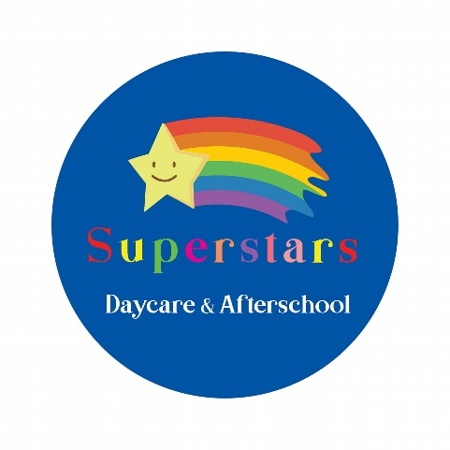

ADDITIONAL NEEDS POLICY

**Principles**

At Superstars Daycare & Afterschool, we recognise that all children have the right to access a broad and balanced curriculum, allowing them to progress and learn at a pace and level reflective of their individual abilities. The nursery believes that all children have a right to gain experience and develop their knowledge and understanding alongside their peers no matter what their individual needs, and are committed to the inclusion of all children.

Superstars aims to give every child the opportunity to develop to their full potential whatever their individual needs. Staff is committed to providing appropriate support for every child within the nursery with additional needs, including special educational needs (SEN). All children have the same basic needs but we may need to meet these needs in different ways. All staff are required to monitor each child’s development and learning through accurate observation and record keeping. Through this process, staff are required to identify any child who may be experiencing difficulties in specific areas and ensure the needs of such children and any children who present to the nursery with individual needs already identified, are met.

**Statement of Intent**

There will be space within the Nursery available for children with additional needs and appropriate measures will be taken and training provided to ensure that they are well cared for during their time with us. The safety of the child is paramount at all times.

*The term “additional needs” refers to Special Educational Needs and Disability (Northern Ireland) Order 2005; disability as defined under the Disability Discrimination Act (1995), the Autism Act (Northern Ireland) 2011; and Children in Need as defined by Article 17 of the Children (Northern Ireland) Order 1995.*

**Procedures**

To the best of our ability, the nursery will provide places for children with additional needs and special educational needs and liaise with relevant persons as and when required.

* The Early Years team will be consulted as necessary for any information and direction required ensuring that every need of the child is being met.
* Staff will be expected to attend any additional recommended training in order to support the child fully during their time in the nursery.
* If additional staffing is required, a meeting will be arranged to include parents, social services and the child’s Social Worker to discuss this.
* The Manager will liaise regularly with the family and external agencies to ensure that the child’s needs are being met effectively and to discuss and solve any issues that may arise.
* If a child with additional needs attends Superstars Daycare & Afterschool, a meeting will be arranged to include parents, the child’s social worker, management of the nursery and any other professionals to develop a care plan. Each child with additional needs will have their own individual care plan.
* Every child has a right to privacy and confidentiality must be respected when discussing the additional needs of the child.

**Owner/Management**

Signature