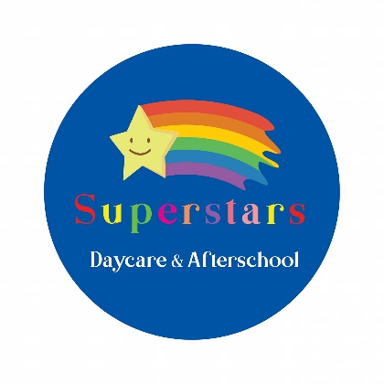

Consent Form

Child’s name ______________________________ Child’s D.O.B _____________

I/we consent to Superstars contacting emergency services should they be required for my/our child. Yes No

I/we consent to Superstars taking my/our child on outings from the nursery after prior notification. Yes No

I/we consent to Superstars to have my child take part in any activities that involve being in the same room as animals under staff supervision. Yes No

I/we consent to Superstars taking my/our child in a vehicle provided with proper child restraints and with valid insurance Yes No

I/we consent to Superstars administering Calpol or alternative___________________ if required and after consultation with me/us. Yes No

I/we consent to Superstars applying sun cream provided by me/us. Yes No

I/we consent to Superstars carrying out observation on my/our child these will be available to view at any time. Yes No

(All observations made will be recorded and remain totally confidential. Any observations made by students will be recorded but your child’s name will not be referred to in any student reports)

I/we consent to Superstars taking photographs of my/our child for display purposes. Yes No

I/we consent to Superstars to forward my/our name, address and contact details to the Southern Health and social care trust to receive annual questionnaires. Yes No

I/we consent to Superstars assisting my child/our child’s toileting needs/nappy changing. Yes No

I/we consent to Superstars assisting my/our child’s intimate care needs: Yes No

Intimate care is one of the following:

Supporting a child with dressing/undressing

Providing comfort or support for a distressed child

Assisting a child requiring medical care, who is not able to carry this out unaided

Cleaning a child who has soiled him/herself, has vomited or feels unwell

I/we consent to Superstars sharing pictures of my/our child on their private parents Facebook page. Yes No

I/we consent to Superstars sharing pictures of my/our child on their main Facebook page. Yes No

I/we consent to Superstars applying face paints to my/our child during fun days / parties. Yes No

I/we consent to our child having their teeth cleaned under supervision of Superstars staff. Yes No

Superstars Daycare & Afterschool operates CCTV throughout the building. I am aware that CCTV is used for settling in periods. Apart from settling in periods, footages from this system will NOT be made available to others except where investigation or legal proceedings are involved. I/ we consent to this. Yes No

Print Name: _________________________________

Signature:___________________________________

Date:_______________________________________