Parent Contract

Superstars Daycare & Afterschool is a private daycare facility catering for babies from 3 months up to the age of 12 years. Superstars is designed to provide every age group with their own rooms; we will have prepared activities to suit each child’s individual needs and stages of development. Our outdoor area has a range of activities for all age groups as well as a fully enclosed area meaning children can play all year round!

Our opening hours are Monday to Friday 7.30am to 6.00pm.

We ask each parent to complete a Superstars Daycare & Afterschool enrollment form. A £60 deposit is required (for each child) to secure a place in the nursery, £50 will be taken off your child/children’s first invoice and £10 is kept as an admin fee to set up your child(ren’s) app. This deposit is non-refundable if you decide not to send your child to Superstars Daycare & Afterschool.

Our fees are as follow from 1st April 2025:
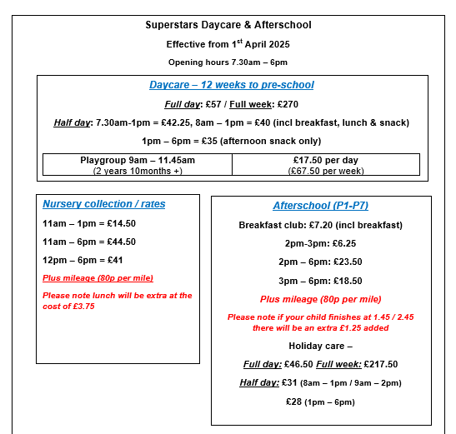

*If you have more than one child in the facility, you will pay full for the youngest child and receive 5% off your eldest child’s fees.

Fees will be paid monthly in advance 52 weeks of the year regardless if the child is off on holiday or is sick or the nursery is closed for bank holidays. If you only want term-time childcare, there will be a retainer fee of 50% of your child’s fees to secure the spot during the summer months.

Please note – fees will increase every April inline with inflation and minimum wage increases.

Unpaid fees may result in immediate suspension or termination of the child’s place unless reasonable arrangements are made and accepted by both parties. Monthly fees include all sick days and holidays taken; fees are based on booked days not attendance. Anyone paying by vouchers we ask could
you please make transfer 2-3 days prior to the 1st of the month. Fees will be reviewed annually.

1st January
17th March
Easter Monday and Easter Tuesday
May Day
May Bank Holiday
Normally 3 days over the 12th July – check Famly app for the years updated dates
August Bank Holiday
Christmas Week and 31st December

* If the holiday falls at the weekend we will take the subsequent Monday.

We request that parents be prompt when collecting their child(ren) we will charge a late collection fee of £5.00 for every 10 minutes or part thereof which will become effective at 6.00pm. If this happens on more than 3 occasions, we may ask that alternative arrangements for collection are put in place.

Please advise the nursery before 10.00am if your child(ren) will not be attending.

Parents agree that a child who is ill (e.g. fever infection or any other type of illness that may be passed on to others) must be kept at home to protect the wellbeing of staff and other children. Children should be symptom free for at least 24 hours before they can return to the nursery. (With the exception of vomiting and diarrhea which is 48 hours symptom free) Please see incubation and exclusion periods in policies and procedures. Parents further agree that should a child become ill while at Superstars Daycare & Afterschool, the nominated emergency contact will be able to collect the child within 20 minutes.

If a child is reducing their days or leaving the nursery, we ask you to provide at least 4 weeks written notice. If days are reduced there is no guarantee that they will be available if required again.

By signing this contract, you are agreeing to the policies and procedures of Superstars Daycare & Afterschool.

I/we ………………………………....................... Have read and agree with the above statements. (PRINT)

Signed ……………………………….................................... ___/___/___

Signed ………………………………..................On behalf of Superstars Daycare & Afterschool __/__/__

CONTRACT
I have read and understood the terms, conditions and policies and would like Superstars to take care of my child during the requested hours.
I agree to give the manager one month’s written notice if we intend to withdraw our child from Superstars Daycare & Afterschool.
Superstars Daycare & Afterschool reserves the right to terminate the contract at any time and without notice.
I will inform the nursery manager immediately of any changes to the registration information.

Signed:______________________________________
Date: _______________________________________

