James #158
The true light of the golden lampstand

Open back up where we left off in Hebrews chapter nine RF.

As we go back into Hebrews 9, I remind you that chapter 8, flows right into this lesson and it was highlighting a new covenant;
/Heb 9:1 Now even the first covenant had regulations for divine worship and the earthly sanctuary.

The earthly sanctuary: The tabernacle ordained by the Old Covenant (Mosaic) was planned by God, designed for a temporal earthly service. It needed to be a shadow of the REAL – Christ ushered in the REAL.\
You now begin to see an overview of the tabernacle and it was the greatest teaching tool for Israel, really for all of us.
/The tabernacle was always situated in the center of the camp surrounded by the 12 tribes, which were strategically station all around the outer boundaries. This meant that the teaching and preservation of the WORD was the main focus and had the highest priority. Israel as a picture of the CA Believer’s soul should have Christ (BD) at the center.\

The whole temple and rituals were visibly available and to be presented as teaching tools even before Moses and Joshua began compiling scriptures.

Let us look at the first tabernacle erected in the wilderness;
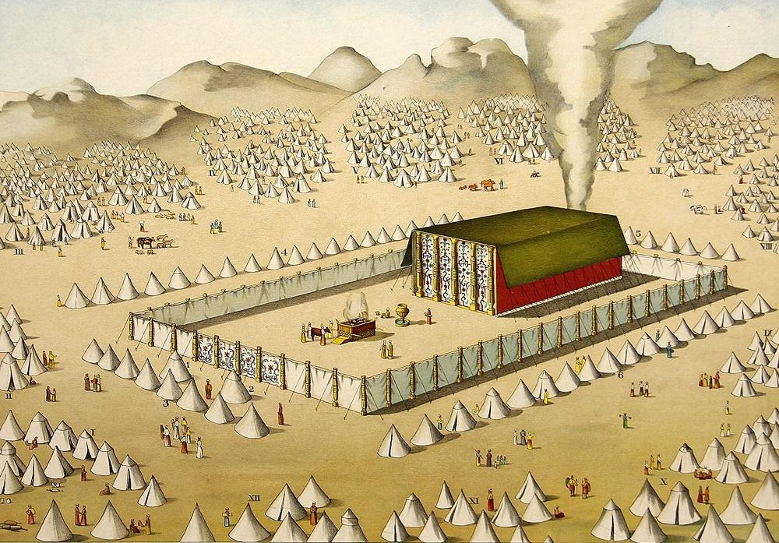
/Heb 9:2 For a tabernacle was equipped, the outer sanctuary, in which were the lampstand, the table, and the sacred bread; this is called the Holy Place.

Everything centered around the tabernacle, the priesthood, the offerings, holy days…etc. There was one person who lived permanently inside the tabernacle: Jesus Christ. He lived in the holy of holies – HIS presence hovered over the mercy seat.\
Heb 9:3 Behind the second veil there was a tabernacle which is called the Most Holy Place,
This is where we find the mercy seat, the covering of the ark of the covenant and presence of TLJC, it was private and sacred beyond reproach.

Heb 9:4 having a golden altar of incense and the ark of the covenant covered on all sides with gold, in which was a golden jar holding the manna, Aaron’s staff which budded, and the tablets of the covenant;
Heb 9:5 and above it were the cherubim of glory overshadowing the atoning cover; but about these things we cannot now speak in detail.
Let us look at a brief description of the first tabernacle set up under Moses.
/ The tabernacle was a tent 45 feet long, 15 feet wide, and 15 feet high, divided into two rooms. The larger room (the first part) was 15 feet by 30 feet – the sanctuary -“holy place.” Behind the second veil was the smaller room, it was 15 feet by 15 feet, called - the Holiest of All, holy of holies.\
This was a layered set of lessons pointing to the perfect person and work of Jesus Christ and also a heavenly and royal kingdom. A KING is never approached without permission and HIS throne room is off limits to the outside world.

/Because Christ had not yet arrived, that curtain means stay out. There is no royalty to live in there, except one…the Lord Himself, the Shekinah glory. Once the Lord arrived, and once He cried out “My God, My God, why hast thou forsaken me?” Starting from top to bottom this thick curtain, which couldn’t even be cut with a sword, was ripped. The spiritual authority and age of Israel, was interrupted.\

In Ezekiel chapter ten it records the time that the Shekinah glory left the temple during the Babylonian captivity.
The dispensation of Israel was fully interrupted at the CROSS. The ignition point of the Church Age and royal family came into existence, and the royal family lives in there now. No curtain any more, the curtain is destroyed.
Because now we have a royal family. There is no blockade to the throne room. We switched from a priesthood of a Levitical bloodline, into a Royal Priesthood.
REPEAT
You will not see another Levitical priesthood until the 2nd Advent of Christ.

/ The priest in the holy place is the shadow of the CA Believer in union with Christ. The holy of holies represents the throne room, the actual presence of God. Christ is seated at the right hand of the Father; it is the place of victory. There was a veil between the holy place and the holy of holies to keep out the Levitical priesthood. No one would be allowed in the holy of holies except the High priest for the day of atonement.\

/The holy of holies is now for the royal priesthood, and the CA royal priesthood could not exist until Christ was glorified. The Holy Spirit was not disbursed for indwelling/filling power of all Bels because Christ was not yet glorified. Right now, in the CA, positionally you occupy the holy of holies, and when you die you go to the holy of holies, the third heaven itself. Because Christ sat down on the throne in glorified victory.\

We are going to look at analogies of many of the tabernacle items because it holds great value for CA Bels to understand.
The first covenant is now fulfilled; we live in the age of a new or second covenant.
Heb 9:6 Now when these things have been so prepared, the priests are continually entering the outer tabernacle, performing the divine worship,
The first altar you would see once you entered the gateway before the temple was the brazen altar. This was considered inside the courtyard and it is described in Exo 27;
/Exo 27:1-2 - “You are to construct the altar of acacia wood, five cubits long and five cubits wide-the altar is to be square-and three cubits high. Make a horn at each of the four corners, so that the horns are of one piece with the altar, and overlay it with bronze.”\
As soon as you entered the courtyard you would see the power and presence of GOD because this altar represented an entrance way toward GOD.
Horns were often symbolic of military power and victory.

/The Bronze Laver was a ritual cleansing station representing acknowledgment of sins and the washing away (rebound) in preparation for fellowship. The Bronze altar was symbolic for the work of Christ, the sacrifice the world witnessed as HE became the LAMB of God for the sins of the world.\
It was about 4 feet high and about 7 feet wide on top.
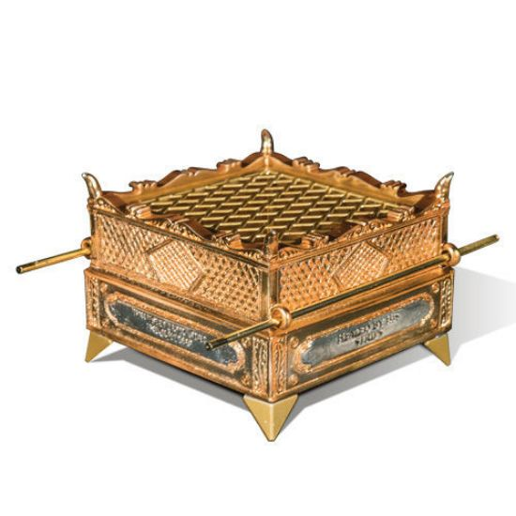
/This altar primarily served as the site where burnt offerings were brought (Lev1:3-9). Animal sacrifices were offered to atone for sins (Lev 4:35), demonstrate thanksgiving, and fulfill vows. Blood, which symbolized life (Lev 17:11), was sprinkled on the altar’s horns, highlighting the serious nature of sin and the importance of an intermediary sacrifice. The bronze laver (washbowl) was also there between the altar and entrance to the tabernacle.\

Bronze represented judicial strength as well as mercy. It was associated with great stability and judgment. It was seen as God’s endurance which lasts forever, it reflected power and judgment as well as purification.
All of this was incredible teaching tools.
For over 500 years the only books that were actually recorded in writing were the Torah (Pentateuch), Joshua, Judges, and Samuel. So, the tabernacle was a form of BD and a constant and detailed reminder of the coming MESSIAH.
REPEAT
/Heb 9:7 but into the second, only the high priest enters once a year, not without taking blood which he offers for himself and for the sins of the people committed in ignorance.

Yom Kippur (Day Atonement) began with the ritual sacrifice in the courtyard, before the high priest would enter the temple.\
This began with a bull offering.
The bull was perfect and young, representing prosperity, power and blessing. A strong bull was an incredible powerful animal to have the ancient world.
/The high priest would sacrifice another bull as a sin offering for himself and his family. He would then select two goats, tying a red scarlet cord around one as the sacrificial goat. The other goat was the scapegoat and would be sent out into the wilderness with Israel’s sins. The two goats represent forgiveness of sins and forgotten sins—sin and guilt. (1Jhn 1:9)\
Only when that was done to exact precision, could the high priest bring the smoking coals into the tabernacle. Which then would lead to him eventually sprinkling blood on the mercy seat, representing TLJC.
There are a lot of painstaking details and measurements, that we won’t dive into. Yet we will cover a few basic principles in relation to items in the temple we may not have touched on in the past.
/Once inside the tabernacle - you had a 5ft lampstand and a table of shewbread. Just in front of the second curtain there was a golden altar which belonged to the second room but was just outside of it. The golden lampstand (Exo 25) placed on the (south) left side of the tabernacle, was hammered out of fine gold like the mercy seat – both pure gold, representing Royality, power and divine glory.\

/There was a lampstand (menorah) as the only source of light inside the first HOLY place in the temple. It was the only light in the holy place, just as the Shekinah glory is the only light in the holy of holies. It was designed with a center shaft and 3 branches extended out from each side, all connected to the taller center pole. They were always lite with an oil feeding system, not common wax – oil representing the power of the HS.\

/Inside the first Holy Place was gold plated walls and a linen woven ceiling with angels designed upon it. It was a breathtaking place to enter. Outside, the world could not see this divine, beauty. The high priest represents the CA Bel in our Royal priesthood having fellowship with GOD. The embroidered cherubs of blue, purple, and scarlet, revealed the essence of GOD’s justice, love, eternal life, omnipotence, omniscience, omnipresence, immutability and veracity.\

/The lampstand (7 lights) speaks to the perfect and finished work Christ, as well as the ministry of God the HS. The 6 branches represented mankind, yet also pointed to our need to be in union with Christ (center). Only Christ, as the light of the world, can show us the FATHER. This lampstand spoke to the true light of the world, the life we have as the branches of the true VINE (Jhn 15:5).\

/Very much like the Mercy Seat it was uniquely made of pure gold and a difficult task of hammering this out of one piece mattered. The beating indicates the cross, the hammering of the metal into a shape of something meaningful. Positional sanctification and eternal security are also indicated by the fact that they did not break off any part of this lampstand which was shaped out of one talent. The branches (Believers), cannot be separated from the central shaft. \
It is interesting that TLJC often used the term - the light of the world.
He is the light of the world and we are called to reflect HIM.
/Jhn 8:12 When Jesus spoke again to the people, he said, “I am the light of the world. Whoever follows me will never walk in darkness, but will have the light of life.”

John 1:5 “The light shines in the darkness, and the darkness has not overcome it.” \

/Mat 5:14 “You are the light of the world. A town built on a hill cannot be hidden.”
(2Cor 4:6, 1Jhn 1:7, Psa 119:105…etc.)
Jhn 12:46 I have come into the world as a light, so that no one who believes in me should stay in darkness.”\
The analogies, the shadows or typologies are incredible and really vast!

/ The shadow became a reality which was formed as the royal family of the Church Age, each branch is not only joined to the center branch (Christ), yet also joined to the branch on the other side to point to unity. Our unity is not based upon human power or human IQ. It is based upon the person and work of Jesus Christ the true VINE.\

This is why personality conflicts, should never bring true separation to Bels walking in union with Christ.

/The unity of the royal family is based upon the fact that at the point of salvation, each one of us was entered into union with Christ. Our unity is in the fact that we are all “in Christ”. All six branches are lower than the central branch in this golden lampstand, indicting the fact that Christ is the head.\
Heb 9:8 The Holy Spirit is signifying this, that the way into the holy place has not yet been disclosed while the outer tabernacle is still standing,
Next message we can look at the table, the showbread.
Heb 9:9 which is a symbol for the present time. Accordingly both gifts and sacrifices are offered which cannot make the worshiper perfect in conscience,
Heb 9:10 since they relate only to food, drink, and various washings, regulations for the body imposed until a time of reformation.

