2Thess #99

Satan always has a counterfeit.

Open up today where we left off in Matthew chapter 23.

Please keep Carol W in prayer. There has been a vast computer hack at her company and she was asking for prayers so that this does not turn into a major theft.

We left off last message looking at the warning from TLJC concerning those who had infiltrated the Sanhedrin and had been promoting satanic doctrines.

Mat 23:27 Woe to you, scribes and Pharisees, hypocrites! For you are like whitewashed tombs which on the outside appear beautiful, but inside they are full of dead men’s bones and all uncleanness.

These are the words of Jesus Christ!

/[Mat 23:28](https://www.blueletterbible.org/nasb95/mat/23/28/s_952028) “So you, too, **outwardly appear righteous to men**, but inwardly you are full of **hypocrisy and lawlessness.\**

[Mat 23:29](https://www.blueletterbible.org/nasb95/mat/23/29/s_952029) “Woe to you, scribes and Pharisees, hypocrites! For you build the tombs of the prophets and adorn the monuments of the righteous,

[Mat 23:30](https://www.blueletterbible.org/nasb95/mat/23/30/s_952030) and say, ‘If we had been *living* in the days of our fathers, we would not have been partners with them in *shedding* the blood of the prophets.’

Those who shed the blood of GOD’s teachers and prophets in the OT were followers of the BAAL system.

/[Mat 23:31](https://www.blueletterbible.org/nasb95/mat/23/31/s_952031) “So you testify against yourselves, that **you are sons of those who murdered the prophets**.\

Mat 23:32 “Fill up, then, the measure *of the guilt* of your fathers.

[Mat 23:33](https://www.blueletterbible.org/nasb95/mat/23/33/s_952033) “You serpents, you brood of vipers, how will you escape the sentence of hell?

This is a very serious indictment and it is pointing backward to the serpent in the garden.

[Mat 23:34](https://www.blueletterbible.org/nasb95/mat/23/34/s_952034)“Therefore, behold, I am sending you prophets and wise men and scribes; some of them you will kill and crucify, and some of them you will scourge in your synagogues, and persecute from city to city,

Future tense - all the early church leaders who embraced the truth would face persecution and attacks by the religious crowd.

Turn to Colossian chapter 3 RF.

/History teaches us that ungodly governments and leaders would put those Christian teachers to death or put them in prison. It was often at the behest of the Roman Catholic Church, who was in bed with kings and queens throughout history. Starting in the 3rd Century and really escalating in later years into the dark ages. Anyone who did not conform to RCC doctrines and authority as the only church under GOD would be attacked.\

Colossians was written around 60 or 62 AD. The Apostle Paul is in his first prison stretch because he was being disciplined and brought back into the plan of GOD.

The recipients of this epistle are located in the Lycus valley in Turkey. There were three towns in the area: Colosse, Hierapolis, and Laodicea. The population of the valley was composed of Jews, Phrygians, and Greeks.

The letter helps to address the invasion of cosmic viewpoint in the form of Gnosticism.

The pastor of the Colossians church at this point was probably Epaphras.

And because of this infiltration of false doctrine, and because Epaphras found that he had members of his own congregation who proved to be intellectual experts known as Gnostics.

These highly respected men, who were slowly infiltrating his authority, became very problematic and the Apostle Paul had to set the congregation back in order.

/The Gnostics were a blend of Magi, Greek philosophers, intellectual leaders and later on (end of 1st Century) some from the Sanhedrin would morph into this group. This would be the earliest formation of denominational hierarchy which became known as the Roman Catholic Church by the mid to end of 2nd century. Asian mysticism, Greek philosophy, Judaism and blends of Christianity would be the early formula for this denomination.\

There would be several spin offs before the strength of the Roman Catholic Church really took a stronghold by the end of the 3rd Century.

/Satan knew going forward from the Cross of Christ that religion would be an operational maneuver upon truth, that he could control. This began from the many years of Israel falling in and out of idolatry. Then finally coming out of Babylonian captivity with completely skewed doctrines (Talmud). The BAAL system of old would have to be cleverly shrouded and mysteriously, maneuvered to remain valid in Satan’s battle plan.\

Keeping in mind many of these early Gnostics were also practicing magicians and experts at mystic beliefs.

Some may well have been Babylonian agents and worshipers of the BAAL system.

/Col 3:8 But now you also, **rid yourselves of all of them**: anger, wrath, malice, slander, *and* obscene speech from your mouth.

The Apostle Paul is getting these Bels back on track and away from the distractions of the Gnostics.\

Christians do not win the battle of truth walking in the OSN and becoming angry or bitter, toward the foolishness of Unbels and even the attacks from Satan’s pawns.

[Col 3:9](https://www.blueletterbible.org/nasb20/col/3/9/s_1110009) Do not lie to one another, since you stripped off the old self with its *evil* practices,

/Col 3:10 and **have put on the new self who is being renewed to a true knowledge** according to the **image of the One who created him**—

This is the two power options again being referenced – rebounding back from sin and applying God’s word in your life.\

NOTICE – the true knowledge – singular, not plural.

You can not solve life’s problems and certainly the attacks by agents of Satan with your flesh – Jesus Christ is the answer, your new nature is made in the image of Christ.

[/Col 3:11](https://www.blueletterbible.org/nasb95/col/3/11/s_1110011) *a renewal* in which there is no *distinction between* **Greek and Jew, circumcised and uncircumcised**, barbarian, Scythian, slave and freeman, but **Christ is all, and in all.**

There is no difference in union with Christ – anyone can become a Believer. The Apostle Paul makes very strong distinction calling out even those seeds or agents of Satan can have opportunity for eternal security.\

It is very important to understand the reason the Apostle Paul does not stick to the normal narrative of JEW or GENTILE, he specifically points out to certain cultures.

REPEAT

/The term *“Scythian”*(Greek, *scythes*) appears in conjunction with the Barbarians (Colossians 3:11). Scythians inhabited Scythia, today’s southern Russia, north of the Caucasus Mountains, between the Black Sea and Caspian Sea. While the Barbarians were considered wild, the Scythians were a special category of Barbarian—the worst of the worst! \

SKO-THACE, this was a very tight-knit group of nomads, who were demonic in their practices and within their culture. They were the most hated and feared of all the so-called barbarians.

/Scythians were known especially for their brutality and were considered by others tribes, as little better than wild beasts. They were known for blood rituals, drinking blood and human sacrifice. Beheading enemies then using their skulls to drink their blood, these were BAAL worshippers. Believed to be descendants of the original Babel (Nimrod).\

By the way, many historians believe the prophet Mohammad was eventually born of one of these tribes.

They practiced inter-marriage relationships - cousins marrying cousins, keeping their bloodline pure was important to this small tribe.

It is also believed by a few Biblical historians, that some of the bloodline of the Edomites (line of Esau) intermingled with the Scythians.

REPEAT

Now, much of this is difficult to trace to the exact dates and tribes.

But there is a great deal of evidence pointing to this group that the Apostle Paul brings up as the exact line coming from ancient Babylon.

Perhaps this explains why GOD was so stern towards the line of Esau. GOD looking ahead knew what was going to come from Esau’s offspring.

/Rom 9:13 Just as it is written: “JACOB I HAVE LOVED, BUT ESAU I HAVE HATED.”

(Malachi 1:1-3) \

Was this the perpetuation of the seed of Satan? My personal belief, is that it is.

We need to look into some historical context, because I am certain this will tie together a great deal of Biblical history and our recent history of what is unfolding in modern times.

This map shows us the time of King Nebuchadnezzar.

Looking north-ward you see the tips of southern Russia, up past the Black Sea & Caspian Sea;

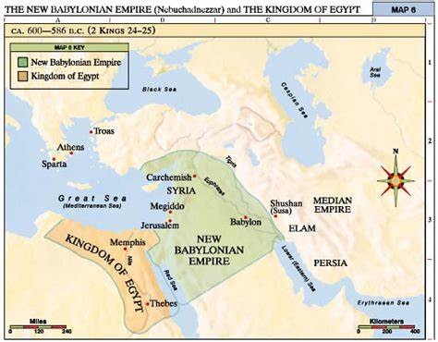

This tribe called Scythians would occupy and eventually control a stronghold in and around the Black Sea & Caspian Sea from around 800 AD into almost 1200 AD;

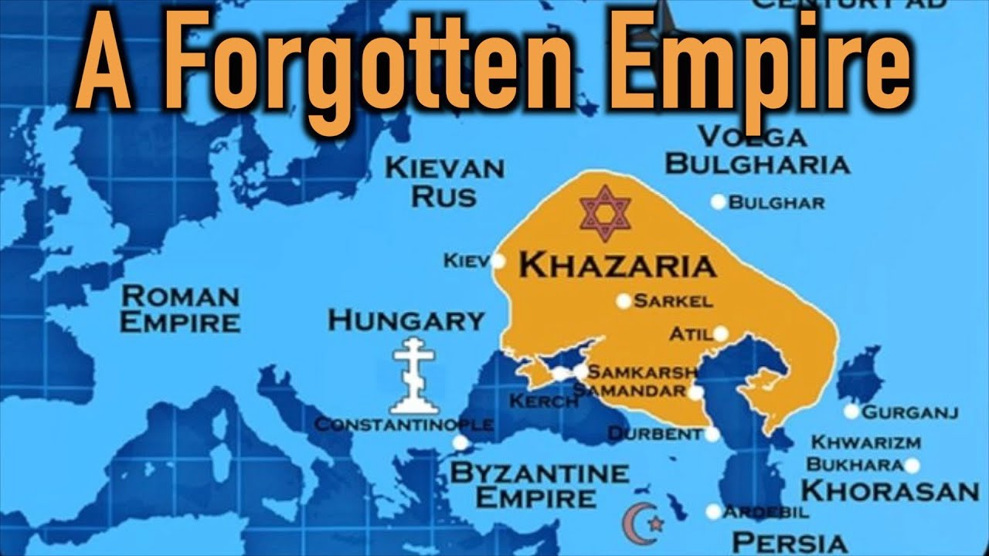

This tribe became known as the oldest mafia on the planet – the Khazarian mafia. During the time that the Apostle Paul wrote Colossians (61 AD) they were still a nomadic group of satanic warriors.

By 100 AD they began to journey and conquer regions into the area on the map.

The areas we know today as Romania, Transylvania, Hungary, the Ukraine and parts of Kazakhstan were all engulfed in this kingdom of evil.

/From about 100-800 AD – an incredibly evil society, slowly emerges in Khazaria: (Scythians) Khazarians develop into a nation ruled by an evil king (Bulan), who had ancient Babylonian black arts, and occult oligarchs serving as his court. During this time, Khazarians became known to surrounding countries as thieves, murderers, and road bandits, and for assuming the identities of those travelers they murdered as a normal occupational practice and way of life.\

Identity theft began with this culture.

If you had real estate, gold or power they found a way to rip it from you. Or they would assume your family identity after they had murdered the patriarchs of the family.

This was one of the ways they rose to great power and they were able to set up a kingdom. The kingdom itself only lasted about 200 years.

It held its ground from about 800 AD into 1000 AD but by 1200 AD it was dismantled.

/The leading countries in and around this region confronted the Khazarian leadership several times concerning their dark practices. Missing children, violent scrimmages with Khazarain warriors, coupled with the theft of neighboring real estate and gold by Khazarain soldiers drew the attention of a Russian Czar. The confrontation led to an ultimatum (900 -1000 AD) by the powerful Russian leader.\

/The Khazarian military was no match for the Russian military and combined with the other forces in the region it would have been a one-day, slaughter of their kingdom. They would be forced to accept an Abrahamic religion and a drastic change to join alliances with their neighbors. The Khazarian’s proclaimed they were descendants of the true Abraham because their origins were from the middle east (Babylon). They produced documents such as the Talmud among other artifacts to prove they were practicing Judaism.\

There was a peace agreement implemented and within a short period of time there was peace in the region.

The Khazarians were now successfully hiding behind Judaism and it worked for a period of time.

Until the missing children and random murders began to once again pop up on the landscape just outside the Khazarian kingdom.

/About 1,200 AD, the Russians led a group of nations surrounding Khazaria and invaded it, in order to stop the Khazarian crimes against their people, which included the kidnapping of their young children and infants for their blood sacrifice ceremonies to Baal. The Khazarian king and his inner court of criminals were given a final warning before the military assault on the kingdom. Dozens of the elite Khazarian families were able to escape days before the battle ensued.\

It is believed the Khazarian king had spies in other kingdoms giving him intel.

These families regrouped in pockets of Europe such as Romania, Poland, Germany, France and into London. They remained much more secretive in their wicked, religious practices. Yet all of them adopted Jewish names and went forward in history, slowly setting up connections to leaders such as kings, queens and dukes or princes.

They came into other countries with all their stolen jewelry and gold or silver.

They focused on the trickery of Babylonian money magic, offering paper notes for the holding of gold and silver.

Slowly over several generations they rose again to great power but this time behind the scenes of kingdoms and governments.

REPEAT

Secret societies we know today, were born between 1000 AD into 1400 AD and this group was mostly likely at the helm of all them.

Now I ask you how will you square what the word of GOD teaches us about Israel?

/Rev 2:9 ‘I know your tribulation and your poverty (but you are rich), and the slander by those who say they are Jews, and are not, but are a synagogue of Satan. (Rev 3:9)

Gen 12:3 And I will bless those who bless you, And the one who curses you I will curse. And in you all the families of the earth will be blessed.”\

I could give you more but what I have taught you in the past few months is enough for now.

You must realize everyone is not who they always claim to be – everything is not what it may appear to be on the surface.

We know the nation of Israel was infiltrated several times in ancient history.

The Sanhedrin was riddled with counterfeits.

And now you know the history of the Khazarian Mafia, who to this very day are not true Israel. Yet they hold prominent positions world-wide.

World-wide banking, Hollywood, energy and pharmaceutical. As well as news outlets and educational systems are almost all run by families with Jewish last names.

We pray for the safety of the nation of Israel and we pray for those who are lost whether Jew or Gentile.

/Mat 5:44 “But I say to you, love your enemies and pray for those who persecute you, 45 so that you may prove yourselves to be sons of your Father who is in heaven; for He causes His sun to rise on *the* evil and *the* good, and sends rain on *the* righteous and *the*  unrighteous.\

I’ll close with this today;

/Deu 29:29 “The secret things belong to the LORD our God, but the things revealed belong to us and to our sons forever, so that we may follow all the words of this Law.

Rom 11:33 Oh, the depth of the riches, both of the wisdom and knowledge of God! How unsearchable are His judgments and unfathomable His ways!\