James #161
The manna, Aaron’s staff and the tablets of Law.

Open back up in Hebrews nine.
The Memorial Weekend coming up on the 23rd and 24^{th -} I will be away with family on a long weekend break.
There will be no Sunday service on May 24th .
I appreciate the time off, as many of you enjoy long holiday weekends with family and friends, I occasionally have to do the same.
So, I am grateful for your understanding in this matter.
We will open back up in Hebrews 9, where we have been looking at specific items in the tabernacle.
We have looked at the outer courtyard with the brass altar and the laver which was a large washbowl for the priests.
We looked at the interior of the first room in the temple - the HOLY Place.
We have noted all the spiritual analogies that apply to us in the CA and the teaching tools designed for the nation of Israel. We looked at the Golden Lampstand and the table of showbread.
Now we have focused upon the altar of incense;
/Heb 9:4 having a golden altar of incense and the ark of the covenant covered on all sides with gold, in which was a golden jar holding the manna, Aaron’s staff which budded, and the tablets of the covenant;

Exo 30:6 “You shall put this altar in front of the veil that is near the ark of the testimony, in front of the atoning cover that is over the ark of the testimony, where I will meet with you.\
There were several very specific instructions concerning this altar of incense.
Exo 30:1-10 covers this in great detail.
/This was a picture of the doctrine of the Hypostatic Union and the victory of Christ after resurrection when HE sat down on the right side of the throne. The mix of wood and gold used in a unique fashion, pointed to the Hypostatic Union. The opposite of the brass altar in the courtyard, which pointed to judgment, this was about victory.\
The table of incense was of wood and gold but also a crown around the edge, it held fire, and incense.
It was 3 ft high and 18 inches in width, square width.
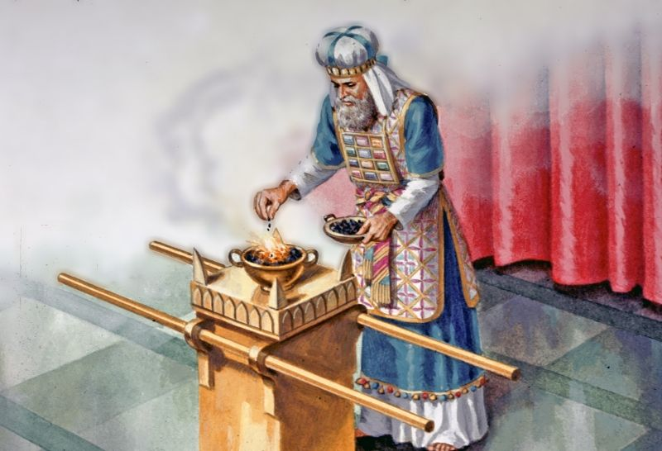
So, there were five articles on the structure of the golden altar:
/The golden altar of incense was made of wood (humanity of Christ), plated with gold (deity of Christ) — a picture of the hypostatic union; then three more articles: a crown, fire, and incense. The horns on this altar spoke to power and prayer as well as victory. The consistent burning of incense day and night, was to point to the fragrant aroma of satisfaction (propitiation) and victory. It was symbolic for prayer to align with the burning of incense.\

Many times, prayer was done with the burning of incense and deep meditation.
/Psa 141:2 May my prayer be counted as incense before You; The raising of my hands as the evening offering.

Luk 1:9 according to the custom of the priestly office, he was chosen by lot to enter the temple of the Lord and burn incense. 10 And the whole multitude of the people were in prayer outside at the hour of the incense offering.\
Unity matters and unity in prayer from God’s people is a powerful weapon.

We know that GOD looked upon OT offerings as a fragrant aroma, this all pointed to the propitiatory work of Christ on the cross.

It was also part of the priesthood to burn incense, pray and meditate when in communication with GOD.
We see this throughout scripture.

/Rev 5:8 When He had taken the scroll, the four living creatures and the twenty-four elders fell down before the Lamb, each one holding a harp and golden bowls full of incense, which are the prayers of the saints. (Rev 8:3-4) \

Our Lord Jesus Christ is always making intercession for us, we in turn, should be praying for others before our own needs.

Both the golden table of incense and the mercy seat, on top of the ark of the covenant, pointed to victory, as well as legal propitiation, highlighting the person and work of Jesus Christ.
/The fire of the incense represented judgement on the Cross. The crown containing that fire pointed to the validity of the work of Christ on the cross which is found in the resurrection, ascension, and session, the strategic victory of the angelic conflict. The crown was for the King of kings, which can only be placed upon the head of the one who sat down at the right hand of the throne in a victorious session. \
Fire is often seen as a cleansing judgment inside the plan of GOD; HE often used consuming fire to not only judge people but to cleanse an environment.

/The brass altar in the courtyard emphasized salvation and how it was accomplished. The golden altar inside in front of the entrance to Holy of Holies, was symbolic of victory and how it was accomplished. The fire for the golden altar was from the brass altar. They carried coals in from the brass altar and put them in the crown which started the fire in the golden altar.\

Without the brass altar and its fire there would be no worship at the golden altar — meaning;
/Apart from the cross and salvation there is no effective worship or prayer mankind can bring forth on their own. You cannot ignore the brass altar (cross of Christ)! Prayer is useless until you believe upon Jesus Christ. There is no spirituality without our union with Christ.\
All prayer from the Believer who is filled by God the HS, is filtered through our mediator Jesus Christ, who sits at the right hand of the throne.
We now have direct access to the throne room.

There were 4 ingredients that were to be used on the altar of incense, each one spoke to the person and work of Jesus Christ.
/Exo 30:34 Then the LORD said to Moses, “Take for yourself spices—stacte, onycha, and galbanum, spices and pure frankincense; there shall be an equal part of each.

Stacte & galbanum were a type of gum resin from certain trees or shrubs – pointing to the perfect humanity of Christ. Onycha was from a shell fish (mussel) representing the death and resurrection of Christ.\

Frankincense burns with a pure white type of flame; it pointed to the purity of Christ and HIS victory of the ascension and session.
What we have been studying is that every detail of the Mosaic Law – be it codex 1, codex 2 or codex 3, the right thing done in the right way matters!

This points back into our anchor study in James chapter 2;
/Jam 2:9 But if you show partiality, you are committing sin and are convicted by the Law as violators. 10 For whoever keeps the whole Law, yet stumbles in one point, has become guilty of all.\

There are numerous examples of this in the Bible.
I have showed you so many painstaking details of certain temple items, it is very apparent it is a serious matter.
So serious, that there are scriptures telling us that the whole Mosaic Law had to be upheld to the letter of the LAW.
The temple protocol was even more strict because it was codex 2, the spiritual representation of Jesus Christ and the communication from God.
REPEAT
Being responsible for the teaching of the WORD of God is held to a higher standard.
/Lev 10:1 Now Nadab and Abihu, the sons of Aaron, took their respective firepans, and after putting fire in them, placed incense on the fire and offered strange fire before the LORD, which He had not commanded them. 2 And fire came out from the presence of the LORD and consumed them, and they died before the LORD.\
Notice the judgment of fire!

Before we finish up in Hebrews nine and go back into James chapter two, we will quickly look at the ark of the covenant.
We already did a recent look at the mercy seat.
As I have clarified before the wood and gold of the ark of the covenant represent the doctrine of the hypostatic union.
The mercy seat on top we have covered recently, it points directly to Jesus Christ, HE is the mercy seat.
The covering angels were seen on the morning of the resurrection of Christ – the empty tomb being guarded. One at the head and one at our Lord’s feet.
/The 3 items inside the ark had deep meaning as well. the urn of manna representing sin in the sense of rejection of God’s provision. Jesus Christ is the bread of life – for the CA Christian, HIS WORD feeds us, just as GOD fed the Exodus generation. They did not appreciate the manna, nor did they follow protocol with the bread or the meat provided for them (Exo 16).\
All 3 items point to perfection and rebellion.
They point to God’s grace provisions and the righteousness of Christ as well as man’s OSN.
/The blossomed rod of Aaron’s staff, pointed to authority (shepherd staff), it had to be established and upheld. The rebellious nature of the people was an ongoing issue. Rebellion toward God usually starts with rebellion toward the teaching of the WORD. Jesus Christ is the Good Shepherd (Jhn 10), HE is the head, the leader, protector and teacher for all of us. The budding also pointed to fruit, spiritual growth from the staff.\
The shepherd staff pointed to leadership and spiritually speaking, that points to pastor-teachers in the CA.
Back then it was the Levitical priests.
The third item within the ark, was the tables of the law. Two tablets.
/The ten commandments represented the written word and perfect commands from Christ. These also pointed to the sin nature of man. Showing us God’s love and mercy by showing us the perfection of God’s laws and commands. The contents of the ark represent Christ bearing our sins on the cross. No matter what HE does for us, our rebellious sin nature will always separate us from HIM.\
Therefore, Christ became the LAMB of God who saved the whole world.
These are symbols of God’s perfect plan; the perfection and righteousness of Christ are far beyond our reach.
The mercy seat which covered the ark displayed the sacrificial work of TLJC for all of us.

Now let us pivot back into Hebrews 9 in closing;
Heb 9:4 having a golden altar of incense and the ark of the covenant covered on all sides with gold, in which was a golden jar holding the manna, Aaron’s staff which budded, and the tablets of the covenant;
The MANNA was held in a golden jar because it is the precious mind of TLJC.
/Heb 9:5 and above it were the cherubim of glory overshadowing the atoning cover; but about these things we cannot now speak in detail.

The details as we have looked at, run so deep and intricate that it would have pulled the teaching of the new covenant off course, which was at the core of this chapter.\
The teacher of Hebrews is saying in essence - this is beyond what we can dive into right now!
Heb 9:6 Now when these things have been so prepared, the priests are continually entering the outer tabernacle, performing the divine worship,
Heb 9:7 but into the second, only the high priest enters once a year, not without taking blood which he offers for himself and for the sins of the people committed in ignorance.

We noted this when we covered the outer courtyard items – the brass altar and the laver.
Heb 9:8 The Holy Spirit is signifying this, that the way into the holy place has not yet been disclosed while the outer tabernacle is still standing,
The tabernacle had served its purpose up until the Cross of Jesus Christ.

Heb 9:9 which is a symbol for the present time. Accordingly both gifts and sacrifices are offered which cannot make the worshiper perfect in conscience,
/ The weakness of the priestly service under the Old Covenant was its inability to address the need for inner transformation in man. The blood of animals never saved anyone, nor did it bring them into deeper knowledge. It was symbolic teaching for what was to come. Therefore, it was only imposed until the time of the reality of Christ giving HIMSELF up on that cross.\

Heb 9:10 since they relate only to food, drink, and various washings, regulations for the body imposed until a time of reformation.
Something new – the old covenant was now fulfilled.

Heb 9:11 But when Christ appeared as a high priest of the good things having come, He entered through the greater and more perfect tabernacle, not made by hands, that is, not of this creation;
/Heb 9:12 and not through the blood of goats and calves, but through His own blood, He entered the holy place once for all time, having obtained eternal redemption.

The repetitive nature of the Levitical order and the rituals were shadows of what became the reality in CHRIST!\
Heb 9:13 For if the blood of goats and bulls, and the ashes of a heifer sprinkling those who have been defiled, sanctify for the cleansing of the flesh,
Heb 9:14 how much more will the blood of Christ, who through the eternal Spirit offered Himself without blemish to God, cleanse your conscience from dead works to serve the living God?
Remember the term blood of Christ speaks to the work, the sacrificial work, Jesus Christ did not bleed out…HE willingly gave HIMSELF up.

/Heb 9:15 For this reason He is the mediator of a new covenant, so that, since a death has taken place for the redemption of the violations that were committed under the first covenant, those who have been called may receive the promise of the eternal inheritance.\

