James #159
Christ is the light of the world

Let us pick it back up in Hebrews chapter nine.
Be prepared to partake of the LORD’s Supper at the end of the message.
/The tabernacle was always situated in the center of the camp surrounded by the 12 tribes, which were strategically stationed all around the outer boundaries. This meant that the teaching and preservation of the WORD was the main focus and had the highest priority. Israel as a picture of the CA Believer’s soul should have Christ (BD) at the center.\

We will go over very quickly the first few scriptures to get us focused back upon our study of the intricacies of the temple items.
Heb 9:1 Now even the first covenant had regulations for divine worship and the earthly sanctuary.
The first covenant pointed to the Mosaic Law. The earthly sanctuary was referencing the tabernacle.
We took a look at the outer courtyard last lesson and the two items you would first see upon opening the gateway of the large courtyard which led to the temple.
It was a bronze altar which was 4 feet high and 7 feet by 7 feet wide, this was usually placed on a mound of dirt with a ramp leading up to that altar.
We also noted the bronze laver (washbowl) and all the spiritual analogues connected with those two items.
Keeping in mind, if a priest did not wash themselves and attempted to enter the tabernacle, it was considered a death sentence.
Now we begin to look into the first room of the tabernacle;
/Heb 9:2 For a tabernacle was equipped, the outer sanctuary, in which were the lampstand, the table, and the sacred bread; this is called the Holy Place.

This was the HOLY PLACE, which was lite only by the golden lampstand.\
Heb 9:3 Behind the second veil there was a tabernacle which is called the Most Holy Place,
This was the second room known as the HOLY of Holies.
The symbolism was incredible as we noted last message.
This tabernacle served as one of several teaching tools within the Mosaic Law.
Remember as I mentioned last lesson for 500 yrs this was like the written word of BD for the nation of Israel.

Heb 9:4 having a golden altar of incense and the ark of the covenant covered on all sides with gold, in which was a golden jar holding the manna, Aaron’s staff which budded, and the tablets of the covenant;
Heb 9:5 and above it were the cherubim of glory overshadowing the atoning cover; but about these things we cannot now speak in detail.
Heb 9:6 Now when these things have been so prepared, the priests are continually entering the outer tabernacle, performing the divine worship,

/Heb 9:7 but into the second, only the high priest enters once a year, not without taking blood which he offers for himself and for the sins of the people committed in ignorance.

Yom Kippur (Day Atonement) began with the ritual sacrifice in the courtyard, before the high priest would enter the temple.\
Once the two bull offerings and two goat offerings were complete, it would be only then, that the high priest could enter the temple.
We covered great details about the altar and laver in the courtyard last lesson, now we approach the inside of the Tabernacle.

Heb 9:8 The Holy Spirit is signifying this, that the way into the holy place has not yet been disclosed while the outer tabernacle is still standing,
We can finish looking at the golden lampstand before we get into the table & showbread.

/Inside the first Holy Place was gold plated walls and a linen woven ceiling with angels designed upon it. It was a breathtaking place to enter. Outside, the world could not see this divine, beauty. The high priest represents the CA Bel in our Royal priesthood having fellowship with GOD. The embroidered cherubs of blue, purple, and scarlet, revealed the essence of GOD’s justice, love, eternal life, omnipotence, omniscience, omnipresence, immutability and veracity.\
If you notice the majesty and Royality of the colors, the gold and brass along with the details of the priests and their dress code and rituals – we see how the Gnostics and Judaizers combined into the 2nd century and created one of the biggest denominations we have today.
Satan is the original counterfeiter.
REPEAT
/The lampstand (7 lights) speaks to the perfect and finished work Christ, as well as the ministry of God the HS. The 6 branches represented mankind, yet also pointed to our need to be in union with Christ (center). Only Christ, as the light of the world, can show us the FATHER. This lampstand spoke to the true light of the world, the life we have as the branches of the true VINE (Jhn 15:5).\

Every time the portable tabernacle was moved and the lampstand was re-ignited, it was always the large middle stem that was lit first and all other 6 stems were lit from that middle stem.
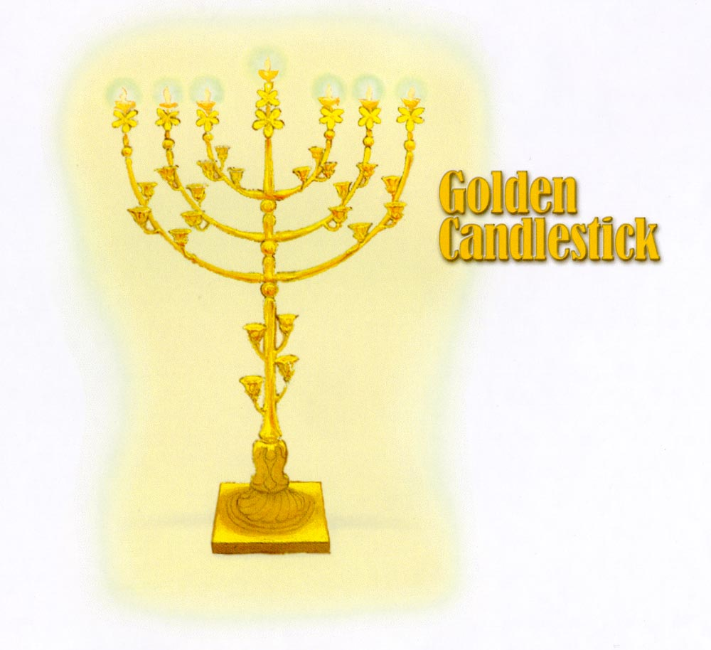
This golden lampstand should be the emblem on the flag of Israel not the star of Rempham. Israel is often referenced as the olive tree, or the fig tree.
We see this also in the golden lampstand.
In fact, olives, figs and grapes are abundantly grown in Israel.

/Very much like the Mercy Seat it was uniquely made of pure gold and a difficult task of hammering this out of one piece mattered. The beating indicates the cross, the hammering of the metal into a shape of something meaningful. Positional sanctification and eternal security are also indicated by the fact that they did not break off any part of this lampstand which was shaped out of one talent. The branches (Believers), cannot be separated from the central shaft. \
It is interesting that TLJC often used the term - the light of the world.
He is the light of the world and we are called to reflect HIM. Just as HIS references to the branch and vine are significant.
/Jhn 8:12 When Jesus spoke again to the people, he said, “I am the light of the world. Whoever follows me will never walk in darkness, but will have the light of life.”

John 1:5 “The light shines in the darkness, and the darkness has not overcome it.” \

/Mat 5:14 “You are the light of the world. A town built on a hill cannot be hidden.”
(2Cor 4:6, 1Jhn 1:7, Psa 119:105…etc.)
Jhn 12:46 I have come into the world as a light, so that no one who believes in me should stay in darkness.”\

The analogies, the shadows or typologies are incredible and really vast!
/The shadow became a reality which was formed as the royal family of the Church Age, each branch is not only joined to the center branch (Christ), yet also joined to the branch on the other side to point to unity. Our unity is not based upon human power or human IQ. It is based upon the person and work of Jesus Christ the true VINE.\

This is why personality conflicts, should never bring true separation to Bels walking in union with Christ. Unity happens when we all have the same mind, the same goals and same norms and standards.
/The unity of the royal family is based upon the fact that at the point of salvation, each one of us was entered into union with Christ. Our unity is in the fact that we are all “in Christ”. All six branches are lower than the central branch in this golden lampstand, indicting the fact that Christ is the head.\
Many modern menorahs are depicted in equal size of all 7 lantern cups, yet that was not the initial design. Just as the size and elaborate details of the original tabernacle were altered by mankind over time.
What I am showing you is the original design given to Moses in the wilderness.
Interesting how mankind always has to add on to, or take away from the person and work of Jesus Christ.

/The original priesthood understood the Messiah as the light of the world, the golden lampstand representing the deity of Christ. What they could not fully see was the mystery of the coming Church age which would grow out from the main VINE (Christ). They understood humanity represented by the number 6, yet did not fully grasp the depth of the whole family of GOD yet to come.\

Also, we know that oil was often symbolic for the presence of God the HS, it was used for anointing leaders and healing – showing us the power of God the HS.
/There was oil in the central lamp, this spoke to God the Holy Spirit indwelling Christ during His earthly ministry (1st advent). The oil in the six lamps of the lampstand were from the branches feeding off the main stem. Pointing ahead to the CA, when God the Holy Spirit makes His residency in the body of every Believer. When we are filled with the Spirit, He also controls our soul, therefore the light burns through the filling power of the Holy Spirit.\
We will begin an introduction into the table and showbread which is appropriate for the Lord’s Supper.

/The BREAD of the PRESENCE was the table of showbread (12 large loaves). The table was wood (humanity of Christ), overlayed with gold (deity of Christ). We see a clear description in Exo 25:23-30, the table was set on the north wall facing the lampstand. From a heavenly vantage point there was a cross shape from the courtyard altar & laver, at the bottom. Into the tabernacle with the lampstand facing across to the table of showbread as the cross beam. Into the Holy of Holies entrance with the altar of incense and the ark of the covenant (mercy seat) at the head of the cross shape.\
So, from the viewpoint of GOD looking down even through the ceiling cover was the shape of the cross, with those 6 temple furnishings.
The cross of TLJC saving mankind (#6).

/The gold crown molding around the table would ensure no bread would ever roll off, it gave the table security and displayed a type of crown for the WORD (Bread). The bread represented the very mind of Christ, which would come to visual fulfillment in the completed canon of scripture. 12 loaves of unleavened (pure) wheat bread, specially prepared. Fresh bread replaced every Sabbath, the outgoing bread was still good and eaten by the priesthood.\
Twelve not only represented the twelve tribes of Israel, it pointed to God’s divine order, HIS power and governing principles for organization and stability.

/The purity and precision of the making of the bread, spoke to the impeccability of the humanity of Christ. From virgin birth into resurrected life, the person of Jesus and the plan of GOD is perfect. There were 2 golden bowls of burning frankincense next to the loaves during the refreshing period on the Sabbath. The frankincense pointed to a fragrant aroma of satisfaction (propitiation).\
The 12 loaves were set up in two rows of six, with the two bowls of frankincense in between. Between each loaf of bread was a set of reeds which speaks of individuality, yet the bread was all in the same size, shape and a line which was a sign of unity.
REPEAT
Every Believer is responsible for their own walk with God, yet we operate in unity and support of on another.

Every aspect of the Mosaic Law pointed to TLJC, it highlighted the power and presence of God. The spiritual presence of God the HS was seen in many realms as well.
Yet the person and work of Jesus Christ is at the center as always...HE is the very center of the universe.
As we prepare for the LORD’s Supper let me read from the Apostle Paul, scriptures that truly points to the power, the person and work of The Lord Jesus Christ.
/Col 1:13 For He rescued us from the domain of darkness, and transferred us to the kingdom of His beloved Son, 14 in whom we have redemption, the forgiveness of sins. 15 He is the image of the invisible God, the firstborn of all creation:\

/Col 1:16 for by Him all things were created, both in the heavens and on earth, visible and invisible, whether thrones, or dominions, or rulers, or authorities—all things have been created through Him and for Him.\
Jesus Christ is the unique GOD-man there is no other MESSIAH. No other way to have eternal security except – faith alone in Christ alone.
/Col 1:17 He is before all things, and in Him all things hold together. 18 He is also the head of the body, the church; and He is the beginning, the firstborn from the dead, so that He Himself will come to have first place in everything.\

/Col 1:19 For it was the Father’s good pleasure for all the fullness to dwell in Him, 20 and through Him to reconcile all things to Himself, whether things on earth or things in heaven, having made peace through the blood of His cross.\
The work of Jesus Christ on that cross resolved the angelic conflict and it paid for the sins of all mankind.
There is no other entrance into heaven outside of faith alone in Christ alone.
/Col 1:21 And although you were previously alienated and hostile in attitude, engaged in evil deeds, 22 yet He has now reconciled you in His body of flesh through death, in order to present you before Him holy and blameless and beyond reproach—\

On the night our LORD was betrayed, He took the bread, broke it and gave thanks. Lifting it up, Jesus told them, “This is my body I give to you…take and eat.”
In remembrance of our LORD let us eat the bread.

In the same manner Jesus lifted the cup and gave thanks, and HE said, “This is the cup of a new covenant which is in MY blood, take it and drink.”
“For each time you eat this bread and drink this cup, you shall bring ME into remembrance until I return.”

In remembrance of our LORD and Saviour Jesus Christ let us drink the cup.

Let us pray….amen.

